Comments to the

California Air Resources Board

on Implementation of California Climate-Disclosure Legislation: Senate Bills 253 and 261, as amended by SB 219

These comments are in response to the California Air Resources Board’s (CARB or Board) solicitation dated December 16, 2024 requesting feedback to inform implementation of Senate Bills (SB) 253 (Wiener, Statutes of 2023) and 261 (Stern, Statutes of 2023), both as amended by SB 219 (Wiener, Statutes of 2024).

# I appreciate the opportunity to comment on implementation of these two new laws, as I have been working with corporations from every sector on both mandatory and voluntary climate disclosures (including corporate GHG inventories) for over 20 years as a consultant. Currently I am a member of the Greenhouse Gas Protocol’s (GHGP) Technical Working Group engaged to develop revisions to the Corporate Standard for GHG Inventories.

# *Comments are provided in italics below,* in response to each question in the CARB solicitation which is repeated here verbatim. I am available to CARB to respond to any questions or provide further information on my comments provided here. If so, my Email address is provided below.

Note: The views and opinions expressed in comments are solely those of the individual commenter and do not necessarily reflect the views of SCS Engineers.

# Sincerely,

# Victoria A. Evans, MS

# National Climate Practice Lead

# SCS Engineers

# 4683 Chabot Drive, Suite 200

# Pleasanton, CA 94588 USA

# [VEvans@scsengineers.com](mailto:VEvans@scsengineers.com)

**Comments Submitted**: [https://ww2.arb.ca.gov/public-comments/public-comments-california-](https://ww2.arb.ca.gov/public-comments/public-comments-california-climate-disclosure-information-solicitation) [climate-disclosure-information-solicitation](https://ww2.arb.ca.gov/public-comments/public-comments-california-climate-disclosure-information-solicitation)

# COMMENTS ON CARB SOLICITATION

# General: Applicability

1. SB 253 and 261 both require an entity that “does business in California” to provide specified information to CARB. This terminology is not defined in the statutes.
   1. Should CARB adopt the interpretation of “doing business in California” found in the Revenue and Tax Code section 23101?
      * *A clear definition of this term is certainly needed and I encourage that one be provided in CARB regulations to guide a clear interpretation of the applicability of these two laws to individual public or private entities. The RTC section 23101 provides clear numerical values that can serve as thresholds for decision making by entities on applicability of the laws to them. If the legislative intent was intended toward a broader applicability of these two laws than provided by this definition, that should be identified and explored.*
   2. Should federal and state government entities that generate revenue be included in the definition of a “business entity” that “does business in California?”
      * *No.*
   3. Should SB 253 and 261 cover entities that are owned in part or wholly owned by a foreign government?
      * *Only if those entities otherwise meet the definition in the legislation.*
   4. Should entities that sell energy, or other goods and services, into California through a separate market, like the energy imbalance market or extended day ahead market, be covered?
      * *Yes, unless this is outside of legislative intent.*
2. What are your recommendations on a cost-effective manner to identify all businesses covered by the laws (i.e., that exceed the annual revenue thresholds in the statutes and do business in California)?
   1. For private companies, what databases or datasets should CARB rely on to identify reporting entities? What is the frequency by which these data are updated and how is it verified?
      * *No comment on the database sources. Recommending that data be updated and verified annually.*
   2. In what way(s) should CARB track parent/subsidiary relationships to assure companies doing business in California that report under a parent are clearly identified and included in any reporting requirements?
      * *No comment.*

# General: Standards in Regulation

1. CARB is tasked with implementing both SB 253 and 261 in ways that would rely on protocols or standards published by external and potentially non-governmental entities.
   1. How do we ensure that CARB’s regulations address California-specific needs and are also kept current and stay in alignment with standards incorporated into the statute as these external standards and protocols evolve?
      * *I recommend tracking revisions to the standards referenced and incorporated in the statutes: the GHG Protocol’s guidance documents for Corporate GHG inventories, and the International Financial Reporting Standards, Standard 2 for Climate risk disclosures for application to California’s requirement for a climate-related financial risk assessment (CRFRA). Each of these organizations have Email notifications for public comment solicitations on revisions and notifications of updated documents.*
      * *The schedule for updates to the GHGP’s guidance documents is at* [*https://ghgprotocol.org/blog/2024-reflections-and-looking-ahead-letter-ghg-protocol-steering-committee-chair-and-vice-chair*](https://ghgprotocol.org/blog/2024-reflections-and-looking-ahead-letter-ghg-protocol-steering-committee-chair-and-vice-chair)
      * *A copy of the GHGP’s matrix of the current key milestones is copied and provided here.*

***KEY MILESTONES FOR GHGP’S REVISIONS***

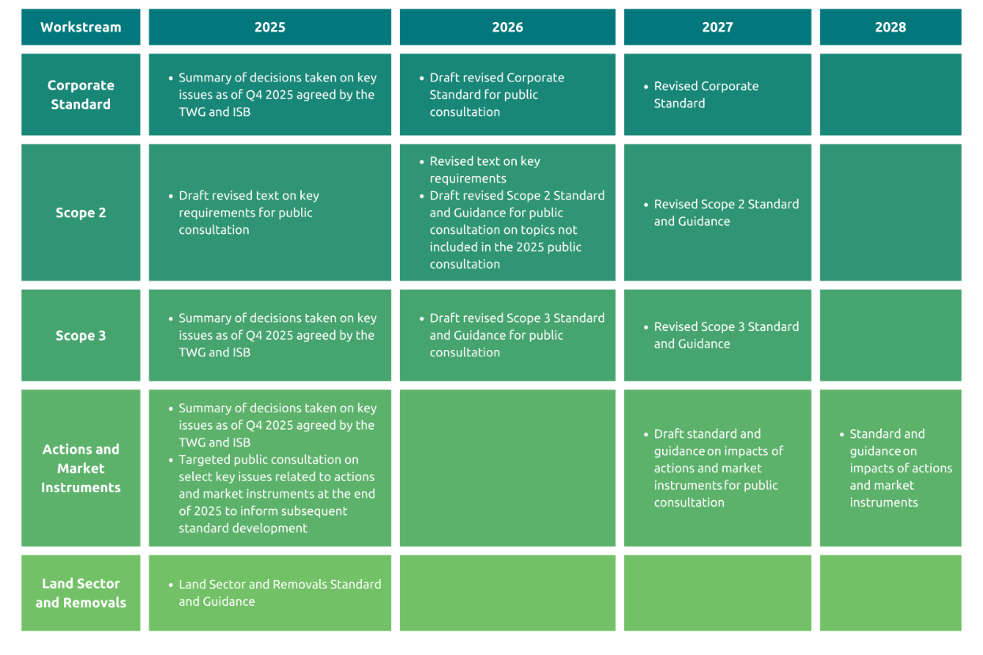

* 1. How could CARB ensure reporting under the laws minimizes a duplication of effort for entities that are required to report GHG emissions or financial risk under other mandatory programs and under SB 253 or 261 reporting requirements?
     + *In two ways: first, review the other mandatory program requirements that companies are required to report under, for differences and similarities. There are numerous sources for existing analyses of these differences that can be accessed and reviewed by CARB. I can provide these references to CARB if that would be helpful. Note there are significant differences between California’s requirements and those of Canada and the EU, for example. This is true for each type of reporting whether it is for GHG emissions or the climate-related financial risk assessment. For GHG inventories, there are some differences in reporting requirements starting with varying materiality definitions that affect the extent of reporting GHGs, and for annual reporting in requiring a calendar year versus a fiscal year duration. In the EU, corporate climate risk assessments are required to consider double materiality versus the single materiality required in SB 261.*
     + *Second, CARB could request entities to self-report on other mandatory programs they are obligated to report under.*
  2. To the extent the standards and protocols incorporated into the statute provide flexibility in reporting methods, should reporting entities be required to pick a specific reporting method and consistently use it year-to-year?
     + *Yes, in general, to enable consistency and comparability in reporting. However, as methodologies are improved for each of emissions calculations and risk assessment, these should be encouraged. Also, as the reporter improves data collection over time, these should be enabled. Note that for Scope 3 GHG analyses, this is the area of the largest uncertainties and of rapidly developing improvements; I recommend that Scope 3 GHG inventorying be especially monitored over time.*

# General: Data Reporting

1. To inform CARB’s regulatory processes, are there any public datasets that identify the costs for voluntary reporting already being submitted by companies? What factors

affect the cost or anticipated cost for entities to comply with either legislation? What data should CARB rely on when assessing the fiscal impacts of either regulation?

1. Should the state require reporting directly to CARB or contract out to an “emissions” and/or “climate” reporting organization?
   1. *Since this is a state program for California, I recommend that reporting be made directly to CARB for GHG emissions inventories and that the current legislative requirement remain for the CRFRAs to be posted at an entity’s website, every two years.*
2. If contracting out for reporting services, are there non-profits or private companies that already provide these services?
   1. *Yes, but reporting is made under their organization’s standards and to maximize scores under their associated ranking systems.*

# SB 253: Climate Corporate Data Accountability Act

1. Entities must measure and report their emissions of greenhouse gases in conformance with the GHG Protocol,1 which allows for flexibility in some areas (i.e. boundary setting, apportioning emissions in multiple ownerships, GHGs subject to reporting, reporting by sector vs business unit, or others). Are there specific aspects of scopes 1, 2, or 3 reporting that CARB should consider standardizing?
   1. *Yes, for Scope 1 and 2 emissions, I agree – see the GHGP guidance for the opportunity to improve emissions reporting by companies by referring to or incorporating the existing, more detailed CARB reporting requirements under the current California MRR for facilities and others. This is an opportunity for CARB to provide prescriptive guidance on reporting GHG emissions to support comparability and consistency of corporate inventories. Existing CARB regulations on MRR cover natural gas, electricity, biogas, energy purchases cover most of Scopes 1 and 2. The addition of fleet fuel usage (if fossil fueled) and fugitive emissions is needed to round out coverage of corporate Scope 1 emissions. Within Scope 1, for example, corporate reporting includes fugitive emissions, e.g., process gas uses (food preservation, beverage production, chip manufacturing) and refrigerants. These would need to be added.*
   2. *Scope 3 emissions accounting is the most time-consuming and demanding in terms of data collection. It would benefit from CARB’s review of methods that are currently relied upon. See GHGP’s reporting Scope 3 standard and guidance at:* 
      * [*https://ghgprotocol.org/corporate-value-chain-scope-3-standard#supporting-documents*](https://ghgprotocol.org/corporate-value-chain-scope-3-standard#supporting-documents)
      * [*https://ghgprotocol.org/sites/default/files/standards/Scope3_Calculation_Guidance_0.pdf*](https://ghgprotocol.org/sites/default/files/standards/Scope3_Calculation_Guidance_0.pdf)
2. SB 253 requires that reporting entities obtain “assurance providers.” An assurance provider is required to be third-party, independent, and have significant experience in measuring, analyzing, reporting, or attesting in accordance with professional standards and applicable legal and regulatory requirements.
   1. For entities required to report under SB 253, what options exist for third-party verification or assurance for scope 3 emissions?
      * *Multiple existing firms provide 3rd party verification/assurance services for corporate GHG inventories, and those firms have been doing so for some time. These voluntary inventories are reported to a number of different platforms for public disclosure and ranking, in some cases; these include CDP, The Climate Registry (TCR), GRI, EcoVadis, for example.*
   2. For purposes of implementing SB 253, what standards should be used to define limited assurance and reasonable level of assurance? Should the existing definition for “reasonable assurance2” in MRR be utilized, and if not why?
      * *Reconciliation, as needed, of the existing definition of ‘reasonable assurance’ versus ‘limited assurance’ in MRR with the financial standard reflected elsewhere, is recommended.*
3. How should voluntary emissions reporting inform CARB’s approach to implementing SB 253 requirements? For those parties currently reporting scopes 1 and 2 emissions on a voluntary basis:
4. What frequency (annual or other) and time period (1 year or more) are currently used for reporting?
   * *Annual reporting for 12 months based on calendar year or the company’s fiscal year is currently the norm.*
5. When are data available from the prior year to support reporting?
   * *Data for the last quarter of the year is typically available within 45 to 60 days after year end. However, these data then need to be collected, compiled and analyzed.*
6. What software systems are commonly used for voluntary reporting?
   * *Excel-based GHG accounting is the most basic software system that many are using to support inventory calculations.*
   * *There are a few free tools at GHGP and elsewhere. As well, quite a number of commercial software tools are available for supporting cloud-based data management and others that include GHG inventory calculations that are SaaS-based. There are online articles that describe these and their pros/cons relative to each other. Costs vary widely.*

1 https://ghgprotocol.org/

2 “Reasonable Assurance” under MRR means a “high degree of confidence that submitted data and statements are valid.”