Los Angeles, March 20, 2025
Response to the Information Solicitation to Inform Implementation of
California Climate-Disclosure Legislation:
Senate Bills 253 and 261, as amended by SB 219

We are UCLA scholars from the Anderson School of Management and its Center for Impact, the School of Law and the Emmett Institute on Climate Change & the Environment, and the Institute of the Environment & Sustainability, combining academic, legal, and policy expertise in corporate sustainability and climate accountability. The UCLA Anderson Center for Impact advances social impact and sustainability research by integrating these principles into business education. The Emmett Institute is a leading source of environmental legal scholarship, nonpartisan expertise, and policy analysis on climate change and other critical issues. The Institute of the Environment & Sustainability moves science to action on the front lines of environmental progress.
Our response draws on academic expertise in climate and corporate sustainability and data from the UCLA Open for Good Initiative. This initiative promotes transparency in sustainability disclosures by evaluating reporting trends, assessing climate data quality, and identifying best practices for accountability. It produces two key reports—The State of Corporate Sustainability Disclosure and The Transparency Index—which provide insights into disclosure trends, data quality, and transparency across industries within the S&P 500. These insights are particularly relevant for understanding how prepared large U.S. companies are to meet California’s new disclosure mandates, as the vast majority of S&P 500 firms are likely to be subject to both SB 253 and SB 261 based on their revenue size and business presence in California.
We thank the California Air Resources Board (CARB) for the opportunity to respond to the December 16, 2024, information solicitation, which is intended to inform CARB's implementation of California's landmark corporate climate accountability legislation, SB 253 (Wiener, 2023) and SB 261 (Stern, 2023). We appreciate CARB's longstanding leadership on climate, and indeed, SB 253 and SB 261 add to a long history of meaningful state action on climate change and a robust framework of existing climate statutes and regulations. These regulations, such as the Cap-and-Trade (C&T) program and the Low Carbon Fuel Standard (LCFS), already require entities to report their emissions to the state.
As CARB moves forward to implement SB 253 and SB 261, it will do so in the context of its broader climate change regulatory regime. Implementing these laws presents an opportunity for continued progress toward the GHG reduction goals mandated by state law and outlined in the Scoping Plan. Through this submission, we hope to provide helpful context regarding climate disclosures for CARB to consider as it works to develop implementing regulations. First, we will provide background on the overarching goals of mandated climate disclosure regulations—and why voluntary disclosures are inadequate to meet those goals. Then, we will discuss key attributes of a mandatory disclosure system that could be robust, cost-effective, and actionable: ensuring the collection of high-quality data, leveraging existing disclosure frameworks and measurement tools while adopting a phased approach to facilitate compliance, and incorporating independent assessments to enhance public understanding and engagement with corporate climate transparency.

Mandatory corporate disclosures drive meaningful environmental outcomes, while voluntary disclosures fall short
Mandated and standardized disclosure of climate impacts and risks to firms aims to provide stakeholders with consistent and reliable information to support informed decision-making, enhance corporate accountability, and drive operational improvements. First, these regulations require firms to measure, report, and disclose their climate-related performance in a standardized manner, fostering internal awareness that drives efficiency gains and best practices. Companies that systematically track emissions and climate risks can identify inefficiencies, benchmark against peers, and adopt best practices. Second, mandated disclosure facilitates external pressure from stakeholders, including investors, consumers, and advocacy groups, who can use this information to hold companies accountable and influence corporate behavior.
Empirical evidence strongly supports the effectiveness of mandatory disclosure in driving environmental improvements. For example, studies of the U.S. Toxic Release Inventory (TRI) demonstrated substantial reductions in toxic emissions following mandated disclosure, with firms cutting toxic releases by an average of 40% between 1988 and 1994 (Konar & Cohen, 1997). In the electricity sector, mandatory disclosure programs have been linked to increased investment in renewable energy and a decline in fossil fuel-based electricity generation (Delmas et al., 2010). Similarly, research on greenhouse gas (GHG) reporting requirements indicates that mandatory disclosure alone can lead to emissions reductions of 3–7.9%, even without direct regulatory limits (Matisoff, 2013; Tomar, 2021). However, these positive outcomes vary with the policy design. They are most pronounced when disclosures are standardized, easily interpretable, and subject to clear benchmarks that enable stakeholders to exert meaningful influence on corporate behavior (Fung et al., 2007).
Voluntary disclosure frameworks remain limited compared to mandated disclosures due to persistent issues with data quality, standardization, and completeness. Inconsistent measurement methodologies hinder firm comparability (Michelon et al., 2015). Many firms choose not to report, preventing a full assessment of pollution levels. Even among disclosing firms, selective reporting highlights favorable metrics while downplaying negative performance (Adams, 2004). The lack of third-party verification further enables misleading disclosures.
The absence of standardized reporting frameworks contributes to greenwashing. A global survey by The Harris Poll for Google Cloud found that 68% of U.S. executives admitted their companies engaged in greenwashing. This highlights broader challenges in voluntary ESG disclosures, where firms manipulate information to appear more sustainable. Without regulatory oversight, firms shape narratives that enhance public image while obscuring environmental risks.
These challenges are particularly evident in voluntary carbon disclosure initiatives. Research on voluntary carbon reporting based on the Carbon Disclosure Project (CDP) data has revealed substantial variation in how companies define reporting boundaries and calculate emissions, leading to inconsistencies that undermine the credibility of reported data (Andrew & Cortese, 2011; Matisoff et al., 2013). A detailed analysis by Callery and Perkins (2020) found that companies frequently employ selective disclosure strategies, emphasizing positive achievements while obscuring negative performance. Moreover, differences in greenhouse gas accounting methodologies further distort comparisons between firms (Depoers et al., 2016). Time lags in voluntary reporting also reduce the practical utility of environmental data for investors and other stakeholders who rely on timely information for decision-making (Sullivan & Gouldson, 2012).
While voluntary disclosure can offer valuable insights into current corporate practices, it cannot be an adequate substitute for mandated environmental reporting. Voluntary systems often provide a fragmented picture, lacking the standardization, verification, and completeness needed to generate reliable and comparable data. Given these systemic flaws, voluntary disclosure fails to deliver the transparency necessary to inform effective market and policy responses. As the evidence on mandatory disclosure programs demonstrates, well-designed, standardized, and enforceable disclosure requirements are essential to ensure data quality, enable meaningful stakeholder engagement, and drive corporate behavior toward real emissions reductions.

Balancing Rigor and Practicality: Implementing Effective Climate Disclosures

CARB should ensure good quality disclosure data is collected
Whether CARB manages reporting directly or through another entity, ensuring high-quality, trustworthy data is critical. To be useful, information must address relevant issues and accurately reflect the realities it describes. As data collection and analysis experts, we emphasize that the entity responsible for managing this data must follow rigorous standards to ensure it is reliable (collected and presented in a way that can be consistently examined and verified), timely (available when decisions are made), and accurate (faithfully representing what it intends to measure). These attributes are essential for an effective corporate disclosure policy.
Reliability refers to the degree to which information is gathered, recorded, compiled, analyzed, and disclosed in a manner that can be consistently verified, and is free from significant error or bias (Global Reporting Initiative, 2016). Reliable data enables consistency and comparability across reporting periods, allowing stakeholders to track meaningful trends rather than being misled by fluctuations due to changing methods (Drost, 2011; Kimberlin & Winterstein, 2008; Simpson, 1981; Widyawati, 2021). Timeliness ensures that disclosures reflect the most recent information aligned with appropriate reporting periods, avoiding situations where outdated data is misinterpreted as current performance and ensuring relevance for decision-making (Global Reporting Initiative, 2016; Stewart & Kamins, 1993; Simpson, 1981). Accuracy means that reported emissions and risk assessments genuinely reflect a company’s actual performance and outlooks and are not distorted by methodological inconsistencies or poor estimation practices (Cort & Esty, 2020; Stewart & Kamins, 1993; Simpson, 1981). Together, reliability, timeliness, and accuracy are foundational to credible and decision-useful disclosures that meet stakeholder expectations and regulatory goals.
If a firm needs to change an element of its reporting methodology, it should clearly justify how the new approach aligns with established best practices and describe adjustments made to maintain data comparability. This transparency is essential to prevent the selective use of methodologies that could obscure trends or mislead stakeholders about emissions performance. For example, the GHG Protocol Corporate Standard — widely recognized as the foundational framework for corporate greenhouse gas accounting — explicitly requires companies to document and disclose any methodological changes that significantly impact emissions figures, including changes to boundary definitions, calculation methodologies, and improvements in data quality. Firms must also restate prior year data when changes are material to ensure comparability over time (GHG Protocol, 2004, Section 5.2). Thus, these are not novel or overly burdensome practices, but simple and well-established rules already applied in voluntary frameworks and should be embedded within CARB's regulatory system to ensure the credibility and usefulness of reported emissions data.
CARB should also standardize the boundary definition for emissions reporting, as it significantly impacts what is included or excluded from emissions disclosures, particularly for determining which business activities are considered part of California operations. Clear rules on boundary setting — for instance, requiring companies to apply the operational control approach— would enhance comparability and prevent selective inclusion or exclusion of emissions. In addition, CARB should require firms to report emissions from all 15 Scope 3 categories, even if some categories are reported as “0” or deemed immaterial. This approach will ensure a comprehensive and transparent view of a firm's indirect emissions, improve data accuracy, and align California's system with best practices already established in leading global frameworks.
The timeliness of reporting is a key factor in ensuring that emissions data and climate risk disclosures are valuable for stakeholders, including regulators, investors, and researchers. Annual reporting is the most common practice for entities voluntarily reporting Scope 1 and 2 emissions. Open for Good's research has found that while voluntary disclosure rates for Scope 1 and 2 emissions are high among large firms, there remains significant variation in the timeliness and completeness of disclosures, highlighting the need for standardized reporting timelines under CARB's regulations (Delmas et al., 2024).
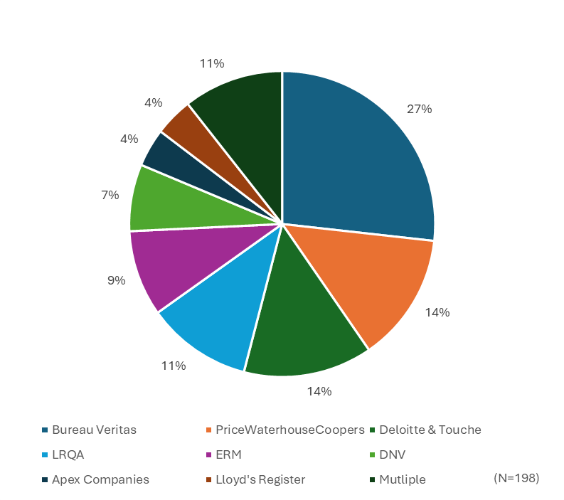
Figure 1: Distribution of assurance firms used in corporate sustainability disclosures of the S&P 500 (Open for Good data sourced from 2022 sustainability reports)
Finally, ensuring the credibility of reported emissions data requires independent assurance to verify its accuracy and consistency. Independent assurance helps confirm that emissions are measured consistently over time and accurately reflect a firm's actual emissions and risks—ensuring that stakeholders can trust the data to inform decisions. By addressing accuracy and consistency, assurance processes play a critical role in upholding the quality and credibility of disclosed data. All the "Big 4" accounting firms (i.e., Deloitte, PwC, EY, KPMG) assure corporate sustainability disclosures. Based on our research on S&P 500 firms, we also find several non-accounting assurance providers that are commonly used, including Apex, Bureau Veritas, Venture, ERM, Lloyd's Register, and LRQA. Figure 1 illustrates the distribution of third-party assurance firms, showing the relative prevalence of different providers in corporate sustainability assurance.

Implementing regulations can leverage existing frameworks and measurement tools and a phased approach to reduce compliance costs
As the California Legislature was considering the adoption of SB 253 and SB 261, and even after the legislation was signed into law, some stakeholders raised concerns that the reporting obligations imposed by the law would be prohibitively costly for regulated entities. We believe that implementing regulations can cost-effectively collect meaningful disclosure data by building in alignment with existing global frameworks for GHG emissions reporting and adopting a phased approach to Scope 3 emissions reporting. A phased approach would start with existing methods for tracking businesses’ supply chain emissions and build to a standardized best-practice approach.

Alignment with existing reporting standards will bring reporting costs down
California can mitigate compliance costs associated with SB 253 and SB 261 by aligning reporting requirements with existing global frameworks. Many firms already adhere to well-established standards for reporting greenhouse gas (GHG) emissions and climate-related risk disclosures, including the Task Force on Climate-Related Financial Disclosures (TCFD) framework, which S&P 500 companies widely use. CARB can implement SB 253 and SB 261 by leveraging these external standards while ensuring that the regulations address California-specific risks, remain aligned with evolving protocols, minimize reporting duplication, and promote consistency in reporting methods over time.
Frameworks such as IFRS S2 Climate-Related Disclosures, the EU's Corporate Sustainability Reporting Directive (CSRD), and California's Low Carbon Fuel Standard (LCFS) Life Cycle Analysis (LCA) offer comprehensive and widely accepted approaches to emissions accounting and climate risk reporting. Using these standards would allow CARB to implement SB 253 and SB 261 without creating entirely new methodologies, reducing the burden on companies while ensuring high-quality, decision-useful data for regulators, investors, and the public.
In particular, CARB should require firms to disclose adaptation strategies that address the recurring climate-related disasters most likely to affect their operations based on their geographic location, assets, and supply chain exposures. For example, firms headquartered in, or with significant operations in California should be required to assess and report on wildfire, drought, flooding, and extreme heat risks, ensuring that adaptation strategies are directly relevant to the state's unique climate challenges and responsive to the needs of California communities and stakeholders.
CARB should align its disclosure requirements with key elements of prominent global standards, such as CSRD and IFRS S2, to minimize duplication for companies already reporting under multiple regulatory frameworks. Many large firms already comply with these frameworks, as evidenced by the widespread adoption of TCFD prior to its integration into IFRS S2. Our research shows that 76% of companies in the S&P 500 report in line with TCFD recommendations, demonstrating that alignment with these global standards would be practical and efficient. Figure 2 illustrates the percentage of S&P 500 firms reporting in line with TCFD across different GICS sectors, highlighting varying levels of disclosure rates by industry.
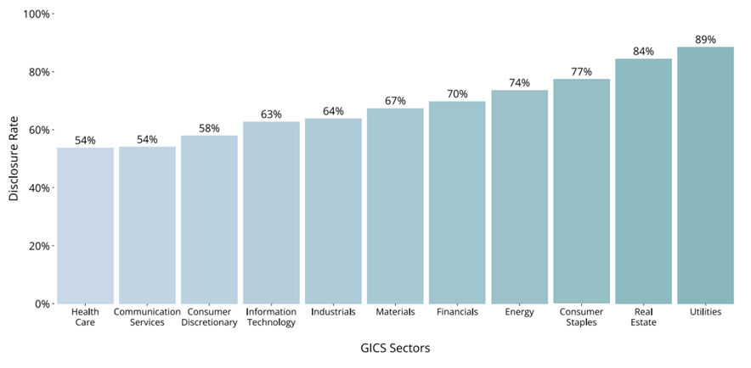
Figure 2. TCFD disclosure rates by sector in the S&P 500 (Source: Delmas et al., 2024 p 13)

Aligning California's requirements with these global standards would reduce reporting burdens, enhance comparability across firms and industries, and enable companies to meet multiple disclosure obligations while efficiently addressing California-specific climate risks. Although SB 261 requires firms to disclose financial risks and adaptation measures aligned with TCFD guidance (Section 2.b.1.A), CARB should make clear that firms must also disclose key elements of TCFD’s broader framework, including governance, strategy, and emissions and targets. These pillars are foundational to understanding a firm’s exposure to climate risks and the adequacy of its response. Governance disclosures explain how climate risks are overseen and managed at the highest levels; strategy disclosures reveal how climate risks and opportunities are integrated into business models and planning; and metrics and targets provide the quantitative basis to assess progress, including emissions reductions critical to California's climate goals.

A phased approach to Scope 3 reporting can ease compliance burdens
Evaluating Scope 3 emissions is complex because the data needed to calculate them is often not readily available to companies. Since Scope 3 emissions arise from activities outside a firm's direct control—such as emissions from suppliers, customers, and other value chain partners—companies must gather information from multiple suppliers across different tiers, many of whom may lack emissions data or be unwilling to share it. Adding to the challenge, Scope 3 emissions typically span numerous products and services, requiring detailed assessments that increase reporting complexity.
Scope 3 emissions are critical to understanding a company's full climate impact despite these obstacles. For many firms, Scope 3 represents the largest share of total greenhouse gas (GHG) emissions (Bianco et al., 2013). Without insight into these indirect emissions, firms risk underestimating their climate footprint and missing key opportunities for decarbonization.
One of the most significant challenges in Scope 3 reporting is obtaining accurate and consistent supplier data. Reporting practices, measurement methods, and data availability vary widely. Some suppliers may not track emissions, while others may resist sharing information due to competitive concerns. As a result, even companies committed to accurate reporting often face data gaps and inconsistencies.
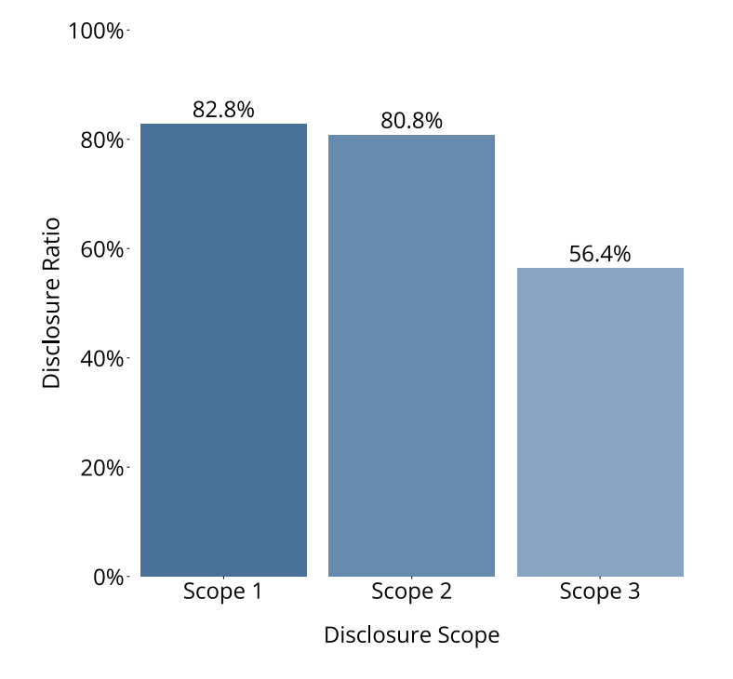
Figure 3. GHG emission disclosure rates by scope in the S&P 500 (Source: Delmas et al., 2024 p 7)
These problems are reflected in the disclosure of Scope 3 emissions, as illustrated by Figure 3. While the average disclosure rate for Scope 1 and Scope 2 emissions is 82.8% and 80.8%, respectively, for S&P 500 firms, the average disclosure rate for Scope 3 emissions drops to 56.4% (Delmas et al., 2024). Overall, fewer companies disclose Scope 3 information, with significant disparities across sectors, as illustrated in Figure 4. A few sectors, such as Information Technology, Financials, and Consumer Staples, have disclosure rates at or above 65%, while other sectors, including Energy, Health Care, and Communication Services, lag far behind.
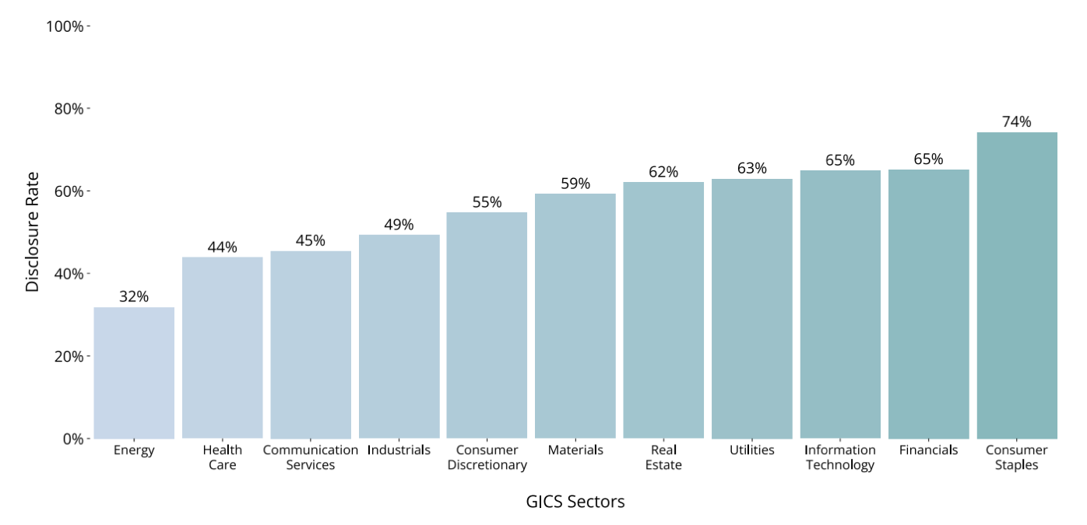
Figure 4. Scope 3 Disclosure by sector in the S&P 500 (Source: Delmas et al., 2024 p 10)
However, even when companies report Scope 3 emissions, the data often lacks completeness and comparability. Scope 3 includes fifteen distinct categories under the GHG Protocol, covering both upstream and downstream emissions across the value chain. However, many companies disclose only a subset of these categories, leaving stakeholders without a complete picture of their indirect emissions. Figure 5 illustrates this point using 2022 disclosure data from the S&P 500. While 431 out of 500 companies report Scope 1 emissions and 422 report Scope 2 emissions, only 329 disclose Scope 3 emissions. Among those, 286 provide category-level details, but 43 report Scope 3 without specifying categories — underscoring persistent gaps in comprehensive GHG emissions reporting. This selective reporting raises two key concerns: first, since not all categories contribute equally to total Scope 3 emissions, partial disclosure may omit material sources; and second, without identifying which categories are included, stakeholders cannot accurately assess or interpret the reported Scope 3 figures.
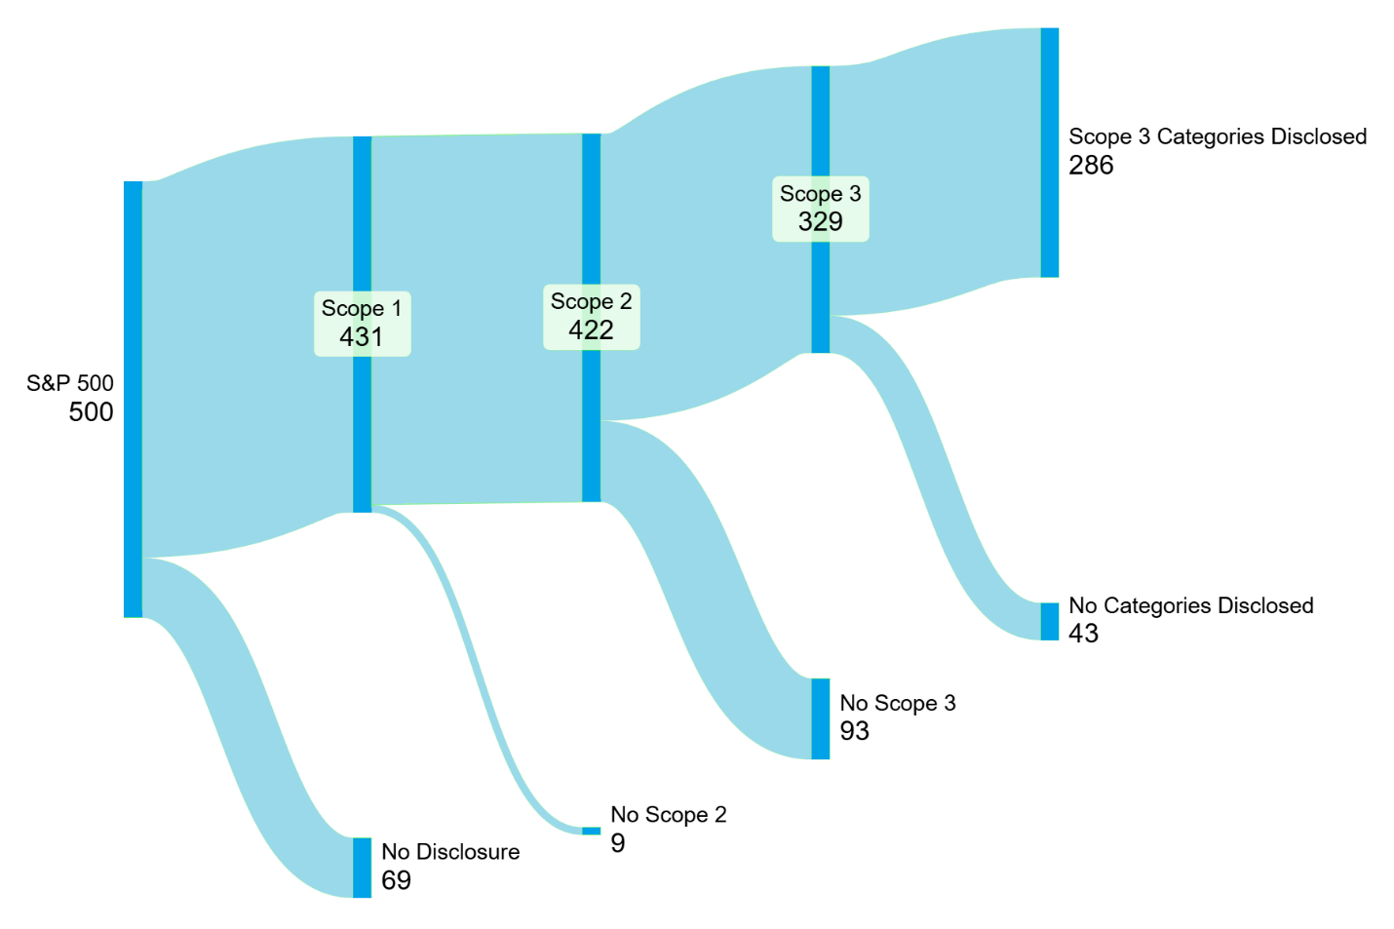
Figure 5. Scope 3 Disclosure by Scope 3 category in the S&P 500 (Open for Good data sourced from 2022 sustainability reports)
At a minimum, regulatory frameworks should require companies to specify which of the fifteen Scope 3 categories are included in their disclosures. This level of granularity is essential for evaluating the scope and materiality of reported emissions, identifying data gaps, and enabling meaningful comparisons across firms and sectors.
Given these data challenges, the Environmental Extended Input-Output (EEIO) method offers a practical starting point for estimating Scope 3 emissions. EEIO uses industry-average emissions factors tied to financial expenditures, allowing firms to approximate their emissions without extensive supplier data. While less precise than activity-based data, EEIO helps companies identify major emission hotspots and prioritize areas for more detailed assessment. This high-level visibility helps firms prioritize which parts of their supply chain to target first for deeper engagement, data collection, and emission reduction efforts.
However, EEIO’s reliance on industry averages can obscure a firm’s specific supply chain realities. For example, in the auto industry, EEIO applies an average emissions factor per dollar for all vehicles (NAICS 336111), which could inaccurately suggest that a firm producing more expensive but cleaner electric vehicles is more polluting than it is.
Therefore, while EEIO is a valuable entry point to help firms rapidly identify and prioritize major emission sources within their supply chains, it is not a substitute for more precise measurement approaches. Firms should transition over time to activity-based methods that rely on primary data from suppliers and company-specific operations. These more granular approaches enable accurate emissions tracking and better-informed decarbonization strategies. However, this transition requires time, supplier engagement, and capacity building.
CARB could facilitate this process by adopting a phased approach. Companies could begin with EEIO-based estimates and progressively shift toward activity-based data as they improve supplier engagement and data collection. This balance between practicality and accuracy would ensure that firms can start disclosing while working toward more robust and precise reporting.
Assurance of Scope 3 emissions remains an emerging and complex area. Because external parties generate these emissions, assuring them is challenging. Two main issues arise: companies may seek assurance for only some categories, creating inconsistencies; assurance engagements vary in rigor—limited assurance (based on high-level reviews) is less demanding than reasonable assurance (which requires thorough verification).
Full assurance would also require suppliers and other partners to verify their emissions, which is often infeasible. Even when suppliers have assured emissions, they may not allocate them to specific products or customers, limiting their usefulness for Scope 3 reporting. Thus, while limited assurance may be achievable for selected categories, reasonable assurance for total Scope 3 emissions remains difficult under current methodologies.
Going forward, widespread assurance of Scope 3 emissions will require greater standardization, improved supplier data, and more transparent allocation methods. Until then, regulators like CARB should recognize the challenges of Scope 3 assurance and adopt flexible, phased expectations that encourage firms to improve data quality over time.

Independent academic assessment of disclosure data would enhance transparency and corporate accountability
Information disclosure policies are most effective when they translate complex corporate data into accessible, actionable insights for the public. Simply requiring companies to report climate-related risks and impacts is not enough. This information must be made publicly available in transparent, standardized formats that enable all stakeholders, including consumers, investors, and communities, to engage with and act on the data. Transparency initiatives that present regulatory data in user-friendly ways — such as sustainability scores, visual dashboards, and comparative benchmarks — help bridge the gap between corporate disclosures and public action. Making this information easily accessible empowers people to choose more sustainable products, support responsible companies, and push for greater accountability. Collaborating with independent institutions, such as academic organizations, can further ensure that regulatory data is translated into community-accessible tools and insights, enhancing public understanding and impact.
An independent corporate climate disclosure assessment led by an academic institution would help ensure that information reported under SB 253 and SB 261 is objective, credible, and actionable. This assessment should include standardized emissions data (Scopes 1, 2, and 3), progress tracking toward net-zero goals, and evaluations of climate-related financial risks and adaptation strategies. The assessment should feature clear, consumer-friendly summaries with visual indicators such as color-coded risk ratings, comparative rankings, and interactive dashboards to enhance public usability. It should also enable sector-level comparisons of disclosure rates and methodologies, supporting ongoing refinement of CARB's guidance to companies based on emerging best practices.
Both the Open for Good Transparency Index and the State of Corporate Sustainability Disclosure reports at UCLA Anderson offer strong models for this approach, focusing on not only disclosure but also accessibility and usability. By scoring companies on the clarity, completeness, and quality of their sustainability data, these initiatives highlight best practices and identify areas for improvement (see Transparency Index [HERE] and State of Corporate Sustainability Disclosure [HERE]). Building on these models, an independent evaluation framework could provide critical third-party validation and sector comparisons, making corporate climate disclosures credible and meaningful for regulators, investors, and the public.
Ideally, the report should include an analysis of corporate disclosures submitted under SB 261 on climate-related financial risks and adaptation measures. It should identify risk patterns across industries, assess statewide economic vulnerabilities, and pay particular attention to impacts on economically vulnerable and frontline communities facing climate-related disruptions in energy, water, housing, and employment. By integrating SB 253 and SB 261 disclosures, the report would provide a comprehensive view of corporate climate performance — including emissions and financial risk management — and evaluate how well companies are preparing for California's low-carbon transition. This integrated analysis would also generate evidence-based recommendations to improve disclosure quality, align emissions and risk reporting, and guide California's broader climate strategy. The report would be a critical resource for regulators, investors, companies, and the public, supporting transparent and accountable corporate action aligned with state climate goals.
A dedicated policy brief could offer key recommendations to further assist regulators in evaluating corporate disclosures, preventing greenwashing, and enhancing the effectiveness of transparency initiatives. Such a brief could outline best practices for structuring climate-related disclosures to improve comparability, credibility, and public accessibility. By incorporating insights from independent research initiatives such as the Open for Good Transparency Index, the brief could serve as a practical roadmap for policymakers seeking to strengthen climate disclosure regulations and their impact. Furthermore, based on an analysis of disclosed data and risk assessments, the policy brief could recommend adjustments to the state's pension fund investments to better align them with net zero goals and commitments.
Additionally, developing teaching case studies based on this data can play a crucial role in training the next generation of corporate leaders to understand how to evaluate and reduce GHG emissions and assess climate risks. Case studies allow students to engage with real-world data, improving their ability to critically analyze disclosure reports and make strategic sustainability decisions. For example, the Open for Good (OFG) initiative has developed a data simulation case study that enables students to explore corporate climate disclosures in a structured, interactive way (see OFG case study). By incorporating these educational tools into business and policy curricula, universities can ensure that future decision-makers are well-equipped to interpret emissions data, identify risk factors, and drive meaningful corporate climate action.

Conclusion
Implementing SB 253 and SB 261 represents a crucial step in enhancing corporate climate accountability and ensuring that emissions data is accurate, comparable, and useful for decision-making. Voluntary disclosures have proven insufficient due to inconsistent methodologies, selective reporting, and widespread greenwashing. Without regulatory oversight, firms lack the incentives to provide transparent and reliable information, limiting the effectiveness of market-based mechanisms in addressing climate change.
By aligning California’s disclosure requirements with existing international frameworks such as IFRS S2 and CSRD, CARB can reduce compliance burdens while maintaining high standards of reporting integrity. Additionally, a structured approach to Scope 3 reporting—starting with EEIO estimates and gradually transitioning to activity-based data—will help firms improve the precision of their disclosures without imposing unmanageable costs. To this end, there is a need for academic research to develop broad guidelines for how businesses can both identify and report the specific activities that contribute to the bulk of their Scope 3 emissions. Assurance mechanisms must also evolve to ensure that reported emissions, particularly Scope 3, are verifiable and reflect actual corporate impacts.
Ultimately, disclosure policies are only as effective as the insights they provide to stakeholders. To maximize the impact of SB 253 and SB 261, CARB should support the development of independent academic reports that synthesize emissions, risk, and adaptation data into actionable, user-friendly formats for regulators, investors, and the public. Transparency initiatives, such as sector comparisons and interactive dashboards, can help bridge the gap between technical disclosures and informed decision-making, driving real progress in corporate sustainability. By implementing these policies thoughtfully and rigorously, California can set a new global standard for climate disclosure, reinforcing its leadership in climate action and corporate accountability.

Submitted by:

Magali Delmas, Professor, UCLA Anderson and UCLA Institute of the Environment & Sustainability (IOES)
Henry Friedman, Professor, UCLA Anderson School of Management
Valentin Haddad, Professor, UCLA Anderson School of Management
Deepak Rajagopal, Professor, UCLA Institute of the Environment & Sustainability (IOES)
Julia Stein, Deputy Director, UCLA Emmett Institute on Climate Change and the Environment, UCLA School of Law
Mary Nichols, Distinguished Counsel, UCLA Emmett Institute on Climate Change and the Environment, UCLA School of Law
Bhavna Sivanand, Executive Director, Center for Impact, UCLA Anderson School of Management

The authors thank Delaney Buskard, Tyson Timmer, and Richard Li for their research support in compiling and analyzing corporate sustainability disclosure data. Their contributions helped inform this response.

References:
Adams, C. A. (2004). The ethical, social and environmental reporting‐performance portrayal gap. Accounting, Auditing & Accountability Journal, 17(5), 731-757.
Andrew, J., & Cortese, C. (2011, September). Accounting for climate change and the self-regulation of carbon disclosures. In Accounting Forum (Vol. 35, No. 3, pp. 130-138).
Blanco, C., Caro, F., & Corbett, C. J. (2016). The state of supply chain carbon footprinting: analysis of CDP disclosures by U.S. firms. Journal of Cleaner Production, 135, 1189-1197.
Callery, P. J., & Perkins, J. (2020). Detecting false accounts of corporate environmental performance: The role of textual complexity in corporate communications. Journal of Business Ethics, 1-21.
Cort, T., & Esty, D. (2020). ESG Standards: Looming challenges and pathways forward. Organization & Environment, 33(4): 491-510.
Delmas, M., Montes‐Sancho, M. J., & Shimshack, J. P. (2010). Information disclosure policies: Evidence from the electricity industry. Economic Inquiry, 48(2), 483-498.
Delmas, Magali A. and Delmas, Magali A. and Clark, Kelly and Li, Jiaxin and Timmer, Tyson, The State of Corporate Sustainability Disclosure-2023 (February 16, 2024). Available at SSRN: https://ssrn.com/abstract=4729321 or http://dx.doi.org/10.2139/ssrn.4729321
Depoers, F., Jeanjean, T., & Jérôme, T. (2016). Voluntary disclosure of greenhouse gas emissions: Contrasting the carbon disclosure project and corporate reports. Journal of Business Ethics, 134(3), 445-461.
Drost, E. A. (2011). Validity and reliability in social science research. Education Research and Perspectives, 38(1): 105-123.
Fung, A., Graham, M., & Weil, D. (2007). Full disclosure: The perils and promise of transparency. Cambridge University Press.
Global Reporting Initiative. (2016). GRI 101 Foundation: 2016. Retrieved from https://growthorientedsustainableentrepreneurship.files.wordpress.com/2017/12/csr-gri-101-foundation-2016.pdf
Kim, E. H., & Lyon, T. P. (2011). When does institutional investor activism increase shareholder value?: The Carbon Disclosure Project. The BE Journal of Economic Analysis & Policy, 11(1).
Kimberlin, C. L., & Winterstein, A. G. (2008). Validity and reliability of measurement instruments used in research. American Journal of Health-System Pharmacy, 65(23): 2276-2284.
Konar, S., & Cohen, M. A. (1997). Information as regulation: The effect of community right to know laws on toxic emissions. Journal of environmental Economics and Management, 32(1), 109-124.
Matisoff, D. C., Noonan, D. S., & O'Brien, J. J. (2013). Convergence in environmental reporting: Assessing the Carbon Disclosure Project. Business Strategy and the Environment, 22(5), 285-305.
Michelon, G., Pilonato, S., & Ricceri, F. (2015). CSR reporting practices and the quality of disclosure: An empirical analysis. Critical perspectives on accounting, 33, 59-78.
Simpson, J. A. (1981). Foundations of metrology. Journal of Research of the National Bureau of Standards, 86(3): 281.
Stewart, D. W., & Kamins, M. A. (1993). Secondary research: Information sources and methods (Vol. 4). Sage.
Sullivan, R., & Gouldson, A. (2012). Does voluntary carbon reporting meet investors’ needs?. Journal of Cleaner Production, 36, 60-67.
Tomar, S. (2023). Greenhouse gas disclosure and emissions benchmarking. Journal of Accounting Research, 61(2), 451-492.
Widyawati, L. (2021). Measurement concerns and agreement of environmental social governance ratings. Accounting & Finance, 61: 1589-1623.

https://cloud.google.com/blog/topics/sustainability/new-survey-reveals-executives-views-about-sustainability

