March 19, 2025

RE: Information Solicitation to Inform Implementation of California Climate-Disclosure Legislation: Senate Bills 253 and 261, as amended by SB 219

EnergyTag is an independent not-for-profit organization focused on promoting and enabling robust hourly electricity accounting standards globally. EnergyTag maintains the world’s only voluntary standard detailing how hourly Energy Attribute Certificates (EACs) can be issued and used to robustly verify hourly matching claims, including claims of deliverability and incrementality. Our standards are supported and developed alongside major stakeholders working on implementing granular electricity accounting including United Nations Energy, AES, Google, M-RETs, PWC, and Microsoft amongst others.

Thank you for the opportunity to provide comment on the implementation of Senate Bills 253 and 261. We have responded to select questions below relevant to our experience and expertise as an organization.

Please reach out to Alex Piper ([alex@energytag.org](mailto:alex@energytag.org)) with any questions.

Alex Piper

Head of US Policy and Markets

EnergyTag

**General: Standards in Regulation**

1. CARB is tasked with implementing both SB 253 and 261 in ways that would rely on protocols or standards published by external and potentially non-governmental entities.
   1. How do we ensure that CARB’s regulations address California-specific needs and are also kept current and stay in alignment with standards incorporated into the statute as these external standards and protocols evolve?

It is critical that implementation of SB 253 incorporate updates expected under the Greenhouse Gas Protocol (GHGP) Corporate Accounting and Reporting Standard. In the forthcoming Scope 2 guidance update, expected by 2027, there may be significant changes in the reporting requirements which drive greater transparency, accountability, and trust. One of the leading proposals for an update to this standard is one that requires hourly and locational matching of electricity production to load. Significant academic evidence supports this reform ([here](https://papers.ssrn.com/sol3/papers.cfm?abstract_id=4636218), [here](https://iopscience.iop.org/article/10.1088/1748-9326/acacb5), [here](https://www.iea.org/reports/advancing-decarbonisation-through-clean-electricity-procurement/executive-summary), and [here](https://www.cell.com/joule/pdf/S2542-4351(23)00499-3.pdf)), and CARB should ensure that implementation of this law, if finalized before the GHGP process is finished, allows for changes when the new Scope 2 guidance is finalized.

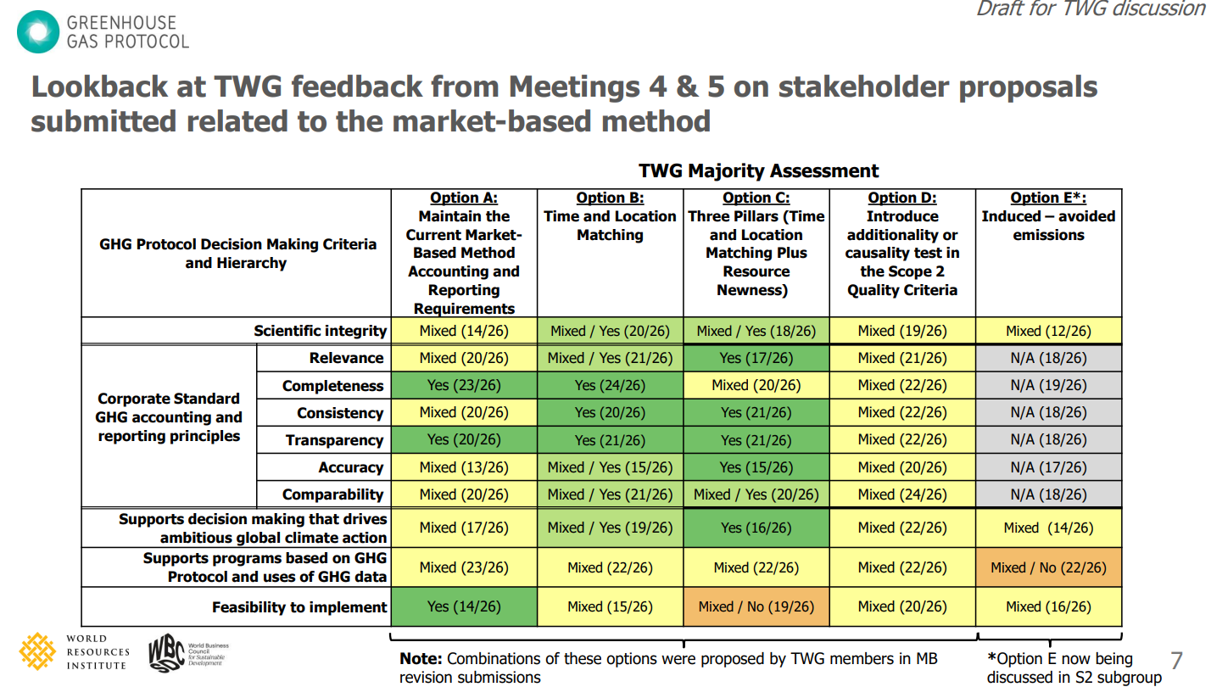

This table shows the broad base of support for a Scope 2 guidance revision that requires some level of granular accounting (hourly and temporal matching). Source: [GHGP Scope 2 - Presentation - 2025.02.19](https://ghgprotocol.org/sites/default/files/2025-02/S2-Meeting8-Presentation-20250219.pdf)

It is possible changes to this kind of protocol will come with flexibilities like phase-ins and exemptions for small electricity loads, which will help companies adapt to new compliance requirements and give CARB time to understand and implement these changes for the California-specific context.

* 1. How could CARB ensure reporting under the laws minimizes a duplication of effort for entities that are required to report GHG emissions or financial risk under other mandatory programs and under SB 253 or 261 reporting requirements?

The best way to minimize a duplication of effort for entities reporting GHG emissions under other programs will be to ensure that implementation maintains reliance on the GHGP requirements. Importantly, the requirements under SB 253 must include updated requirements from the current GHGP revision process.

* 1. To the extent the standards and protocols incorporated into the statute provide flexibility in reporting methods, should reporting entities be required to pick a specific reporting method and consistently use it year-to-year?

Reporting entities should be required to follow the Greenhouse Gas Protocol’s reporting requirements, but should have the option to report on optional metrics included in the GHGP process year to year. One of the decisions being made in the current GHGP update process is which types of reporting metrics will be required and which will be optional/recommended. Reporting entities should at the very least follow these rules from GHGP when conforming with California state law.

**SB 253: Climate Corporate Data Accountability Act**

1. Entities must measure and report their emissions of greenhouse gases in conformance with the GHG Protocol, which allows for flexibility in some areas (i.e. boundary setting, apportioning emissions in multiple ownerships, GHGs subject to reporting, reporting by sector vs business unit, or others). Are there specific aspects of scopes 1, 2, or 3 reporting that CARB should consider standardizing?

As noted above, the GHG Protocol Scope 2 guidance is undergoing an update process today and will be finished by 2027. Certain flexibilities and requirements are likely to change in this guidance update process. CARB should ensure that its rules allow for those updates to be applied to companies required to report under SB 253.

Additionally, to demonstrate compliance with GHG Protocol, CARB should consider adopting standards around the use and retirement of granular electricity attribute certificates (EACs). EnergyTag has developed [voluntary standards](https://energytag.org/standards/) for the issuance, tracking, and retirement of EACs to support demonstration of high integrity electricity procurement and compliance with matching standards like the 45V clean hydrogen production tax credit rules and potential updates to the GHGP.

Standardizing what data should be included in EACs, what roles and responsibilities should be fulfilled by different actors in a granular certificate issuance scheme, and what kind of transparency and verifiability is needed (all included in EnergyTag’s standards) will support greater integrity and impact for SB 253. Establishing a similar standard or adopting EnergyTag’s standard will also support the advancement of a granular registry that can serve all California customers and load serving entities. The availability of granular EACs will help entities achieve voluntary procurement targets (like 24/7 carbon free energy goals), support any policy or programmatic reforms in California that require hourly reporting and tracking (like the newly updated [California Power Source Disclosure Program](https://www.energy.ca.gov/programs-and-topics/programs/power-source-disclosure-program) requiring hourly reporting starting in 2028)

**Respondents may also provide any additional information they feel is important to inform staff’s work to implement the statutes.**

It is also important that SB 253 implementation aligns with California’s Power Source Disclosure program’s recent update to require hourly tracking of electricity supplied to customers and broader electricity accounting standards such as 45V, European clean hydrogen rules, and potentially the updated GHGP Scope 2 guidance. Hourly tracking of electricity and matching of supply to load on an hourly basis is the highest integrity mechanism to ensure low-emissions impacts from electricity usage when contracting with zero-carbon resources. This law will not have the intended impact of transparency and accountability without an accounting structure that requires this level of granularity.

The academic research supporting granular electricity accounting and its accuracy and impacts can be found in the table below:

| **Institution** | **Studies** |
| --- | --- |
| **MIT** | [The influence of additionality and time-matching requirements on the emissions from grid-connected hydrogen production](https://www.nature.com/articles/s41560-023-01435-0) |
| **Princeton University** | - ["System-level Impacts of Voluntary Carbon-free Electricity Procurement Strategies](https://www.cell.com/joule/pdf/S2542-4351(23)00499-3.pdf)  - [Enabling grid-based hydrogen production with low embodied emissions in the United States](https://iopscience.iop.org/article/10.1088/1748-9326/acacb5)  - [System-level Impacts of 24/7 Carbon-free Electricity Procurement](https://www.dropbox.com/s/ela5hwzpb1tzmer/2021-11-16_24-7_Carbon-Free-Electricity.pdf?dl=0)  - [Electricity System and Market Impacts of Time-based Attribute Trading and 24/7 Carbon-free Electricity Procurement](https://zenodo.org/records/7082212)  - [Short-run marginal emission factors neglect impactful phenomena and are unsuitable for assessing the power sector emissions impacts of hydrogen electrolysis](https://www.sciencedirect.com/science/article/abs/pii/S0301421524001393) |
| **TU Berlin** | - [Spatio-temporal load shifting for truly clean computing](https://zenodo.org/records/10869650)  - [On the means, costs, and system-level impacts of 24/7 carbon-free energy procurement](https://zenodo.org/records/10407831)  - [The value of space-time load-shifting flexibility for 24/7 carbon-free electricity procurement](https://zenodo.org/records/8185850)  - [System-level impacts of 24/7 carbon-free electricity procurement in Europe](https://zenodo.org/record/7180098#.Y9Fm9xPMJUy)  - [Hourly versus annually matched renewable supply for electrolytic hydrogen](https://zenodo.org/record/7457441#.Y9FmyxPMJUy) |
| **Denmark Technical University** | - [Does the purchase of voluntary renewable energy certificates lead to emission reductions? A review of studies quantifying the impact](https://papers.ssrn.com/sol3/papers.cfm?abstract_id=4636218) |
| **EPRI** | - [Impacts of IRA’s 45V Clean Hydrogen Production Tax Credit](https://www.epri.com/research/products/000000003002028407) |
| **International Energy Agency** | - [Advancing Decarbonisation through Clean Electricity Procurement](https://www.iea.org/reports/advancing-decarbonisation-through-clean-electricity-procurement) |
| **Florence School of Regulation** | - [Green hydrogen: - how grey can it be?](https://papers.ssrn.com/sol3/papers.cfm?abstract_id=4214688) |