Strategic projects.
AMERICA’S NEW WEIGHT PROBLEM. The real issue with EV, Hybrid, Plug-in-hybrid cars with different pros and cons, considering mainly internal different design for these cars, is that they get large and heftier with significantly increased size, number of many heavy packs of, mostly, flammable Li-batteries ( for the same energy density as gasoline), and new cars tend to weight a lot more than internal combustion engine cars. They tend to be much heavier, putting more pressure on the tires, makes tires work harder, getting worm down faster, putting more wear on the road, increases the rate of wear, tire noise, and, as consequences – They generate more than 25 percent of global warming emissions, 45 percent of NOx emissions, and nearly 60 percent of direct PM2. Assuming that EV models are heavier (with battery packs enabling a driving range of 300 miles or higher), the report finds that they reduce PM10 by only 4-7% and increase PM2.5. Electric vehicle PM emissions are comparable to those of conventional vehicles. Non-exhaust sources account for 90% of PM10 and 85% of PM2.5 from traffic. PM2.5 is a type of particulate matter, which is a general term for solid or liquid substances that are suspended in the air. PM2.5 can travel deep into the lungs, causing cancer and may even enter the bloodstream, posing a threat to public health. PM2.5 can come from various sources, such as wildfire smoke, dust, or soot. From Global Energy specialists- If we assume that all cars sold in 2040 onwards are electric, we’ll see an additional electricity demand of around 3,000 terawatt hours in 2050. In addition to the health impacts, tire particulate pollution can also have ecological effects. The particles can accumulate in soil and waterways, potentially harming plants, and aquatic life. World is dangerously close to a global warming limit. From CNN- Global warming surpassed 1.5 degrees Celsius over the past 12 months for the first time on record, and if it continues-it will push the limits of life on Earth to adapt. Climate Change Is Speeding Toward Catastrophe. The Next Decade Is Crucial, U.N. Panel Says. Future policy must focus on reducing vehicle weight. We urgently need a more effective approach for lighter more safer transportation. . Clean, more efficient renewable energy is a vital tool for tackling climate change.
I am presenting first time new Innovative Renewables/Technologies based on unique Piezo (from Greek word pressure) energy materials, Piezoelectricity is produced under any kinds of controllable pressure, vibration, motion with important reverse effect. All natural pressure piezo energy sources were waisted.

Pic. below – just one example of the emerging ZEV application (Different cars, trucks, railways- New Piezoelectric Railways Harvest Energy From Passing Trains, bicycles, using self-charging electric bike, etc.) with Soft, Light, uniquely designed Piezo Array embedded tires, which generate clean electricity just driving the vehicle, providing pressure (regardless of- sun is shining, or wind is blowing under required 90 degree) as unique technology or as Integrated technology with much less number of selected, safer batteries, charging stations infrastructure to charge 8 hours, with more other advantages.
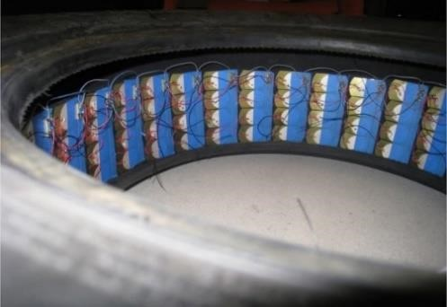

Such Piezo materials are also considered - for the more efficient PV combinational piezo- semiconductors materials’ monitoring. After decades of deep Piezo investigation- we can introduce different kinds of Piezo materials/ their advanced manufacturing, and it’d be very beneficial to start deeper investigations on such unique Piezo energy materials (specially Soft Piezo Crystals) which produce long lasting, clean, sustainable electricity, without any chemistries involvement ( which introduce many challenges to solve), under any kind of controllable pressure, vibration, motion for different applications, especially - for the most emerging applications for significant and stable not only GHGs emission reduction, but also all kinds of toxic fumes, non-exhaust dangerous pollutants.

Lala Agamirov-Nost,
Single Crystals Innovative Sensors Inc.

