Strategic Projects1.
We have problems with Electric vehicles. A new study suggests that car exhaust fumes are the least of our problems. There is a part of our vehicles that could be causing much more pollution- Car tires may represent a greater threat to the environment than exhaust fumes. As a new study is suggesting -tire wear produced almost 2,000 times more particle pollution, especially under the pressure of heavy packs of batteries. 52% of all small particle pollution comes from tire and break wear. Air pollution causes 7 million a year death globally. Tires are full of toxic compounds. Emissions Analytics reveal that - tires produce more than one trillion of these ultrafine particles for each kilometre driven. The study indicates that -Just 15% of the emissions came from the exhausts of cars and a further 10% from the exhausts of vans and HGVs.
Diesel engines emit a complex mixture of pollutants, including very small carbon particles, or "soot" coated with numerous organic compounds, known as diesel particulate matter (PM). Diesel exhaust also contains more than 40 cancer-causing substances, most of which are readily absorbed onto the soot particles. The European Union also has plans for tire regulations to help reduce tire emissions by eliminating the most toxic tires, as tires vary significantly in chemical composition and potential extremely dangerous toxicity. But improved chemical composition of tires will work much more effectively and efficiently with integrated light technology, leading to big environmental gain.
Climate Change Is Speeding Toward Catastrophe. The Next Decade Is Crucial, U.N. Panel Says. Future policy must focus on reducing vehicle weight. We urgently need a more effective approach for lighter, safer transportation. Clean, more efficient renewable energy, technologies are a vital tool for tackling climate change.
I am presenting first time new Innovative Renewables/ Strategic clean efficient Technologies based on unique energy materials, which produce clean, sustainable electricity, without any chemistries involvement (which introduce many challenges to solve), under any kinds of controllable pressure, vibration, motion with important reverse effect. All Natural pressure energy sources unfortunately were waisted.

Pic. below – just one example of the emerging ZEV application -different cars, trucks, railways, self-charging EV bikes, etc. with Soft, Light, uniquely designed energy materials’ Soft Array embedded tires, which generate clean electricity just driving the vehicle, providing pressure (regardless of- sun is shining, or wind is blowing under required 90 degree) - as unique technology/ or as Integrated technology with much less number of selected, safer batteries & charging stations infrastructure to charge 8 hours, with more other advantages.
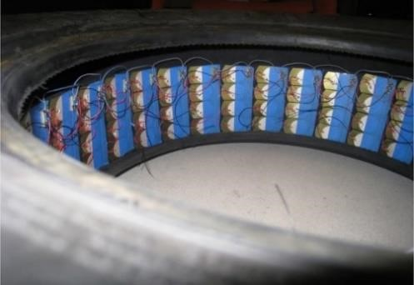

Such energy harvesting Piezo materials are also considered - for the more efficient PV Panels monitoring. Innovative technologies, based on such unique light, energy materials - are very beneficial for different applications, especially - for the most emerging applications for significant and stable not only GHGs emission reduction, but also-for all kinds of toxic fumes, non-exhaust dangerous pollutants.

Lala Agamirov-Nost,
Ph.D., Chemistry, Materials science, Engineering.
Founder & CEO
Single Crystals Innovative Sensors Inc.
https://innovativecrystals.com

