
ANALYTICAL
Services & Technology

5200 Blazer Parkway
Dublin, OH 43017
614-790-1587

Sampling and Analysis of Short Chain Aldehydes from a Lawnmower Engine

Gary Schoening
Ashland Specialty Chemical Company
P. O. Box 2219 Columbus, Ohio

Abstract

An impinger method for acrolein, formaldehyde and acetaldehyde in air was developed as a modification of CARB 430 under CARB contract number 00-721 in 2002. This method has performed well on various internal combustion sources with low acrolein emission concentrations from single digit ppb to over 1 ppm. Gas chromatographic analysis with nitrogen-phosphorus detection (GC/NPD) offers interference free analysis for formaldehyde, with only rare interferences for acetaldehyde and acrolein when acetone is present at high levels. The acetone interference has not been observed from combustion sources and only rarely from process vents.

Recent sampling and analysis of the exhaust from a six horsepower, single-cylinder lawnmower engine offered challenges to this method with aldehyde concentrations 100 to 500 times higher than were observed with a gas fired turbine engine. Spiked side-by-side lawnmower exhaust samples were calculated according to US-EPA Method 18, and demonstrated aldehyde recoveries that were approximately 80 per cent for acrolein and formaldehyde, and 108 per cent for acetaldehyde. Typical aldehyde emission concentrations from the test engine, during normal constant temperature operations, were formaldehyde, 21 ppm; acetaldehyde, 3.2 ppm; and acrolein, 1.3 ppm.
OBJECTIVE
Determine if the Modified Impinger Method for Acrolein in Air will perform well at high aldehyde concentrations. Use a single-cylinder lawnmower engine with no emission controls as a source of airborne aldehydes. Fabricate a duct extension with multiple sampling ports capable of sampling side-by-side samples, where one sampling train is spiked and the other is not spiked. Determine aldehyde recoveries according to US-EPA Method 18.

EXPERIMENTAL
The sampling duct extension was fabricated with 304 stainless steel, schedule10, two inch O.D pipe and has two 0.25-inch sampling ports on each side, four inches apart. The ports on one side are offset by one inch from the ports on the other side. Sampling probes made of Teflon® tubing were inserted into the centroid of the duct extension. The closest sampling port to the engine was 8.8 duct diameters from the muffler. The duct extension was 30 inches long, with an inside diameter of 1.7 inches. Four pictures are included that show how the sampling set-up was configured using the exhaust extension.

The sample flow was achieved with critical orifices protected by in-line Balston® filters to avoid fouling of the orifice. The sample flow through the train was produced by a Gast Model
DOA-V722-AA diaphragm pump, adequate to maintain at least 15.5 inches Hg vacuum with multiple sample ports in use. An in-line vacuum gauge was monitored during sampling to assure that there was no pump failure. The system maintained 20 inches Hg during sampling.

Each sampling train included three midget impingers in series. Each impinger included an acidic dinitrophenylhydrazine (DNPH) solution and two milliliters of toluene. The toluene breaks up into small droplets during sampling, performing a liquid-liquid extraction that quickly removes the hydrazones from the aqueous solution. If the first impinger receives enough carbonyl containing compounds (aldehydes and ketones) to consume all of the DNPH reagent, the lower water phase will be clear, indicating that less sample should be collected in following tests. For details on media preparation, sampling and analysis with this method, see Attachment A, Ashland Specialty Chemical Company Modified Impinger Method for Acrolein in Air. Attachment B has sample chromatograms and calibration curves for the three aldehydes.

RESULTS and DISCUSSION

Three side-by-side spiked tests were conducted to estimate the aldehyde emissions from the lawnmower engine. The first test was initiated at cold start and sampled for 20 minutes. This test was designated 68 from the notebook page number. Two side-by-side spiked tests were sampled after the engine was fully warmed up and the exhaust temperature in the duct extension was constant (352°F to 357°F) when measured at the access port two inches down stream from the last sampling port. These tests were designated 73 and 73a. The three impingers were labeled A, B and C. Impinger A, the first impinger in the three impinger sampling train, was spiked with a mixture of the three aldehydes. Analyte concentrations in the spike solution are listed in Table 1.

Table 1 Aldehyde Spike Solution
Aldehyde | Aldehyde / 500μL
Formaldehyde | 47.1 μg
Acetaldehyde | 18.5 μg
Acrolein | 5.8 μg

Spiked impingers in the number one (A) position each received 500 μL of the spike solution. Additional lab spikes and trip spikes were prepared to be analyzed with the sample sets collected from the lawnmower exhaust, and at additional time intervals to demonstrate the time lapse stability of the procedure.

The impinger train flow rates were measured with an electronic flow meter before and after the 20-minute samples. The flow rates and total sample volume in liters are listed in Table 2. Sample 68s indicates the spiked sample. The 73a spiked sample had a flow interruption during sampling, and was not included in the data tables. Sample 73a was calculated using the typical recovery from previous tests.

Table 2 Sample flow and Volume Measurements
Sample | Start, L/min | End, L/min | Average, L/min | Volume, L
68s | 0.227 | 0.214 | 0.221 | 4.41
68 | 0.271 | 0.257 | 0.264 | 5.28
73s | 0.318 | 0.305 | 0.312 | 6.24
73 | 0.312 | 0.302 | 0.307 | 6.14
73a | 0.317 | 0.305 | 0.311 | 6.22

Table 3 shows the micrograms of aldehydes recovered from the 68s and 68 paired samples collected during 20 minutes following a cold start . The aldehyde capture in each of the three impingers is listed to demonstrate the efficiency of capture for each aldehyde compound.

Table 3
Aldehyde | Impinger A, μg | Impinger B, μg | Impinger C, μg | Recovery, % | PPM

Sample 68s, Spiked sample
Formaldehyde | 119 | 0.11 | 0.08
Acetaldehyde | 73.9 | 0.46 | ≤ Blank
Acrolein | 24.3 | 0.96 | 0.04

Sample 68, Non-Spiked sample
Formaldehyde | 98.0 | 0.14 | 0.10 | 78 | 20.2
Acetaldehyde | 73.9 | 0.76 | 0.02 | 128 | 5.79
Acrolein | 22.0 | 1.28 | 0.08 | 79 | 2.55

Table 4 shows the micrograms of aldehydes recovered from the 73s and 73 paired samples collected during normal constant temperature operations of the lawnmower for a total of 20 minutes. Results from the analysis of the three impingers are listed to demonstrate the efficiency of capture for each aldehyde compound.

Table 4
Aldehyde | Impinger A, μg | Impinger B, μg | Impinger C, μg | Recovery, % | PPM

Sample 73s, Spiked sample
Formaldehyde | 159 | 0.14 | 0.08
Acetaldehyde | 57.3 | 1.18 | 0.02
Acrolein | 16.6 | 2.0 | ≤ Blank

Sample 73, Non-Spiked sample
Formaldehyde | 121 | 0.14 | 0.18 | 77 | 21.2
Acetaldehyde | 37.1 | 0.82 | 0.10 | 108 | 3.24
Acrolein | 11.6 | 2.08 | 0.16 | 79 | 1.28

Table 5 shows the micrograms of aldehydes recovered from the 73a collected during normal constant temperature operations of the lawnmower for a total of 20 minutes. Again, results from the analysis of the three impingers are listed to demonstrate the efficiency of capture for each aldehyde compound.

Table 5 Sample 73a, Non-Spiked sample
Aldehyde | Impinger A, μg | Impinger B, μg | Impinger C, μg | Recovery, % | PPM
Formaldehyde | 118 | 0.12 | 0.62 | 78 | 19.9
Acetaldehyde | 35.9 | 0.90 | 0.12 | 108 | 3.05
Acrolein | 11.1 | 2.08 | 0.24 | 79 | 1.19

The aldehyde data clearly show that the gasoline engine produces more acetaldehyde and acrolein during cold start than during constant temperature operations. Formaldehyde emissions stay about the same under both conditions.

The solution blank, the capture solution in each impinger, was analyzed as a sample. Blank results for the three aldehydes are listed in Table 6. Formaldehyde data listed in the tables are uncorrected to show the aldehyde capture in each of the three impingers. The calculated results in the sample data Tables #3, #4, and #5 were corrected for formaldehyde. Acetaldehyde and acrolein blank levels were below detection and were not corrected.

Table 6 Impinger Blank Data
Aldehyde | μg / Impinger
Formaldehyde | 0.04
Acetaldehyde | <0.01
Acrolein | <0.01

The spike solutions used in this study were prepared on February 13, 2004. Analysis of the trip spikes #1 and #2 were completed on February 18, 2004, while that for trip spike #3 was done on February 19, 2004. All of the samples and the trip spikes remained at room temperature prior to analysis to demonstrate the durability of the method. The toluene solution had not been removed from contact with the acidic DNPH solution until February 18, 2004. The trip spike recovery data are in Table 7.

Table 7
Aldehyde | μg Found | μg Added | Recovery, %

Trip spike Recovery #1
Formaldehyde | 46.2 | 47.1 | 98.1
Acetaldehyde | 17.0 | 18.5 | 92.0
Acrolein | 5.67 | 5.80 | 97.8

Trip spike Recovery #2
Formaldehyde | 47.9 | 47.1 | 102
Acetaldehyde | 18.1 | 18.5 | 97.0
Acrolein | 6.16 | 5.80 | 106

Trip spike Recovery #3
Formaldehyde | 49.2 | 47.1 | 104
Acetaldehyde | 18.4 | 18.5 | 99.0
Acrolein | 5.77 | 5.80 | 99.0

The data in this study show that the hydrazones of the three aldehydes are stable after five days at room temperature in the impinger vials without separating the toluene layer. Work done in 2002 also demonstrated stable spike recovery for acrolein after two weeks.

According to the US-EPA Method 18, the spike levels should be added at 40 % to 60 % of the anticipated analyte concentration. The spike levels selected for this study were estimated based on previous experiments done in 2003. The spike levels for the three aldehydes are listed in Table 8.

Table 8 Aldehyde Spike Levels
Aldehyde | Spike, %
Formaldehyde | 39
Acetaldehyde | 35
Acrolein | 43

Spike levels are all on the low end of the target range which may have reduced the recovery compared to a spike closer to the 50 % level. The analysis results in this study have estimated the emissions from an uncontrolled single cylinder gasoline engine very close to the results in a similar study done in 2003.

CONCLUSIONS
The Modified Impinger Method for Acrolein in Air is an effective method for estimating short chain aldehydes in air, process vents, internal combustion engines, and hot/wet emission sources. Modifications described in these experiments have provided acceptable results from traditionally difficult sources.

Attachments:
A, Modified Impinger Method for Acrolein in Air
B-1, Five Level Calibration Plot and Calibration Analyte Level Table
B-2, Chromatogram of Sample 73A
B-3, Chromatogram of Sample 73B
B-4, Chromatogram of Sample 73C
B-5, Reagent Blank
B-6, Formaldehyde Calibration Curve
B-7, Acetaldehyde Calibration Curve
B-8, Acrolein Calibration Curve

Picture 1

The stainless steel duct extension is mounted to the engine muffler by the muffler mounting bolts not visible on the under side of the duct extension.

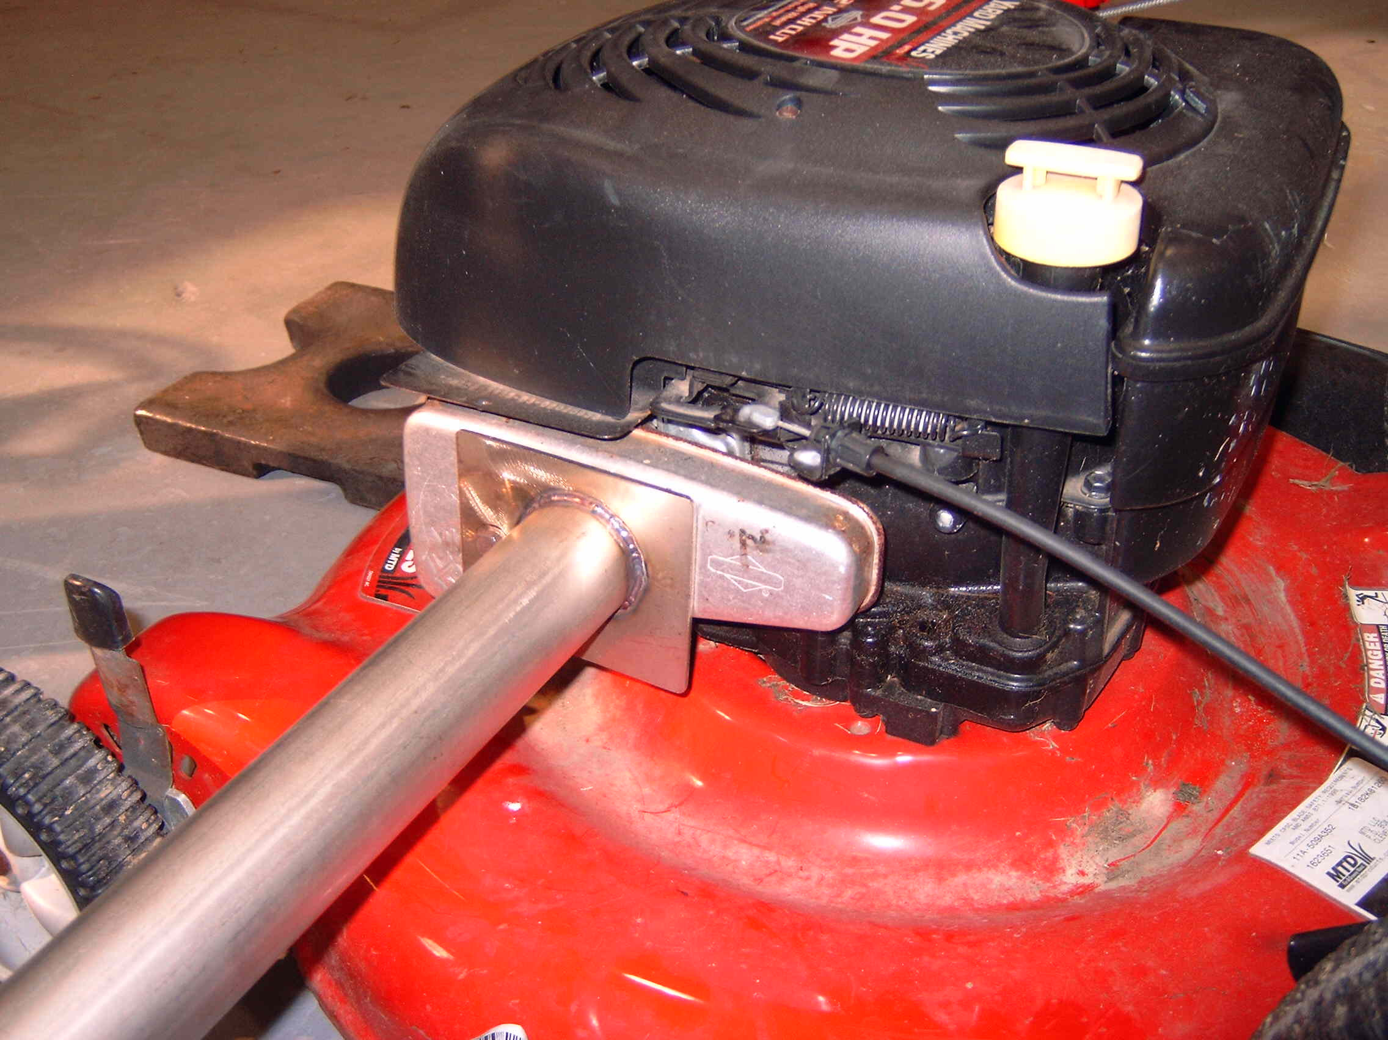

Picture 2
The lawnmower wheels are immobilized with 30-pound cast iron weights. The duct extension is supported by a ring stand to stabilize the extension. An exhaust duct is in position to capture the exhaust from the engine.

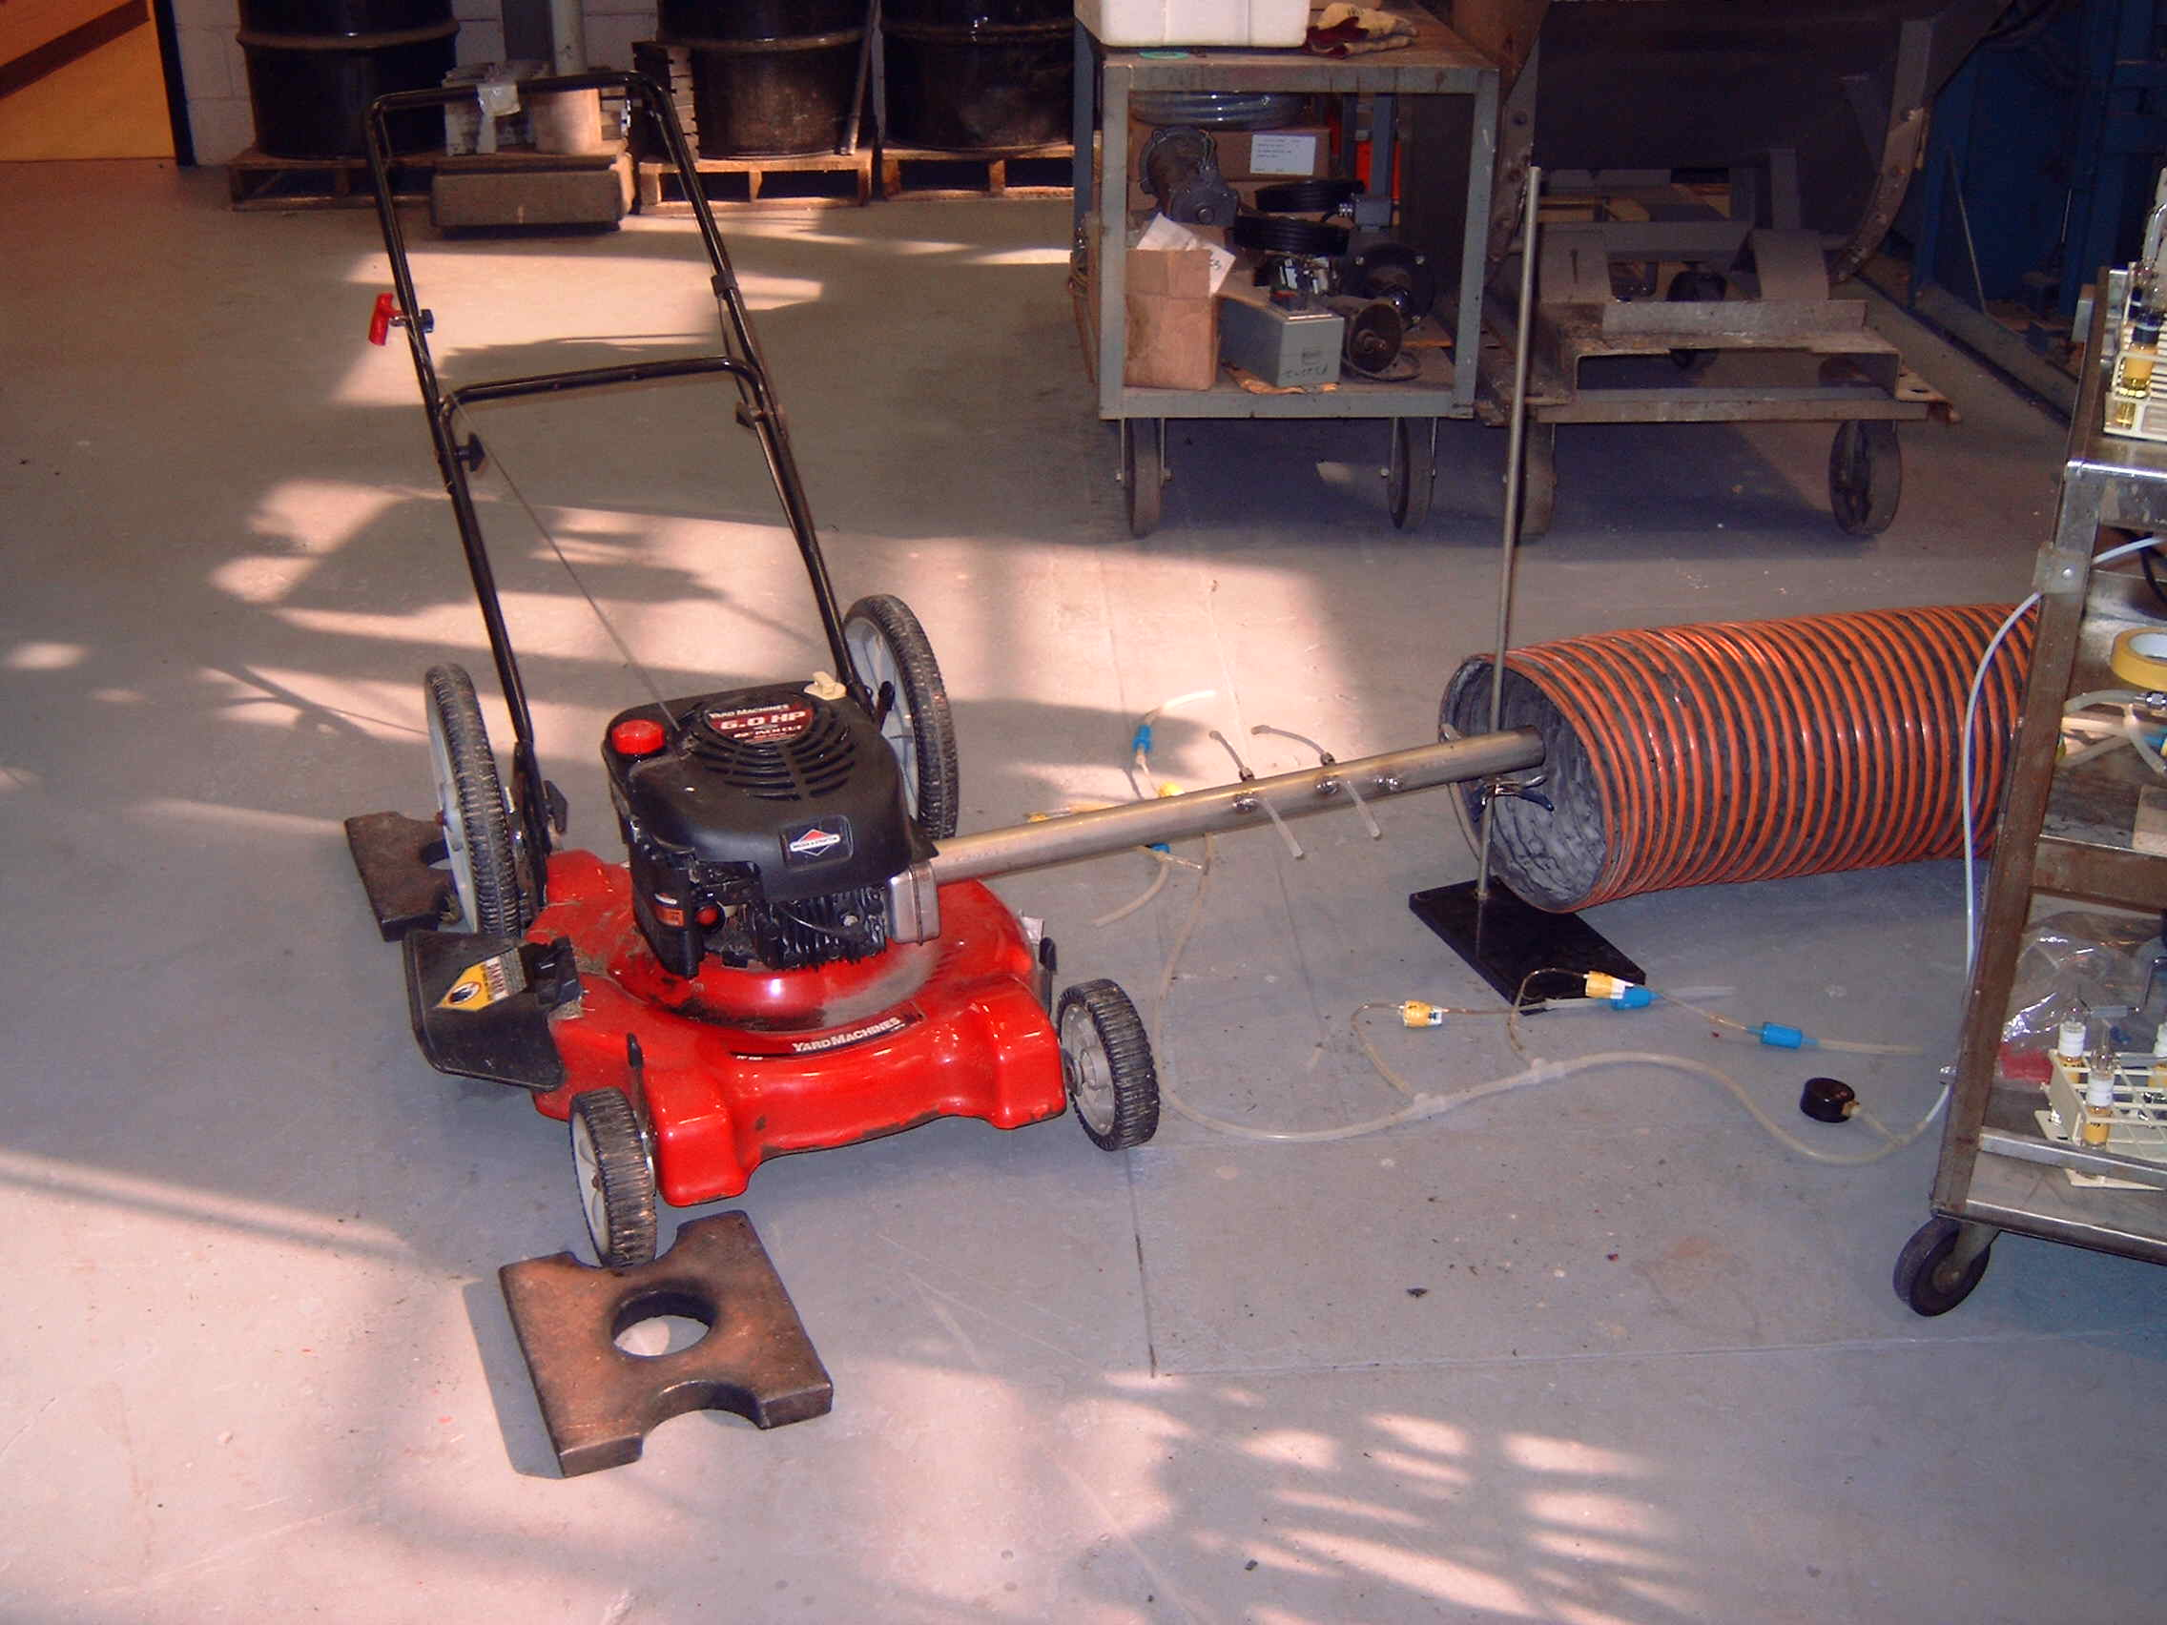

Picture 3
Sampling is under way for aldehydes with two dual sampling trains. A single vacuum pump is supplying vacuum to the four critical orifices each sampling at approximately 300 mL per minute. Notice the vacuum gauge on the floor to the left of the picture.

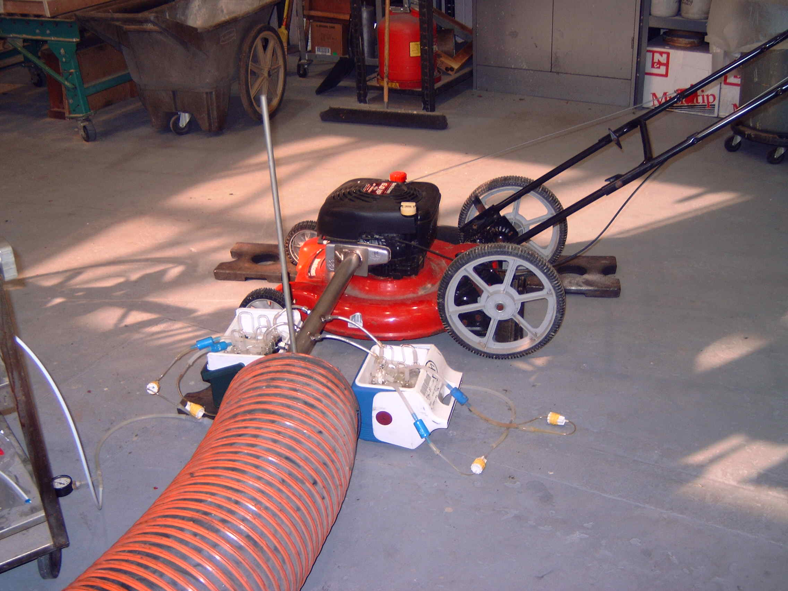

Picture 4
This is a second view of the aldehyde sampling showing the support cart that has supplies of sampling media, tools, notebook and the vacuum pump.

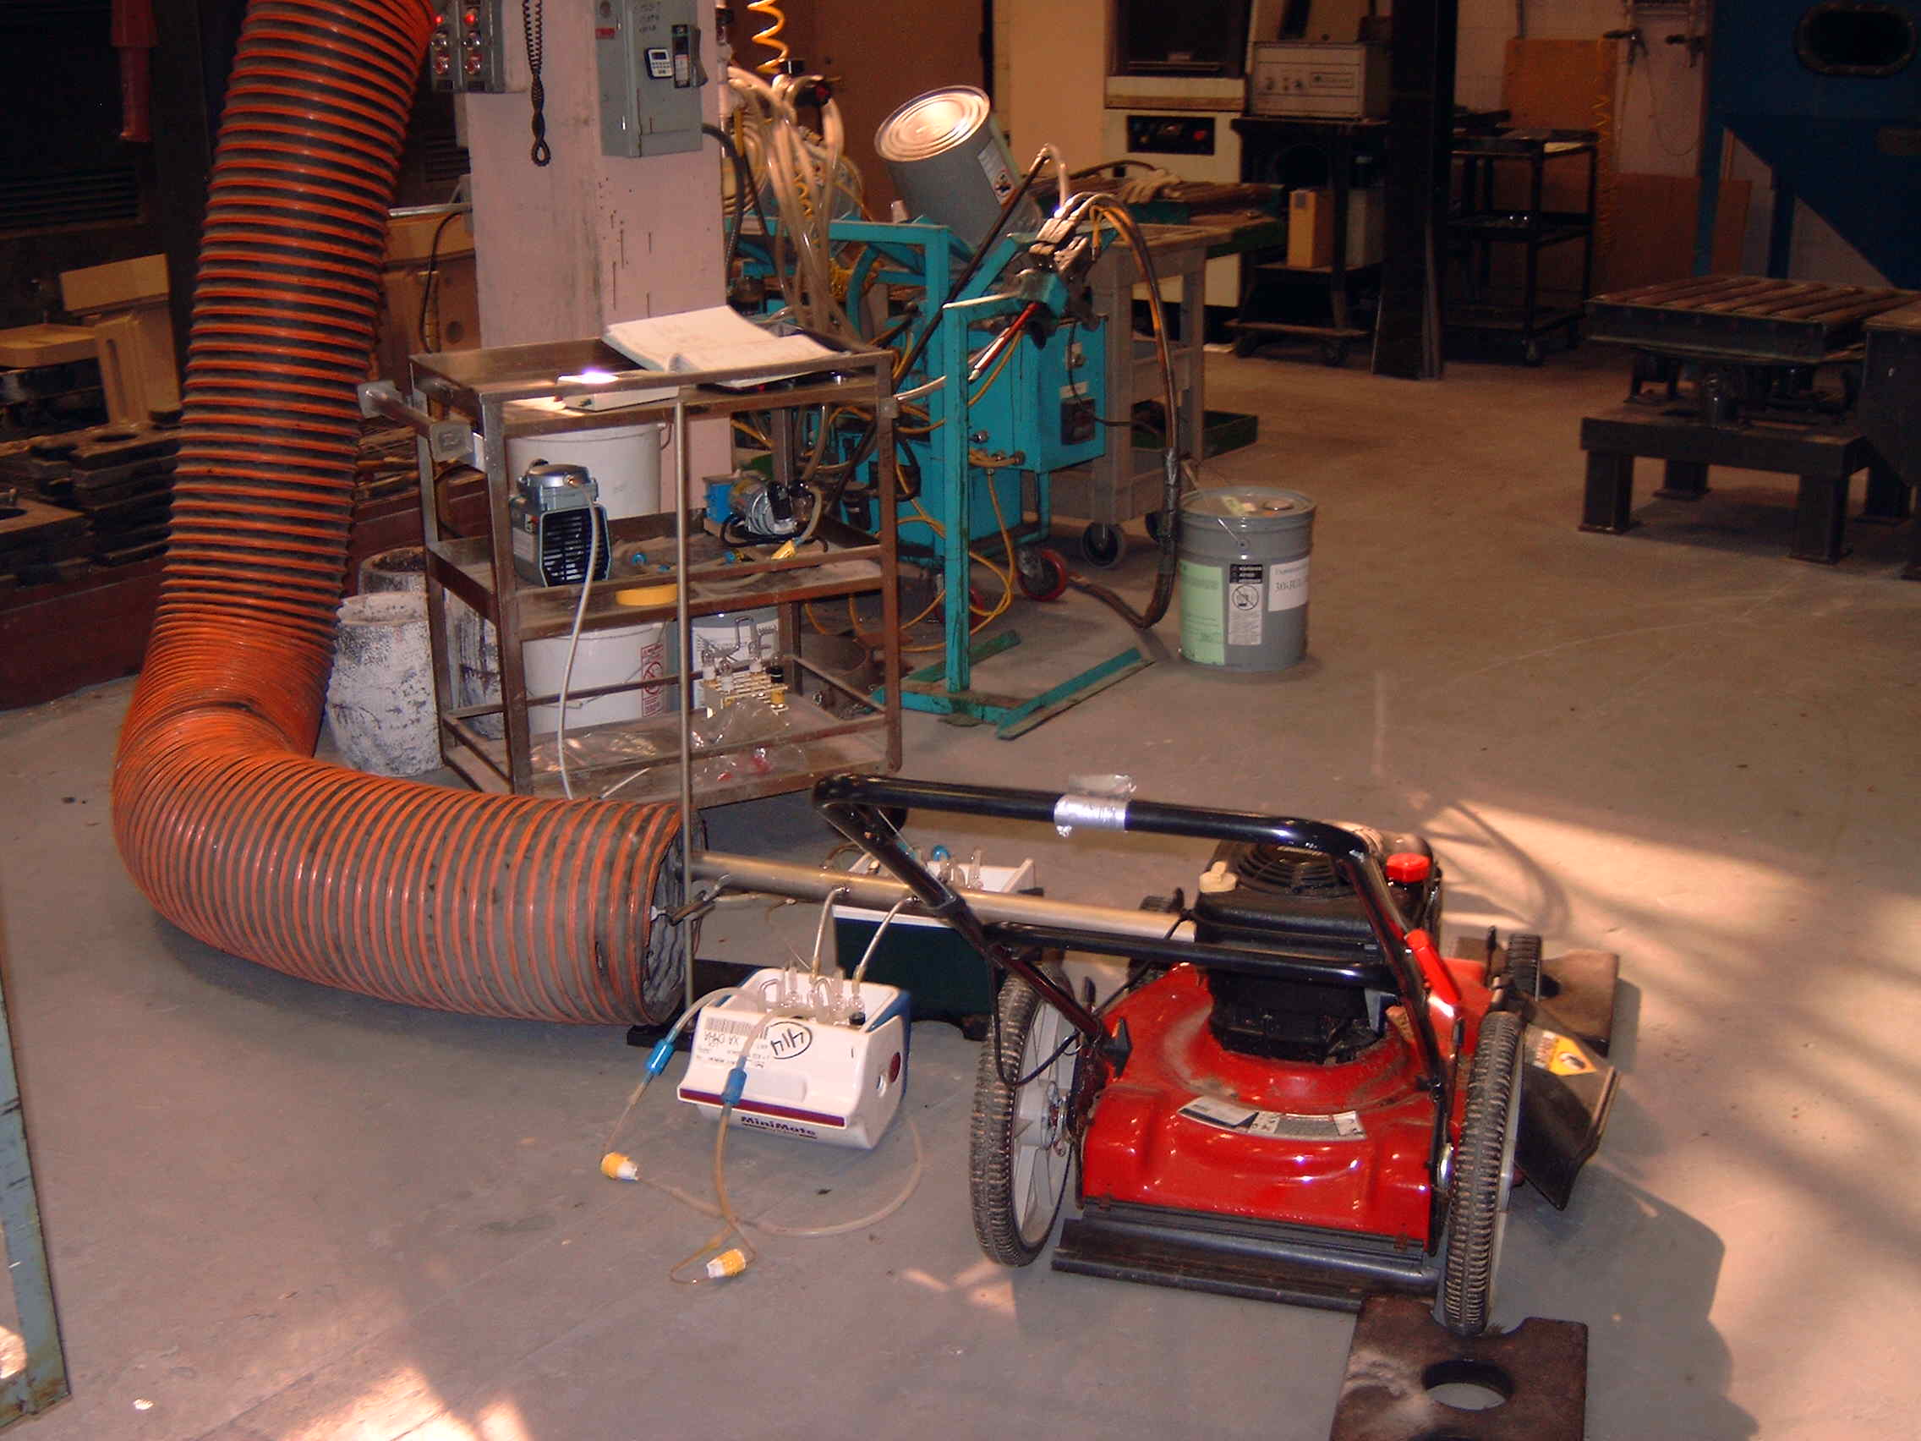

Ashland Specialty Chemical Company
Modified Impinger Method for Acrolein in Air

Background

This procedure is based on dinitrophenylhydrazine (DNPH) chemistry similar to Method CARB 430 to capture acrolein in air (and other selected carbonyl containing air toxics) and form a stable hydrazone derivative for the quantification of the acrolein. The acrolein reacts with DNPH in the acidic solution and is continuously extracted out of the aqueous phase by the toluene. The sampling train usually has three impingers connected in series. Two impingers may be inadequate to capture all of the acrolein in some sources. This was evident where two impingers were used to sample a two cylinder gasoline fueled lawn tractor engine. Acrolein has low water solubility compared to formaldehyde and rapidly purges out of a deionized water impinger. Conversely, formaldehyde is effectively captured in deionozed water. The tendency for acrolein carry-over, even in the presence of DNPH solution, requires more impingers for acrolein than for formaldehyde. Each impinger contains 10 mL of water, two mL of DNPH-HCl acidic solution and two mL of toluene. The bubbling action of the air sampling breaks up the toluene layer into small droplets that perform a liquid-liquid extraction of the aqueous phase continuously during sampling. The toluene is an effective co-solvent for the acrolein which increases the capture efficiency of the acrolein. The sampling flow was achieved with a rotary vane vacuum pump with a critical orifice in line. Recommended sample flow rates are 0.2 to 0.4 liters per minute. This sampling rate provides desirable extraction performance.

Impinger methods using DNPH have historically given low recovery for acrolein. The acidic solution is believed to be responsible for the loss of the hydrazone formed in the reaction of DNPH and the aldehyde. Nitrogen oxides in the sample appear to accelerate the loss of the hydrazones and the parent DNPH. Increased acid concentration and corresponding higher DNPH loadings did not improve the analyte recovery. Field extraction with organic solvents immediately following sampling has improved recoveries, but this is often difficult to perform in the field and recoveries were still lower than desired. Sampling times have been reduced to minimize the loss of the hydrazones. This also raises the method detection limit (MDL). The continuous toluene extraction employed in this procedure has provided stable and consistent recovery of acrolein. Field spike recovery average for 14 spiked samples was 94.2%. The field spikes were stable for two weeks at ambient conditions.

1. PURPOSE:

This procedure describes the sampling and analysis of short chain aldehydes in air.

2. SCOPE:
This procedure can be used for ambient air, industrial hygiene surveys, process engineering surveys, or in accordance with Code of Federal Regulations, Volume 40, Part 60, Appendix A, Method 18.

This method can be used to analyze the aldehydes listed in Table 1 in a single chromatogram that are collected in ambient air, work place air, combustion sources, vehicle emissions, or hot wet process emissions.
TABLE 1
Analytes

 | Boiling Point (°C) | Density (g/mL) | MW (g/mole) | Range (mg/m3)
formaldehyde | -21 | 0.815 | 30.03 | 0.002-1000
acetaldehyde | 20.8 | 0.783 | 44.05 | 0.005-1000
acrolein | 52.5 | 0.863 | 56.06 | 0.002-1000

3. APPARATUS and REAGENTS:
3.1 Midget impingers using a removable six-dram threaded vial, available from Supelco, part number 64712-U.
3.2 6mm glass tube impinger connectors secured with 3/16 inch ID silicone tubing.
3.3 Sampling pump suitable to provide sample flow at 0.2 to 0.4 liters per minute.
3.4 Gas chromatograph equipped with a nitrogen phosphorus detector (NPD).
3.5 Column - see instrument parameters for specific analyte.
3.6 Syringe - 10 μL
  - DNPH-HCl solution. Place 4 grams of recrystallized DNPH in a one-liter Erlenmeyer flask (see Method CARB 430 for recrystallizing details) and add 500 mL 2N HCl. Add 4mL 85% phosphoric acid. Heat with stirring to dissolve. Blanket with nitrogen. When the yellow-orange solution is clear, remove from heat and allow it to cool to room temperature. Maintain a nitrogen blanket. Some precipitate may form. Check the blank level for the compounds of interest. Extract the DNPH solution with toluene if the blank levels are too high. Pour the solution into a glass bottle and cap with an airtight closure. Maintain a nitrogen blanket every time the bottle is opened. Impinger vials may be prepared by adding two mL of the DNPH-HCl solution, 10 mL D. I. water and two mL of toluene. For large batches of impingers, pre-dilute the DNPH-HCl solution and add 12 mL to each vial.

4. SAMPLING PROCEDURE:
4.1 Prepare three impingers connected in series using the 6mm glass tube connectors.
4.2 Attach the impinger vials filled with DNPH-HCL solution to the impinger stems. Place the impingers in a rack inside a small cooler. Add ice and maintain the ice bath during sampling. Connect the impingers to the sampling pump and turn on the sampling pump prior to connecting the impinger train to the sample probe.
  - Sample at 0.2 to 0.4 liters per minute for as long as necessary to collect adequate mass for desired detection level. Samples were collected for up to one hour without any problems. Ambient sampling may require two to three hours to collect adequate mass for desirable quantification.
  - When sampling is complete, disconnect the sampling probe prior to stopping the sampling pump. This will prevent loss of sample if the stack has positive or negative pressure. Remove and cap each impinger vial and transport the vials to the analytical laboratory.

- SAMPLE ANALYSIS
  - Remove the toluene layer with a graduated pipette and measure the volume. Another option is to make up the toluene layer to the original 2.0 mL. Place the toluene fraction in labeled vials or autosampler vials for analysis by GC/NPD. The toluene solution may need to be further diluted to keep the peak areas on the linear portion of the calibration curve. The NPD detector response-to-mass is best fit with a quadratic curve. As the detector bead ages, the response may become less linear, but the data is valid as demonstrated by spike recovery and methods of addition.
  - Analyze according to Ashland Chemical Method CA4618.

6. REFERENCES

Analyte Reference
Formaldehyde CARB 430
Acetaldehyde CARB 430
Acrolein CARB 430

APPENDIX A

INSTRUMENT PARAMETERS

 | Formaldehyde, Acetaldehyde, Acrolein
Instrument: | Varian 3800
Column:
length, m | 30.0
I.D, mm | 0.53
OD, in | 0.8
material | fused silica
Stationary Phase:
type | DB-17 ( J&W Scientific or equivalent)
thickness (μm) | 1.0
Temperature:
injector | 230°C, on-column
detector | 280°C
Oven:
initial | 200°C for 10 min
final | 230°C
program rate | 5.0°C/min
Carrier Gas:
type | helium
rate | 7-10 mL/min (8psig)
 | 20 mL/min make-up at detector
Sample:
injection volume | 2.0 μl
solvent | toluene
Detection:
type | NPD
sensitivity | 1 X 10-11 a/MV

Five-Level Calibration Standards

Calibration levels, μg/mL

Aldehyde | std L5 | std L4 | std L3 | std L2 | std L1
Formaldehyde | 14.20 | 7.100 | 3.550 | 1.775 | 0.5917
Acetaldehyde | 7.080 | 3.540 | 1.770 | 0.8850 | 0.2950
Acrolein | 5.827 | 2.914 | 1.456 | 0.7280 | 0.2427

Chromatogram of Sample 73A

Chromatogram of Sample 73B

Chromatogram of Sample 73C

Reagent Blank
Prepared 2-12-04, loaded in impingers 2-13-04, analyzed 2-18-04

Formaldehyde Calibration Curve

Acetaldehyde Calibration Curve

Acrolein Calibration Curve

