California Environmental Protection Agency

AIR RESOURCES BOARD

**Final**

CALIFORNIA EXHAUST EMISSION STANDARDS AND TEST PROCEDURES FOR

**2018 THROUGH 2025 MODEL YEAR ZERO-EMISSION VEHICLES AND HYBRID ELECTRIC VEHICLES, IN THE PASSENGER CAR,**

LIGHT-DUTY TRUCK AND MEDIUM-DUTY VEHICLE CLASSES

Adopted: March 22, 2012

Amended: December 6, 2012

Amended: May 30, 2014

Amended: September 2, 2015

Amended: September 3, 2015

Amended: August 25, 2022

[Note: This version of the Final Test Procedure also complies with Government Code section 11346.2 subdivision (a)(3), and 11346.8, subdivision (c). It is provided to also improve the accessibility and readability of the regulatory text. The existing, original test procedure language currently incorporated by reference in the California Code of Regulations is shown as plain, clean text, while the final amendments are shown in tracked changes. To review this document in a clean format (no underline or strikeout to show changes), please select “Simple Markup” or “No Markup” in Microsoft Word’s Review menu, or accept all changes. You can also change the view to the original (originally proposed regulatory text prior to final modifications) by selecting “Original” or rejecting all tracked changes. Additionally, “Advanced Track Changes Options” will allow for further options regarding color and other markings. [Instructions on using/viewing Track Changes can be found here](https://support.microsoft.com/en-us/office/track-changes-in-word-197ba630-0f5f-4a8e-9a77-3712475e806a).]

[This page is left intentionally blank]

NOTE: This document is incorporated by reference in section 1962.2, title 13, California Code of Regulations (CCR). Additional requirements necessary to complete an application for certification of zero-emission vehicles and hybrid electric vehicles are contained in other documents that are designed to be used in conjunction with this document. These other documents include:

1. “California 2015 through 2025 Model Year Criteria Pollutant Exhaust Emission Standards and Test Procedures and 2017 and Subsequent Model Year Greenhouse Gas Exhaust Emission Standards and Test Procedures for Passenger Cars, Light-Duty Trucks, and Medium-Duty Vehicles” (incorporated by reference in section 1961.2, title 13, CCR);

2. “California Evaporative Emission Standards and Test Procedures for 2001 through 2025 Model Year Passenger Cars, Light-Duty Trucks, Medium-Duty Vehicles, and Heavy-Duty Vehicles and 2021 and Subsequent Model Year Motorcycles” (incorporated by reference in section 1976(c), title 13, CCR);

3. “California Refueling Emission Standards and Test Procedures for 2001 and Subsequent Model Motor Vehicles” (incorporated by reference in section 1978(b), title 13, CCR);

4. OBD II (section 1968, et seq. title 13, CCR, as applicable);

5. “California Environmental Performance Label Specifications for 2009 and Subsequent Model Year Passenger Cars, Light-Duty Trucks, and Medium-Duty Passenger Vehicles” (incorporated by reference in 1965, title 13, CCR);

6. Warranty Requirements (sections 2037 and 2038, title 13, CCR);

7. “Specifications for Fill Pipes and Openings of Motor Vehicle Fuel Tanks” (incorporated by reference in section 2235, title 13, CCR);

8. Guidelines for Certification of Federally Certified Light-Duty Motor Vehicles for Sale in California (incorporated by section 1960.5, title 13, CCR); and

9. “California Non-Methane Organic Gas Test Procedures for 2017 and Subsequent Model Years,” (incorporated by reference in section 1961.2(d), title 13, CCR).

A. Applicability A-1

B. Definitions and Terminology. B-1

1. Definitions. B-1

2. Terminology. B-6

C. Zero-Emission Vehicle Standards. C-1

1. C-1

2. Percentage ZEV Requirements. C-1

3. Transitional Zero-Emission Vehicles (TZEV). C-5

4. Qualification for Credits From ZEVs. C-7

5. [Reserved] C-13

6. [Reserved] C-13

7. Generation and Use of ZEV Credits; Calculation of Penalties. C-13

8. Severability. C-18

9. Public Disclosure. C-18

D. Certification Requirements. D-1

1. Durability and Emission Testing Requirements. D-1

2. Information Requirements: Application for Certification. D-1

3. ZEV Reporting Requirements. D-3

E. Determination of NEV Acceleration, Top Speed, and Constant Speed Range E-1

F. Test Procedures for 2018 THROUGH 2025 Model Zero-Emission Vehicles (including Fuel Cell Vehicles and Hybrid Fuel Cell Vehicles) and All 2018 THROUGH 2025 Model Hybrid-Electric Vehicles, Except Off-Vehicle Charge Capable Hybrid Electric Vehicles. F-1

1. Electric Dynamometer. F-1

2. Vehicle and Battery Break-In Period. F-1

3. F-1

4. Determination of Battery Specific Energy for ZEVs. F-5

5. Determination of the Emissions of the Fuel-fired Heater for Vehicles Other Than ZEVs. F-5

6. Urban Emission Test Provisions for All Hybrid Electric Vehicles, Except Hybrid Fuel Cell Vehicles and Off-Vehicle Charge Capable Hybrid Electric Vehicles. F-5

7. Highway Emission Test Provisions for All Hybrid Electric Vehicles, Except Hybrid Fuel Cell Vehicles and Off-Vehicle Charge Capable Hybrid Electric Vehicles. F-12

8. SFTP Emission Test Provisions for All Hybrid Electric Vehicles, Except Hybrid Fuel Cell Vehicles and Off-Vehicle Charge Capable Hybrid Electric Vehicles. F-13

9. State-of-Charge Net Energy Change Tolerances for All Hybrid Electric Vehicles, Except Hybrid Fuel Cell Vehicles and Off-Vehicle Charge Capable Hybrid Electric Vehicles. F-16

10. 50oF and 20oF Test Provision for All Hybrid Electric Vehicles, Except Hybrid Fuel Cell Vehicles and Off-Vehicle Capable Hybrid Electric Vehicles. F-18

G. Test Procedures for 2018 through 2025 Model Off-Vehicle Charge Capable Hybrid Electric Vehicles. G-1

1. Electric Dynamometer. G-1

2. Vehicle and Battery Break-In Period. G-1

3. General Testing Requirements. G-1

4. Determination of the Emissions of the Fuel-fired Heater. G-3

5. Urban Emission Test Provisions for Off-Vehicle Charge Capable Hybrid Electric Vehicles. G-3

6. Highway Emission Test Provisions for Off-Vehicle Charge Capable Hybrid Electric Vehicles. G-19

7. SFTP Emission Test Provisions for Off-Vehicle Charge Capable Hybrid Electric Vehicles. G-22

8. 50oF and 20oF Test Provision for Off-Vehicle Charge Capable Hybrid Electric Vehicles. G-27

9. Additional Provisions. G-29

10. State-of-Charge Net Energy Change Tolerances for Off-Vehicle Charge Capable Hybrid Electric Vehicles. G-29

11. Calculations – Equivalent All-Electric Range for Off-Vehicle Charge Capable Hybrid Electric Vehicles. G-31

12. The Calculations of the Combined Greenhouse Gas Regulatory Rating of Off-vehicle Charge Capable Hybrid Electric Vehicles G-35

H. Off-Vehicle Charge Capable Hybrid Electric Vehicle Exhaust Emission Test Sequence. H-1

I. Examples of Off-Vehicle Charge Capable Hybrid Electric Vehicle Terminology. I-1

J. Advanced Technology Demonstration Program data requirements. J-1

1. Project Description J-1

2. Vehicle data J-1

3. Vehicle specifications J-1

CALIFORNIA EXHAUST EMISSION STANDARDS AND TEST PROCEDURES FOR

**2018 THROUGH 2025 MODEL YEAR ZERO-EMISSION VEHICLES AND HYBRID ELECTRIC VEHICLES, IN THE PASSENGER CAR,**

LIGHT-DUTY TRUCK AND MEDIUM-DUTY VEHICLE CLASSES

# Applicability

The emission standards and test procedures in this document are applicable to 2018 through 2025 model-year zero-emission passenger cars, light-duty trucks, and medium-duty vehicles, and 2018 through 2025 model-year hybrid electric passenger cars, light-duty trucks, and medium-duty vehicles. The general procedures and requirements necessary to certify a vehicle for sale in California are contained in the “California 2015 through 2025 Model Year Criteria Pollutant Exhaust Emission Standards and Test Procedures and 2017 and Subsequent Model Year Greenhouse Gas Exhaust Emission Standards and Test Procedures for Passenger Cars, Light-Duty Trucks, and Medium-Duty Vehicles” (hereinafter “LDV/MDV TPs”), and apply except as amended herein.

# Definitions and Terminology.

## 1. Definitions.

In addition to the following, these test procedures incorporate by reference the definitions and abbreviations set forth in the Title 40 Code of Federal Regulations (CFR) §86.1803-01, the definitions and abbreviations set forth in the LDV/MDV TPs, and the definitions set forth in section 1900, title 13, CCR.

**“Advanced technology PZEV” or “AT PZEV”** means any PZEV with an allowance greater than 0.2 before application of the PZEV early introduction phase-in multiplier.

**“All‑Electric Range” or “AER”** means the total miles driven electrically (with the engine off) before the engine turns on for the first time, after the battery has been fully charged. The AER is defined in terms of the Urban All-Electric Range (AERu) and the Highway All-Electric Range (AERh).

**“All‑Electric Range Test” or “AERT”** means a test sequence used to determine the range of an electric vehicle or of a hybrid electric vehicle without the use of its auxiliary power unit. The vehicle shall be tested for all-electric range in default mode or in normal mode if the vehicle does not have a default mode. The Urban All‑Electric Range Test (AERTu) determines the Urban All-Electric Range (AERu) and the Highway All-Electric Range (AERTh) determines the Highway All-Electric Range (AERh) (see section G of these test procedures).

**“Alternative Continuous Urban Test Schedule”** means a series of the following sequence: UDDS, 10 minute key-off hot soak, UDDS, and 10-30 minute key-off hot soak. This alternative procedure may be substituted for the Continuous Urban Test Schedule when the Continuous Urban Test Schedule cannot be performed.

**“Alternative Continuous Highway Test Schedule”** means a series of the following sequence: HFEDS, 15 second key-on pause, HFEDS, and 10-30 minute key-off hot soak or a 15 second key-on pause. This alternative procedure may be substituted for the Continuous Highway Test Schedule when the Continuous Highway Test Schedule cannot be performed.

“**Automotive-Related Global Revenue**” means global net revenues in U.S. dollars derived from the sale of passenger cars, light-duty trucks, and medium-duty vehicles, as reported in the most recently available audited annual consolidated financial statements or reports. If these financial statements or reports are published using a currency other than U.S. dollars, the value of net revenues is to be converted to U.S. dollars using the average foreign exchange (FX) rate during the corresponding

fiscal year as reported by USForex.

**“Auxiliary power unit” or “APU”** (also referred to as “engine”) means a device that converts consumable fuel energy into mechanical or electrical energy. Some examples of auxiliary power units are internal combustion engines, gas turbines, or fuel cells. For the purposes of range extended battery electric vehicles, auxiliary power unit means any device that provides electrical or mechanical energy, meeting the requirements of subdivision C.3.2, to a BEVx, after the zero emission range has been fully depleted. A fuel fired heater does not qualify under this definition for an APU.

**“Battery electric vehicle” or “BEV”** means any vehicle that operates solely by use of a battery or battery pack, or that is powered primarily through the use of an electric battery or battery pack but uses a flywheel or capacitor that stores energy produced by the electric motor or through regenerative braking to assist in vehicle operation.

**“Battery or Battery pack”** means any electrical energy storage device consisting of any number of individual battery modules or cells that is used to propel a battery electric or hybrid electric vehicle. These terms may also generically refer to capacitor and flywheel energy storage devices in the context of hybrid electric vehicles.

**“Battery state-of-charge”** means the quantity of electrical energy remaining in the battery relative to the maximum rated capacity of the battery expressed in percent.

**“Blended off-vehicle charge capable hybrid electric vehicle”** means an off-vehicle charge capable hybrid electric vehicle that uses the engine to supplement battery/electric motor power during charge depleting operation.

**“Blended operation mode”** means an operating mode in which the energy storage state-of-charge decreases, on average, while the vehicle is driven and the engine is used occasionally to support power requests.

**“Charge-depleting net energy consumption”** means the net electrical energy, Ecd, measured in watt-hours consumed by vehicle over a charge depleting cycle range, Rcdc. Ecd can be expressed as AC or DC watt hours, where appropriate.

**“Charge-depleting (CD) operation”** means a type of vehicle operation in which the energy storage state-of-charge (SOC) may fluctuate but, on average, decreases while the vehicle is driven.

**“Charge depleting actual range, urban” or “Rcdau”** means the distance traveled on the Urban Charge Depleting Test Procedure at which the state-of-charge is first equal to the average state-of-charge of the two consecutive UDDS cycles used to end the Urban Charge Depleting Test Procedure. This range must be reported to the nearest 0.1 miles. (See section G.11.9.)

**“Charge depleting actual range, highway” or “Rcdah”** means the distance traveled on the Highway Charge Depleting Test Procedure at which the state-of-charge is first equal to the average state-of-charge of the HFEDS cycle used to end the Highway Charge Depleting Test Procedure. This range must be reported to the nearest 0.1 miles.

**“Charge depleting cycle range” or “Rcdc”** means the distance traveled on the Urban or Highway Charge Depleting Test Procedure up to the test cycle prior to where the state-of-charge is above the lower bound state-of-charge tolerance for one test cycle. This range will appear as the sum of a discrete number of test cycle distances. This range shall be reported to the nearest 0.1 miles. (See section F.11.8.)

**“Charge-increasing operation”** means a type of vehicle operation that occurs when the energy storage SOC may fluctuate but, on average, increases while the vehicle is driven over two or more consecutive UDDS cycles. To test PHEVs with charge-increasing operation, follow the test requirements for charge-sustaining operation in section G.5 with the modifications specific to charge-increasing operation. A charge-increasing driver-selectable mode is not included in this definition but is considered a mode and not an operation.

**“Charge-sustaining net energy consumption”** means the net electrical energy, Ecs, measured in watt-hours consumed by vehicle during charge sustaining operation. For charge sustaining operation, this number should be ~ 0.

**“Charge-sustaining (CS) operation”** means a type of vehicle operation in which the energy storage SOC may fluctuate but, on average, is maintained at a certain level while the vehicle is driven.

“**Cold start UDDS**” is defined as the first UDDS cycle in which the engine turns on.

**“Consumable fuel”** means any solid, liquid, or gaseous matter that releases energy when consumed by an auxiliary power unit.

**“Continuous Highway Test Schedule”** means a repeated series comprised of four consecutive key-on Highway Fuel Economy Driving Schedules (HFEDS) with a 15 second key-on pause in-between each HFEDS cycle. If this schedule cannot be performed continuously, a key-off soak up to 30 minutes is permitted after every fourth HFEDS cycle.

**“Continuous Urban Test Schedule”** means a repeated series comprised of an Urban Dynamometer Driving Schedules (UDDS), 40 CFR, Part 86, Appendix I, which is incorporated herein by reference; each test is followed by a 10 minute key-off soak period.

**“Continuous US06 Test Schedule”** means a repeated series of US06 driving schedules (US06) with a key-on idle period of not less than one minute and not greater than two minutes between each US06.

“**Conventional rounding method**” means to increase the last digit to be retained when the following digit is five or greater. Retain the last digit as is when the following digit is four or less.

**“Default Mode”** means the operating mode to which the vehicle automatically reverts after a vehicle is turned off and subsequently turned on. A vehicle with default mode would require the driver to select an alternative mode each time the vehicle is turned on if the driver chooses to use an alternative mode.

“**Discounted PZEV and AT PZEV credits**” means credits earned under section 1962 and 1962.1 by delivery for sale of PZEVs and AT PZEVs, discounted according to subdivision C.7.2(f).

“**Driver-Selectable Mode”** means an operating mode that the vehicle driver can manually engage by means of an instrument panel button, switch, screen menu, etc., anytime the vehicle is activated (e.g., when the key is in the on position).

“**East Region pool**” means the combination of Section 177 states east of the Mississippi River.

**“Electric drive system”** means an electric motor and associated power electronics, which provide acceleration torque to the drive wheels sometime during normal vehicle operation. This does not include components that could act as a motor, but are configured to act only as a generator or engine starter in a particular vehicle application.

**“Electric range fraction”** means the fraction of electrical energy derived from off-vehicle charging and regenerative braking energy relative to total traction energy used over the charge depletion range on a specified drive cycle.

“**Energy storage device**” means a storage device able to provide the minimum power and energy storage capability to enable engine stop/start capability, traction boost, regenerative braking, and (nominal) charge sustaining operation. In the case of TZEVs, a minimum range threshold relative to certified, new-vehicle range capability is not specified or required.

**“Enhanced AT PZEV”** means any model year 2009 through 2011 PZEV that has an allowance of 1.0 or greater per vehicle without multipliers and makes use of a ZEV fuel. Enhanced AT PZEV means Transitional Zero Emission Vehicle.

**“Equivalent all-electric range” or “EAER”** means the portion of the total charge depleting range attributable to the use of electricity from the battery over a charge depleting test.

**“Fuel cell vehicle” or “FCV”** means any vehicle that receives propulsion solely from an onboard fuel cell power system.

**“Fuel-fired heater”** means a fuel burning device that creates heat for the purpose of warming the passenger compartment of a vehicle but does not contribute to the propulsion of the vehicle.

**“Full State-of-Charge (SOC)”** means the energy storage device of an off-vehicle charge capable hybrid electric vehicle is at full energy capacity following a recharging event with an off-vehicle charger.

**“Grid-connected hybrid electric vehicle”** means a hybrid electric vehicle that has the capacity for the battery to be recharged from an off-board source of electricity and has some all-electric range. This type of hybrid electric vehicle is also called a plug-in hybrid electric vehicle or PHEV.

**“Highway Fuel Economy Driving Schedule” or** **“HFEDS”** means highway fuel economy driving schedule. See 40 CFR Part 600 §600.109(b).

**“Hybrid electric vehicle” or “HEV”** means any vehicle that can draw propulsion energy from both of the following on-vehicle sources of stored energy: 1) a consumable fuel and 2) an energy storage device such as a battery, capacitor, or flywheel.

**“Hybrid fuel cell vehicle” or “HFCV”** means any vehicle that receives propulsion energy from both an onboard fuel cell power system and either a battery or a capacitor.

“**Hydrogen fuel cell vehicle**” means a ZEV that is fueled primarily by hydrogen, but may also have off-vehicle charge capability.

“**Hydrogen internal combustion engine vehicle**” means a TZEV that is fueled exclusively by hydrogen.

**“Majority ownership situations”** means when one manufacturer owns another manufacturer more than 33.4%, for determination of size under CCR Section 1900. **“Manufacturer US PC and LDT Sales”** means a manufacturer’s total passenger car and light duty truck (up to 8,500 pounds loaded vehicle weight) sales sold in the United States of America in a given model year.

**“Neighborhood Electric Vehicle” or “NEV**” means a motor vehicle that meets the definition of “low-speed vehicle” either in section 385.5 of the Vehicle Code or in 49 CFR §571.500 (July 1, 2000), and is certified to zero-emission vehicle standards.

**“NIST”** means the National Institute of Standards and Technology.

**“Normal Mode”** means the operating mode where the vehicle automatically optimizes engine, battery, transmission, and braking operation for the most common driving conditions as determined by the manufacturer. Normal mode would be equivalent to default mode if the vehicle has default mode.

**“Off-vehicle charge capable”** means having the capability to charge a battery from an off-vehicle electric energy source that cannot be connected or coupled to the vehicle in any manner while the vehicle is being driven. A grid-connected hybrid electric vehicle is one example of an off-vehicle charge capable hybrid electric vehicle.

**“Placed in service”** means having been sold or leased to an end-user and not just to a dealer or other distribution chain entity, and having been individually registered for on-road use by the California Department of Motor Vehicles.

**“Proportional value”** means the ratio of a manufacturer’s California applicable sales volume to the manufacturer’s Section 177 state applicable sales volume. In any given model year, the same applicable sale volume calculation method must be used to calculate proportional value.

**“Partial Zero Emission Vehicle” or “PZEV”** means any vehicle that is delivered for sale in California and that qualifies for a partial ZEV allowance of at least 0.2, under section 1962.1.

**“Range Extended Battery Electric Vehicle” or “BEVx”** means a vehicle powered predominantly by a zero emission energy storage device, able to drive the vehicle for more than 75 all-electric miles, and also equipped with a backup APU, which does not operate until the energy storage device is fully depleted, and meeting requirements in subdivision C.4.5(g),

**“Regenerative braking”** means the partial recovery of the energy normally dissipated into friction braking that is returned as electrical current to an energy storage device.

**“SAE J1634”** means the “Battery Electric Vehicle Energy Consumption and Range Test Procedure,” as revised by SAE International in October, 2012.

**“SAE J1711”** means the “Recommended Practice for Measuring the Exhaust Emissions and Fuel Economy of Hybrid-Electric Vehicles, Including Plug-in Hybrid Vehicles,” as revised by SAE International in June, 2010.

**“SAE J2572”** means the “Recommended Practice for Measuring Fuel Consumption and Range of Fuel Cell and Hybrid Fuel Cell Vehicles Fuelled by Compressed Gaseous Hydrogen,” as published by the Society of Automotive Engineers in October, 2008.

**“Section 177 State”** means a state that is administering the California ZEV requirements pursuant to section 177 of the federal Clean Air Act (42 U.S.C. § 7507).

**“SC03”** means the U.S. EPA SC03 driving schedule representing vehicle operation with air conditioning, as set forth in Appendix I of 40 CFR Part 86.

**“State of Charge (SOC) Net Energy Change Tolerance”** means the state-of-charge net energy change tolerance that is applied to the SOC Criterion for charge-sustaining hybrid electric vehicles when validating an emission test. See section F.9 and G.10 of these procedures for tolerance specifications.

**“State of Charge (SOC) Criterion”** means the state-of-charge criterion that is applied to a charge-sustaining hybrid electric vehicle to validate an emission test. The SOC Criterion requires that no net change in battery energy occurs over a given test cycle, i.e. the final battery state-of-charge that is recorded at the end of the emission test must be equivalent to the initial battery state-of-charge that is set at the beginning of the emission test. The SOC Net Energy Change Tolerance shall be applied to the SOC Criterion.

**“Transitional Zero Emission Vehicle” or “TZEV”** means a vehicle that meets all the criteria of subdivision C.3.2 and qualifies for an allowance in subdivision C.3.3(a) or (e).

**“UDDS”** means urban dynamometer driving schedule as set forth in Appendix I of 40 CFR Part 86.

**“US06”** means the US06 driving schedule for aggressive driving as set forth in Appendix I of 40 CFR Part 86.

“**West Region pool**” means the combination of Section 177 states west of the Mississippi River.

**“Zero‑emission vehicle”** or “**ZEV”** means a vehicle that produces zero exhaust emissions of any criteria pollutant (or precursor pollutant) or greenhouse gas under any possible operational modes or conditions.

**“Zero-emission Vehicle Miles Traveled” or “zero emission VMT”** means the vehicle miles traveled with zero exhaust emissions of any criteria pollutant (or precursor pollutant).

**“ZEV fuel”** means a fuel that provides traction energy in on-road ZEVs. Examples of current technology ZEV fuels include electricity, hydrogen, and compressed air.

## 2. Terminology.

|  |  |  |
| --- | --- | --- |
|  | Abbreviation | Units |
| Charge Depleting Net Energy Consumption | Ecd | wh |
| Charge Depleting CO2 Produced | Mcd | g/mi |
| Charge Sustaining CO2 Produced | Mcs | g/mi |
| Highway All-Electric Range | AERh | mi |
| Highway Charge Depleting Actual Range | Rcdah | mi |
| Highway Charge Depleting Cycle Range | Rcdch | mi |
| Highway Charge Depleting to Charge Sustaining Range | Rcdcsh | mi |
| Highway Electric Range Fraction | ERFh | % |
| Highway Equivalent All-Electric Range | EAERh | mi |
| Highway Equivalent All-Electric Range Energy Consumption | EAERECh | wh/mi |
| Urban All-Electric Range | AERu | mi |
| Urban Charge Depleting Actual Range | Rcdau | mi |
| Urban Charge Depleting Cycle Range | Rcdcu | mi |
| Urban Charge Depleting to Charge Sustaining Range | Rcdcsu | mi |
| Urban Electric Range Fraction | ERFu | % |
| Urban Equivalent All-Electric Range | EAERu | mi |
| Urban Equivalent All-Electric Range scaled to 40 mi limit | EAERu40 | mi |
| Urban Equivalent All-Electric Range Energy Consumption | EAERECu | wh/mi |

# Zero-Emission Vehicle Standards.

1. ZEV Emission Standard.The Executive Officer shall certify new 2018 through 2025 passenger cars, light-duty trucks and medium-duty vehicles as ZEVs if the vehicles produce zero exhaust emissions of any criteria pollutant (or precursor pollutant) or greenhouse gas, excluding emissions from air conditioning systems, under any and all possible operational modes and conditions.

## 2. Percentage ZEV Requirements.

**2.1 General Percentage ZEV Requirement.**

(a) *Basic Requirement.* The minimum percentage ZEV requirement for each manufacturer is listed in the table below as the percentage of the PCs and LDT1s, and LDT2s to the extent required by subdivision C.2.2(c), produced by the manufacturer and delivered for sale in California that must be ZEVs, subject to the conditions in subdivision C.2.2. The ZEV requirement will be based on the annual NMOG production report for the appropriate model year.

|  |  |
| --- | --- |
| Model Year | Credit Percentage Requirement |
| 2018 | 4.5% |
| 2019 | 7.0% |
| 2020 | 9.5% |
| 2021 | 12.0% |
| 2022 | 14.5% |
| 2023 | 17.0% |
| 2024 | 19.5% |
| 2025 | 22.0% |

(b) *Calculating the Number of Vehicles to Which the Percentage ZEV Requirement is Applied.* For 2018 through 2025 model years, a manufacturer’s production volume for the given model year will be based on the three-year average of the manufacturer’s volume of PCs and LDTs, produced and delivered for sale in California in the prior second, third, and fourth model year [for example, 2019 model year ZEV requirements will be based on California production volume average of PCs and LDTs for the 2015 to 2017 model years]. This production averaging is used to determine ZEV requirements only, and has no effect on a manufacturer’s size determination (eg. three-year average calculation method). In applying the ZEV requirement, a PC or LDT, that is produced by one manufacturer (e.g., Manufacturer A), but is marketed in California by another manufacturer (e.g., Manufacturer B) under the other manufacturer’s (Manufacturer B) nameplate, shall be treated as having been produced by the marketing manufacturer (i.e., Manufacturer B).

(1) *[Reserved]*

(2) *[Reserved]*

(3) A manufacturer may apply to the Executive Officer to be permitted to base its ZEV obligation on the number of PCs and LDTs, produced by the manufacturer and delivered for sale in California that same model year (ie, same model-year calculation method) as an alternative to the three-year averaging of prior year production described above, for up to two model years, total, between model year 2018 through 2025. For the same model-year calculation method to be allowed, a manufacturer’s application to the Executive Officer must show that their volume of PCs and LDTs produced and delivered for sale in California has decreased by at least 30 percent from the previous year due to circumstances that were unforeseeable and beyond their control.

(c) *[Reserved]*

(d) *Exclusion of ZEVs in Determining a Manufacturer’s Sales Volume.* In calculating a manufacturer’s applicable sales, using either method described in subdivision C.2.1(b), a manufacturer shall exclude the number of NEVs produced and delivered for sale in California by the manufacturer itself, or by a subsidiary in which the manufacturer has more than 33.4% percent ownership interest.

**2.2 Requirements for Large Volume Manufacturers.**

(a) *[Reserved]*

(b) *[Reserved]*

(c) *[Reserved]*

(d) *[Reserved]*

(e) *Requirements for Large Volume Manufacturers in 2018 through 2025 Model Years.* LVMs must produce credits from ZEVs equal to minimum ZEV floor percentage requirement, as enumerated below. Manufacturers may fulfill the remaining ZEV requirement with credits from TZEVs, as enumerated below.

|  |  |  |  |
| --- | --- | --- | --- |
| *Model Years* | *Total ZEV Percent Requirement* | *Minimum*  *ZEV floor* | *TZEVs* |
| 2018 | 4.5% | 2.0% | 2.5% |
| 2019 | 7.0% | 4.0% | 3.0% |
| 2020 | 9.5% | 6.0% | 3.5% |
| 2021 | 12.0% | 8.0% | 4.0% |
| 2022 | 14.5% | 10.0% | 4.5% |
| 2023 | 17.0% | 12.0% | 5.0% |
| 2024 | 19.5% | 14.0% | 5.5% |
| 2025 | 22.0% | 16.0% | 6.0% |

**2.3** **Requirements for Intermediate Volume Manufacturers.** For 2018 through 2025model years, an intermediate volume manufacturer may meet all of its ZEV credit percentage requirement, under subdivision C.2, with credits from TZEV.

**2.4 Requirements for Small Volume Manufacturers and Independent Low Volume Manufacturers.** A small volume manufacturer is not required to meet the ZEV credit percentage requirements. However, a small volume manufacturer may earn, bank, market, and trade credits for the ZEVs and TZEVs it produces and delivers for sale in California.

**2.5*****[Reserved]***

**2.6 *[Reserved]***

**2.7** **Changes in Small Volume, Independent Low Volume, and Intermediate Volume Manufacturer Status in 2018 through 2025 model years.**

(a) *Increases in California Production Volume.* For 2018 through 2025 model years, if a small volume manufacturer’s average California production volume exceeds 4,500 units of new PCs, LDTs, and MDVs based on the average number of vehicles produced and delivered for sale for the three previous consecutive model years (i.e., total production volume exceeds 13,500 vehicles in a three-year period), for three consecutive averages, the manufacturer shall no longer be treated as a small volume manufacturer, and must comply with the ZEV requirements for intermediate volume manufacturers beginning with the next model year after the last model year of the third consecutive average. For example, if (a small volume) Manufacturer A exceeds 4,500 PCs, LDTs, and MDVs for their 2018 – 2020, 2019 – 2021, and 2020 – 2022 model year averages, Manufacturer A would be subject to intermediate volume requirements starting in 2023 model year.

If an intermediate volume manufacturer’s average California production volume exceeds 20,000 units of new PCs, LDTs, and MDVs in five consecutive model years based on the average number of vehicles produced and delivered for sale in the five associated sets of three model year averages that begin no sooner than the 2018 model year associated with the 2015 through 2017 three-year average (i.e., total production volume exceeds 60,000 vehicles in each of five consecutive three-year periods), the manufacturer shall no longer be treated as an intermediate volume manufacturer and shall comply with the ZEV requirements for large volume manufacturers beginning with the next model year after the model year corresponding to the fifth consecutive three-year average. For example, if (an intermediate volume) Manufacturer B exceeds 20,000 PCs, LDTs, and MDVs for its 2016 - 2018, 2017 - 2019, 2018 – 2020, 2019 – 2021, and 2020 – 2022 averages, as evidenced by its 2019 through 2023 model year reports, Manufacturer B would be subject to large volume manufacturer requirements starting in the 2024 model year.

If an intermediate volume manufacturer’s average annual automotive-related global revenues for the 2018, 2019, or 2020 fiscal year, based upon the immediately prior and consecutive three fiscal years, is no greater than 40 billion dollars, then the three-model-year production volume average corresponding to that fiscal year will not apply to the five consecutive three-model-year production volume averages necessary for transition to large volume manufacturer requirements conditional upon the manufacturer submitting to the Executive Officer, in writing, a report that demonstrates the types and numbers of ZEVs and TZEVs the manufacturer will deliver to California subsequent to the 2020 fiscal year to meet the requirements specified in subdivision C 2.1(a). For example, assuming the production volumes described for Manufacturer B at the end of the preceding paragraph, and assuming Manufacturer B had automotive-related global revenue of 39 billion dollars in fiscal year 2019 and 41 billion dollars in fiscal year 2020, the 2016-2018 production volume average associated with fiscal year 2019 would not apply, but the 2017-2019 production volume average associated with fiscal year 2020 would apply. Thus, Manufacturer B would be subject to large volume manufacturer requirements starting in the 2025 model year.

Any new requirement described in this subdivision will begin with the next model year after the last model year of the third or fifth consecutive three-year average when a manufacturer ceases to be a small or intermediate volume manufacturer respectively in 2018 or subsequent years due to the aggregation requirements in majority ownership situations. The first of the consecutive three-year averages shall not precede the 2015 through 2017 three-year average.

(b) *Decreases in California Production Volume.* If a manufacturer’s average California production volume falls below 4,500 or 20,000 units of new PCs, LDT1 and 2s, and MDVs, based on the average number of vehicles produced and delivered for sale for the three previous consecutive model years, for three consecutive averages, the manufacturer shall be treated as a small volume or intermediate volume manufacturer, as applicable, and shall be subject to the requirements for a small volume or intermediate volume manufacturer beginning with the next model year. For example, if Manufacturer C falls below 20,000 PCs, LDTs, and MDVs for its 2019 – 2021, 2020 – 2022, and 2021 – 2023 averages, Manufacturer C would be subject to IVM requirements starting in 2024 model year.

(c) *Calculating California Production Volume in Change of Ownership Situations.* Where a manufacturer experiences a change in ownership in a particular model year, the change will affect application of the aggregation requirements on the manufacturer starting with the next model year. When a manufacturer is simultaneously producing two model years of vehicles at the time of a change of ownership, the basis of determining next model year must be the earlier model year. The manufacturer’s small or intermediate volume manufacturer status for the next model year shall be based on the average California production volume in the three previous consecutive model years of those manufacturers whose production volumes must be aggregated for that next model year. For example, where a change of ownership during the 2019 calendar year occurs and the manufacturer is producing both 2019 and 2020 model year vehicles resulting in a requirement that the production volume of Manufacturer A be aggregated with the production volume of Manufacturer B, Manufacturer A’s status for the 2020 model year will be based on the production volumes of Manufacturers A and B in the 2017 – 2019 model years. Where the production volume of Manufacturer A must be aggregated with the production volumes of Manufacturers B and C for the 2019 model year, and during that model year a change in ownership eliminates the requirement that Manufacturer B’s production volume be aggregated with Manufacturer A’s, Manufacturer A’s status for the 2020 model year will be based on the production volumes of Manufacturers A and C in the 2017 – 2019 model years. In either case, the lead time provisions in subdivisions 1962.2(b)(7)(A) and (B) will apply.

## 3. Transitional Zero-Emission Vehicles (TZEV).

**3.1** **Introduction***.* This subdivision C.3 sets forth the criteria for identifying vehicles delivered for sale in California as TZEVs.

**3.2 TZEV Requirements***.* In order for a vehicle to be eligible to receive a ZEV allowance, the manufacturer must demonstrate compliance with all of the following requirements:

(a) *SULEV Standards.* Certify the vehicle to the 150,000-mile SULEV 20 or 30 exhaust emission standards for PCs and LDTs in subdivision 1961.2(a)(1). Bi-fuel, fuel flexible and dual-fuel vehicles must certify to the applicable 150,000-mile SULEV 20 or 30 exhaust emission standards when operating on both fuels. Manufacturers may certify 2018 and 2019 TZEVs to the 150,000-mile SULEV exhaust emission standards for PCs and LDTs in subdivision 1961(a)(1);

(b) *Evaporative Emissions.* Certify the vehicle to the evaporative emission standards in subdivision 1976(b)(1)(G) or 1976(b)(1)(E);

(c) *OBD.* Certify that the vehicle will meet the applicable on-board diagnostic requirements in sections 1968.1 or 1968.2, as applicable, for 150,000 miles; and

(d) *Extended Warranty.* Extend the performance and defects warranty period set forth in subdivisions 2037(b)(2) and 2038(b)(2) to 15 years or 150,000 miles, whichever occurs first, except that the time period is to be 10 years for a zero emission energy storage device used for traction power (such as a battery, ultracapacitor, or other electric storage device).

**3.3** **Allowances for TZEVs**.

(a) *Zero Emission Vehicle Miles Traveled TZEV Allowance Calculation.* A vehicle that meets the requirements of subdivision C.3.2 and has zero-emission vehicle miles traveled (VMT), as defined by and calculated by this test procedure and measured as equivalent all electric range (EAER) capability will generate allowance according to the following equation:

|  |  |
| --- | --- |
| *UDDS Test Cycle Range (AER)* | *Allowance* |
| <10 all electric miles | 0.00 |
| ≥10 miles range | TZEV Credit = [(0.01) * EAER + 0.30] |
| >80 miles (credit cap) | 1.10 |

(1) Allowance for US06 Capability. TZEVs with US06 all electric range capability (AER) of at least 10 miles shall earn an additional 0.2 allowance. US06 test cycle range capability shall be determined in accordance with section G.7.3 of these test procedures.

(B) *[Reserved]*

(C) *[Reserved]*

(D) *[Reserved]*

(e) *Credit Hydrogen Internal Combustion Engine Vehicles.* A hydrogen internal combustion engine vehicle that meets the requirements of subdivision C.3.2 and has a total range of at least 250 UDDS miles will earn an allowance of 0.75, which may be in addition to allowances earned in subdivision C.3.3(a), and subject to an overall credit cap of 1.25

## 4. Qualification for Credits From ZEVs.

**4.1 *[Reserved]***

**4.2 *[Reserved]***

**4.3 *[Reserved]***

**4.4 *[Reserved]***

**4.5** **Credits for 2018 through 2025 Model Years.**

(a) *ZEV Credit Calculations*. Credits from a ZEV delivered for sale are based on the ZEV’s UDDS all electric range, determined in accordance with these test procedures using the following equation:

ZEV Credit = (0.01) * (UDDS range) + 0.50

(1) A ZEV with less than 50 miles UDDS range will receive zero credits.

(2) Credits earned under this provision C.4.5(a) are be capped at 4 credits per ZEV.

(b) *[Reserved]*

(c) *[Reserved]*

(d) *[Reserved]*

(e)

(1) *Counting Specified ZEVs Placed in a Section 177 State and in California.*Large volume manufacturers and intermediate volume manufacturers with credits earned from hydrogen fuel cell vehicles that are certified to the California ZEV standards applicable for the ZEV’s model year, delivered for sale and placed in service in California or in a Section 177 state, may be counted towards compliance in California and in all Section 177 states with the percentage ZEV requirements in subdivision C.2. The credits earned are multiplied by the ratio of a manufacturer’s applicable production volume for a model year, as specified in subdivision C.2.1(b), in the state receiving credit to the manufacturer’s applicable production volume as specified in subdivision C.2.1(b), for the same model year in California (hereafter, “proportional value”). Credits generated from ZEV placement in a Section 177 state will be earned at the proportional value in the Section 177 state, and earned in California at the full value specified in subdivision C.4.5(a).

(2) *Optional Section 177 State Compliance Path.*

(A) *Additional ZEV Requirements for Intermediate Volume Manufacturers.* Intermediate volume manufacturers that elect the optional Section 177 state compliance path must generate additional 2012 through 2025 model year ZEV credits, including no more than 50% Type 1.5x and Type IIx vehicle credits and excluding all TZEV, NEV, Type 0 ZEV credits, and transportation system credits, in each Section 177 state to fulfill the following percentage requirements of their sales volume determined under subdivision C.2.1(b):

**Intermediate Volume Manufacturers**

| *Model Year* | *Additional Section 177*  *State ZEV Requirements* |
| --- | --- |
| Two model years prior to compliance with LVM requirements | 0.75% |
| One model year prior to compliance  with LVM requirements | 1.50% |

Subdivision C.4.5(e)(1) shall not apply to any ZEV credits used to meet an intermediate volume manufacturer’s additional ZEV requirements for the appropriate model years as described in the table above under this subdivision C.4.5(e)(2)(A).

Intermediate volume manufacturers that choose to elect the optional Section 177 state compliance path must notify the Executive officer and each Section 177 state in writing no later than September 1, 2016.

(B) *ZEV and TZEV Percentages for Intermediate Volume Manufacturers.* Intermediate volume manufacturers that have fully complied with the optional Section 177 state compliance path requirements in subdivision 1962.1(d)(5)(E)3 or intend to comply or have fully complied with requirements in subdivision C.4.5(e)(2)(A) are allowed to meet their total ZEV percentage requirements specified in subdivision C.2 in each section 177 state by utilizing subdivisions C.4.5(e)(2)(B)i. and ii., below.

**i. *Trading and Transferring ZEV and TZEV Credits within West Region Pool and East Region Pool.***  Intermediate volume manufacturers may trade or transfer 2012 through 2025 model year ZEV and TZEV credits within the West Region pool to meet the requirements in subdivision C.4.5(e)(2)(A), and will incur no premium on their credit values. For example, for a manufacturer to make up a 2020 model year shortfall of 100 credits in State X, the manufacturer may transfer 100 (2018 through 2020 model year) ZEV credits from State Y, within the West Region pool. Intermediate volume manufacturers may trade or transfer 2012 through 2025t model year ZEV and TZEV credits within the East Region pool to meet the requirements in subdivision C.2, and will incur no premium on their credit values. For example, for a manufacturer to make up a 2020 model year shortfall of 100 credits in State W, the manufacturer may transfer 100 (2018 through 2020 model year) ZEV credits from State Z, within the East Region pool.

**ii. *Trading and Transferring ZEV and TZEV Credits between the West Region Pool and East Region Pool****.* Intermediate volume manufacturers may trade or transfer 2012 through 2025 model year ZEV and TZEV credits to meet the requirements in subdivision C.2. between the West Region pool and the East Region pool; however, any credits traded will incur a premium of 30% of their value. For example, in order for a manufacturer to make up a 2020 model year shortfall of 100 credits in the West Region Pool, the manufacturer may transfer 130 (2018 through 2020 model year) credits from the East Region Pool. No credits may be traded or transferred to the East Region pool or West Region pool from a manufacturer’s California ZEV bank, or from the East Region pool or West Region pool to a manufacturer’s California ZEV bank.

(C) *.*  Large volume manufacturers that have fully complied with the optional Section 177 state compliance path requirements in subdivision 1962.1(d)(5)(E)3. are allowed to meet ZEV percentage requirements and optional TZEV percentages reduced from the minimum ZEV floor percentages and TZEV percentages in subdivision C.2.2(e) in each Section 177 state equal to the following percentages of their sales volume determined under subdivision 1962.2(b)(1)(B):

**ZEVs**

| *Model Year* | *2018* | *2019* | *2020* | *2021* |
| --- | --- | --- | --- | --- |
| Existing Minimum ZEV Floor | 2.00% | 4.00% | 6.00% | 8.00% |
| Section 177 State Adjustment for Optional Compliance Path | 62.5% | 75% | 87.5% | 100% |
| Minimum Section 177 State ZEV Requirement | 1.25% | 3.00% | 5.25% | 8.00% |

**TZEVs**

| *Model Year* | *2018* | *2019* | *2020* | *2021* |
| --- | --- | --- | --- | --- |
| Existing TZEV Percentage | 2.50% | 3.00% | 3.50% | 4.00% |
| Section 177 State Adjustment for Optional Compliance Path | 90.00% | 100% | 100% | 100% |
| New Section 177 State TZEV Percentage | 2.25% | 3.00% | 3.50% | 4.00% |

**Total Percent Requirement**

| *Model Year* | *2018* | *2019* | *2020* | *2021* |
| --- | --- | --- | --- | --- |
| New Total Section 177 State Optional Requirements1 | 3.50% | 6.00% | 8.75% | 12.00% |

i. *Trading and* *Transferring ZEV and TZEV Credits within West Region Pool and East Region Pool.*Manufacturers that have fully complied with the optional Section 177 state compliance path requirements in subdivision 1962.1(d)(5)(E)3. may trade or transfer 2012through 2021 model year ZEV and TZEV credits within the West Region pool to meet the requirements in subdivision C.4.5(e)(2)(C) and will incur no premium on their credit values. For example, for a manufacturer to make up a 2019 model year shortfall of 100 credits in State X, the manufacturer may transfer 100 (2012 through 2019 model year) ZEV credits from State Y, within the West Region pool. Manufacturers that have fully complied with the optional Section 177 state compliance path requirements in subdivision 1962.1(d)(5)(E)3. may trade or transfer 2012 through 2021 model year ZEV and TZEV credits within the East Region pool to meet the requirements in subdivision C.4.5(e)(2)(C), and will incur no premium on their credit values. For example, for a manufacturer to make up a 2019 model year shortfall of 100 credits in State W, the manufacturer may transfer 100 (2012 through 2019 model year) ZEV credits from State Z, within the East Region pool.

ii. *Trading and Transferring ZEV and TZEV Credits between the West Region Pool and the East Region Pool.* Manufacturers that have fully complied with the optional Section 177 state compliance path requirements in subdivision 1962.1(d)(5)(E)3. may trade or transfer 2012 through 2021 model year ZEV and TZEV credits to meet the requirements in subdivision C.4.5(e)(2)(C) between the West Region pool and the East Region pool; however, any credits traded will incur a premium of 30% of their value. For example, in order for a manufacturer to make up a 2019 model year shortfall of 100 credits in the West Region Pool, the manufacturer may transfer 130 (2012 through 2019 model year) credits from the East Region Pool. No credits may be traded or transferred to the East Region pool or West Region pool from a manufacturer’s California ZEV bank, or from the East Region pool or West Region pool to a manufacturer’s California ZEV bank.

(D) *Reporting Requirements.* On an annual basis, by May 1st of the calendar year following the close of a model year, each manufacturer that elects the optional Section 177 state compliance path under subdivision 1962.1(d)(5)(E)3. shall submit, in writing, to the Executive Officer and each Section 177 state a report, including an itemized list, that demonstrates the manufacturer has met the requirements of subdivisions C.4.5(e)(2)(B) and(C) within the East Region pool and within the West Region pool. The itemized list shall include the following:

1. The manufacturer’s total applicable volume of PCs and LDTs delivered for sale in each Section 177 state within the regional pool, as determined under subdivision C.2.1(b).

2. Make, model, credit earned, and Section 177 state where delivery for sale of TZEVs and ZEV occurred and to meet manufacturer’s requirements under subdivision C.4.5(e)(2)(A), (B), and (C).

(E) *Right to Request Vehicle Identification Numbers.* Upon request by the Executive officer, or a Section 177 state, each manufacturer that elects the optional Section 177 state compliance path under subdivision 1962.1(d)(5)(E)3. or subdivision C.4.5(e)(2) shall provide the vehicle identifications numbers in the report required by subdivision C.4.5(e)(3)(D).

(F)  *Failure to Meet Optional Section 177 State Compliance Path Requirements.* A large volume manufacturer that elects the optional Section 177 state compliance path subdivision under 1962.1(d)(5)(E)3. and does not meet the modified percentages in subdivision C.4.5(e)(2)(C) in a model year or make up their deficit within the specified time and with the specified credits allowed by subdivision C.7.7(a) in all Section 177 states of the applicable pool, shall be treated as subject to the total ZEV percentage requirements in section C.2 for all future model years in each Section 177 state, and the pooling provisions in subdivision C.4.5(e)(2)(C) shall not apply. Any future transfers of ZEV or TZEV credits between Section 177 states will be prohibited.

An intermediate volume manufacturer that elects the optional Section 177 state compliance path under subdivision 1962.1(d)(5)(E)3. or subdivision C.4.5(e)(2) but delivers fewer ZEVs than required under subdivision C.4.5(e)(2)(A) shall make up the deficit by the end of the second model year in which the manufacturer is complying as an large volume manufacturer. For example, an intermediate volume manufacturer that becomes subject to large volume manufacturer requirements in 2019 model year must deliver the number of ZEVs required by subdivision C.4.5(e)(2)(A) by June 30, 2021. The pooling provisions in subdivision C.4.5(e)(2)(B)i. and ii. shall not apply to an intermediate volume manufacturer that fails to provide the required amount of ZEVs under subdivision C.4.5(e)(2)(A). In that case, any future transfers of ZEV or TZEV credits within or between Section 177 states will be prohibited.

Penalties shall be calculated separately by each Section 177 state where a manufacturer fails to make up the ZEV deficits within the specified time and with the credits allowed by subdivision C.7.7(a).

(G)The provisions of section C shall apply to a manufacturer electing the optional Section 177 state compliance path, except as specifically modified by this subdivision C.4.5(e)(2).

(f) *NEVs.* NEVs must meet the following to be eligible for 0.15 credits:

(1) *Specifications.* A NEV earns credit when it meets all the following specifications:

(A) *Acceleration.* The vehicle has a 0-20 mph acceleration of 6.0 seconds or less when operating with a payload of 332 pounds and starting with the battery at a 50% state of charge.

(B) *Top Speed.* The vehicle has a minimum top speed of 20 mph when operating with a payload of 332 pounds and starting with the battery at a 50% state of charge. The vehicle’s top speed shall not exceed 25 mph when tested in accordance with 49 CFR 571.500 (68 FR 43972, July 25, 2003).

(C) *Constant Speed Range.* The vehicle has a minimum 25 mile range when operating at constant top speed with a payload of 332 pounds and starting with the battery at 100% state of charge.

(2) *Battery Requirement*. A qualifying NEV must be equipped with sealed, maintenance‑free batteries.

(3) *Warranty Requirement*. A NEV drive train, including battery packs, must be covered for a period of at least 24 months. The first 6 months of the NEV warranty period must be covered by a full warranty; the remaining warranty period may be optional extended warranties (available for purchase) and may be prorated. If the extended warranty is prorated, the percentage of the battery pack's original value to be covered or refunded must be at least as high as the percentage of the prorated coverage period still remaining. For the purpose of this computation, the age of the battery pack must be expressed in intervals no larger than three months. Alternatively, a manufacturer may cover 50 percent of the original value of the battery pack for the full period of the extended warranty.

Prior to allowance approval, the Executive Officer may request that the manufacturer provide copies of representative vehicle and battery warranties.

(5) *NEV Charging Requirements*. A NEV must meet charging connection standard portion of the requirements specified in subdivision 1962.3(c).

(g) *BEVx.* A BEVx must meet the following in order to receive credit, based on its zero emission UDDS range, through subdivision C.4.5(a):

(1) *Emissions Requirements.*  BEVxs must meet all TZEV requirements, specified in subdivision C.3.2 (a) through (d).

(2) *APU Operation.* The vehicle’s UDDS range after the APU first starts and enters “charge sustaining hybrid operation” must be less than or equal to the vehicle’s UDDS all-electric test range prior to APU start. The vehicle’s APU cannot start under any user-selectable driving mode unless the energy storage system used for traction power is fully depleted.

(3) *Minimum Zero Emission Range Requirements.*  BEVxs must have a minimum of 75 miles UDDS zero emission range.

## 5. [Reserved]

## 6. [Reserved]

## 7. Generation and Use of ZEV Credits; Calculation of Penalties.

**7.1** **Introduction.** A manufacturer that produces and delivers for sale in California ZEVs or TZEVs in a given model year exceeding the manufacturer’s ZEV requirement set forth in subdivision C.2 shall earn ZEV credits in accordance with this subdivision C.2.

**7.2 ZEV Credit Calculations.**

(a) *Credits from ZEVs*. The amount of credits earned by a manufacturer in a given model year from ZEVs shall be expressed in units of credits, and shall be equal to the number of credits from ZEVs produced and delivered for sale in California that the manufacturer applies towards meeting the ZEV requirements, or, if applicable, requirements specified under subdivision C.4.5(e)(1)(A) for the model year subtracted from the number of ZEVs produced and delivered for sale in California by the manufacturer in the model year.

(b) *Credits from TZEVs.*  The amount of credits earned by a manufacturer in a given model year from TZEVs shall be expressed in units of credits, and shall be equal to the total number of TZEVs produced and delivered for sale in California that the manufacturer applies towards meeting its ZEV requirement, or, if applicable, requirements specified under subdivision C.4.5(e)(1)(A) for the model year subtracted from the total number of ZEV allowances from TZEVs produced and delivered for sale in California by the manufacturer in the model year.

(c) *Separate Credit Accounts.* Credits from a manufacturer’s ZEVs, BEVxs, TZEVs, and NEVs shall each be maintained in separate accounts.

(d) *Rounding Credits.* ZEV credits and debits shall be rounded to the nearest 1/100th only on the final credit and debit totals using the conventional rounding method.

**7.3 ZEV Credits for MDVs and LDTs Other Than LDT1s**. Credits from ZEVs and TZEVs classified as MDVs, may be counted toward the ZEV requirement for PCs and LDTs, and included in the calculation of ZEV credits as specified in this subdivision C.7 if the manufacturer so specifies.

**7.4 ZEV Credits for Advanced Technology Demonstration Programs**.

(a) *[Reserved]*

(b) *ZEVs.* ZEVs, including BEVxs, excluding NEVs, placed in a small or intermediate volume manufacturer’s California advanced technology demonstration program for a period of two or more years, may earn ZEV credits even if the vehicle is not “delivered for sale” or registered with the California DMV. To earn such credits, the manufacturer must demonstrate to the reasonable satisfaction of the Executive Officer that the vehicles will be regularly used in applications appropriate to evaluate issues related to safety, infrastructure, fuel specifications or public education, and that for 50 percent or more of the first two years of placement the vehicle will be operated in California. Such a vehicle is eligible to receive the same credit that it would have earned if delivered for sale, and for fuel cell vehicles, placed in service. To determine vehicle credit, the model year designation for a demonstration vehicle shall be consistent with the model year designation for conventional vehicles placed in the same timeframe. Manufacturers may earn credit for up to 25 vehicles per model, per Section 177 state, per year under this subdivision C.7.4. A manufacturer’s vehicles in excess of the 25-vehicle cap will not be eligible for advanced technology demonstration program credits.

**7.5 ZEV Credits for Transportation Systems**.

(a) *[Reserved]*

(b) *[Reserved]*

(c) *Cap on Use of Transportation System Credits.*

(1) *ZEVs.* Transportation system credits earned or allocated by ZEVs or BEVxs pursuant to subdivision 1962.1(g)(5), not including any credits earned by the vehicle itself, may be used to satisfy up to one‑tenth of a manufacturer’s ZEV obligation in any given model year, and may be used to satisfy up to one-tenth of a manufacturer’s ZEV obligation which must be met with ZEVs, as specified in subdivision C.2.2(e) , or, if applicable, requirements specified under subdivision C.4.5(e)(2)(A).

(2) *TZEVs*. Transportation system credits earned or allocated by TZEVs pursuant to subdivision 1962.1(g)(5), not including all credits earned by the vehicle itself, may be used to satisfy up to one-tenth of the portion of a manufacturer’s ZEV obligation that may be met with TZEVs or, if applicable, the portion of a manufacturer’s obligation that may be met with TZEVs specified under subdivision C.4.5(e)(2)(A) in any given model year, but may only be used in the same manner as other credits earned by vehicles of that category.

**7.6 Use of ZEV Credits**. A manufacturer may meet the ZEV requirements in a given model year by submitting to the Executive Officer a commensurate amount of ZEV credits, consistent with subdivision C.2. Credits in each of the categories may be used to meet the requirement for that category as well as the requirements for lesser credit earning ZEV categories, but shall not be used to meet the requirement for a greater credit earning ZEV category, except for discounted PZEV and AT PZEV credits. For example, credits produced from TZEVs may be used to comply with the portion of the requirement that may be met with credits from TZEV, but not with the portion that must be satisfied with credits from ZEVs. These credits may be earned previously by the manufacturer or acquired from another party.

(a) *Use of Discounted PZEV and AT PZEV Credits and NEV Credits.* For model years 2018 through 2025, discounted PZEV and AT PZEV credits, and NEV credits may be used to satisfy up to one-quarter of the portion of a manufacturer’s requirement that can be met with credits from TZEVs or, if applicable, the portion of a manufacturer’s obligation that may be met with TZEVs specified under subdivision C.4.5(e)(2)(A). Intermediate volume manufacturers may fulfill their entire requirement with discounted PZEV and AT PZEV credits, and NEV credits in model years 2018 and 2019. These credits may be earned previously by the manufacturer or acquired from another party. Discounted PZEV and AT PZEV credits may no longer be used after model year 2025 compliance.

(b) *Use of BEVx Credits.* BEVx credits may be used to satisfy up to 50% of the portion of a manufacturer’s requirement that must be met with ZEV credits.

(c) *GHG-ZEV Over Compliance Credits.*

(1) *Application***.** Manufacturers may apply to the Executive Officer, no later than December 31, 2016, to be eligible for this subdivision C.7.6(c), based on the following qualifications:

(A) A manufacturer must have no model year 2017 compliance debits and no outstanding debits from all previous model year compliance with sections 1961.1 and 1961.3, or compliance with the National greenhouse gas program as allowed by subdivisions 1961.1(a)(1)(A)(ii) and 1961.3(c), and

(B) A manufacturer must have no model year 2017 compliance debits and no outstanding debits from all previous model year compliance with section 1962.1, and

(C) A manufacturer must submit documentation of its projected product plans to show over compliance with the manufacturer’s section 1961.3 requirements, or over compliance with the National greenhouse gas program requirements as allowed by subdivision 1961.3(c), by at least 2.0 gCO2/mile in each model year through the entire 2018 through 2021 model year period.

(2) *Credit Generation and Calculation.* Manufacturers must calculate their over compliance with section 1961.3 requirements, or over compliance with the National greenhouse gas program requirements as allowed by subdivision 1961.3(c) for model years 2018 through 2021 based on compliance with the previous model year standard. For example, to generate credits for this subdivision C.7.6(c), for model year 2018, manufacturers would calculate credits based on model year 2017 compliance with section 1961.3, or compliance with the National greenhouse gas program requirements as allowed by subdivision 1961.3(c).

(A) At least 2.0 gCO2/mile over compliance with section 1961.3, or over compliance with the National greenhouse gas program as allowed by subdivision 1961.3(c) is required in each year and the following equation must be used to calculate the amount of ZEV credits earned for purposes of this subdivision C.7.6(c):

[(Manufacturer US PC and LDT Sales) x (gCO2/mile below manufacturer GHG standard for a given model year)] / (Manufacturer GHG standard for a given model year)

(B) Credits earned under subdivision 1961.3(a)(9), or credits earned under 40 CFR, part 86, Subpart S, 86.1866-12(a), 86.1866-12(b), or 86.1870-12 may not be included in the calculation of gCO2/mile credits for use in the above equation in subdivision (A). All ZEVs included in the calculation above must include associated upstream emission values found in section 1961.3.

(C) Banked gCO2/mile credits earned under 1961.1 and 1961.3, or under the National greenhouse gas program requirements as allowed by subdivision 1961.3(c) from previous model years or from other manufacturers may not be included in the calculation of gCO2/mile credits for use in the above equation in subdivision (A).

(3) *Use of GHG-ZEV Over Compliance Credits*. A manufacturer may use no more than the percentage enumerated in the table below to meet either the total ZEV requirement nor the portion of their ZEV requirement that must be met with ZEV credits, with credits earned under this subdivision C.7.6(c).

|  |  |  |  |
| --- | --- | --- | --- |
| **2018** | **2019** | **2020** | **2021** |
| 50% | 50% | 40% | 30% |

Credits earned in any given model year under this subdivision C.7.6(c) may only be used in the applicable model year and may not be used in any other model year.

Credits calculated under this provision must also be removed from the GHG compliance bank, and cannot be banked for future compliance toward section 1961.3, or towards compliance with the National greenhouse gas program requirements as allowed by subdivision 1961.3(c).

(4) *Reporting Requirements.*Annually, manufacturers are required to submit calculations of credits for this subdivision C.7.6(c) for the model year, any remaining credits/debits from previous model years under section 1961.3, or under the National greenhouse gas program requirements as allowed by subdivision 1961.3(c), and projected credits/debits for future years through 2021 under section 1961.3, or under the National greenhouse gas program requirements as allowed by subdivision 1961.3(c), and this subdivision C.7.6(c).

If a manufacturer, who has been granted the ability to generate credits under this subdivision C.7.6(c), fails to over comply by at least 2.0 gCO2/mile in any one year, the manufacturer will be subject to the full ZEV requirements for the model year and future model years, and will not be able to earn credits for any other model year under this subdivision C.7.6(c).

(d) *Cap on Use of Specified Credits.*

For 2018 through 2025 model year, manufacturers may only meet up to 50% of the portion of their requirement that must be met with credits from ZEVs from a combination of credits earned under subsections 1962.1(d)(5)(G), 1962.1(g)(5), or subdivisions C.4.5(g), C.7.6(c). Individual caps for credits earned under subsections 1962.1(d)(5)(G), 1962.1(g)(5), or subdivisions C.4.5(g), C.7.6(c) remain in effect in any given model year.

**7.7 Requirement to Make Up a ZEV Deficit**.

(a) *General*. A manufacturer that produces and delivers for sale in California fewer ZEVs or TZEVs than required to meet its ZEV credit obligation in a given model year must make up the deficit by the next model year by submitting a commensurate amount of ZEV credits to the Executive Officer. An intermediate volume manufacturer may request, and the Executive Officer may grant, up to three consecutive model years to make up a credit deficit for a given model year provided that: (1) it has delivered for sale in California ZEVs or TZEVs within that model year, and (2) it submits a plan to the Executive Officer, as part of the request, demonstrating how it will make up the credit deficit within the requested time period. The amount of ZEV credits required to be submitted shall be calculated by [i] adding the number of credits from ZEVs produced and delivered for sale in California by the manufacturer for the model year to the number of credits from TZEVs produced and delivered for sale in California by the manufacturer for the model year (for a LVM, not to exceed that permitted under subdivision C.2.2), and [ii] subtracting that total from the number of credits required to be produced and delivered for sale in California by the manufacturer for the model year. BEVx, TZEV, NEV, or converted AT PZEV and PZEV credits are not allowed to be used to fulfill a manufacturer’s ZEV deficit; only credits from ZEVs may be used to fulfill a large volume manufacturer’s ZEV deficit. Intermediate volume manufacturers may only use ZEV and TZEV credits to fulfill a manufacturer’s ZEV deficit.

**7.8 *Penalty for Failure to Meet ZEV Requirements.*** Any manufacturer that fails to produce and deliver for sale in California the required number of ZEVs and submit an appropriate amount of credits and does not make up ZEV deficits within the specified time allowed by subdivision C.7.7(a) shall be subject to the Health and Safety Code section 43211 civil penalty applicable to a manufacturer that sells a new motor vehicle that does not meet the applicable emission standards adopted by the state board. The cause of action shall be deemed to accrue when the ZEV deficit is not balanced by the end of the specified time allowed by subdivision 1962.2(g)(7)(A). For the purposes of Health and Safety Code section 43211, the number of vehicles not meeting the state board’s standards shall be equal to the manufacturer’s credit deficit, rounded to the nearest 1/100th, calculated according to the following equation, provided that the percentage of a manufacturer’s ZEV requirement for a given model year that may be satisfied with TZEVs or credit from such vehicles may not exceed the percentages permitted under subdivision C.2.2::

(No. of ZEV credits required to be generated for the model year) – (Amount of credits submitted for compliance for the model year)

8. Severability. Each provision of these standards and test procedures is severable, and in the event that any provision of these standards and test procedures is held to be invalid, the remainder of the standards and test procedures remains in full force and effect.

9. Public Disclosure. Records in the Board’s possession for the vehicles subject to the requirements of section C shall be subject to disclosure as public records as follows:

(a) Each manufacturer’s annual production data and the corresponding credits per vehicle earned for ZEVs (including ZEV type), TZEVs, AT PZEVs, and PZEVs for the 2018 through 2025 model years; and

(b) Each manufacturer’s annual credit balances for 2018 through 2025 for:

(1) Each type of vehicle: ZEVs (minus NEVs), BEVx, NEV, TZEV, and discounted AT PZEV and PZEV credits; and

(2) Advanced technology demonstration programs; and

(3) Transportation systems; and

(4) Credits earned under section C.4.4(c), including credits acquired from, or transferred to another party, and the parties themselves.

# Certification Requirements.

1. Durability and Emission Testing Requirements.All ZEVs, excluding Type I.5x and Type IIx vehicles, are exempt from all mileage and service accumulation, durability-data vehicle, and emission-data vehicle testing requirements.

2. Information Requirements: Application for Certification.Except as noted below, the Part I (40 CFR §86.1843-01(c)) certification application shall include the following:

2.1 Identification and description of the vehicle(s) covered by the application.

2.2 Identification of the vehicle weight category to which the vehicle is certifying: PC, LDT 0‑3750 lbs. LVW, LDT 3751‑5750 lbs. LVW, LDT 3751 lbs. LVW - 8500 lbs. GVW, or MDV (state test weight range), and the curb weight and gross vehicle weight rating of the vehicle.

2.3 Identification and description of the propulsion system for the vehicle.

2.4 Identification and description of the climate control system used on the vehicle.

2.5 Projected number of vehicles produced and delivered for sale in California, and projected California sales.

2.6 Identification of the energy usage in kilowatt‑hours per mile from:

(a) the battery output (DC energy) (to be submitted with the Part II certification application (40 CFR §86.1843-01(d));

(b) the point when electricity is introduced from the electrical outlet (AC energy); and

(c) the operating range in miles of the vehicle when tested in accordance with the All‑Electric Range Test set forth in section F, below. For off-vehicle charge capable hybrid electric vehicles certifying to section G, the manufacturer shall provide the energy usage in kilowatt hours per mile from the Urban Equivalent All-Electric Range and the Highway Equivalent All-Electric Range.

2.7 For those vehicles that use fuel-fired heaters, the manufacturer shall provide:

(a) a description of the control system logic of the fuel-fired heater, including an evaluation of the conditions under which the fuel-fired heater can be operated and an evaluation of the possible operational modes and conditions under which evaporative emissions can exist;

(b) the exhaust emissions value per mile produced by the auxiliary fuel-fired heater operated between 68oF and 86oF; and

(c) the test plan which describes the procedure used to determine the mass emissions of the fuel-fired heater.

2.8 All information necessary for proper and safe operation of the vehicle, including information on the safe handling of the battery system, emergency procedures to follow in the event of battery leakage or other malfunctions that may affect the safety of the vehicle operator or laboratory personnel.

2.9 Method for determining battery state‑of‑charge, battery charging capacity and recharging procedures, and any other relevant information as determined by the Executive Officer.

2.10 Battery specific energy data and calculations as specified in section F.4 of these procedures including the weight of the battery system and the three hour discharge rate (C/3) energy capacity.

2.11 Vehicle and battery break-in period, and the method used to determine them, as specified in sections F.2 and G.2 of these test procedures.

2.12 Labeling shall conform with the requirements specified in section 1965, title 13, CCR and the “California Environmental Performance Label Specifications for 2009 and Subsequent Model Year Passenger Cars, Light-Duty Trucks, and Medium-Duty Passenger Vehicles” (incorporated by reference therein).

2.13 For a ZEV, extended range HEV or PZEV that qualifies to receive one or more multipliers under sections C.3 - C.7, the manufacturer shall provide all information relevant to the vehicle’s qualification for, and the estimated value of, the multiplier(s). The Executive Officer may request additional information needed to appropriately characterize the vehicle. Based on the submitted information and other relevant data, the Executive Officer shall assign to the vehicle the highest multiplier(s) for which the manufacturer has demonstrated the vehicle qualifies at that time.

2.14 When a manufacturer plans to require any scheduled maintenance for a PZEV before 150,000 miles, the manufacturer must submit information demonstrating the need for each scheduled maintenance item before 150,000 miles, including actual in-use data, engineering evaluation of the durability of the part, or other relevant information. The manufacturer may require such maintenance for a PZEV only upon the Executive Officer’s determination, prior to certification, the manufacturer has demonstrated the need for the scheduled maintenance; this determination may not unreasonably be denied.

2.15 For off-vehicle charge capable hybrid electric vehicles certifying to section G, the manufacturer shall provide the Urban All-Electric Range (AERu), Urban Charge-Depleting Cycle Range (Rcdcu), the Urban Charge-Depleting Actual Range (Rcdau), the Urban Charge-Depleting to Charge-Sustaining Range (Rcdcsu), the Highway All-Electric Range (AERh), the Highway Charge-Depleting Cycle Range (Rcdch), the Highway Charge-Depleting Actual Range **(**Rcdah), the Highway Charge-Depleting to Charge-Sustaining Range (Rcdcsh), the Urban Equivalent All-Electric Range (EAERu), the Highway Equivalent All-Electric Range (EAERh), the Urban Electric Range Fraction (ERFu), and the Highway Electric Range Fraction (ERFh). In addition, the manufacturer shall provide the following:

(a) all data recorded in accordance with section G.3.1;

(b) worst case emissions from each test cycle used to determine compliance with all applicable emission standards (a manufacturer must clearly indicate where the reported emissions from each of these test cycles are used in the calculations in sections G.8, G.10, G.11, and G.12);

(c) grams per mile emissions of NMOG, NOx, CO, and CO2 for each test cycle conducted in accordance with sections G.4 (if applicable), G.5, G.6, G.7, and G.8;

(d) end-of-test option(s) selected for the Urban Charge-Sustaining Emission Test and Urban Charge-Depleting Emission Test as described in section(s) G.5.3 and G.5.4.2, respectively;

(e) if the Alternative Urban Charge-Depleting Emission Test was used as described in section G.5.4.5 and if so, the AER/EAER ratio and the attestation that a minimum of four UDDS cycles were driven without any engine startups.

(f) end-of-test option selected for Highway Emission Test as described in section G.6.1;

(g) end-of-test option selected for US06 Test as described in section G.7.1;

(h) end-of-test option selected for SC03 Test as described in section G.7.2.

3. ZEV Reporting Requirements. In order to verify the status of each manufacturer’s compliance with the ZEV requirements for a given calendar year, each manufacturer shall submit a report to the Executive Officer at least annually, by May 1 of the calendar year following the close of the model year, that identifies the necessary delivery and placement data of all vehicles generating ZEV credits or allowances, and all transfers and acquisitions of ZEV credits. A manufacturer electing to reserve credits from model year 2024 and 2025 vehicles for early compliance with the requirements for model years 2026 – 2028 under CCR, title 13, section 1962.4, must report that reservation in its report under this section as required in CCR, title 13, section 1962.4(j)(4). The manufacturer may update the report by September 1 to cover activities occurring between April 1 and June 30. If a manufacturer updates their annual California production numbers in their ZEV report, the annual NMOG production must also be updated.

# Determination of NEV Acceleration, Top Speed, and Constant Speed Range

The acceleration and constant speed range for a NEV shall be determined as specified in ETA-NTP002 Revision 3, “Implementation of SAE Standard J1666 May 93: Electric Vehicle Acceleration, Gradeability, and Deceleration Test Procedure,” (December 1, 2004), and ETA-NTP004 Revision 3, “Electric Vehicle Constant Speed Range Tests,” February 1, 2008.

# Test Procedures for 2018 through 2025 Model

# Year Zero-Emission Vehicles (including Fuel Cell Vehicles and Hybrid Fuel Cell Vehicles) and All 2018 through 2025 Model Year Hybrid-Electric Vehicles, Except Off-Vehicle Charge Capable Hybrid Electric Vehicles.

The “as adopted or amended dates” of the 40 CFR Part 86 regulations and the 40 CFR Part 1066 regulations referenced by this document are the dates identified in the “California 2015 through 2025 Model Year Criteria Pollutant Exhaust Emission Standards and Test Procedures and 2017 and Subsequent Model Year Greenhouse Gas Exhaust Emission Standards and Test Procedures for Passenger Cars, Light-Duty Trucks, and Medium-Duty Vehicles,” unless otherwise noted. Unless otherwise noted, these requirements shall apply to all ZEVs (including fuel cell vehicles and hybrid fuel cell vehicles) and all HEVs, except off-vehicle charge capable HEVs.

Migration of the test procedures for measuring exhaust emissions from 40 CFR Part 86 to 40 CFR Part 1066 and from 40 CFR Part 600 to 40 CFR Part 1066 shall be done in accordance with Part II, Subpart A, section 100.1 and Part I, Subpart B, section 2, respectively, of the “California 2015 through 2025 Model Year Criteria Pollutant Exhaust Emission Standards and Test Procedures and 2017 and Subsequent Model Year Greenhouse Gas Exhaust Emission Standards and Test Procedures for Passenger Cars, Light-Duty Trucks, and Medium-Duty Vehicles.”

A manufacturer of a hybrid vehicle equipped with an energy storage device that is not included in these procedures may request Executive Officer approval to employ an alternative to the SOC Criterion in section F.9. Executive Officer approval of an SOC Criterion alternative shall be conditioned upon the manufacturer providing supporting data and/or engineering evaluation demonstrating the equivalence of the proposed alternative procedure to the SOC Criterion.

1. Electric Dynamometer. ZEVs and HEVs must be tested using an electric dynamometer meeting the requirements of 40 CFR Part 1066 Subpart C.

2. Vehicle and Battery Break-In Period.A manufacturer shall use good engineering judgment in determining the proper stabilized emissions mileage test point and report same according to the requirements of section D.2.11 above.

3. All-Electric Range Test for Zero-Emission Vehicles (including Fuel Cell Vehicles and Hybrid Fuel Cell Vehicles).All 2018through 2025 model year ZEVs shall be subject to the All Electric Range Test specified below for the purpose of determining the energy efficiency and operating range of the ZEV.

3.1 **Determination of Urban All-Electric Range for Zero-Emission Vehicles.**

3.1.1 **Urban All-Electric Range Test for Battery Electric Vehicles.**

The urban all-electric range for a battery electric vehicle shall be determined in accordance with this section F.3.1.1. As an option, a manufacturer may elect to determine the urban all-electric range for a battery electric vehicle in accordance with SAE J1634.

(a) **Cold soak**. The vehicle shall be stored at an ambient temperature not less than 68°F (20°C) and not more than 86°F (30°C) for 12 to 36 hours. During this time, the vehicle’s battery shall be charged to a full state‑of‑charge. Charge time shall not exceed soak time.

(b) At the end of the cold soak period, the vehicle shall be placed or pushed, onto a dynamometer and operated through successive Urban Dynamometer Driving Schedules (UDDS), 40 CFR, Part 86, Appendix I [February 19, 2015], which is incorporated herein by reference. A 10‑minute soak shall follow each UDDS.

(c) For vehicles with a maximum speed greater than or equal to the maximum speed on the UDDS cycle, this test sequence shall be repeated until the vehicle is no longer able to maintain either the speed or time tolerances in 40 CFR §86.115-78 (b)(1) and (2) or in 40 CFR §1066.425, as applicable, in accordance with 40 CFR §86.101, or the manufacturer determines that the test should be terminated for safety reasons, e.g. excessively high battery temperature, abnormally low battery voltage, etc.

(d) For vehicles with a maximum speed less than the maximum speed on the UDDS cycle, the vehicle shall be operated at maximum available power (or full throttle) when the vehicle cannot achieve the speed trace within the speed and time tolerances specified in 40 CFR §1066.425 in accordance with 40 CFR §86.101. The test shall be terminated when the vehicle speed when operated at maximum available power (or full throttle) falls below 95 percent of the maximum speed initially achieved on the UDDS cycle or when the battery state-of-charge is depleted to the lowest level allowed by the manufacturer, or the manufacturer determines that the test should be terminated for safety reasons, e.g. excessively high battery temperature, abnormally low battery voltage, etc., whichever occurs first.

3.1.2 **Urban All-Electric Range Test for Fuel Cell Vehicles and Hybrid Fuel Cell Vehicles.**

(a) The urban all-electric range for a fuel cell vehicle and a hybrid fuel cell vehicle shall be determined in accordance with SAE J2572. As an option, a manufacturer may elect to determine the urban all-electric range for a fuel cell vehicle or a hybrid fuel cell vehicle in accordance with section F.3.1.1 above.

3.2 **Determination of Highway All-Electric Range for Zero-Emission Vehicles and Range for Fuel Cell Vehicles and Hybrid Fuel Cell Vehicles.**

3.2.1 **Highway All-Electric Range Test for Battery Electric Vehicles.**

(a) **Cold soak**. The vehicle shall be stored at an ambient temperature not less than 68°F (20°C) and not more than 86°F (30°C) for 12 to 36 hours. During this time, the vehicle’s battery shall be charged to a full state‑of‑charge. Charge time shall not exceed soak time.

(b) At the end of the cold soak period, the vehicle shall be either placed or pushed onto a dynamometer and operated through Continuous Highway Test Schedules of the Highway Fuel Economy Driving Schedule (HFEDS).

(c) For vehicles with a maximum speed greater than or equal to the maximum speed on the HFEDS cycle, this test sequence shall be repeated until the vehicle is no longer able to maintain either the speed or time tolerances in 40 CFR §1066.425 in accordance with 40 CFR §86.101, or the manufacturer determines that the test should be terminated for safety reasons, e.g. excessively high battery temperature, abnormally low battery voltage, etc.

(d) For vehicles with a maximum speed less than the maximum speed on the HFEDS cycle, the vehicle shall be operated at maximum available power (or full throttle) when the vehicle cannot achieve the speed trace within the speed and time tolerances specified in] 40 CFR §1066.425 in accordance with 40 CFR §86.101. The test shall be terminated when the vehicle speed when operated at maximum available power (or full throttle) falls below 95 percent of the maximum speed initially achieved on the HFEDS or when the battery state-of-charge is depleted to the lowest level allowed by the manufacturer, or the manufacturer determines that the test should be terminated for safety reasons, e.g. excessively high battery temperature, abnormally low battery voltage, etc., whichever occurs first.

(e) NEVs are exempt from the all-electric range highway test.

3.2.2 **Highway All-Electric Range Test for Fuel Cell Vehicles and Hybrid Fuel Cell Vehicles.**

(a) The highway all-electric range for a fuel cell vehicle and a hybrid fuel cell vehicle shall be determined in accordance with SAE J2572. As an option, a manufacturer may elect to determine the highway all-electric range for a fuel cell vehicle or a hybrid fuel cell vehicle in accordance with section F.3.2.1 above.

3.3 **Recording requirements.**

*For all battery electric vehicles and hybrid electric vehicles, except off-vehicle charge capable hybrid electric vehicles*: Once the vehicle is no longer able to maintain the speed and time requirements specified in F.3.1 or F.3.2 above, the vehicle shall be brought to an immediate stop and the following data shall be recorded:

(a) mileage accumulated during the All-Electric Range Test;

(b) Net DC energy from the battery that was expended during the All-Electric Range Test (may be reported as the total DC battery energy output and the total DC battery energy input during the All-Electric Range Test);

(c) AC energy required to fully charge the battery after the All-Electric Range Test from the point where electricity is introduced from the electric outlet to the battery charger;

(d) DC energy required to fully charge the battery after the All-Electric Range Test from the point where electricity is introduced from the battery charger to the battery; and

(e) Measured AC and DC watt hours and amp hours shall be reported to the nearest hundredths of a kilowatt hour and tenths of an amp hour.

Battery charging shall begin within 1 hour after terminating the All-Electric Range Test.

3.4 **Regenerative braking**. Regenerative braking systems may be utilized during the range test. The braking level, if adjustable, shall be set according to the manufacturer’s specifications for normal driving conditions prior to the commencement of the test. The driving schedule speed and time tolerances specified in F.3.1 or F.3.2 shall not be exceeded due to the operation of the regenerative braking system.

3.5 **Measurement Accuracy**. For battery electric vehicles, the overall error in voltage and current recording instruments shall be NIST traceable with an accuracy as specified in 40 CFR §1066.501 subparagraph (a)(iv) [February 19, 2015]. Instruments measuring voltage and current shall be as specified in 40 CFR §1066.501 subparagraph (a)(iv)(4) [February 19, 2015].

3.6 **Watt Hour Calculation for Battery Electric Vehicles.**

DC energy (watt-hours) shall be calculated as follows

DC energy = ∫v(t) *i(t) dt

Where v = vehicle DC main battery pack voltage

i = vehicle DC main battery pack current

AC energy (in watt-hours) shall be calculated as follows

AC energy = ∫v(t) *i(t) dt in watt-hours

Where v = AC instantaneous voltage

i = AC instantaneous current

3.7 **Charger Requirements for Battery Electric Vehicles.**

The standard charging apparatus (or equivalent) normally furnished with or specified for the vehicle shall be used for charging during vehicle testing.

## 4. Determination of Battery Specific Energy for ZEVs.

Determine the specific energy of batteries used to power a ZEV in accordance with the U.S. Advanced Battery Consortium’s Electric Vehicle Battery Procedure Manual (January 1996), Procedure No. 2, “Constant Current Discharge Test Series,” using the C/3 rate. The weight calculation must reflect a completely functional battery system as defined in the Appendix of the Manual, including pack(s), required support ancillaries (e.g., thermal management), and electronic controller.

## 5. Determination of the Emissions of the Fuel-fired Heater for Vehicles Other Than ZEVs.

The exhaust emissions result of the fuel-fired heater shall be determined by operating at a maximum heating capacity with a cold start between 68oF and 86oF for a period of 20 minutes and dividing the grams of emissions by 20. The resulting grams per minute shall be multiplied by 3.0 minutes per mile to obtain a grams per mile value.

## **6. Urban** **Emission Test Provisions** **for All Hybrid Electric Vehicles, Except Hybrid Fuel Cell Vehicles and Off-Vehicle Charge Capable Hybrid Electric Vehicles.**

Alternative procedures may be used if shown to yield equivalent results and if approved in advance by the Executive Officer of the Air Resources Board.

For vehicles with one or more driver-selectable modes (e.g., normal mode, economy mode, performance mode, or any other operating mode available to the driver), emission testing must be done in the one driver-selectable mode that represents the worst case urban NMOG + NOx emissions over the Urban Emission Test set forth in this section F.6. For example, if a vehicle has two driver-selectable modes, the manufacturer shall determine worst case NMOG + NOx emissions by comparing the emission results of the two driver-selectable modes. Compliance with applicable emission standards shall be based on worst case emission testing.

Confirmatory testing and/or in-use compliance testing may be performed in any driver-selectable mode to ensure compliance with emission standards.

**6.1 Urban Test Applicability and General Provisions for All Hybrid Electric Vehicles, Except** Hybrid Fuel Cell Vehicles and Off-Vehicle Charge Capable Hybrid Electric Vehicles**.**

To be conducted pursuant to 40 CFR §1066.801 with the following revisions:

6.1.1 Subparagraphs (a) through (b). [No change.]

6.1.2 Amend subparagraph (c)(1): The Urban Emission Test, which includes the general driving cycle.

6.1.3 Amend subparagraph (c)(1)(i): The Urban Emission Test consists of an engine startup during the first UDDS cycle followed by a 10-minute key-off soak. The first engine startup (with all accessories turned off) that occurs during a UDDS cycle with vehicle shutdown at the end of the UDDS cycle makes a complete cold-start UDDS cycle. Following a 10-minute key-off soak, the subsequent UDDS cycle is a hot-start UDDS cycle. The UDDS cycle can be considered as a two phase cycle where the first 505 seconds of the UDDS cycle is the transient phase, and the remaining 867 seconds of the UDDS cycle is the stabilized phase.

6.1.4 Delete subparagraphs (c)(1)(ii) through (c)(5).

6.1.5 Subparagraph (d). [No change.]

6.1.6 Subparagraph (e). [No change except the hot soak test temperature in the three-day diurnal emission test sequence is 105°F.]

**6.2 Urban Vehicle Preconditioning** for All Hybrid Electric Vehicles, Except Hybrid Fuel Cell Vehicles and Off-Vehicle Charge Capable Hybrid Electric Vehicles.

To be conducted pursuant to the “California Evaporative Emission Standards and Test Procedures for 2001 through 2025 Model Year Passenger Cars, Light-Duty trucks, Medium-Duty Vehicles, and Heavy-Duty Vehicles and 2021 and Subsequent Model Year Motorcycles” with the following supplemental requirements:

6.2.1 The vehicle shall be preconditioned in the driver-selectable mode to be tested.

6.2.2 The hybrid electric vehicle shall be pushed or towed to a work area for the initial fuel drain and fill according to section III.D.1. of the “California Evaporative Emission Standards and Test Procedures for 2001 through 2025 Model Year Passenger Cars, Light-Duty trucks, Medium-Duty Vehicles, and Heavy-Duty Vehicles and 2021 and Subsequent Model Year Motorcycles.”

6.2.3 Following the initial fuel drain and fill, the vehicle shall complete an initial soak period of a minimum of 6 hours. After completing the initial soak period, the vehicle shall be pushed or towed into position on a dynamometer and preconditioned by driving the UDDS cycle.

6.2.4 After completing the preconditioning drive,initial state-of-charge may be set by driving an additional distance on the chassis dynamometer such that the SOC Criterion is satisfied by applying the ±1% SOC Net Energy Change Tolerances in section F.9. However, if the alternative End-of-Test Criterion in section F.6.3.18 is used, then setting initial SOC shall not be permitted due to the larger ±5% SOC Net Energy Change Tolerance provided by the alternative End-of-Test Criterion in section F.6.3.18.

6.2.5 A fuel drain and fill shall be performed pursuant to the provisions of the “California Evaporative Emission Standards and Test Procedures for 2001 through 2025 Model Year Passenger Cars, Light-Duty trucks, Medium-Duty Vehicles, and Heavy-Duty Vehicles and 2021 and Subsequent Model Year Motorcycles.”

6.2.6 The vehicle shall be soaked for 12-36 hours. During this soak period, canister preconditioning shall be performed pursuant to the provisions of the “California Evaporative Emission Standards and Test Procedures for 2001 through 2025 Model Year Passenger Cars, Light-Duty trucks, Medium-Duty Vehicles, and Heavy-Duty Vehicles and 2021 and Subsequent Model Year Motorcycles.” Initial SOC may be set during the soak period by discharging or charging the battery such that the SOC Criterion is satisfied when applying the ±1% SOC Net Energy Change Tolerances in section F.9. However, if the alternative End-of-Test Criterion in section F.6.3.18 is used, then setting initial SOC shall not be permitted due to the larger ±5% SOC Net Energy Change Tolerance provided by the alternative End-of-Test criterion in section F.6.3.18.

**6.3 Urban Dynamometer Test Run, Gaseous and Particulate Emissions for All Hybrid Electric Vehicles, Except** Hybrid Fuel Cell Vehicles **and Off-Vehicle Charge Capable Hybrid Electric Vehicles.**

To be conducted pursuant to 40 CFR §1066.815 with the following revisions:

6.3.1 Amend subparagraph (a): *General*. The Urban Emission Test consists of a cold-start UDDS cycle and a hot-start UDDS cycle as described in section F.6.1.3. If driver-selectable modes are available, activate the driver-selectable mode to be tested for the Urban Emission Test to determine worst case emissions as described in the introductory paragraphs of section F.6.

6.3.2 Amend subparagraph (b): *PM sampling options*. Collect PM using the procedures specified in subparagraphs (b)(1) or (b)(2) or (b)(5) of 40 CFR §1066.815 (subparagraphs (b)(3) and (b)(4) are not applicable) and use the corresponding equation in section F.6.5 to calculate composite PM emissions. Testing must meet the requirements related to filter face velocity as described in 40 CFR §1065.170(c)(1)(vi) [April 28, 2014], except as specified in paragraph (b)(5) of 40 CFR §1066.815. For procedures involving flow weighting, set the filter face velocity to a weighting target of 1.0 to meet the requirements of 40 CFR §1065.170(c)(1)(vi) [April 28, 2014]. Allow filter face velocity to decrease as a percentage of the weighting factor if the weighting factor is less than 1.0. Use the appropriate equations in 40 CFR §1066.610 to show that you meet the dilution factor requirements of 40 CFR §1066.110(b)(2)(iii)(B).

6.3.3 Amend subparagraphs (b)(1): A separate PM sample for transient and stabilized phases of the cold-start UDDS cycle and the hot-start UDDS cycle may be collected. This may be done by sampling with four filters.

6.3.4 Subparagraph (b)(2). [No change.]

6.3.5 Delete subparagraphs (b)(3) and (b)(4).

6.3.6 Subparagraphs (b)(5) through (c)(2). [No change.]

6.3.7 Delete subparagraph (c)(3).

6.3.8 Amend subparagraph (d): *Test sequence*. Follow the exhaust emission measurement procedures specified in 40 CFR §1066.410 through §1066.425, subject to the following exceptions and additional provisions:

6.3.9 Subparagraph (d)(1). [No change.]

6.3.10 Amend subparagraph (d)(1)(i): Precondition the vehicle as described in section F.6.2. Initiate the cold-start UDDS cycle in the driver-selectable mode to be tested for the Urban Emission Test following the 12 to 36 hour soak period.

6.3.11 Subparagraphs (d)(1)(ii) and (d)(1)(iii). [No change.]

6.3.12 Amend subparagraph (d)(1)(iv): Five seconds after the vehicle is turned off, stop all stabilized interval sampling and recording, including background sampling. Stop any integrating devices for the stabilized interval and indicate the end of the stabilized interval in the recorded data. Note that the 5 second delay is intended to account for sampling system transport.

6.3.13 Subparagraph (2). [No change.]

6.3.14 Amend subparagraph (2)(i): Initiate the hot-start UDDS cycle in the same driver-selectable mode as in section F.6.3.10 above (9 to 11) minutes after the end of the sample period for the cold-start UDDS cycle.

6.3.15 Amend subparagraph (2)(ii): Repeat the steps in paragraph (d)(1)(ii) of this section.

6.3.16 Amend subparagraph (2)(iii): For bag 4 measurement or single bag per UDDS cycle measurement, operate the vehicle over the remainder of the UDDS and conclude the testing as described in paragraphs (d)(1)(iii) and (iv) of this section.

6.3.17 Amend subparagraph (3): **End-of-Test Criteria.** A valid test shall satisfy the SOC Net Energy Change Tolerances in section F.9. For HEVs that use a battery as an energy storage device, (Amp-hrinitial) is the stored charge at the beginning of the cold-start UDDS cycle, and (Amp-hrfinal) is the stored battery charge at the end of the subsequent hot-start UDDS cycle. The final stored battery charge, (Amp-hrfinal), shall not exceed either (Amp-hrfinal)max or (Amp-hrfinal)min for a valid test. For HEVs that use a capacitor as an energy storage device, (V2initial) is the square of the capacitor voltage stored at the beginning of the cold-start UDDS cycle, and (Vfinal) is the stored capacitor voltage at the end of the subsequent hot-start UDDS cycle. The final stored capacitor voltage, (Vfinal), shall not exceed either (Vfinal)max or (Vfinal)min for a valid test. For HEVs that use an electro-mechanical flywheel as an energy storage device, (rpm2initial) is the squared flywheel rotational speed at the beginning of the cold-start UDDS cycle, and (rpmfinal) is the flywheel rotational speed at the end of the subsequent hot-start UDDS cycle. The final flywheel rotational speed, (rpmfinal), shall not exceed either (rpmfinal)max or (rpmfinal)min for a valid test

6.3.18 **Additional End-of-Test Criterion.** If the SOC Net Energy Change Tolerance is not satisfied after the hot-start UDDS cycle in section F.6.3.17, then the alternative End-of-Test criterion of ±5% SOC Net Energy Change Tolerance in Appendix C of SAE J1711 may be used to validate an Urban Emission Test with approval from the Executive Officer. Appendix C of SAE J1711 may not be used to correct measured values for any emissions.

**6.4 Calculations – Urban Gaseous Emissions for All Hybrid Electric Vehicles, Except** Hybrid Fuel Cell Vehicles **and Off-Vehicle Charge Capable Hybrid Electric Vehicles.**

To be conducted pursuant to 40 CFR §1066.820 [April 28, 2014] with the following revisions:

6.4.1 Subparagraph (a). [No change.]

6.4.2 Amend subparagraph (b): Calculate the final composite gaseous test results as a mass-weighted value, [emission]-FTPcomp, in grams per mile using the following equation:

Where:

*m*c = the mass emissions determined from the cold-start UDDS cycle, in grams. If the cold-start UDDS cycle consists of phase 1 cold transient emissions and phase 2 cold stabilized emissions, then sum phase 1 and phase 2 emissions to determine *m*c.

*D*c = the measured driving distance from the cold-start UDDS cycle, in miles. If the cold-start UDDS cycle consists of phase 1 distance and phase 2 distance, then sum phase 1 and phase 2 distances to determine *D*c.

*m*h = the mass emissions determined from the hot-start UDDS cycle, in grams. If the hot-start UDDS cycle consists of phase 3 hot transient emissions and phase 4 hot stabilized emissions, then sum phase 3 and phase 4 emissions to determine *m*h.

*D*h = the driving distance from the hot-start UDDS cycle, in grams. If the hot-start UDDS cycle consists of phase 3 distance and phase 4 distance, then sum phase 3 and phase 4 distances to determine *D*h.

6.4.3 Subparagraph (c). [Not applicable.]

**6.5 Calculations – Urban Particulate Emissions for All Hybrid Electric Vehicles, Except** Hybrid Fuel Cell Vehicles **and Off-Vehicle Charge Capable Hybrid Electric Vehicles.**

To be conducted pursuant to 40 CFR §1066.820 [April 28, 2014] with the following revisions:

6.5.1 Subparagraphs (a) to (b). [Not applicable.]

6.5.2 Amend subparagraphs (c) through (c)(1): Calculate the final composite PM test results as a mass-weighted value, PM-FTPcomp, in grams per mile as follows:

(1) Use the following equation for PM measured as described in §1066.815(b)(1) or (2):

Where:

*m*PM-cUDDS = the combined PM mass emissions determined from the cold-start UDDS cycle (phase 1 and phase 2), in grams, as calculated using Eq. 1066.605-2.

*D*c = the measured driving distance from the cold-start UDDS cycle, in miles. If the cold-start UDDS cycle consists of phase 1 distance and phase 2 distance, then sum phase 1 and phase 2 distances to determine Dc.

*m*PM-hUDDS = the combined PM mass emissions determined from the hot-start UDDS cycle (phase 3 and phase 4), in grams, as calculated using Eq. 1066.605-2.

*D*h = the driving distance from the hot-start UDDS cycle, in grams. If the hot-start UDDS cycle consists of phase 3 distance and phase 4 distance, then sum phase 3 and phase 4 distances to determine Dh.

6.5.3 Subparagraph (c)(2). [Not applicable.]

6.5.4 Amend subparagraph (c)(3): Use the following equation for PM measured as described in §1066.815(b)(5):

$$e_{PM-FTPcomp}= \frac{m_{PM}}{0.43\left(D_{c}\right)+0.57\left(D_{h}\right)}$$

Where:

*m*PM = the combined PM mass emissions determined from the cold-start UDDS cycle and the hot-start UDDS cycle (phase 1, phase 2, phase 3, and phase 4), in grams, as calculated using Eq. 1066.605-4.

*D*c = the measured driving distance from the cold-start UDDS cycle, in miles. If the cold-start UDDS cycle consists of phase 1 distance and phase 2 distance, then sum phase 1 and phase 2 distances to determine *D*c.

*D*h = the driving distance from the hot-start UDDS cycle, in grams. If the hot-start UDDS cycle consists of phase 3 distance and phase 4 distance, then sum phase 3 and phase 4 distances to determine *D*h.

## 7. Highway Emission Test Provisions for All Hybrid Electric Vehicles, Except Hybrid Fuel Cell Vehicles and Off-Vehicle Charge Capable Hybrid Electric Vehicles.

To be conducted pursuant to 40 CFR §1066.801, except as noted.

Alternative procedures may be used if shown to yield equivalent results and if approved in advance by the Executive Officer of the Air Resources Board.

For vehicles with one or more driver-selectable modes (e.g., normal mode, economy mode, performance mode, or any other operating mode available to the driver), emission testing must be done in the one driver-selectable mode that represents the worst case highway NMOG + NOx emissions over the Highway Emission Test set forth in this section F.7. For example, if a vehicle has two driver-selectable modes, the manufacturer shall determine worst case NMOG + NOx emissions by comparing the emission results of the two driver-selectable modes. Compliance with applicable emission standards shall be based on worst case emission testing.

**7.1 Determination of Highway Emissions for All Hybrid Electric Vehicles, Except Hybrid Fuel Cell Vehicles and Off-Vehicle Charge Capable Hybrid Electric Vehicles.**

To be conducted pursuant to 40 CFR §1066.840 with the following revisions:

7.1.1 Amend subparagraph (a): Perform the Highway Emission Test immediately following the Urban Emission Test or a previous Highway Emission Test when this is practical. If the Highway Emission Test starts more than 3 hours after the Urban Emission Test (including evaporative emission measurements, if applicable) or a previous Highway Emission Test, operate the vehicle over one UDDS cycle to precondition the vehicle. If driver-selectable modes are available, activate the driver-selectable mode to be tested for the UDDS preconditioning drive. Additional preconditioning UDDS cycles may be approved in advance by the Executive Officer if the need for additional preconditioning is demonstrated by the manufacturer.

7.1.2 Amend subparagraph (b): Operate the vehicle over the HFEDS cycle for preconditioning. If driver-selectable modes are available, activate the driver-selectable mode to be tested for the preconditioning drive and for the following HFEDS cycle with emission sampling. Allow the vehicle to idle for 15 seconds (with the vehicle in gear), then start a repeat run of the HFEDS cycle and simultaneously start sampling and recording. **End-of-Test Criterion:** A valid test shall satisfy the SOC Net Energy Change Tolerances in section F.9 for the HFEDS cycle with emission sampling. For HEVs that use a battery as an energy storage device, (Amp-hrinitial) is the stored charge at the beginning of the HFEDS cycle with emission sampling, and (Amp-hrfinal) is the stored battery charge at the end of the same HFEDS cycle with emission sampling. The final stored battery charge, (Amp-hrfinal), shall not exceed either (Amp-hrfinal)max or (Amp-hrfinal)min for a valid test. For HEVs that use a capacitor as an energy storage device, (V2initial) is the square of the capacitor voltage stored at the beginning of the same HFEDS cycle with emission sampling, and (Vfinal) is the stored capacitor voltage at the end of the HFEDS cycle with emission sampling. The final stored capacitor voltage, (Vfinal), shall not exceed either (Vfinal)max or (Vfinal)min for a valid test. For HEVs that use an electro-mechanical flywheel as an energy storage device, (rpm2initial) is the squared flywheel rotational speed at the beginning of the HFEDS cycle with emission sampling, and (rpmfinal) is the flywheel rotational speed at the end of the same HFEDS cycle with emission sampling. The final flywheel rotational speed, (rpmfinal), shall not exceed either (rpmfinal)max or (rpmfinal)min for a valid test.

7.1.3 Amend subparagraph (c): Turn the vehicle off at the end of the HFEDS cycle and stop all sampling and recording, including background. Stop any integrating devices and indicate the end of the test cycle in the recorded data.

7.1.4 **Additional End-of-Test Criterion.** If the SOC Net Energy Change Tolerance is not satisfied for the HFEDS cycle with emission sampling in section F.7.1.2, then the alternative End-of-Test criterion of ±5% SOC Net Energy Change Tolerance in Appendix C of SAE J1711 may be used to validate a Highway Emission Test with approval from the Executive Officer. Appendix C of SAE J1711 may not be used to correct measured values for any emissions.

## 8. SFTP Emission Test Provisions for All Hybrid Electric Vehicles, Except Hybrid Fuel Cell Vehicles and Off-Vehicle Charge Capable Hybrid Electric Vehicles.

Alternative procedures may be used if approved in advance by the Executive Officer of the Air Resources Board.

For vehicles with one or more driver-selectable modes (e.g., normal mode, economy mode, performance mode, or any other operating mode available to the driver), emission testing must be done in the one driver-selectable mode that represents the worst case SFTP NMOG + NOx emissions over the SFTP Emission Test set forth in this section F.8. For example, if a vehicle has two driver-selectable modes, the manufacturer shall determine worst case NMOG + NOx emissions by comparing the emission results of the two driver-selectable modes. Compliance with applicable emission standards shall be based on worst case emission testing.

To be conducted pursuant to 40 CFR §1066.801, except as noted.

**8.1 US06 Emission Test.**

To be conducted pursuant to 40 CFR §1066.831 with the following revisions:

8.1.1 Subparagraphs (a) through (b)(1). [No change.]

8.1.2 Amend subparagraph (b)(1)(i): For aggressive-driving tests that do not follow the Urban Emission Test or the Highway Emission Test.

8.1.3 Amend subparagraph (b)(1)(ii): For a test element that starts more than 72 hours after the most recent Urban Emission Test or Highway Emission Test (with or without evaporative emission measurements).

8.1.4 Amend subparagraph (b)(1)(iii): For testing in which the test vehicle has not remained in an area where ambient temperatures were within the range specified for testing since the previous Urban Emission Test or Highway Emission Test.

8.1.5 Subparagraphs (b)(2) through (b)(3)(i). [No change.]

8.1.6 Amend subparagraph(b)(3)(ii): Operate the vehicle one time over one of the driving schedules specified in this paragraph (b)(3)(ii). A particular preconditioning driving schedule that is related to fuel effects on adaptive memory systems may be requested. If driver-selectable modes are available, activate the driver-selectable mode to be tested for the preconditioning drive and for the following US06 cycle with emission sampling. Sampling equipment may be exercised, but emissions measured during preconditioning may not be used to determine compliance with applicable emission standards. Choose from the following driving schedules:

8.1.7 Subparagraphs (b)(3)(ii)(A) through (b)(3)(ii)(B). [No change.]

8.1.8 Amend subparagraph (b)(3)(ii)(C): The HFEDS cycle.

8.1.9 Subparagraphs (b)(3)(ii)(D) through (e)(2)(iii): [No change.]

8.1.10 Amend subparagraph (e)(3): Turn the vehicle off 2 seconds after the end of the last deceleration. Five seconds after the vehicle stops running, stop all sampling and recording, including background sampling. Stop any integrating devices and indicate the end of the test cycle in the recorded data. Note that the 5 second delay is intended to account for sampling system transport. **End-of-Test Criterion**: A valid test shall satisfy the SOC Net Energy Change Tolerances in section F.9 for the US06 cycle with emission sampling. For HEVs that use a battery as an energy storage device, (Amp-hrinitial) is the stored charge at the beginning of the US06 cycle with emission sampling, and (Amp-hrfinal) is the stored battery charge at the end of the same US06 cycle with emission sampling. The final stored battery charge, (Amp-hrfinal), shall not exceed either (Amp-hrfinal)max or (Amp-hrfinal)min for a valid test. For HEVs that use a capacitor as an energy storage device, (V2initial) is the square of the capacitor voltage stored at the beginning of the US06 cycle with emission sampling, and (Vfinal) is the stored capacitor voltage at the end of the US06 cycle with emission sampling. The final stored capacitor voltage, (Vfinal), shall not exceed either (Vfinal)max or (Vfinal)min for a valid test. For HEVs that use an electro-mechanical flywheel as an energy storage device, (rpm2initial) is the squared flywheel rotational speed at the beginning of the US06 cycle with emission sampling, and (rpmfinal) is the flywheel rotational speed at the end of the US06 cycle with emission sampling. The final flywheel rotational speed, (rpmfinal), shall not exceed either (rpmfinal)max or (rpmfinal)min for a valid test.

8.1.11 Subparagraph (e)(4). [No change.]

8.1.12 **Additional End-of-Test Criterion.** If the SOC Net Energy Change Tolerance is not satisfied for the US06 cycle with emission sampling in section F.8.1.10, then the alternative End-of-Test criterion of ±5% SOC Net Energy Change Tolerance in Appendix C of SAE J1711 may be used to validate a US06 Emission Test with approval from the Executive Officer. Appendix C of SAE J1711 may not be used to correct measured values for any emissions.

**8.2 SC03 Emission Test.**

To be conducted pursuant to 40 CFR §1066.835 with the following revisions:

8.2.1 Subparagraphs (a) through (c)(4). [No change.]

8.2.2 Amend subparagraph (c)(5): Perform a preconditioning drive by operating the test vehicle over the first 505 seconds of the UDDS cycle (phase 1), the last 867 seconds of the UDDS cycle (phase 2), or the SC03 driving schedule. If driver-selectable modes are available, activate the driver-selectable mode to be tested for the preconditioning drive and for the following SC03 cycle with emission sampling. If the air conditioning test sequence starts more than 2 hours after a different exhaust emission test, the vehicle may be driven over one full UDDS cycle for the preconditioning drive instead of over one of the cycles listed previously in this section (c)(5).

8.2.3 Subparagraphs (c)(6) through (d). [No change.]

8.2.4 Amend subparagraph (d)(1): Place the vehicle in gear 15 seconds after starting vehicle, which is 3 seconds before the first acceleration. If a driver-selectable mode is to be tested, start the vehicle, activate the driver-selectable mode, and place the vehicle in gear 15 seconds after starting vehicle. Follow the SC03 driving schedule.

8.2.5 Amend subparagraph (d)(2): Turn the vehicle off 2 seconds after the end of the last deceleration. Five seconds after the vehicle stops running, stop all sampling and recording, including background sampling. Stop any integrating devices and indicate the end of the test cycle in the recorded data. Note that the 5 second delay is intended to account for sampling system transport. End-of-Test Criterion: A valid test shall satisfy the SOC Net Energy Change Tolerances in section F.9 for the SC03 cycle with emission sampling. For HEVs that use a battery as an energy storage device, (Amp-hrinitial) is the stored charge at the beginning of the SC03 cycle with emission sampling, and (Amp-hrfinal) is the stored battery charge at the end of the SC03 cycle with emission sampling. The final stored battery charge, (Amp-hrfinal), shall not exceed either (Amp-hrfinal)max or (Amp-hrfinal)min for a valid test. For HEVs that use a capacitor as an energy storage device, (V2initial) is the square of the capacitor voltage stored at the beginning of the SC03 cycle with emission sampling, and (Vfinal) is the stored capacitor voltage at the end of the SC03 cycle with emission sampling. The final stored capacitor voltage, (Vfinal), shall not exceed either (Vfinal)max or (Vfinal)min for a valid test. For HEVs that use an electro-mechanical flywheel as an energy storage device, (rpm2initial) is the squared flywheel rotational speed at the beginning of the SC03 cycle with emission sampling, and (rpmfinal) is the flywheel rotational speed at the end of the SC03 cycle with emission sampling. The final flywheel rotational speed, (rpmfinal), shall not exceed either (rpmfinal)max or (rpmfinal)min for a valid test.

8.2.6 Subparagraphs (d)(3) through (f)(3)(iv). [No change.]

8.2.7 **Additional End-of-Test Criterion.** If the SOC Net Energy Change Tolerance is not satisfied for the SC03 cycle with emission sampling in section F.8.2.4, then the alternative End-of-Test criterion of ±5% SOC Net Energy Change Tolerance in Appendix C of SAE J1711 may be used to validate an SC03 Emission Test with approval from the Executive Officer. Appendix C of SAE J1711 may not be used to correct measured values for any emissions.

## 9. State-of-Charge Net Energy Change Tolerances for All Hybrid Electric Vehicles, Except Hybrid Fuel Cell Vehicles and Off-Vehicle Charge Capable Hybrid Electric Vehicles.

9.1 For hybrid electric vehicles that use a battery as an energy storage device, the following state-of-charge net energy change tolerance shall apply:

(Amp-hrfinal)max = (Amp-hrinitial) + 0.01 

(Amp-hrfinal)min = (Amp-hrinitial) - 0.01 

Where:

(Amp-hrfinal)max = Maximum allowed Amp-hr stored in battery at the end of the test

(Amp-hrfinal)min = Minimum allowed Amp-hr stored in battery at the end of the test

(Amp-hrinitial) = Battery Amp-hr stored at the beginning of the test

NHVfuel = Net heating value of consumable fuel, in Joules/kg

mfuel = Total mass of fuel consumed during test, in kg

K1 = Conversion factor, 3600 seconds/hour

Vsystem = Open circuit voltage (OCV) that corresponds to the SOC of the target SOC during charge sustaining operation. This value shall be submitted for testing purposes, and it shall be subject to confirmation by the Air Resources Board.

9.2 For hybrid electric vehicles that use a capacitor as an energy storage device, the following state-of-charge net energy change tolerance shall apply:

(Vfinal)max = 

(Vfinal)min = 

Where:

(Vfinal)max = The maximum stored capacitor voltage allowed at the end of the test

(Vfinal)min = The minimum stored capacitor voltage allowed at the end of the test

V = The square of the capacitor voltage stored at the beginning of the test

NHVfuel = Net heating value of consumable fuel, in Joules/kg

mfuel = Total mass of fuel consumed during test, in kg

C = Rated capacitance of the capacitor, in Farads

9.3 For hybrid electric vehicles that use an electro-mechanical flywheel as an energy storage device, the following state-of-charge net energy change tolerance shall apply:

(rpmfinal)max = 

(rpmfinal)min = 

Where:

(rpmfinal)max = The maximum flywheel rotational speed allowed at the end of the test

(rpmfinal)min = The minimum flywheel rotational speed allowed at the end of the test

rpm = The squared flywheel rotational speed at the beginning of the test

NHVfuel = Net heating value of consumable fuel, in Joules/kg

mfuel = Total mass of fuel consumed during test, in kg

K3 = Conversion factor, 

I = Rated moment of inertia of the flywheel, in kg-m2

## 10. 50oF and 20oF Test Provision for All Hybrid Electric Vehicles, Except Hybrid Fuel Cell Vehicles and Off-Vehicle Capable Hybrid Electric Vehicles.

50oF testing shall be conducted pursuant to section F.6 with the modifications in Part II, Section D of the “California 2015 through 2025 Model Year Criteria Pollutant Exhaust Emission Standards and Test Procedures and 2017 and Subsequent Model Year Greenhouse Gas Exhaust Emission Standards and Test Procedures for Passenger Cars, Light-Duty Trucks, and Medium-Duty Vehicles” and the additional following revisions.

20oF testing shall be conducted pursuant to section F.6 with the modifications in Part II Section B or Part II Section C, as applicable, of the “California 2015 through 2025 Model Year Criteria Pollutant Exhaust Emission Standards and Test Procedures and 2017 and Subsequent Model Year Greenhouse Gas Exhaust Emission Standards and Test Procedures for Passenger Cars, Light-Duty Trucks, and Medium-Duty Vehicles” and the additional following revisions.

10.1 To satisfy test requirements for the 50oF emission test, the vehicle shall be emission tested in driver-selectable mode (if available) that represents the worst case urban NMOG + NOx emissions as determined in section F.6. To satisfy test requirements for the 20oF emission test, the vehicle shall be emission tested in the driver-selectable mode (if available) that represents the worst case CO emissions of the urban emission test following the procedure outlined in section F.6. For the 20oF and 50oF emission tests, the vehicle is not required to meet SOC net energy change tolerances.

10.2 One of the following two emission test options must be performed.

(i) A three phase test that includes phase one as the first 505 seconds of the cold-start UDDS cycle, phase two as the remaining 867 seconds of the cold-start UDDS cycle, a 10 minute key-off soak period, and phase three as the first 505 seconds of the hot-start UDDS cycle. Emission weighting is as follows:

Ywm = 

Where:

Ywm = Weighted mass emissions of each pollutant, i.e., THC, CO, THCE, NMOG, NMHCE, CH4, NOx, or CO2, in grams per vehicle mile.

Y1 = Mass emissions as calculated from phase one of the three phase test.

Y2 = Mass emissions as calculated from phase two of the three phase test.

Y3 = Mass emissions as calculated from phase three of the three phase test.

D1 = The measured driving distance from phase one of the three phase tests, in miles.

D2 = The measured driving distance from phase two of the three phase tests, in miles.

D3 = The measured driving distance from phase three of the three phase tests, in miles.

(ii) A two phase test that includes phase one as a UDDS cycle, a 10 minute key-off soak period, and phase two as a UDDS cycle. Emission weighting for the four phase test will follow the procedure outlined in section F.6.4.

# Test Procedures for 2018 through 2025 Model Year Off-Vehicle Charge Capable Hybrid Electric Vehicles.

The “as adopted or amended dates” of the 40 CFR Part 86 regulations and the 40 CFR Part 1066 regulations referenced by this document are the dates identified in the “California 2015 through 2025 Model Year Criteria Pollutant Exhaust Emission Standards and Test Procedures and 2017 and Subsequent Model Year Greenhouse Gas Exhaust Emission Standards and Test Procedures for Passenger Cars, Light-Duty Trucks, and Medium-Duty Vehicles,” unless otherwise noted.

Migration of the test procedures for measuring exhaust emissions from 40 CFR Part 86 to 40 CFR Part 1066 shall be done in accordance with Part II, Subpart A, section 100.1 of the “California 2015 through 2025 Model Year Criteria Pollutant Exhaust Emission Standards and Test Procedures and 2017 and Subsequent Model Year Greenhouse Gas Exhaust Emission Standards and Test Procedures for Passenger Cars, Light-Duty Trucks, and Medium-Duty Vehicles.”

## 1. Electric Dynamometer.

All off-vehicle charge capable HEVs must be tested using an electric dynamometer meeting the requirements of 40 CFR Part 1066 Subpart C.

## 2. Vehicle and Battery Break-In Period.

A manufacturer shall use good engineering judgment in determining the proper stabilized emissions mileage test point and report same according to the requirements of section D.2.11 above.

## 3. General Testing Requirements.

3.1 **Recording requirements.**

*For off-vehicle charge capable hybrid electric vehicles*: The following data shall be recorded for all tests and for each individual test cycle therein, except for the 20oF and 50oF tests, conducted in accordance with section G.8:

(a) mileage accumulated during the All-Electric Range portion of the test, where applicable;

(b) Net DC energy from the battery that was expended during the test (may be reported as the total DC battery energy output and the total DC battery energy input);

(c) AC energy required to fully charge the battery after a charge depleting or charge sustaining test from the point where electricity is introduced from the electric outlet to the battery charger;

(d) DC energy required to fully charge the battery after a charge depleting or charge sustaining test from the point where electricity is introduced from the battery charger to the battery. As an alternative, DC energy required to fully charge the battery after a charge-depleting or charge-sustaining test from the point where electricity is introduced from the battery charger to the vehicle may be reported;

(e) Net DC amp-hrs from the battery that was expended during the test (may be reported as the total DC amp-hrs output and the total DC amp-hrs input); and

(f) Measured AC and DC watt hours and amp hours shall be reported to the nearest hundredths of a kilowatt hour and tenths of an amp hour.

3.2 **Regenerative braking**. Regenerative braking systems may be utilized during the range test. The braking level, if adjustable, shall be set according to the manufacturer’s specifications for normal driving conditions prior to the commencement of the test. The driving schedule speed and time tolerances specified in 40 CFR §1066.425 shall not be exceeded due to the operation of the regenerative braking system.

3.3 **Measurement Accuracy**. The overall error in voltage and current recording instruments shall be NIST traceable with an accuracy as specified in 40 CFR §1066.501 subparagraph (a)(iv) [February 19, 2015]. Instruments measuring voltage and current shall be as specified in 40 CFR §1066.501 subparagraph (a)(iv)(4) [February 19, 2015].

3.4 **Watt Hour Calculation.**

DC energy (watt hours) shall be calculated as follows

DC energy = ∫v(t) *i(t) dt

Where v = vehicle DC main battery pack voltage

i = vehicle DC main battery pack current

AC energy (in watt-hours) shall be calculated as follows

AC energy = ∫v(t) *i(t) dt in watt-hours

Where v = AC instantaneous voltage

i = AC instantaneous current

3.5 **Charger Requirements**

The standard charging apparatus (or equivalent) normally furnished with or specified for the vehicle shall be used for charging during vehicle testing.

## 4. Determination of the Emissions of the Fuel-fired Heater.

The exhaust emissions result of the fuel-fired heater shall be determined by operating at a maximum heating capacity with a cold start between 68oF and 86oF for a period of 20 minutes and dividing the grams of emissions by 20. The resulting grams per minute shall be multiplied by 3.0 minutes per mile to obtain a grams per mile value.

## 5. Urban Emission Test Provisions for Off-Vehicle Charge Capable Hybrid Electric Vehicles.

Alternative procedures may be used if shown to yield equivalent results and if approved in advance by the Executive Officer of the Air Resources Board.

For the purpose of determining Urban All-Electric Range and Urban Equivalent All-Electric Range, the vehicle shall be range tested in default mode or in normal mode if the vehicle does not have a default mode.

For the purpose of demonstrating compliance with exhaust emission standards, a vehicle must be emission tested in the vehicle operation (i.e., either charge-depleting, charge-sustaining, or charge-increasing operation) that represents the worst case urban NMOG + NOx emissions.

Vehicles with one or more driver-selectable modes (e.g., normal mode, economy mode, performance mode, battery charging mode, or any other operating mode available to the driver) for a given charge-depleting, charge-sustaining, or charge-increasing operation must be emission tested in the one driver-selectable mode and vehicle operation (i.e., charge-depleting, charge-sustaining, charge-increasing) which represents the worst case urban NMOG + NOx emissions. For example, if a vehicle has two driver-selectable modes that can be tested in charge-depleting, charge-sustaining, and charge-increasing operations, the manufacturer shall determine worst case urban NMOG + NOx emissions by comparing the following (1) mode 1 charge-depleting emissions, (2) mode 2 charge-depleting emissions, (3) mode 1 charge-sustaining emissions, (4) mode 2 charge-sustaining emissions, (5) mode 1 charge-increasing emissions, and (6) mode 2 charge-increasing emissions based on the Urban Charge-Depleting Emission Test and Urban Charge-Sustaining Emission Test. The exception to this would be for vehicles qualifying for the Alternative Urban Charge-Depleting Emission Test where the one driver-selectable mode representing the worst case urban NMOG + NOx emissions would be tested only on the Alternative Urban Charge-Depleting Emission Test. In addition, some driver-selectable modes are incompatible with testing of certain vehicle operations. For example, a charge-increasing driver-selectable mode is not compatible with a charge-depleting test.

In lieu of demonstrating the worst case urban NMOG + NOx emissions by certification testing in every urban charge-depleting driver-selectable mode, every urban charge-sustaining driver-selectable mode, and every charge-increasing driver-selectable mode, a manufacturer may determine the worst case operating mode by using non-certification emission data and/or an engineering evaluation. The manufacturer must report the data and/or engineering evaluation used to determine the worst case operating mode. The manufacturer must demonstrate compliance with all applicable emission standards using test data for the worst case operating mode.

For vehicles that qualify for and are tested on the Alternative Urban Charge-Depleting Emission Test in section G.5.4.5, the urban worst case NMOG + NOx emissions may be determined for the Alternative Urban Charge-Depleting Emission Test alone. Therefore, a vehicle qualifying for the Alternative Urban Charge-Depleting Emission Test would not be required to be emission tested in charge-depleting, charge-sustaining, charge-increasing operations. If driver-selectable modes are available, each driver-selectable mode must still be considered for worst case NMOG + NOx emissions for the Alternative Urban Charge-Depleting Emission Test.

Confirmatory testing and/or in-use compliance testing may be performed in any driver-selectable mode in charge-depleting, charge-sustaining, or charge-increasing operation to ensure compliance with emission standards. For vehicles that qualify for and are certified on the Alternative Urban Charge-Depleting Emission Test, confirmatory testing and/or in-use compliance testing may be performed in any driver-selectable mode solely using the Alternative Urban Charge-Depleting Emission Test to ensure compliance with emission standards.

For the Urban Charge-Depleting Emission Test in section G.5.4.2, confirmatory and in-use compliance testing shall use two hot-start UDDS cycles to ensure that the vehicle has achieved full warm-up conditions in accordance with section G.5.4.2.1. If, based on the last cycle or series of cycles, the Additional End-of-Test criteria in section G.5.4.3.1 are not satisfied at the end of the second hot-start, then a third hot-start UDDS cycle shall be performed. If criteria are still not satisfied at the end of the third hot-start UDDS cycle, then additional hot-start UDDS cycles shall be performed until:

1. based on the last cycle or series of cycles, the Additional End-of-Test criteria in section G.5.4.3.1 are satisfied; or
2. the Additional End-of-Test criteria in section G.5.4.3.2 are satisfied.

For the Alternative Urban Charge-Depleting Emission Test, confirmatory and in-use compliance testing shall use one hot-start UDDS cycle as specified in section G.5.4.6.

**5.1 Urban Test Applicability and General Provisions for Off-Vehicle Charge Capable Hybrid Electric Vehicles.**

To be conducted pursuant to 40 CFR §1066.801 with the following revisions:

5.1.1 Subparagraphs (a) through (b). [No change.]

5.1.2 Amend subparagraph (c)(1): The Urban Charge-Sustaining Emission Test and the Urban Charge-Depleting Emission Test.

5.1.3 Amend subparagraph (c)(1)(i): The Urban Charge-Sustaining Emission Test consists of an engine startup during the first UDDS cycle followed by a 10-minute key-off soak. The Urban Charge-Depleting Emission Test consists of a series of charge-depleting UDDS cycles each followed by a 10-minute key-off soak until charge-sustaining operation is achieved. The Urban Charge-Depleting Emission Test begins with the vehicle at full state-of-charge with engine startup occurring during the driving of the series of charge-depleting UDDS cycles. The first engine startup (with all accessories turned off) that occurs during a UDDS cycle followed by a vehicle shutdown at the end of the UDDS cycle makes a complete cold-start UDDS cycle. After a 10-minute key-off soak, the subsequent UDDS cycle is a hot-start UDDS cycle. The UDDS cycle can be considered as a two phase cycle where the first 505 seconds of the UDDS cycle is the transient phase, and the remaining 867 seconds of the UDDS cycle is the stabilized phase. For the Urban Charge-Depleting Emission Test, additional hot-start UDDS cycles each followed by a 10-minute key-off soak may be needed to achieve charge-sustaining operation.

5.1.4 Subparagraphs (c)(1)(ii) through (c)(5). [Not applicable.]

5.1.5 Subparagraph (d). [No change.]

5.1.6 Subparagraph (e). [No change except the hot soak test temperature in the three-day diurnal emission test sequence is 105°F.]

**5.2 Urban Vehicle Preconditioning for Off-Vehicle Charge Capable Hybrid Electric Vehicles.**

To be conducted pursuant to the “California Evaporative Emission Standards and Test Procedures for 2001 through 2025 Model Year Passenger Cars, Light-Duty trucks, Medium-Duty Vehicles, and Heavy-Duty Vehicles and 2021 and Subsequent Model Year Motorcycles” with the following supplemental requirements:

5.2.1 The vehicle shall be preconditioned in charge-sustaining operation with the vehicle in default mode or in normal mode if the vehicle does not have default mode. If, however, the vehicle is to be tested in charge-increasing operation (this does not apply to a driver-selectable charge-increasing mode), then the initial SOC for the preconditioning drive shall be set at the lowest normal SOC level allowed by the vehicle when driving on the UDDS cycle.

5.2.2 The vehicle shall be pushed or towed to a work area for the initial fuel drain and fill according to section III.D.1.4 of the “California Evaporative Emission Standards and Test Procedures for 2001 through 2025 Model Year Passenger Cars, Light-Duty trucks, Medium-Duty Vehicles, and Heavy-Duty Vehicles and 2021 and Subsequent Model Year Motorcycles.”

5.2.3 Following the initial fuel drain and fill, the vehicle shall complete an initial soak period of a minimum of 6 hours.

5. 2.4 After completing the initial soak period, the vehicle shall be pushed or towed into position on a dynamometer and preconditioned.

5.2.5 For the Urban Charge-Depleting Emission Test and the Urban Charge-Sustaining Emission Test, the preconditioning cycle shall be the UDDS cycle and performed at this time. For the Urban Charge-Sustaining Emission Test, except as noted in sections G.5.2.8.1, G.5.2.8.2, and G.5.2.8.3, the initial SOC may be set after the preconditioning cycle by driving an additional distance on the chassis dynamometer such that the SOC Criterion is satisfied when applying the ±1% SOC Net Energy Change Tolerances in section G.10.

5.2.6 A fuel drain and fill shall be performed pursuant to the provisions of the “California Evaporative Emission Standards and Test Procedures for 2001 through 2025 Model Year Passenger Cars, Light-Duty trucks, Medium-Duty Vehicles, and Heavy-Duty Vehicles and 2021 and Subsequent Model Year Motorcycles.”

5.2.7 The vehicle shall be soaked for 12-36 hours. During this soak period, canister preconditioning shall be performed pursuant to the provisions of the “California Evaporative Emission Standards and Test Procedures for 2001 through 2025 Model Year Passenger Cars, Light-Duty trucks, Medium-Duty Vehicles, and Heavy-Duty Vehicles and 2021 and Subsequent Model Year Motorcycles.”

5.2.8 For the Urban Charge-Depleting Emission Test, charge the vehicle to full state-of-charge as specified by the vehicle manufacturer. For the Urban Charge-Sustaining Emission Test, except as noted in sections G.5.2.8.1, G.5.2.8.2, and G.5.2.8.3, initial SOC may be set during the soak period by discharging or charging the vehicle such that the SOC Criterion is satisfied when applying the ±1% SOC Net Energy Change Tolerances in section G.10. For the Alternative Urban Charge-Depleting Emission Test, only the initial dynamometer run to determine urban all-electric range as described in G.5.4.5 (ii) would require the vehicle to be charged to full state-of-charge prior to testing. For any subsequent dynamometer run to determine urban emissions for the Alternative Urban Charge-Depleting Emission Test, the initial SOC would be set according to G.5.4.5 (iv). The vehicle must be turned off during charging and charge time shall not exceed soak time.

5.2.8.1 If the alternative End-of-Test Criterion in section G.5.3.18 is used, then initial SOC setting shall not be permitted after the preconditioning cycle nor during the soak period prior to the Urban Charge-Sustaining Emission Test.

5.2.8.2 If testing a vehicle in a charge-increasing driver-selectable mode, then initial SOC setting shall not be permitted after the preconditioning cycle nor during the soak period prior to the Urban Charge-Sustaining Emission Test.

5.2.8.3 If testing a vehicle in charge-increasing operation, then the initial SOC for the preconditioning drive shall be set at the lowest normal SOC level allowed by the vehicle when driving on the UDDS cycle.

**5.3 Determination of Urban Charge-Sustaining Emissions –Dynamometer Test Run, Gaseous and Particulate Emissions for Off-Vehicle Charge Capable Hybrid Electric Vehicles.**

To be conducted pursuant to 40 CFR §1066.815 with the following revisions:

5.3.1 Amend subparagraph (a): *General*. The Urban Charge-Sustaining Emission Test consists of a cold-start UDDS cycle and a hot-start UDDS cycle as described in section G.5.1.3. If driver-selectable modes are available, activate the driver-selectable mode to be tested for the Urban Charge-Sustaining Emission Test to determine worst case emissions as described in the introductory paragraphs of section G.5. If a vehicle has a driver-selectable, charge-increasing mode, SOC shall be set in accordance with section G.5.4.5(iv) with the charge-increasing mode activated at the start of the cold-start UDDS cycle.

5.3.2 Amend subparagraph (b): *PM sampling options*. Collect PM using the procedures specified in subparagraphs (b)(1) or (b)(2) or (b)(5) of 40 CFR §1066.815 (subparagraphs (b)(3) and (b)(4) are not applicable) and use the corresponding equation in section G.5.6 to calculate composite PM emissions. Testing must meet the requirements related to filter face velocity as described in 40 CFR §1065.170(c)(1)(vi) [April 28, 2014], except as specified in paragraph (b)(5) of 40 CFR §1066.815 [February 19, 2015]. For procedures involving flow weighting, set the filter face velocity to a weighting target of 1.0 to meet the requirements of 40 CFR §1065.170(c)(1)(vi) [April 28, 2014]. Allow filter face velocity to decrease as a percentage of the weighting factor if the weighting factor is less than 1.0. Use the appropriate equations in 40 CFR §1066.610 to show that you meet the dilution factor requirements of 40 CFR §1066.110(b)(2)(iii)(B).

5.3.3 Amend subparagraphs (b)(1): A separate PM sample for transient and stabilized phases of the cold-start UDDS cycle and the hot-start UDDS cycle may be collected. This may be done by sampling with four filters.

5.3.4 Subparagraph (b)(2). [No change.]

5.3.5 Delete subparagraphs (b)(3) and (b)(4).

5.3.6 Subparagraphs (b)(5) through (c)(2). [No change.]

5.3.7 Delete subparagraph (c)(3).

5.3.8 Amend subparagraph (d): *Test sequence*. Follow the exhaust emission measurement procedures specified in 40 CFR §1066.410 through §1066.425, subject to the following exceptions and additional provisions:

5.3.9 Subparagraph (d)(1). [No change.]

5.3.10 Amend subparagraph (d)(1)(i): Precondition the vehicle as described in section G.5.2. Initiate the cold-start Urban Charge-Sustaining Emission Test in the driver-selectable mode to be tested following the 12 to 36 hour soak period.

5.3.11 Subparagraphs (d)(1)(ii) and (d)(1)(iii). [No change.]

5.3.12 Amend subparagraph (d)(1)(iv): Five seconds after the vehicle is turned off, stop all stabilized interval sampling and recording, including background sampling. Stop any integrating devices for the stabilized interval and indicate the end of the stabilized interval in the recorded data. Note that the 5 second delay is intended to account for sampling system transport.

5.3.13 Subparagraph (d)(2). [No change.]

5.3.14 Amend subparagraph (d)(2)(i): Initiate the hot-start UDDS cycle (9 to 11) minutes after the end of the sample period for the cold-start UDDS cycle.

5.3.15 Amend subparagraph (d)(2)(ii): Repeat the steps in paragraph (d)(1)(ii) of this section.

5.3.16 Amend subparagraph (d)(2)(iii): For bag 4 measurement or single bag per UDDS cycle measurement, operate the vehicle over the remainder of the UDDS and conclude the testing as described in paragraphs (d)(1)(iii) and (iv) of this section.

5.3.17 Amend subparagraph (3): **End-of-Test Criteria.** A valid test shall satisfy the SOC Net Energy Change Tolerances in section G.10. For PHEVs that use a battery as an energy storage device, (Amp-hrinitial) is the stored charge at the beginning of the cold-start UDDS cycle, and (Amp-hrfinal) is the stored battery charge at the end of the subsequent hot-start UDDS cycle. The final stored battery charge, (Amp-hrfinal), shall not exceed either (Amp-hrfinal)max or (Amp-hrfinal)min for a valid test. For PHEVs that use a capacitor as an energy storage device, (V2initial) is the square of the capacitor voltage stored at the beginning of the cold-start UDDS cycle, and (Vfinal) is the stored capacitor voltage at the end of the subsequent hot-start UDDS cycle. The final stored capacitor voltage, (Vfinal), shall not exceed either (Vfinal)max or (Vfinal)min for a valid test. For PHEVs that use an electro-mechanical flywheel as an energy storage device, (rpm2initial) is the squared flywheel rotational speed at the beginning of the cold-start UDDS cycle, and (rpmfinal) is the flywheel rotational speed at the end of the subsequent hot-start UDDS cycle. The final flywheel rotational speed, (rpmfinal), shall not exceed either (rpmfinal)max or (rpmfinal)min for a valid test.

5.3.18 **Additional End-of-Test Criteria.** With approval from the Executive Officer, if the SOC Net Energy Change Tolerance is not satisfied after the hot-start UDDS cycle in section G.5.3.17, an Urban Charge-Sustaining Emission Test may be considered valid if:

5.3.18.1 The alternative End-of-Test criterion of ±5% SOC Net Energy Change Tolerance in Appendix C of SAE J1711 is satisfied (Note: Appendix C of SAE J1711 may not be used to correct measured values for any emissions.); or

5.3.18.2 The SOC at the end of the hot-start UDDS cycle is higher than the SOC at the beginning of the cold-start UDDS cycle.

**5.4 Determination of Urban All-Electric Range, Urban Equivalent All-Electric Range, and Urban Charge-Depleting Emissions for Off-Vehicle Charge Capable Hybrid Electric Vehicles.**

5.4.1 The **Urban All-Electric Range** shall be defined as the distance that the vehicle is driven from the start of Urban Charge-Depleting Emission Test until the engine first starts in accordance with section G.5.4.2.1. Record the SOC when the engine first starts. The Urban Charge-Depleting Emission Test is performed with the vehicle initially at full state-of-charge. When emission testing a vehicle in a driver-selectable mode other than default mode or normal mode, the distance of the Urban All-Electric Range, which occurs during the first portion of the Urban Charge-Depleting Emission Test, shall not be considered as certification urban all-electric range for the purposes of compliance with the requirements in section C.

5.4.1.1 **Urban Equivalent All-Electric Range** shall be calculated in accordance with section G.11.

5.4.2 **Urban Charge-Depleting Emission Test.**

To be conducted pursuant to 40 CFR §1066.815 with the following revisions:

5.4.2.1 Amend subparagraph (a): *General*. The Urban Charge-Depleting Emission Test consists of the Urban All-Electric Range Test, a cold-start UDDS cycle when the engine starts followed by a 10-minute key off soak and hot-start UDDS cycle(s) as described in section G.5.1.3. The Continuous Urban Test Schedule is used for the Urban Charge-Depleting Emission Test. If driver-selectable modes are available that can be appropriately tested with charge-depleting operation, then test the appropriate driver-selectable mode(s) as required for the Urban Charge-Depleting Emission Test to determine worst case emissions as described in the introductory paragraphs of section G.5. The Alternative Continuous Urban Test Schedule may be substituted for the Continuous Urban Test Schedule if the test facility is unable to perform the Continuous Urban Test Schedule. Refer to sections G.5.5, G.5.6, and G.11, for calculations of urban exhaust emissions, urban particulate emissions, and equivalent all-electric range, respectively. Emissions shall be measured for all test cycles when the engine is operating. For each test cycle during which emissions are not generated, emissions are not required to be sampled. However, the manufacturer must validate that the engine did not turn on at any time during the test cycle. If the engine starts operating toward the end of the cold-start UDDS cycle such that the vehicle does not achieve full warm-up conditions prior to the subsequent hot-start UDDS cycle, an additional hot-start UDDS cycle may be performed following the first hot-start UDDS cycle and be included in the hot-start mass summations Σ*m*h in the equation of section 5.5.1.2 and Σ*m*PM-hUDDS of the equation in section 5.6.1.2(1) along with the associated distance summations Σ*D*h.

5.4.2.2 Amend subparagraph (b): *PM sampling options*. Collect PM using the procedures specified in subparagraphs (b)(1) or (b)(2) or (b)(5) of 40 CFR §1066.815 (subparagraphs (b)(3) and (b)(4) are not applicable) and use the corresponding equation in section G.5.6 to calculate composite PM emissions. Testing must meet the requirements related to filter face velocity as described in 40 CFR §1065.170(c)(1)(vi) [April 28, 2014], except as specified in paragraph (b)(5) of 40 CFR §1066.815. For procedures involving flow weighting, set the filter face velocity to a weighting target of 1.0 to meet the requirements of 40 CFR §1065.170(c)(1)(vi) [April 28, 2014]. Allow filter face velocity to decrease as a percentage of the weighting factor if the weighting factor is less than 1.0. Use the appropriate equations in 40 CFR §1066.610 to show that you meet the dilution factor requirements of 40 CFR §1066.110(b)(2)(iii)(B).

5.4.2.3 Amend subparagraphs (b)(1): A separate PM sample for transient and stabilized phases of the cold-start UDDS cycle and the hot-start UDDS cycle may be collected. This may be done by sampling with four filters.

5.4.2.4 Subparagraph (b)(2). [No change.]

5.4.2.5 Delete subparagraphs (b)(3) and (b)(4).

5.4.2.6 Subparagraphs (b)(5) through (c)(2). [No change.]

5.4.2.7 Delete subparagraph (c)(3).

5.4.2.8 Amend subparagraph (d): *Test sequence*. Follow the exhaust emission measurement procedures specified in 40 CFR §1066.410 through §1066.425, subject to the following exceptions and additional provisions:

5.4.2.9 Subparagraph (d)(1). [No change.]

5.4.2.10 Amend subparagraph (d)(1)(i): Precondition the vehicle as described in section G.5.2. Initiate the cold-start Urban Charge-Depleting Emission Test in the appropriate driver-selectable mode to be tested following the 12 to 36 hour soak period.

5.4.2.11 Subparagraphs (d)(1)(ii) and (d)(1)(iii). [No change.]

5.4.2.12 Amend subparagraph (d)(1)(iv): Five seconds after the vehicle is turned off, stop all stabilized interval sampling and recording, including background sampling. Stop any integrating devices for the stabilized interval and indicate the end of the stabilized interval in the recorded data. Note that the 5 second delay is intended to account for sampling system transport.

5.4.2.13 Subparagraph (d)(2). [No change.]

5.4.2.14 Amend subparagraph (d)(2)(i): Initiate the hot-start UDDS cycle (9 to 11) minutes after the end of the sample period for the cold-start UDDS cycle.

5.4.2.15 Amend subparagraph (d)(2)(ii): Repeat the steps in paragraph (d)(1)(ii) of this section.

5.4.2.16 Amend subparagraph (d)(2)(iii): For bag 4 measurement or single bag per UDDS cycle measurement, operate the vehicle over the remainder of the UDDS and conclude the testing as described in subparagraphs (d)(1)(iii) and (iv) of this section.

5.4.2.17 Amend subparagraph (3): **End-of-Test Criteria.** A valid test shall satisfy the SOC Net Energy Change Tolerances in section G.10. For PHEVs that use a battery as an energy storage device, (Amp-hrinitial) is the stored charge at the beginning of the cold-start UDDS cycle, and (Amp-hrfinal) is the stored battery charge at the end of the next hot-start UDDS cycle immediately following the cold-start UDDS cycle. The final stored battery charge, (Amp-hrfinal), shall not exceed either (Amp-hrfinal)max or (Amp-hrfinal)min for a valid test. For PHEVs that use a capacitor as an energy storage device, (V2initial) is the square of the capacitor voltage stored at the beginning of the cold-start UDDS cycle, and (Vfinal) is the stored capacitor voltage at the end of the next hot-start UDDS cycle immediately following the cold-start UDDS cycle. The final stored capacitor voltage, (Vfinal), shall not exceed either (Vfinal)max or (Vfinal)min for a valid test. For PHEVs that use an electro-mechanical flywheel as an energy storage device, (rpm2initial) is the squared flywheel rotational speed at the beginning of the cold-start UDDS cycle, and (rpmfinal) is the flywheel rotational speed at the end of the next hot-start UDDS cycle immediately following the cold-start UDDS cycle. The final flywheel rotational speed, (rpmfinal), shall not exceed either (rpmfinal)max or (rpmfinal)min for a valid test.

5.4.3 **Additional End-of-Test Criteria.** With approval from the Executive Officer, if the SOC Net Energy Change Tolerance is not satisfied after the hot-start UDDS cycle in section G.5.4.2.17, an Urban Charge-Depleting Emission Test may be considered valid if:

5.4.3.1 The alternative End-of-Test criteria in Section 3.9 or Section 3.9.1 of SAE J1711 are satisfied; or

5.4.3.2 The SOC at the end of the hot-start UDDS cycle is higher than the SOC at the beginning of the cold-start UDDS cycle.

5.4.4 **Vehicle charging after testing.** Vehicle charging shall begin within three hours after the charge depleting emission test, and the vehicle shall be charged to the manufacturer specified full state-of-charge. During charging, all applicable requirements in section G.3 must be met, and energy consumption shall be calculated pursuant to the requirements in section G.11.7.

5.4.5 **Alternative Urban Charge-Depleting Emission Test.**

A vehicle with an Urban All-Electric Range that is equal to or greater than four UDDS cycles and has an AER/EAER ratio that is equal to or greater than 0.98 may demonstrate compliance with applicable exhaust emission standards using this section G.5.4.5 in lieu of sections G.5.3 and G.5.4.2. The AER and EAER values used to calculate the AER/EAER ratio must each contain three significant figures after the decimal point. Rounding the calculated AER/EAER ratio up to 0.98 is prohibited. Use of the Alternative Urban Charge-Depleting Emission Test must be approved in advance by the Executive Officer.

For the purpose of measuring vehicle emissions, subparagraphs 5.4.5(i) and (ii) must be performed during the initial Alternative Urban Charge-Depleting Emission Test to determine urban all-electric range; these sections may be omitted during any subsequent Alternative Urban Charge-Depleting Emission Tests.

(i) The vehicle shall be charged to full state-of-charge.

(ii) **Dynamometer run to determine Urban All-Electric Range.** The vehicle shall be placed or pushed onto a chassis dynamometer and operated through the Continuous Urban Test Schedule or the Alternative Continuous Urban Test Schedule with the vehicle in default mode or in normal mode if the vehicle does not have default mode. When the engine first starts, record SOC, and continue driving until charge-sustaining operation is achieved. As an option, emissions may be measured so the full Urban Charge-Depleting Emission Test as described in section G.5.4.2 may be used to determine urban charge-depleting emissions for vehicles operating in default or normal mode. If this option is used, vehicle preconditioning according to section G.5.2 must be performed prior to this section G.5.4.5(ii). To determine the Urban Equivalent All-Electric Range for the TZEV Allowance in section C.3.3(a), the full Urban Charge-Depleting Emission Test option shall be performed and the Urban Equivalent All-Electric Range calculated in accordance with section G.11.

(iii) **Vehicle preconditioning.** The vehicle shall be preconditioned according to section G.5.2.

(iv) **Dynamometer run to determine Urban Emissions.** After the cold soak period, using the engine start SOC data from the previous section G.5.4.5(ii), set the SOC so that the engine starts at or before the first 45 seconds of the cold-start UDDS cycle. The SOC shall not be set below the normal operating SOC threshold of the vehicle as observed during the UDDS cycle when driving in default mode or in normal mode if the vehicle does not have default mode. If testing a vehicle in driver-selectable, charge-increasing mode: first set SOC in accordance with the conditions set forth in the first two sentences of this section G.5.4.5(iv) with the vehicle in default mode or in normal mode if the vehicle does not have default mode, then activate the charge-increasing mode at the start of the cold-start UDDS cycle. For all tests, the engine must start at or before the first 45 seconds of the cold-start UDDS cycle to be valid.

(v) The vehicle shall be placed or pushed onto a dynamometer and operated through a cold-start UDDS cycle followed by a 10 minute key-off soak and then a hot-start UDDS cycle. At the completion of the hot-start UDDS cycle, the test is completed. For additional testing information, the testing parameters for the Urban Charge-Sustaining Emission Test in section G.5.3 are applicable. However, the Alternative Urban Charge-Depleting Emission Test does not require satisfying the SOC Net Energy Change Tolerance to be a valid test.

(vi) Refer to sections G.5.5 and G.5.6, for calculating urban gaseous emissions and urban particulate emissions, respectively.

(vii) **Optional** **vehicle charging after testing.** Vehicle may be fully charged following the Urban All-Electric Range Test in section G.5.4.5(ii). If this option is performed, vehicle charging shall begin within three hours after completing the Urban All-Electric Range Test in section G.5.4.5(ii), and the vehicle shall be charged to the manufacturer specified full state-of-charge. During charging, all applicable requirements in section G.3 must be met, and energy consumption shall be calculated pursuant to the requirements in section G.11.7.

**5.5 Calculations – Urban Gaseous Emissions for Off-Vehicle Charge Capable Hybrid Electric Vehicles.**

5.5.1 Urban Charge-Depleting Gaseous Emissions Calculations.

To be conducted pursuant to 40 CFR §1066.820 [April 28, 2014] with the following revisions:

5.5.1.1 Subparagraph (a). [No change.]

5.5.1.2 Amend subparagraph (b): Calculate the final composite gaseous test results as a mass-weighted value, [emission]-FTPcomp, in grams per mile using the following equation:

Where:

*m*c = the mass emissions determined from the cold-start UDDS cycle, in grams. If the cold-start UDDS cycle consists of phase 1 cold transient emissions and phase 2 cold stabilized emissions, then sum phase 1 and phase 2 emissions to determine *m*c.

*D*c = the measured driving distance from the cold-start UDDS cycle, in miles. If the cold-start UDDS cycle consists of phase 1 distance and phase 2 distance, then sum phase 1 and phase 2 distances to determine *D*c.

Σ*m*h = the summation of the mass emissions determined from each hot-start UDDS cycle, in grams. If a hot-start UDDS cycle consists of phase 3 hot transient emissions and phase 4 hot stabilized emissions, then sum phase 3 and phase 4 emissions to determine *m*h for the each hot-start UDDS cycle.

Σ*D*h = the summation of the driving distances from each hot-start UDDS cycle, in miles. If a hot-start UDDS cycle consists of phase 3 distance and phase 4 distance, then sum phase 3 and phase 4 distances to determine *D*h for each hot-start UDDS cycle.

5.5.1.3 Subparagraphs (c). [Not applicable.]

5.5.2 Urban Charge-Sustaining Gaseous Emissions Calculations.

To be conducted pursuant to 40 CFR §1066.820 [April 28, 2014] with the following revisions:

5.5.2.1 Subparagraph (a). [No change.]

5.5.2.2 Amend subparagraph (b): Calculate the final composite gaseous test results as a mass-weighted value, [emission]-FTPcomp, in grams per mile using the following equation:

Where:

*m*c = the mass emissions determined from the cold-start UDDS cycle, in grams. If the cold-start UDDS cycle consists of phase 1 cold transient emissions and phase 2 cold stabilized emissions, then sum phase 1 and phase 2 emissions to determine *m*c.

*D*c = the measured driving distance from the cold-start UDDS cycle, in miles. If the cold-start UDDS cycle consists of phase 1 distance and phase 2 distance, then sum phase 1 and phase 2 distances to determine *D*c.

*m*h = the mass emissions determined from the hot-start UDDS cycle, in grams. If the hot-start UDDS cycle consists of phase 3 hot transient emissions and phase 4 hot stabilized emissions, then sum phase 3 and phase 4 emissions to determine *m*h.

*D*h = the driving distance from the hot-start UDDS cycle, in grams. If the hot-start UDDS cycle consists of phase 3 distance and phase 4 distance, then sum phase 3 and phase 4 distances to determine *D*h.

5.5.2.3 Subparagraph (c). [Not applicable.]

**5.6 Calculations - Urban Particulate Emissions for Off-Vehicle Charge Capable Hybrid Electric Vehicles.**

5.6.1 Urban Charge-Depleting Particulate Emissions Calculations.

To be conducted pursuant to 40 CFR §1066.820 with the following revisions:

5.6.1.1 Subparagraph (a) to (b). [Not applicable.]

5.6.1.2 Amend subparagraphs (c) through (c)(1): Calculate the final composite PM test results as a mass-weighted value, PM-FTPcomp, in grams per mile as follows:

(1) Use the following equation for PM measured as described in §1066.815(b)(1) or (2):

Where:

*m*PM-cUDDS = the combined PM mass emissions determined from the cold-start UDDS cycle (phase 1 and phase 2), in grams, as calculated using Eq. 1066.605-2.

*D*c = the measured driving distance from the cold-start UDDS cycle, in miles. If the cold-start UDDS cycle consists of phase 1 distance and phase 2 distance, then sum phase 1 and phase 2 distances to determine *D*c.

Σ*m*PM-hUDDS = the summation of the PM mass emissions determined from each hot-start UDDS cycle, in grams, as calculated using Eq. 1066.605-2. If a hot-start UDDS cycle consists of phase 3 hot transient emissions and phase 4 hot stabilized emissions, then sum phase 3 and phase 4 emissions to determine *m*PM-hUDDS for the each hot-start UDDS cycle.

Σ*D*h = the summation of the driving distances from each hot-start UDDS cycle, in miles. If a hot-start UDDS cycle consists of phase 3 distance and phase 4 distance, then sum phase 3 and phase 4 distances to determine *D*h for each hot-start UDDS cycle.

5.6.1.3 Subparagraph (c)(2). [Not applicable.]

5.6.1.4 Amend subparagraph (c)(3): Use the following equation for PM measured as described in §1066.815(b)(5):

$$e_{PM-FTPcomp}= \frac{m_{PM}}{0.43\left(D_{c}\right)+0.57\left(D_{h}\right)}$$

Where:

*m*PM = the combined PM mass emissions determined from the cold-start UDDS cycle and the hot-start UDDS cycle (phase 1, phase 2, phase 3, and phase 4), in grams, as calculated using Eq. 1066.605-4.

*D*c = the measured driving distance from the cold-start UDDS cycle, in miles. If the cold-start UDDS cycle consists of phase 1 distance and phase 2 distance, then sum phase 1 and phase 2 distances to determine *D*c.

*D*h = the driving distance from the hot-start UDDS cycle, in grams. If the hot-start UDDS cycle consists of phase 3 distance and phase 4 distance, then sum phase 3 and phase 4 distances to determine *D*h.

5.6.2 Urban Charge-Sustaining Particulate Emissions Calculations.

To be conducted pursuant to 40 CFR §1066.820 with the following revisions:

5.6.2.1 Subparagraphs (a) to (b). [Not applicable.]

5.6.2.2 Amend subparagraphs (c) through (c)(1): Calculate the final composite PM test results as a mass-weighted value, $e_{PM-FTPcomp}$, in grams per mile as follows:

(1) Use the following equation for PM measured as described in §1066.815(b)(1) or (2):

$$e_{PM-FTPcomp}=0.43\left(\frac{m_{PM-cUDDS}}{D_{c}}\right)+0.57\left(\frac{m_{PM-hUDDS}}{D_{h}}\right)$$

Where:

*m*PM-cUDDS = the combined PM mass emissions determined from the cold-start UDDS cycle (phase 1 and phase 2), in grams, as calculated using Eq. 1066.605-2.

*D*c = the measured driving distance from the cold-start UDDS cycle, in miles. If the cold-start UDDS cycle consists of phase 1 distance and phase 2 distance, then sum phase 1 and phase 2 distances to determine *D*c.

*m*PM-hUDDS = the combined PM mass emissions determined from the hot-start UDDS cycle (phase 3 and phase 4), in grams, as calculated using Eq. 1066.605-2.

*D*h = the driving distance from the hot-start UDDS cycle, in grams. If the hot-start UDDS cycle consists of phase 3 distance and phase 4 distance, then sum phase 3 and phase 4 distances to determine *D*h.

5.6.2.3 Subparagraph (c)(2). [Not applicable.]

5.6.2.4 Amend subparagraph (c)(3): Use the following equation for PM measured as described in §1066.815(b)(5):

$$e_{PM-FTPcomp}= \frac{m_{PM}}{0.43\left(D_{c}\right)+0.57\left(D_{h}\right)}$$

Where:

*m*PM = the combined PM mass emissions determined from the cold-start UDDS cycle and the hot-start UDDS cycle (phase 1, phase 2, phase 3, and phase 4), in grams, as calculated using Eq. 1066.605-4.

*D*c = the measured driving distance from the cold-start UDDS cycle, in miles. If the cold-start UDDS cycle consists of phase 1 distance and phase 2 distance, then sum phase 1 and phase 2 distances to determine *D*c.

*D*h = the driving distance from the hot-start UDDS cycle, in grams. If the hot-start UDDS cycle consists of phase 3 distance and phase 4 distance, then sum phase 3 and phase 4 distances to determine *D*h.

## 6. Highway Emission Test Provisions for Off-Vehicle Charge Capable Hybrid Electric Vehicles.

To be conducted pursuant to 40 CFR §1066.801, except as noted.

Alternative procedures may be used if shown to yield equivalent results and if approved in advance by the Executive Officer of the Air Resources Board.

For the purpose of determining Highway All-Electric Range and Highway Equivalent All-Electric Range, the vehicle shall be range tested in default mode or in normal mode if the vehicle does not have a default mode.

For the purpose of demonstrating compliance with exhaust emission standards, a vehicle must be emission tested in the vehicle operation (i.e., either charge-sustaining or charge-increasing operation) that represents the worst case highway NMOG + NOx emissions.

Vehicles with one or more driver-selectable modes (e.g., normal mode, economy mode, performance mode, battery charging mode, or any other operating mode available to the driver) for a given charge-sustaining or charge-increasing operation (if available) must be emission tested in the one driver-selectable mode and vehicle operation (i.e., charge-sustaining, charge-increasing) which represents the worst case highway NMOG + NOx emissions. For example, if a vehicle has two driver-selectable modes that can be tested in charge-sustaining and charge-increasing operations, the manufacturer shall determine worst case highway emissions of NMOG + NOx by comparing the following (1) mode 1 charge-sustaining emissions, (2) mode 2 charge-sustaining emissions, (3) mode 1 charge-increasing emissions, and (4) mode 2 charge-increasing emissions based on the Highway Emission Test.

In lieu of demonstrating the worst case highway NMOG + NOx emissions by certification testing in every highway charge-sustaining driver-selectable mode and every highway charge-increasing (if available) driver-selectable mode, a manufacturer may determine the worst case operating mode by using non-certification emission data and/or an engineering evaluation. The manufacturer must report the data and/or engineering evaluation used to determine the worst case operating mode. The manufacturer must demonstrate compliance with all applicable emission standards using test data for the worst case operating mode.

Confirmatory testing and/or in-use compliance testing may be performed in any driver-selectable mode charge-sustaining or charge-increasing operation (if available) to ensure compliance with emission standards.

**6.1 Determination of Highway All-Electric Range, Highway Equivalent All-Electric Range, and Highway Emissions for Off-Vehicle Charge Capable Hybrid Electric Vehicles.**

6.1.1 The **Highway All-Electric Range** shall be defined as the distance that the vehicle is driven from the start of the Highway Charge-Depleting Range Test until the engine first starts. The Highway Charge-Depleting Range Test is performed with the vehicle initially at full state-of-charge and in default mode or in normal mode if the vehicle does not have a default mode.

6.1.2 **Highway Charge Depleting Range Test.**

(i) **Dynamometer run.** Starting at full state-of-charge, the vehicle shall be placed or pushed, onto a dynamometer and operated through the Continuous Highway Test Schedule until the SOC Net Energy Change Tolerances (specified in section G.10 of these test procedures) that indicate charge sustaining operation are met for one HFEDS cycle. Additional End-of-Test Criteria as provided for in the Urban Charge-Depleting Emission Test in sections G.5.4.3.1 and G.5.4.3.2 may be used for the Highway Charge-Depleting Range Test with approval from the Executive Officer. The Alternative Continuous Highway Test Schedule may be substituted for the Continuous Highway Test Schedule if the test facility is unable to perform the Continuous Highway Test Schedule. Emissions shall be measured for all test cycles when the engine is operating. For each test cycle during which emissions are not generated, emissions are not required to be sampled. However, the manufacturer must validate that the engine did not turn on at any time during the test cycle.

(ii) **Vehicle charging after testing.** Vehicle charging shall begin within three hours after the Highway Charge Depleting Range Test and the vehicle shall be charged to the manufacturer specified full state-of-charge. During charging, all applicable requirements in section G.3 must be met, and energy consumption shall be calculated according to the requirements in section G.11.7.

6.1.3 **Equivalent All-Electric Range** shall be calculated in accordance with section G.11.

6.1.4 **Highway Emission Test.**

To be conducted pursuant to 40 CFR §1066.840 with the following revisions:

6.1.4.1 Amend subparagraph (a): Perform the Highway Emission Test immediately following any of the urban emission tests, the Highway Charge-Depleting Range Test, or a previous Highway Emission Test when this is practical. If the Highway Emission Test starts more than 3 hours after any of the urban emission tests (including evaporative emission measurements, if applicable), Highway Charge-Depleting Range Test, or a previous Highway Emission Test, operate the vehicle over one UDDS cycle in charge-sustaining operation to precondition the vehicle. If driver-selectable modes are available, do not activate the driver-selectable mode to be tested for the UDDS preconditioning drive, but set the vehicle in default mode or normal mode for the UDDS preconditioning drive with the vehicle in charge-sustaining operation. Additional preconditioning UDDS cycles may be approved in advance by Executive Officer if the need for additional preconditioning is demonstrated by the manufacturer.

6.1.4.2 Amend subparagraph (b): Operate the vehicle over the HFEDS cycle in charge-sustaining operation for preconditioning. If driver-selectable modes are available, do not activate the driver-selectable mode to be tested for the preconditioning drive, but set the vehicle in default mode or normal mode for the preconditioning drive with the vehicle in charge-sustaining operation. If, however, the vehicle is to be tested in charge-increasing operation (this does not apply to a driver-selectable charge-increasing mode), then the initial SOC shall be set at the lowest normal SOC level allowed by the vehicle when driving on the UDDS cycle. After the preconditioning drive, allow the vehicle to idle for 15 seconds (with the vehicle in gear), then start a repeat run of the HFEDS cycle and simultaneously start sampling and recording. If a driver-selectable mode is to be tested after the preconditioning drive, allow the vehicle to idle for 15 seconds (with the vehicle in gear), activate the driver-selectable mode to be tested, then start a repeat run of the HFEDS cycle and simultaneously start sampling and recording. End-of-Test Criterion: A valid test shall satisfy the SOC Net Energy Change Tolerances in section G.10 for the HFEDS cycle with emission sampling. For PHEVs that use a battery as an energy storage device, (Amp-hrinitial) is the stored charge at the beginning of the HFEDS cycle with emission sampling, and (Amp-hrfinal) is the stored battery charge at the end of the same HFEDS cycle with emission sampling. The final stored battery charge, (Amp-hrfinal), shall not exceed either (Amp-hrfinal)max or (Amp-hrfinal)min for a valid test. For PHEVs that use a capacitor as an energy storage device, (V2initial) is the square of the capacitor voltage stored at the beginning of the HFEDS cycle with emission sampling, and (Vfinal) is the stored capacitor voltage at the end of the same HFEDS cycle with emission sampling. The final stored capacitor voltage, (Vfinal), shall not exceed either (Vfinal)max or (Vfinal)min for a valid test. For PHEVs that use an electro-mechanical flywheel as an energy storage device, (rpm2initial) is the squared flywheel rotational speed at the beginning of the HFEDS cycle with emission sampling, and (rpmfinal) is the flywheel rotational speed at the end of the same HFEDS cycle with emission sampling. The final flywheel rotational speed, (rpmfinal), shall not exceed either (rpmfinal)max or (rpmfinal)min for a valid test.

6.1.4.3 Amend subparagraph (c): Turn the vehicle off at the end of the final HFEDS cycle and stop all sampling and recording, including background. Stop any integrating devices and indicate the end of the test cycle in the recorded data.

6.1.5 **Additional End-of-Test Criterion.** With approval from the Executive Officer, if the SOC Net Energy Change Tolerance is not satisfied for the HFEDS cycle with emission sampling in section G.6.1.4.2, a Highway Emission Test may be considered valid if:

6.1.5.1 The alternative End-of-Test criterion of ±5% SOC Net Energy Change Tolerance in Appendix C of SAE J1711 is satisfied (Note: Appendix C of SAE J1711 may not be used to correct measured values for any emissions.); or

6.1.5.2 The SOC at the end of the HFEDS cycle with emission sampling is higher than the SOC at the beginning of the same HFEDS cycle with emission sampling.

## 7. SFTP Emission Test Provisions for Off-Vehicle Charge Capable Hybrid Electric Vehicles.

To be conducted pursuant to 40 CFR §1066.801, except as noted.

Alternative procedures may be used if approved in advance by the Executive Officer of the Air Resources Board.

For the purpose of determining US06 all electric range capability as required in section C.3.3(a)(1), a vehicle shall be range tested in default mode or in normal mode if the vehicle does not have a default mode in accordance with section G.7.3.

For the purpose of demonstrating compliance with exhaust emission standards, a vehicle must be emission tested in the vehicle operation (i.e., either charge-sustaining or charge-increasing operation) that represents the worst case SFTP NMOG + NOx emissions.

Vehicles with one or more driver-selectable modes (e.g., normal mode, economy mode, performance mode, battery charging mode, or any other operating mode available to the driver) for a given charge-sustaining or charge-increasing operation (if available) must be emission tested in the one driver-selectable mode and vehicle operation (i.e., charge-sustaining, charge-increasing) which represents the worst case SFTP NMOG + NOx emissions. For example, if a vehicle has two driver-selectable modes that can be tested in charge-sustaining and charge-increasing operations, the manufacturer shall determine worst case SFTP NMOG + NOx emissions by comparing the following (1) mode 1 charge-sustaining emissions, (2) mode 2 charge-sustaining emissions, (3) mode 1 charge-increasing emissions, and (4) mode 2 charge-increasing emissions based on the US06 Emission Test and SC03 Emission Test.

In lieu of demonstrating the worst case SFTP NMOG + NOx emissions by certification testing in every SFTP charge-sustaining driver-selectable mode and every SFTP charge-increasing (if available) driver-selectable mode, a manufacturer may determine the worst case operating mode by using non-certification emission data and/or an engineering evaluation. The manufacturer must report the data and/or engineering evaluation used to determine the worst case operating mode. The manufacturer must demonstrate compliance with all applicable emission standards using test data for the worst case operating mode.

Confirmatory testing and/or in-use compliance testing may be performed in any driver-selectable mode in charge-sustaining or charge-increasing operation to ensure compliance with emission standards.

**7.1 US06 Emission Test.**

To be conducted pursuant to 40 CFR §1066.831 with the following revisions:

7.1.1 Subparagraphs (a) through (b)(1). [No change.]

7.1.2 Amend subparagraph (b)(1)(i): For aggressive-driving tests that do not follow any urban emission test or the Highway Emission Test.

7.1.3 Amend subparagraph (b)(1)(ii): For a test element that starts more than 72 hours after any most recent urban emission test or the Highway Emission Test (with or without evaporative emission measurements).

7.1.4 Amend subparagraph (b)(1)(iii): For testing in which the test vehicle has not remained in an area where ambient temperatures were within the range specified for testing since any previous urban emission test or the Highway Emission Test.

7.1.5 Subparagraphs (b)(2) through (b)(3)(i). [No change.]

7.1.6 Amend subparagraph(b)(3)(ii): Operate the vehicle one time over one of the driving schedules specified in this paragraph (b)(3)(ii). A particular preconditioning driving schedule that is related to fuel effects on adaptive memory systems may be requested. The vehicle shall be in charge-sustaining operation for this preconditioning drive. If driver-selectable modes are available, do not activate the driver-selectable mode to be tested for the preconditioning drive, but set the vehicle in default mode or normal mode for the preconditioning drive with the vehicle in charge-sustaining operation. If, however, the vehicle is to be tested in charge-increasing operation (this does not apply to a driver-selectable charge-increasing mode), then the initial SOC shall be set at the lowest normal SOC level allowed by the vehicle when driving on the UDDS cycle. Sampling equipment may be exercised, but emissions may not be determined during preconditioning. Choose from the following driving schedules:

7.1.7 Subparagraphs (b)(3)(ii)(A) through (b)(3)(ii)(B). [No change.]

7.1.8 Amend subparagraph (b)(3)(ii)(C): The HFEDS cycle.

7.1.9 Subparagraphs (b)(3)(ii)(D) through (e). [No change.]

7.1.10 Amend subparagraph (e)(1): Following the preconditioning specified in paragraph (b) of this section, place the vehicle in gear and simultaneously start sampling and recording. If a driver-selectable mode is to be tested following the preconditioning, activate the driver-selectable mode, place the vehicle in gear, and simultaneously start sampling and recording. Begin the first acceleration 5 seconds after placing the vehicle in gear.

7.1.11 Subparagraphs (e)(2) through (e)(2)(iii). [No change.]

7.1.12 Amend subparagraph (e)(3): Turn the vehicle off 2 seconds after the end of the last deceleration. Five seconds after the vehicle stops running, stop all sampling and recording, including background sampling. Stop any integrating devices and indicate the end of the test cycle in the recorded data. Note that the 5 second delay is intended to account for sampling system transport. End-of-Test Criterion: A valid test shall satisfy the SOC Net Energy Change Tolerances in section G.10 for the US06 cycle with emission sampling. For PHEVs that use a battery as an energy storage device, (Amp-hrinitial) is the stored charge at the beginning of the US06 cycle with emission sampling, and (Amp-hrfinal) is the stored battery charge at the end of the same US06 cycle with emission sampling. The final stored battery charge, (Amp-hrfinal), shall not exceed either (Amp-hrfinal)max or (Amp-hrfinal)min for a valid test. For PHEVs that use a capacitor as an energy storage device, (V2initial) is the square of the capacitor voltage stored at the beginning of the US06 cycle with emission sampling, and (Vfinal) is the stored capacitor voltage at the end of the same US06 cycle with emission sampling. The final stored capacitor voltage, (Vfinal), shall not exceed either (Vfinal)max or (Vfinal)min for a valid test. For PHEVs that use an electro-mechanical flywheel as an energy storage device, (rpm2initial) is the squared flywheel rotational speed at the beginning of the US06 cycle with emission sampling, and (rpmfinal) is the flywheel rotational speed at the end of the same US06 cycle with emission sampling. The final flywheel rotational speed, (rpmfinal), shall not exceed either (rpmfinal)max or (rpmfinal)min for a valid test.

7.1.13 Subparagraph (e)(4). [No change.]

7.1.14 **Additional End-of-Test Criterion.** With approval from the Executive Officer, if the SOC Net Energy Change Tolerance is not satisfied for the US06 cycle with emission sampling in section G.7.1.12, a US06 Emission Test may be considered valid if:

7.1.14.1 The alternative End-of-Test criterion of ±5% SOC Net Energy Change Tolerance in Appendix C of SAE J1711 is satisfied (Note: Appendix C of SAE J1711 may not be used to correct measured values for any emissions.); or

7.1.14.2 The SOC at the end of the US06 cycle with emission sampling is higher than the SOC at the beginning of the same US06 cycle with emission sampling.

**7.2 SC03 Emission Test.**

To be conducted pursuant to 40 CFR §1066.835 with the following revisions:

7.2.1 Subparagraphs (a) through (c)(4). [No change.]

7.2.2 Amend subparagraph (c)(5): Perform a preconditioning drive by operating the test vehicle in charge-sustaining operation over the first 505 seconds of the UDDS cycle (phase 1), the last 867 seconds of the UDDS cycle (phase 2), or the SC03 driving schedule. If driver-selectable modes are available, do not activate the driver-selectable mode to be tested for the preconditioning drive, but set the vehicle in default mode or normal mode for the preconditioning drive with the vehicle in charge-sustaining operation. If, however, the vehicle is to be tested in charge-increasing operation (this does not apply to a driver-selectable charge-increasing mode), then the initial SOC shall be set at the lowest normal SOC level allowed by the vehicle when driving on the UDDS cycle. If the air conditioning test sequence starts more than 2 hours after a different exhaust emission test, the vehicle may be driven over one full UDDS cycle for the preconditioning drive instead of over one of the cycles listed previously in this section (c)(5).

7.2.3 Subparagraphs (c)(6) through (d). [No change.]

7.2.4 Amend subparagraph (d)(1): Place the vehicle in gear 15 seconds after starting vehicle, which is 3 seconds before the first acceleration. If a driver-selectable mode is to be tested, start the vehicle, activate the driver-selectable mode, and place the vehicle in gear 15 seconds after starting vehicle. Follow the SC03 driving schedule.

7.2.5 Amend subparagraph (d)(2): Turn the vehicle off 2 seconds after the end of the last deceleration. Five seconds after the vehicle stops running, stop all sampling and recording, including background sampling. Stop any integrating devices and indicate the end of the test cycle in the recorded data. Note that the 5 second delay is intended to account for sampling system transport. End-of-Test Criterion: A valid test shall satisfy the SOC Net Energy Change Tolerances in section G.10 for the SC03 cycle with emission sampling. For PHEVs that use a battery as an energy storage device, (Amp-hrinitial) is the stored charge at the beginning of the SC03 cycle with emission sampling, and (Amp-hrfinal) is the stored battery charge at the end of the same SC03 cycle with emission sampling. The final stored battery charge, (Amp-hrfinal), shall not exceed either (Amp-hrfinal)max or (Amp-hrfinal)min for a valid test. For PHEVs that use a capacitor as an energy storage device, (V2initial) is the square of the capacitor voltage stored at the beginning of the SC03 cycle with emission sampling, and (Vfinal) is the stored capacitor voltage at the end of the same SC03 cycle with emission sampling. The final stored capacitor voltage, (Vfinal), shall not exceed either (Vfinal)max or (Vfinal)min for a valid test. For PHEVs that use an electro-mechanical flywheel as an energy storage device, (rpm2initial) is the squared flywheel rotational speed at the beginning of the SC03 cycle with emission sampling, and (rpmfinal) is the flywheel rotational speed at the end of the same SC03 cycle with emission sampling. The final flywheel rotational speed, (rpmfinal), shall not exceed either (rpmfinal)max or (rpmfinal)min for a valid test.

7.2.6 Subparagraphs (d)(3) through (f)(3)(iv). [No change.]

7.2.7 **Additional End-of-Test Criterion.** With approval from the Executive Officer, if the SOC Net Energy Change Tolerance is not satisfied for the SC03 cycle with emission sampling in section G.7.2.5, an SC03 Emission Test may be considered valid if:

7.2.7.1 The alternative End-of-Test criterion of ±5% SOC Net Energy Change Tolerance in Appendix C of SAE J1711 is satisfied (Note: Appendix C of SAE J1711 may not be used to correct measured values for any emissions.); or

7.2.7.2 The SOC at the end of the SC03 cycle with emission sampling is higher than the SOC at the beginning of the same SC03 cycle with emission sampling.

**7.3 Optional Cold Start US06 All-Electric Range Test.**

7.3.1 **Cold soak and vehicle charging.** The vehicle shall be stored at an ambient temperature not less than 68oF (20oC) and not more than 86oF (30oC) for 12 to 36 hours. During this time, the vehicle battery shall be charged to a full state-of-charge. The vehicle must be turned off during charging. Charge time shall not exceed soak time.

7.3.2 At the end of the cold soak period with the vehicle in default mode or in normal mode if the vehicle does not have a default mode, place or push the vehicle onto a dynamometer, and drive the vehicle on a continuous US06 test cycle until either:

1. the auxiliary power unit starts, or
2. the vehicle can no longer meet the speed trace limits of the US06 driving schedule as specified in CFR 86 Appendix I to within 2 mph higher than the highest point on the trace within 1 second for the upper limit or within 2 mph lower than the lowest point on the trace within 1 second for the lower limit.

When either of these conditions is met, the test shall be ended. The range for this test, in miles, shall be the distant driven from the start of the test to when condition (a) or (b) is met. Emission sampling is not required for this test.

## 8. 50oF and 20oF Test Provision for Off-Vehicle Charge Capable Hybrid Electric Vehicles.

50oF testing shall be conducted pursuant to section G.5 with the modifications in Part II, Section D of the “California 2015 through 2025 Model Year Criteria Pollutant Exhaust Emission Standards and Test Procedures and 2017 and Subsequent Model Year Greenhouse Gas Exhaust Emission Standards and Test Procedures for Passenger Cars, Light-Duty Trucks, and Medium-Duty Vehicles” and the additional following revisions.

20oF testing shall be conducted pursuant to section G.5 with the modifications in Part II Section B or Part II Section C, as applicable, of the “California 2015 through 2025 Model Year Criteria Pollutant Exhaust Emission Standards and Test Procedures and 2017 and Subsequent Model Year Greenhouse Gas Exhaust Emission Standards and Test Procedures for Passenger Cars, Light-Duty Trucks, and Medium-Duty Vehicles” and the additional following revisions.

For 50oF and 20oF charge depleting testing, vehicle charging, prior to emissions testing, shall be performed during the soak period at 50oF and 20oF, respectively.

8.1 To satisfy test requirements for the 50oF emission test, a vehicle shall be emission tested in the vehicle operation and driver-selectable mode (if available) that represents the worst case urban NMOG + NOx emissions as determined in section G.5. To satisfy test requirements for the 20oF emission test, a vehicle shall be emission tested in the vehicle operation and driver-selectable mode (if available) that represents the worst case CO emissions of the urban charge-depleting emission test or urban charge-sustaining emission test following the procedure outlined in section G.5. For the 20oF and 50oF emission tests, a vehicle is not required to meet SOC net energy change tolerances. If a vehicle qualifies for the Urban Alternative Charge-Depleting Emission Test, the 50oF and 20oF emission test shall be performed using the Alternative Charge-Depleting Emission Test in lieu of the urban charge-depleting emission test or urban charge-sustaining emission test.

8.2 If the worst case for emissions is charge sustaining operation, the vehicle shall be preconditioned, and one of the following two emission test options must be performed.

(i) A three phase test that includes phase one as the first 505 seconds of the UDDS cycle, phase two as 506 seconds to the end of the UDDS cycle, a 10 minute key-off soak period, and phase three the first 505 seconds of the UDDS cycle. The first two phases test shall be counted as the first UDDS cycle and the second and third phases will constitute the second UDDS cycle. Emission weighting is as follows:

Ywm = 

Where:

Ywm = Weighted mass emissions of each pollutant, i.e., THC, CO, THCE, NMOG, NMHCE, CH4, NOx, or CO2, in grams per vehicle mile.

Y1 = Mass emissions as calculated from phase one of the three phase test.

Y2 = Mass emissions as calculated from phase two of the three phase test.

Y3 = Mass emissions as calculated from phase three of the three phase test.

D1 = The measured driving distance from phase one of the three phase tests, in miles.

D2 = The measured driving distance from phase two of the three phase tests, in miles.

D3 = The measured driving distance from phase three of the three phase tests, in miles.

(ii) A two phase test that includes phase one as a UDDS cycle, a 10 minute key-off soak period, and phase two as a UDDS cycle. Emission weighting for the four phase test will follow the procedure outlined in section G.5.5.

8.3 If measurement of worst case emissions requires the urban charge depleting emission test to be performed, the vehicle shall be preconditioned and fully charged. The continuous urban test schedule shall then be performed. The UDDS cycle, in which the auxiliary power unit first starts, shall be the cold UDDS cycle. Emissions shall be sampled according to one of the options in section G.8.2. For the three phase test option, if the auxiliary power unit starts in phase two of the UDDS cycle, phase one emissions are considered zero for emission calculation purposes. Emissions are weighted according to section G.8.2.

## 9. Additional Provisions.

9.1 Confirmatory testing may be performed on all tests to establish if higher emissions occur at different states-of-charge in charge depleting mode. This is to ensure that cold start and other emissions standards are not exceeded at other operating SOCs.

9.2 For an example of an off-vehicle charge capable hybrid electric vehicle with all-electric range and blended operation that has charge depleting actual range and charge depleting cycle range, please see section I, Figure 1.

9.3 For an example of charge depleting to charge sustaining range with and without transitional range and end of test conditions, please see section I, Figure 2.

9.4 When determining the SOC Net Energy Change tolerance during testing, the current drive cycle may be aborted if the SOC Net Energy Change tolerance is met for previous drive cycle.

9.5 If the manufacturer determines there is insufficient fuel to run the subsequent test, the manufacturer may perform a fuel drain and fill or add fuel pursuant to the provisions of the “California Evaporative Emission Standards and Test Procedures for 2001 through 2025 Model Year Passenger Cars, Light-Duty trucks, Medium-Duty Vehicles, and Heavy-Duty Vehicles and 2021 and Subsequent Model Year Motorcycles”

## 10. State-of-Charge Net Energy Change Tolerances for Off-Vehicle Charge Capable Hybrid Electric Vehicles.

10.1 For vehicles that use a battery as an energy storage device, the following state-of-charge net energy change tolerance shall apply:

(Amp-hrfinal)max = (Amp-hrinitial) + 0.01 

(Amp-hrfinal)min = (Amp-hrinitial) - 0.01 

Where:

(Amp-hrfinal)max = Maximum allowed Amp-hr stored in battery at the end of the test

(Amp-hrfinal)min = Minimum allowed Amp-hr stored in battery at the end of the test

(Amp-hrinitial) = Battery Amp-hr stored at the beginning of the test

NHVfuel = Net heating value of consumable fuel, in Joules/kg

mfuel = Total mass of fuel consumed during test, in kg

K1 = Conversion factor, 3600 seconds/hour

Vsystem = Open circuit voltage (OCV) that corresponds to the SOC of the target SOC during charge sustaining operation. This value shall be submitted for testing purposes, and it shall be subject to confirmation by the Air Resources Board.

10.2 For vehicles that use a capacitor as an energy storage device, the following state-of-charge net energy change tolerance shall apply:

(Vfinal)max = 

(Vfinal)min = 

Where:

(Vfinal)max = The maximum stored capacitor voltage allowed at the end of the test

(Vfinal)min = The minimum stored capacitor voltage allowed at the end of the test

V = The square of the capacitor voltage stored at the beginning of the test

NHVfuel = Net heating value of consumable fuel, in Joules/kg

mfuel = Total mass of fuel consumed during test, in kg

C = Rated capacitance of the capacitor, in Farads

10.3 For vehicles that use an electro-mechanical flywheel as an energy storage device, the following state-of-charge net energy change tolerance shall apply:

(rpmfinal)max = 

(rpmfinal)min = 

Where:

(rpmfinal)max = The maximum flywheel rotational speed allowed at the end of the test

(rpmfinal)min = The minimum flywheel rotational speed allowed at the end of the test

rpm = The squared flywheel rotational speed at the beginning of the test

NHVfuel = Net heating value of consumable fuel, in Joules/kg

mfuel = Total mass of fuel consumed during test, in kg

K3 = Conversion factor, 

I = Rated moment of inertia of the flywheel, in kg-m2

## 11. Calculations – Equivalent All-Electric Range for Off-Vehicle Charge Capable Hybrid Electric Vehicles.

11.1 Charge Depleting CO2 Produced means the cumulative tailpipe CO2 emissions produced, Mcd, in grams per mile during the charge depleting cycle range.

Mcd = Σ Yi

where:

Yi = The sum of the CO2 grams per mile in the charge depleting mode from each test cycle (UDDS cycles or HFEDS cycles)

i = Number (UDDS cycles or HFEDS cycles) of the test over the charge depleting cycle range, Rcdc

11.2 Charge Sustaining CO2 Produced - urban means the cumulative tailpipe CO2 emissions produced, Mcs, in grams per mile, during the cold start charge sustaining urban test.

Mcs = 

where:

Rcdcu = Urban Charge Depleting Cycle Range, in miles

Dc = The measured driving distance from the cold start UDDS cycle, in miles

Yc = Grams per mile CO2 emissions as calculated from the cold start UDDS cycle

Yh = Grams per mile CO2 emissions as calculated from the hot start UDDS cycle

11.3 Charge Sustaining CO2 Produced - highway means the grams per mile tailpipe CO2 emissions produced, Mcs, during the cold start charge sustaining highway test.

Mcs = 

where:

Rcdch = Highway Charge Depleting Cycle Range, in miles

Dh = The measured driving distance from the hot start HFEDS cycle, in miles

Yh = Grams per mile emissions as calculated from the hot start HFEDS cycle

11.4 Urban Equivalent All-Electric Range (EAERu) shall be calculated as follows:

EAERu = 

where:

Mcs is as defined in G.11.2.

Mcd is as defined in G.11.1, using the UDDS test cycle.

11.5 Highway Equivalent All-Electric Range (EAERh) shall be calculated as follows:

EAERh = 

where:

Mcs is as defined in G.11.3.

Mcd is as defined in G.11.1, using the HFEDS test cycle.

Rcdch is as defined in G.11.3

11.6 Electric Range Fraction (%).

The Electric Range Fraction means fraction of the total miles driven electrically (with the engine off) for blended operation hybrid electric vehicles.

The Urban Electric Range Fraction (ERFu) is calculated as follows:

ERFu (%) = 

The Highway Electric Range Fraction (ERFh) is calculated as follows:

ERFh (%) = 

11.7 Equivalent All-Electric Range Energy Consumption.

The Urban Equivalent All-Electric Range Energy Consumption (EAERECu) shall be calculated as follows:

EAERECu (wh/mi) = 

where:

Ecd = Total electrical energy used to fully charge the vehicle battery from an external power source after the charge depleting test has been completed. This shall be calculated for both AC and DC energy.

The Highway Equivalent All-Electric Range Energy Consumption (EAERECh) shall be calculated as follows:

EAERECh (wh/mi) = 

where:

Ecd = Total electrical energy used to fully charge the vehicle battery from an external power source after the charge depleting test has been completed. This shall be calculated for both AC and DC energy.

11.8 The Urban Charge Depleting Cycle Range, Rcdcu, (see section H for an illustration of Rcdcu) shall be defined as the distance traveled on the Urban Charge Depleting Procedure up to the UDDS cycle prior to where the state-of-charge is above the lower bound state-of-charge tolerance for one test cycle given by:

(Amp-hrfinal)min = (Amp-hrinitial) – 0.01 * 

Where:

(Amp-hrfinal)min = Minimum allowed Amp-hr stored in battery at the end of the test

(Amp-hrinitial) = Battery Amp-hr stored at the beginning of the test

NHVfuel = Net heating value of consumable fuel, in Joules/kg

mfuel = Total mass of fuel consumed during test, in kg

K1 = Conversion factor, 3600 seconds/hour

Vsystem = Open circuit voltage (OCV) that corresponds to the SOC of the target SOC during charge sustaining operation. This value shall be submitted for testing purposes, and it shall be subject to confirmation by the Air Resources Board.

11.9 The Charge Depleting Actual Range, Rcda, shall be defined as the range at which the state-of-charge is first equal to the average state-of-charge of the one or two UDDS cycles used to end the Urban Charge Depleting Test. This range must be reported to the nearest 0.1 miles. For an illustration of Rcda see section I.

11.10 The Charge Depleting to Charge Sustaining Urban Range shall be defined as the distance driven in miles from the start of the Urban Charge Depleting Test through the UDDS cycle preceding the one or two UDDS cycles used to end the Urban Charge Depleting Test.

11.11 The Highway Charge Depleting Cycle Range, Rcdch, shall be defined as the sum of the distance traveled on the Highway Charge Depleting Range Test up to the HFEDS cycle prior to where the state-of-charge is above the lower bound state-of-charge tolerance for one test cycle given by:

(Amp-hrfinal)min = (Amp-hrinitial) – 0.01 * 

Where:

(Amp-hrfinal)min = Minimum allowed Amp-hr stored in battery at the end of the test

(Amp-hrinitial) = Battery Amp-hr stored at the beginning of the test

NHVfuel = Net heating value of consumable fuel, in Joules/kg

mfuel = Total mass of fuel consumed during test, in kg

K1 = Conversion factor, 3600 seconds/hour

Vsystem = Open circuit voltage (OCV) that corresponds to the SOC of the target SOC during charge sustaining operation. This value shall be submitted for testing purposes, and it shall be subject to confirmation by the Air Resources Board.

11.12 he Charge Depleting to Charge Sustaining Highway Range shall be defined as the distance driven in miles from the start of the Highway Charge Depleting Range Test through the HFEDS cycle preceding the final HFEDS cycle.

11.13 The Urban Equivalent All Electric Range for vehicles with an urban charge depleting actual range greater than 40 miles, EAERu40, is determined through the following equation:

EAERu40 (miles) = 

## 12. The Calculations of the Combined Greenhouse Gas Regulatory Rating of Off-vehicle Charge Capable Hybrid Electric Vehicles

12.1 The combined Greenhouse Gas (GHG) emissions value is determined by the following equation.

*GHGPHEV, combined* = 0.55 * (*GHGurban*) + 0.45 * (*GHGhighway*) (Eq. 1)

12.2 The urban GHG emissions value for off-vehicle charge capable hybrid electric vehicles is calculated using the following equations.

12.2.1 The urban GHG emissions value is determined by the following equation.



(Eq. 2)

Where,

*GHGurban* = Rated urban GHG emissions for PHEV, ingCO2e/mile

*i* = Number of charge-depleting urban test cycle

*Nurban* = Total number of urban test cycles in charge depleting to charge sustaining range (*Rcdtcs*)

*UFi* = Utility factor for urban test cycle *i*

*YCD.i* = Mass emissions of CO2 in grams per vehicle mile, for the “*i*”th test in the charge depleting test

*D.i* = Distance of the “*i*”th urban test cycle, in miles.

*GHGcd.AC.i* = Rated GHG emissions for test cycle *i*, ingCO2e/mile

*Ycs.urban* = Weighted mass emissions of CO2 in grams/mi of the charge sustaining test.

*Gupstream* = Gasoline upstream factor = *0.25 * GHGtarget*.

12.2.2 The Charge Depleting to Charge Sustaining Range (*Rcdtcs*) is the total number of cycles driven at least partially in charge depleting mode times the cycle distance. Cycles meets charge sustaining criterion are not included in the *Rcdtcs*. The *Rcdtcs* includes the transitional cycle, where the vehicle may have operated in both depleting and sustaining modes.

12.2.3 The utility factors for urban and highway cycles are provided in the following table.

Utility factors for each PHEV drive cycle test with charge-depletion operation

| Test cycle number | Test cycle utility factor | |
| --- | --- | --- |
| Urban, *UFi* | Highway, *UFj* |
| 1 | 0.176 | 0.233 |
| 2 | 0.141 | 0.172 |
| 3 | 0.112 | 0.127 |
| 4 | 0.091 | 0.095 |
| 5 | 0.074 | 0.071 |
| 6 | 0.059 | 0.054 |
| 7 | 0.049 | 0.041 |
| 8 | 0.039 | 0.032 |
| 9 | 0.033 | 0.025 |
| 10 | 0.027 | 0.020 |
| 11 | 0.023 | 0.017 |
| 12 | 0.019 | 0.013 |

12.2.4 This charge-depleting GHG rate from electricity use in each test cycle is defined by the following equation:

*GHGcd.AC.i = GHGgrid * Ecd.AC.i* (Eq. 3)

Where,

*GHGcd.AC.i* = Rated GHG emissions for charge-depleting PHEV, ingCO2e/mile

*Ecd.AC.i* = Urban or highway charge depleting electricity use, inkWh/mile

*GHGgrid* = Lifecycle California electricity GHG intensity, 270 gCO2e/kWh

12.2.5 The urban or highway charge depleting electricity use is defined by the following formula:

 (Eq. 4)

Where,

*N*  = Total number of test cycles in the charge depleting to charge sustaining range (Rcdtcs) of the urban or highway charge depleting range test.

*Ecd.AC.i*  = AC kWh consumed in the “i”th cycle of the charge depleting test.

*Ecd.DC.i*  = Depleted DC energy for the “i”th cycle in the charge depleting test. It is defined in section F.3.4 of these test procedures.

*Ecd.AC.total* = Charge-depleting net AC energy consumption is determined according to section F.3.4 of these test procedures.

12.2.6 The *Ycs.urban* , which is the weighted CO2 mass emissions of the charge-sustaining test, is determined by the following equation, which can be found in section F.5.5 of these test procedures.

 (Eq. 5)

Where,

*YCS.Urban*= Weighted mass emissions of CO2 in grams/mi of the charge sustaining test.

*YC*  = Mass emissions as calculated from the cold start UDDS cycle, in grams per cycle.

*YH*  = Mass emissions as calculated from the hot start UDDS cycle, in grams per cycle.

*DC*  = The measured driving distance from the cold start UDDS cycle, in miles.

*DH*  = The measured driving distance from the hot start UDDS cycle, in miles.

12.3 The highway GHG emissions value for off-vehicle charge capable hybrid electric vehicles is calculated using the following equation.

 (Eq. 7)

Where,

*GHGhighway*= Rated highway GHG emissions for PHEV, ingCO2e/mile

*j* = Number of charge-depleting highway test cycle

*Nhighway* = Total number of highway test cycles in charge depleting to charge sustaining range (*Rcdtcs*)

*UFj* = Utility factor for highway test cycle j (see Table 1)

*YCD.j* = Mass emissions of CO2 in grams per vehicle mile, for the “j”th test in the charge depleting test

*Dj* = Distance of the HFEDS cycle, in miles.

*GHGcd.AC.j* = Rated GHG emissions for test cycle *j*, ingCO2e/mile (see Eq. 3)

*Ycs.highway* = Mass emissions of CO2 in grams/mi of the highway charge sustaining emission test, which can be found in section F.6.3.3 of these test procedures.

*Gupstream* = Gasoline upstream factor *0.25 * GHGtarget*

# Off-Vehicle Charge Capable Hybrid Electric Vehicle Exhaust Emission Test Sequence.

[This page left intentionally blank for formatting purposes.]

**Off-Vehicle Charge Capable HEV Exhaust Emissions Test Sequence**

* Equivalent to within ± 1% of AC energy used to charge battery to full state of charge

Start

Drain & Fuel

Cold Soak 6 hours

Vehicle Preconditioning: 1 CS UDDS minimum

12 – 36 hour cold soak, charge and record energy

12 – 36 hour cold soak,

canister preconditioning

12 – 36 hour cold soak, charge,

canister preconditioning

Urban Charge Sustaining Emission Test

Drain & Fuel

Urban Charge Depleting Emission Test

Discharge

Charge and record energy

Y

N

Is CS Ecd Equivalent* to Urban CD range test ?

Highway Charge Depleting Range Test

SC03 Charge Sustaining Emission Test

US06 Charge Sustaining Emission Test

Highway Cold Start Charge Sustaining Emission Test

12 – 36 hour cold soak

# Examples of Off-Vehicle Charge Capable Hybrid Electric Vehicle Terminology.

The figures in this section I are for illustrative purposes only. If any discrepancies exist between the language in the proceeding sections A through H and the figures in this section I, the requirements in sections A through H shall apply. The acronym “NEC” as used in this section I means “Net Energy Change.”

[This page left intentionally blank for formatting purposes.]

**SOC**

**Charge Depleting**

**Cycle Range,**

**Rcdc = 22.5 mi**

**Charge**

**Sustaining**

**Operation**

UDDS 1

**-1% Fuel**

**Energy Used for**

**Lower Boundary (Cycles 4-5)**

UDDS 2

UDDS 3

UDDS 4

UDDS 5

**+1% Fuel Energy Used**

**for Upper Boundary (Cycles 4-5)**

**End of Test**

**Example of an Off-Vehicle Charge Capable HEV with AER and Blended Operation**

**Undergoing the Urban Charge Depleting Range Test**

**Charge Depleting**

**Actual Range,**

**Rcda = 18 mi**

**Avg SOC for CS Operation**

**(Cycles 4-5)**

**AER = 10 mi**

**EAER = 13.7 mi**

**Engine**

**Start**

**Figure 1**

**SOC**

**Charge Depleting**

**Cycle Range**

**Charge**

**Sustaining**

**Operation**

Cycle 1

**Charge Depleting to Charge**

**Sustaining Range**

**-1% Fuel Energy Used Lower Boundary Used for Rcdc Determination (Cycle 5)**

Cycle 2

Cycle 3

Cycle 4

Cycle 5

Cycle 6

Cycle 7

* **+1% Fuel Energy Used for Rcdc Determination (Cycle 5)**

**End of Test**

**SOC**

**Charge Depleting**

**Cycle Range**

**Charge**

**Sustaining**

**Operation**

Cycle 1

**Charge Depleting to Charge**

**Sustaining Range**

**-1% Fuel Energy Used for Lower Boundary (Cycles 5-6)**

Cycle 2

Cycle 3

Cycle 4

Cycle 5

Cycle 6

**+1% Fuel Energy Used for**

**Upper Boundary (Cycles 5-6)**

**End of Test**

**Example of Urban End of Test Conditions for Off-Vehicle Charge Capable HEV**

**with Transitional Range**

**+1% Fuel Energy Used for Upper Boundary (Cycle 6-7)**

**-1% Fuel Energy Used for Lower Boundary (Cycle 6-7)**

**Example of Urban End of Test Conditions for Off-Vehicle Charge Capable HEV**

**Transitional**

**Range**

**Figure 2 2**

**Urban Charge-Sustaining Emission Test**

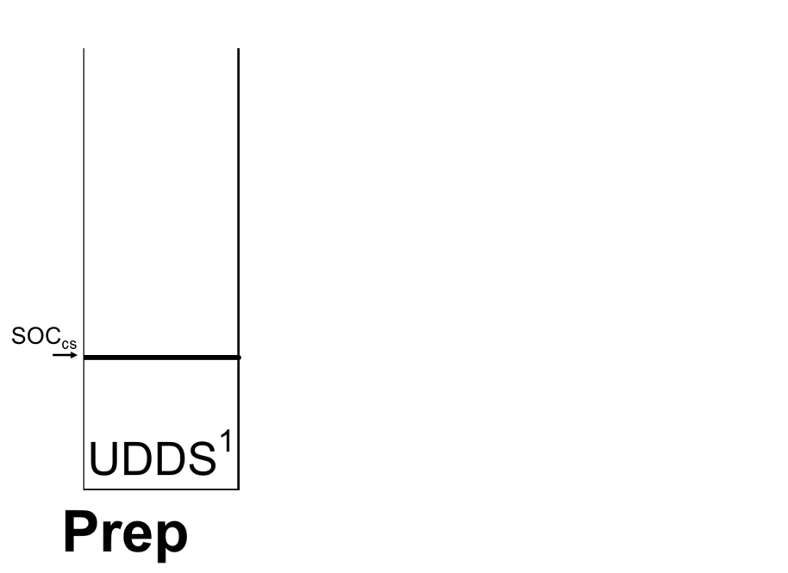  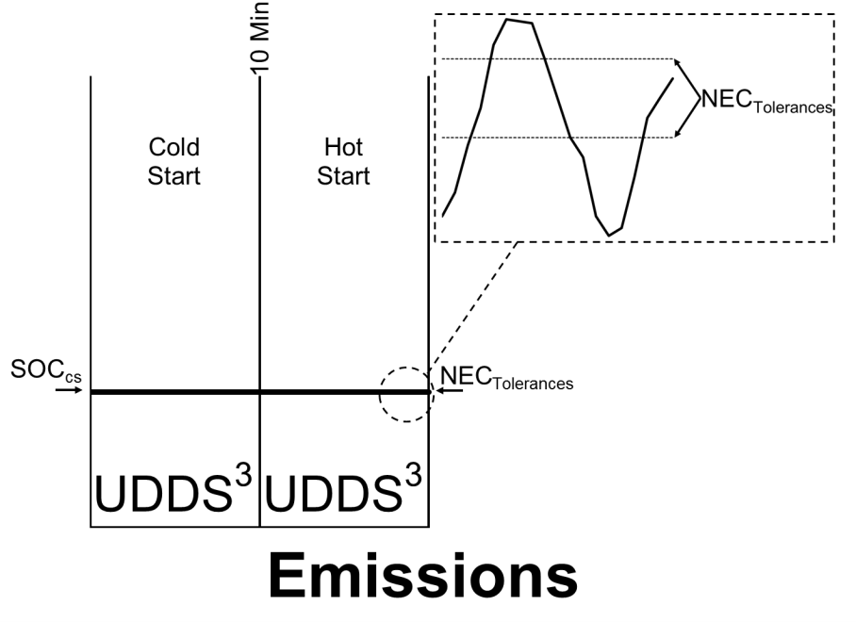

**Urban Charge-Sustaining Emission Test with**

**Charge-Increasing Driver-Selectable Mode Activated**

  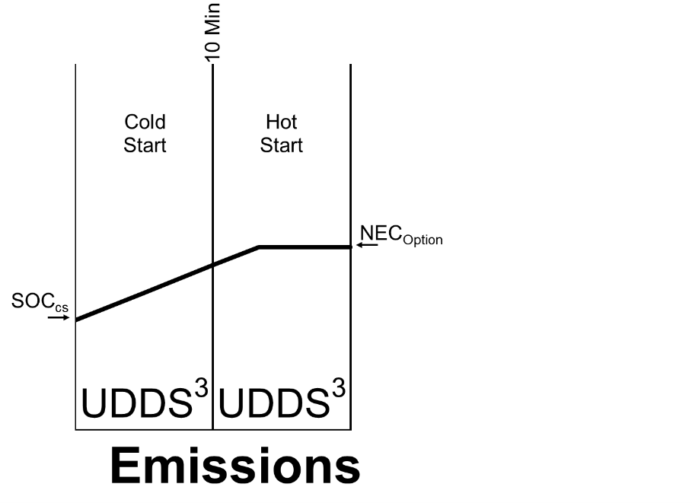

1 Emission sampling not required

2 Emission sampling optional

3 Emission sampling required

SOCcs: State-of-Charge at charge-sustaining level

NECTolerances: Net Energy Change Tolerances required

NECOption: NEC Tolerances apply; however, option available to validate test when SOC final > SOC initial.

**Figure 3**

**Urban Charge-Depleting Emission Test with**

**Urban AER and EAER**

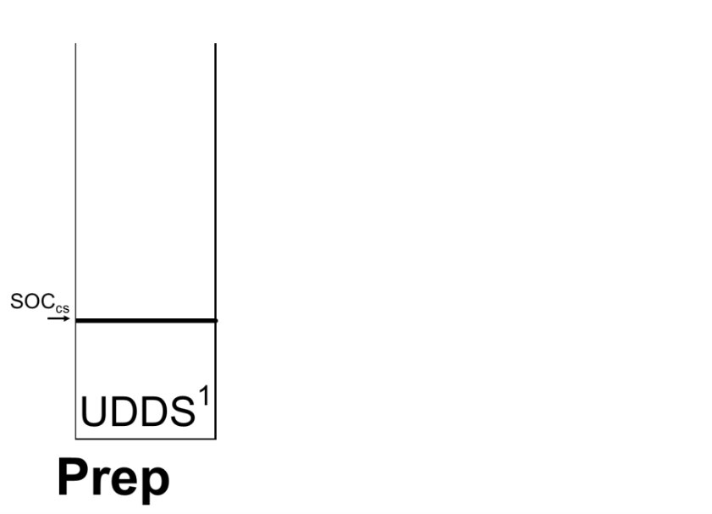  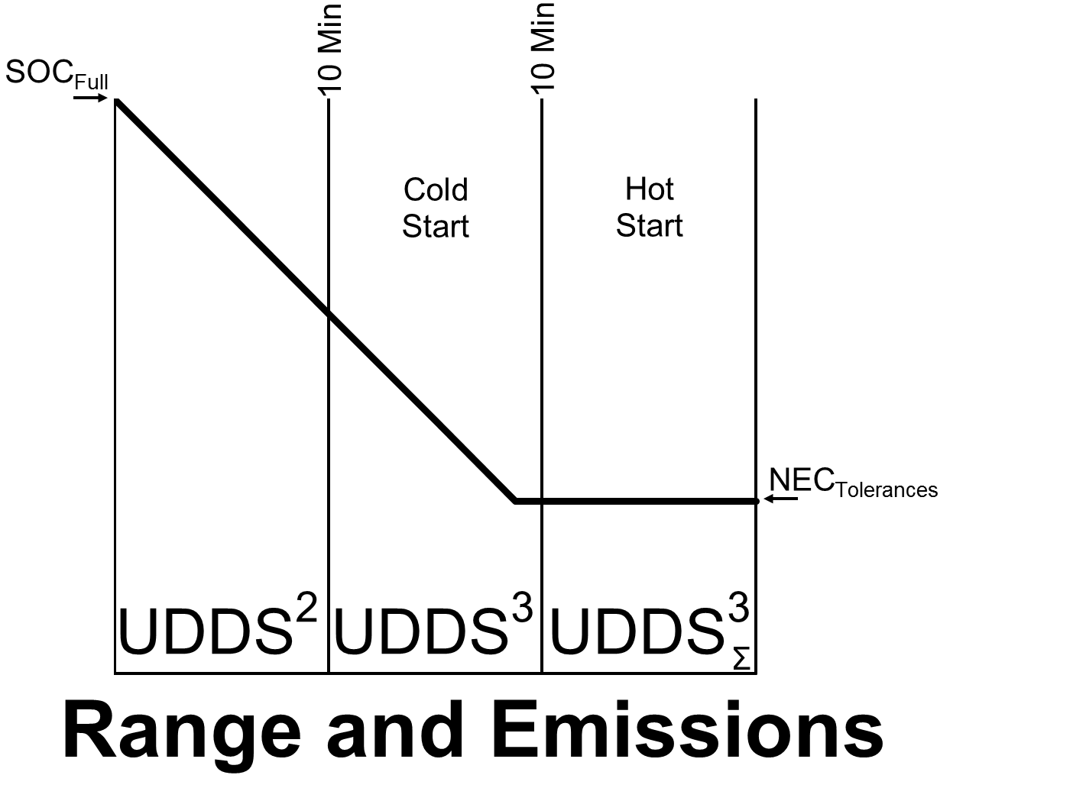

**Alternative Urban Charge-Depleting Emission Test**

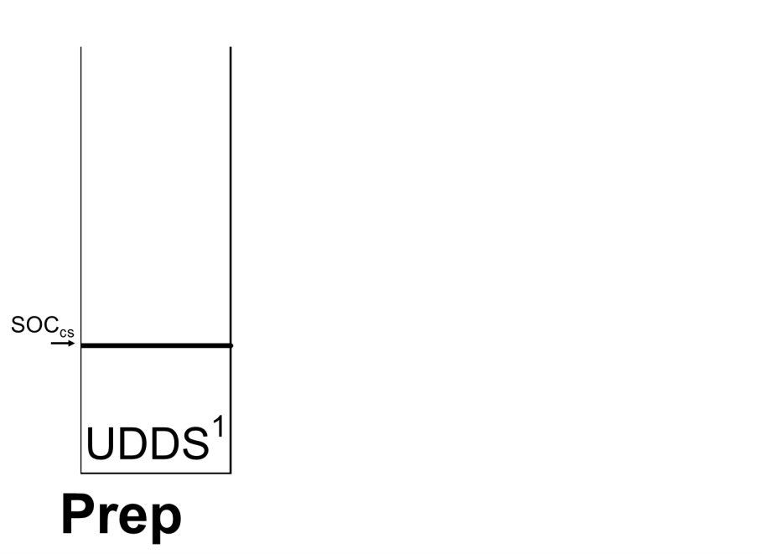  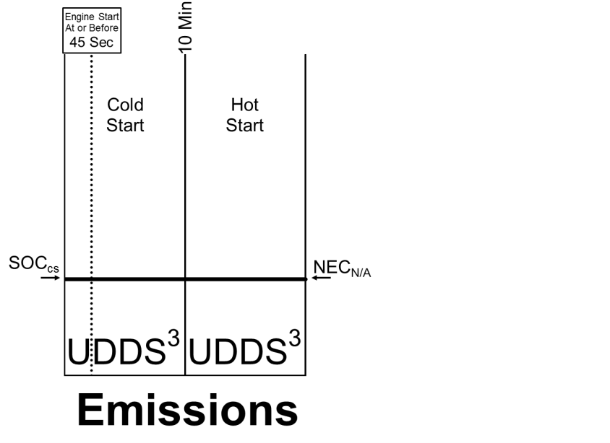

1 Emission sampling not required

2 Emission sampling optional

3 Emission sampling required

UDDSS: Multiple Hot Start UDDS cycles may be required to satisfy NEC Tolerances

SOCcs: State-of-Charge at charge-sustaining level

SOCFull: State-of-Charge at full charge

NECTolerances: Net Energy Change Tolerances required

NECN/A: Net Energy Change Tolerances not applicable

**Figure 4**

**Alternative Urban Emission Test with**

**Charge-Increasing Driver-Selectable Mode Activated**

  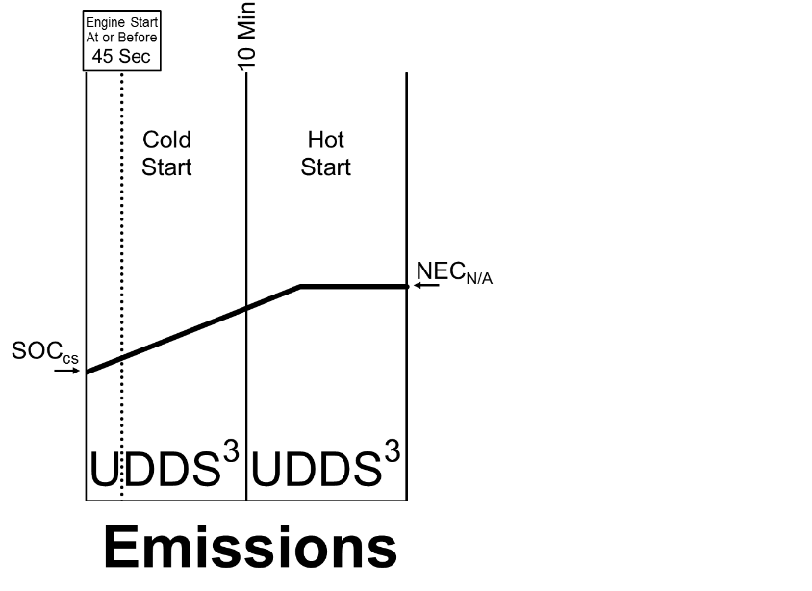

**HWY AER and EAER Test**

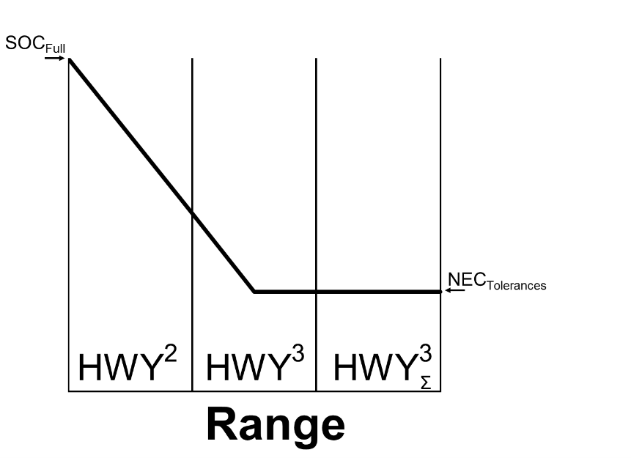

1 Emission sampling not required

2 Emission sampling optional

3 Emission sampling required

HWYS: Multiple HFEDS cycles may be required to satisfy NEC Tolerances

SOCcs: State-of-Charge at charge-sustaining level

SOCFull: State-of-Charge at full charge

NECTolerances: Net Energy Change Tolerances required

NECN/A: Net Energy Change Tolerances not applicable

**Figure 5**

**HWY and SFTP Emission Test**

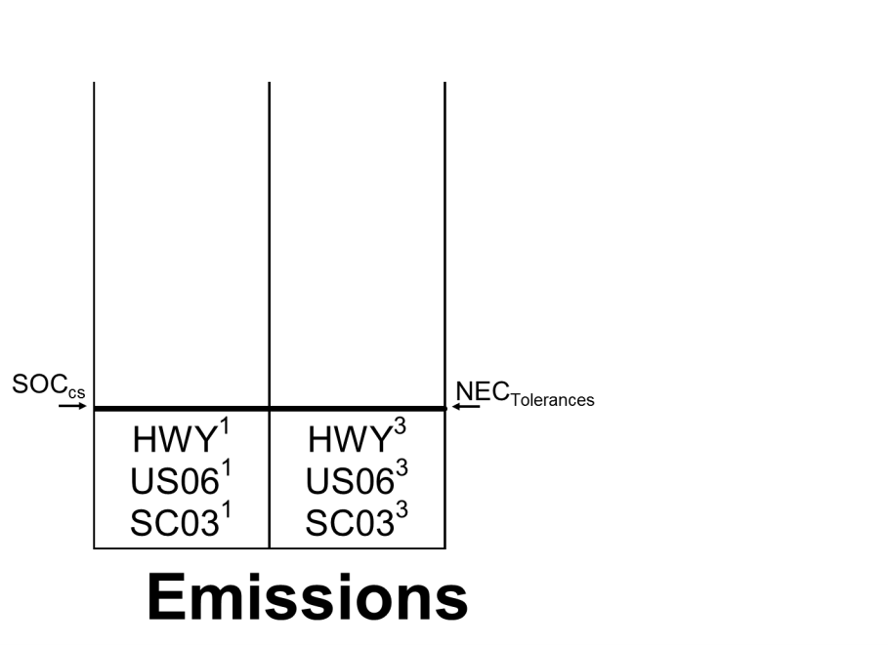

**HWY and SFTP Emission Test with**

**Charge-Increasing Driver-Selectable Mode Activated**

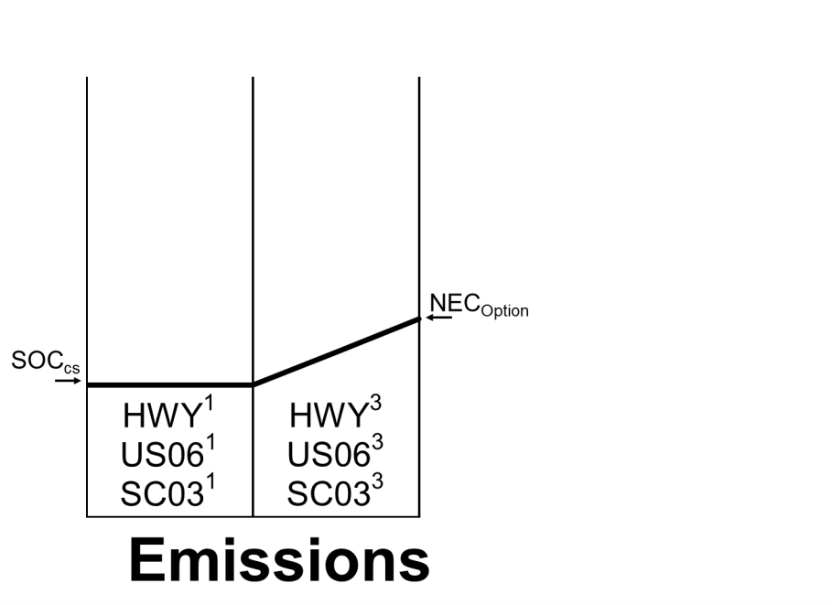

1 Emission sampling not required

2 Emission sampling optional

3 Emission sampling required

SOCcs: State-of-Charge at charge-sustaining level

NECTolerances: Net Energy Change Tolerances required

NECOption: NEC Tolerances apply; however, option available to validate test when SOC final > SOC initial.

**Figure 6**

**Urban Charge-Sustaining Emission Test with Charge-Increasing Operation (not for charge-increasing driver-selectable mode testing)**

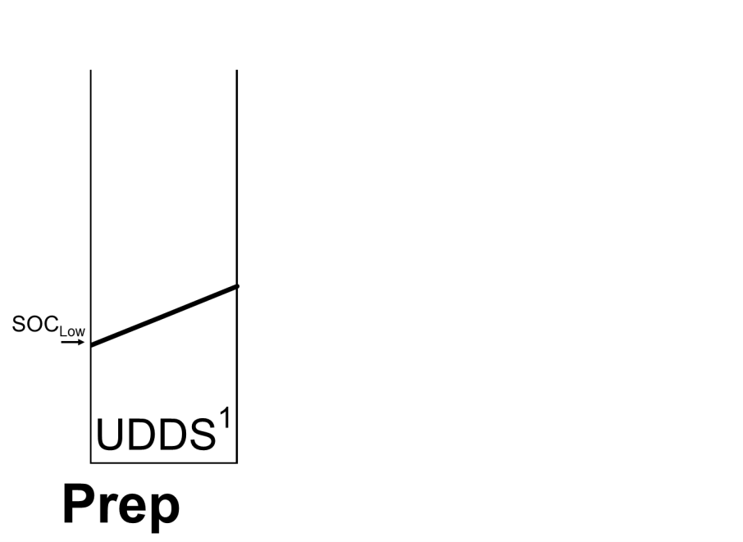  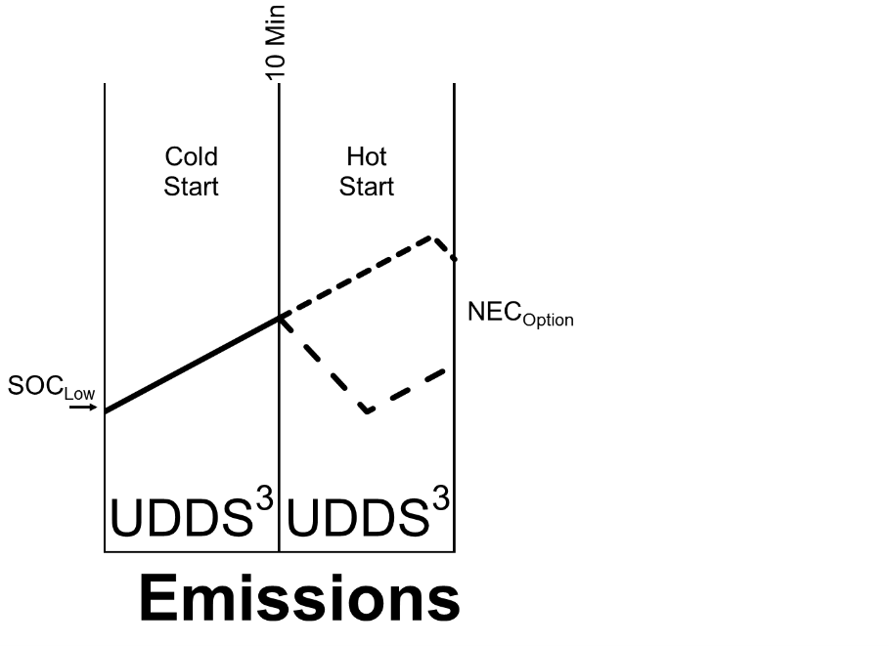

**Urban Charge-Depleting Emission Test with Charge-Increasing Operation (not for charge-increasing driver-selectable mode testing)**

**Includes AER and EAER.**

  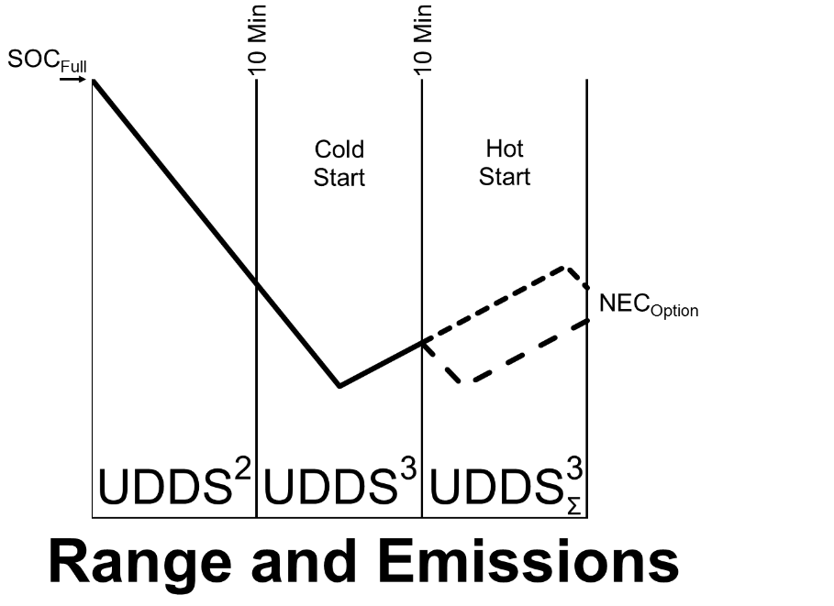

1 Emission sampling not required

2 Emission sampling optional

3 Emission sampling required

UDDSS: Multiple Hot Start UDDS cycles may be required to satisfy NEC Tolerances

SOCLow: Initial State-of-Charge set at lowest normal SOC allowed by vehicle when driving on UDDS

NECOption: NEC Tolerances apply; however, option available to validate test when SOC final > SOC initial.

**Figure 7**

**HWY AER and EAER Test with Charge-Increasing Operation**

**(not for charge-increasing driver-selectable mode testing)**

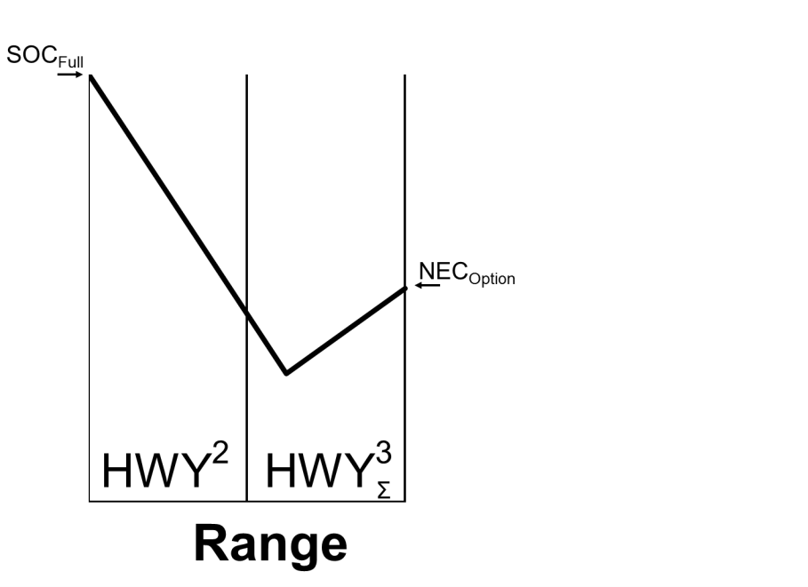

**HWY and SFTP Emission Test with Charge-Increasing Operation**

**(not for charge-increasing driver-selectable mode testing)**

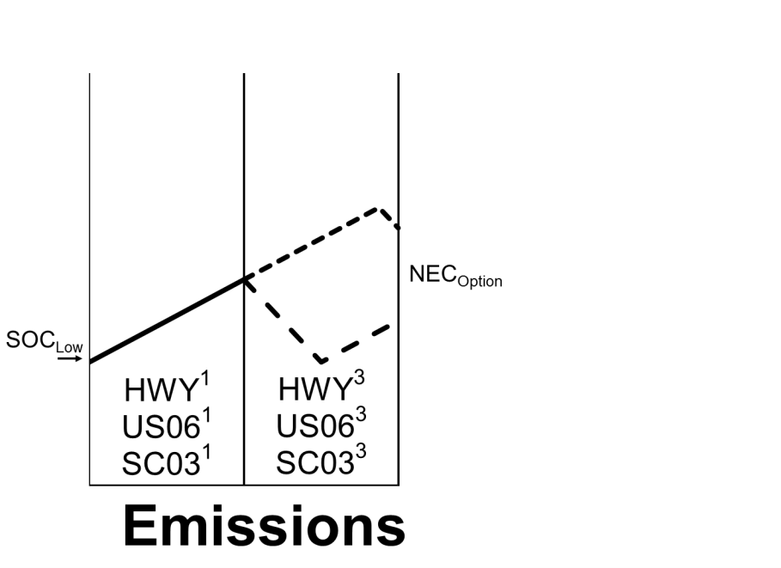

1 Emission sampling not required

2 Emission sampling optional

3 Emission sampling required

HWYS: Multiple HFEDS cycles may be required to satisfy NEC Tolerances

SOCFull: State-of-Charge at full charge

SOCLow: Initial State-of-Charge set at lowest normal SOC allowed by vehicle when driving on UDDS

NECOption: NEC Tolerances apply; however, option available to validate test when SOC final > SOC initial.

**Figure 8**

**Urban Charge-Sustaining Emission Test – Valid Test**

**Figure 9**

10 Min

***Hot-Start UDDS***

***Cold-Start UDDS***

NECTolerances +1% or +5%

SOC

Final

SOC

Initial

NECTolerances -1% or -5%

**Highway and SFTP Emission Tests – Valid Test**

NECTolerances -1% or -5%

SOC

Final

SOC

Initial

***Preconditioning***

***Emission Sampling***

NECTolerances +1% or +5%

**Figure 9**

# Advanced Technology Demonstration Program data requirements.

A vehicle placed in a California advanced technology demonstration program may earn ZEV credits even if it is not “delivered for sale” in accordance with the ZEV regulation section C.7.4. Approval by the ARB’s Executive Officer is required for Advanced Technology Demonstration Program credits. The following data shall be provided in order to evaluate applications for an Executive Order:

## 1. Project Description

1. General description
2. Goal
3. Specific objectives (e.g. durability tests, customer marketability)
4. Location (include state, city, and agency/organization)

## 2. Vehicle data

1. Model
2. Model year
3. Date placed in program
4. Vehicle Identification Number (VIN)

## 3. Vehicle specifications

1. Passenger car (PC) or light duty truck (LDT)
2. Curb weight – pounds (lbs)
3. Payload (lbs)
4. City/highway range – miles (mi)
5. Estimated fuel economy or EPA fuel economy city/highway – miles per gallon (mpg)
6. Fuel type
7. Refueling time
8. Electric motor output – kilowatts (kW)
9. Hybrid energy storage; type, capacity and peak power
10. For Battery Electric Vehicles and hybrids – fuel fired heater (yes/no)
11. For Fuel Cell Vehicles (FCVs), fuel cell stack: type, peak output, manufacturer and estimated design life.