BizFed Central Valley Member Alliance

African American Farmers of California

Associated Builders and Contractors – Cen Cal

Associatied Builders and Contractors – Nor Cal

Building Industry Association, Tulare-Kings

California Association of Food Banks

California Association of Mutual Water Companies

California Business Roundtable

California Independent Petroleum Association

California Manufacturers & TechnologyAssn.

Downtown Visalians

Employers Group

Fresno County Farm Bureau

Fresno Metro Black Chamber

Greater Bakersfield Chamber of Commerce

Hong Kong Trade Development Council

Independent Oil Producers Agency

Kern Citizens for Energy

Kern Hispanic Chamber of Commerce

Kern Home Builders Association
Manufacturer's Council of the Central Valley

National Association of Royalty Owners - CA Chapter

Nisei Farmers League

Pacific Merchants Shipping Association

Tulare County Association of REALTORS
Visalia Economic Development Corporation
Water Association of Kern County

Western State Petroleum Association

7/23/18

California Air Resources Board

Comments on AB 617 Blueprint
To whom it may concern:
We are writing on behalf of BizFed Central Valley, a federation of businesses and top business associations representing 20,000 employers and more than 400,000 employees in the five counties from Kern to Madera.
Our members live, work and raise their families in the San Joaquin Valley, considered one of the most air quality challenged areas in the state, if not the nation.
We cannot escape our geography (a bowl capped by an inversion layer) and the fact that the state’s two main transportation arteries, Highway 99 and Interstate 5, cut through the valley’s heart leaving their emissions behind as they move goods between northern and southern California.
Air quality is a top concern for our members not only in regards to the health of valley residents, including their own employees and neighbors, but for purely business reasons as well.
The valley’s pollution levels are often cited as a reason professionals decline jobs here and why some companies haven’t located here. Many of the valley’s brightest youth take their education and skills elsewhere, often seeking cleaner air.
So, finding smart, sustainable ways to protect air quality while also allowing our economy to thrive is key for BizFed Central Valley members.
Unfortunately, we believe the Air Resources Board’s proposed Blueprint to implement AB 617, the Community Air Protection Program, falls short in terms of providing proper guidance to successfully implement the measure and achieve our mutual goals.
The San Joaquin Valley Air Pollution Control District has, per AB 617, recommended two areas for initial monitoring. Those are the south-central part of Fresno and the northwest area of Bakersfield extending to the Shafter area.
Both are high growth areas. In Bakersfield/Shafter the growth is mainly residential with some light industrial/business mixed in. In Fresno, the growth is mainly manufacturing/heavy industry.
In both areas, that growth is vitally beneficial, providing much needed housing and even more needed, high wage jobs.
It’s crucial that the AB 617 Blueprint give residents and businesses clear parameters for how to achieve necessary emissions reductions while preserving incentives for equally necessary economic growth.
The proposed Blueprint, however, doesn’t give guidance for how the air districts will identify pollutants of concern, how emissions in growing areas will be accounted for at the outset of community-level programs and how they will be monitored in the future.
What equipment will be used for monitoring? How will it be calibrated? Who will oversee that work? What are the protocols for making sure the data is properly collected and interpreted? How will that data be used?
These questions are unanswered in the Blueprint.
Our members urge ARB to limit the program to air district-supervised monitoring of localized criteria pollutants and the health-risk-driving toxic air contaminants only and employ validated sampling protocols using properly calibrated technologies consistent with the air district’s current protocols.
Once the program moves into the emissions reduction phase, it’s unclear from the proposed Blueprint how the air districts will determine what air quality goals are necessary to reduce the “high cumulative burden.”
It is also unclear as to how emissions reduction programs will account for expected emissions reductions from implementation of existing regulations and air quality plans.
References to “health outcomes” is also troubling because ARB has not indicated how this information will be sourced, how the air districts will differentiate the many other factors that contribute to health outcomes from air quality-related factors and how this information will be used apart from initial community assessments and selections.
In regards to northwest Bakersfield/Shafter and south-central Fresno, are “health outcomes” related to those who live in those areas? Work there? Both? Which health outcomes will be evaluated? Cancer? COPD? Heart ailments? How will exposures to other environmental media, lifestyle choices, genetic predisposition or access to health care factor in?
The Blueprint is unclear on these issues, but public health experts have acknowledged an inability to identify cause-and-effect linkages between air pollution and particular health outcomes.
With this in mind, AB 617 emissions reduction programs should be focused only on those air pollutants that significantly impact air quality in selected communities.
BizFed Central Valley asks that ARB’s Blueprint make sure emissions reduction programs are goal-oriented, time-limited and limited to existing air district regulatory standards and thresholds.
Businesses — especially those in the valley, which already operate under some of the most stringent air quality rules in the nation — should also be relied on to find the best fit, most cost-effective technologies to reduce emissions from their operations.
Mandating specific technologies hamstrings businesses, stymies creative solutions and creates economic disadvantages for sources within the identified communities.
It may also result in inefficient allocation of private resources that could otherwise be invested in strategies that yield greater emissions reductions benefits in a shorter period of time.
All of which would be counterproductive.
Rather, BizFed members would like to see the Blueprint include language that allows for flexibility and takes into account whether solutions are technically feasible and cost-effective.
Additionally, ARB and Air District funding and incentives should be provided not only to community groups but also to businesses within those communities that are potentially impacted by additional monitoring and regulation.
The proposed Blueprint also mentions “engagement with local agencies on land use and transportation strategies.” (P15).
This is, again, vague as to what “engagement” means and BizFed Central Valley members would point out that the San Joaquin Valley Air Pollution Control District already works closely with land use agencies in regards to new or expanding businesses to develop plans with the least potential impact to air quality.
Adding another layer of bureaucracy to the mix with poorly defined goals and structure would be a counterproductive use of time and resources.
BizFed also has concerns about including the public in programs for enhanced enforcement, particularly with respect to the lack of a procedure at the air district level for sources to be treated fairly in that process.
Community representatives already play a role in enforcement by reporting potential violations to the air districts. They do not have the necessary expertise or objectivity to properly investigate complaints, determine if any violation has occurred and whether it rises to a level of concern that warrants enforcement action.
BizFed members feel it would be most productive for AB 617 implementation to be folded into existing air quality regulations and related enforcement procedures.
For these, and many other reasons, BizFed Central Valley members urge ARB to make sure business owners/operators have a central — rather than a token — presence in the Community Steering Committee process.
They are experts in their areas of operation and that expertise will be invaluable as we move forward together to clean our air.
Finally, BizFed members also feel the Blueprint should have a mechanism to make periodic adjustments to AB 617 implementation rules.
Everything changes over time. New information, new technologies, etc.
Efforts to clean our air into the future should not be held back by 2018 thinking.
To sum up:
- Limit monitoring to localized criteria pollutants and risk-driving toxic air contaminants.
- Monitoring should use validated sampling protocols/equipment compatible with current air district methods.
- Emissions reduction programs must be tied to specific goals and time limits.
- Funding should also be made available for potentially affected businesses.
- Emission reduction strategies/technologies should not be dictated and must be technically feasible, cost-effective and achievable within a reasonable period of time.
- Account for expected emissions reductions from implementation of existing regulations and air quality plans and void creating duplicative regulatory mechanisms and requirements.
- Any enforcement actions must be limited to air district decisions and come with due process.
- Potentially regulated sources must be brought into the Community Steering Committee process.
- Allow for adjustments to the program going into the future.

Thank you for considering our comments.

Sincerely,

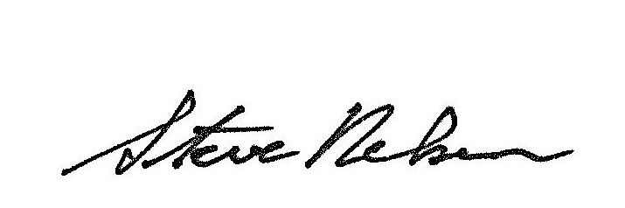
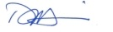
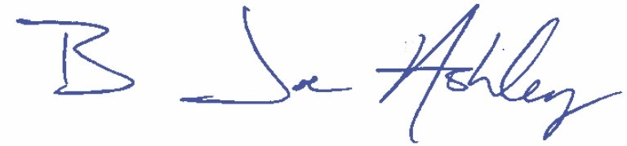

Joe Ashley  BizFed Chair  California Resources Corp. | Darius Assemi  BizFed Advocacy Co-Chair  Granville Homes | Steve Nelsen  BizFed Advocacy Co-Chair  Downtown Visalians

