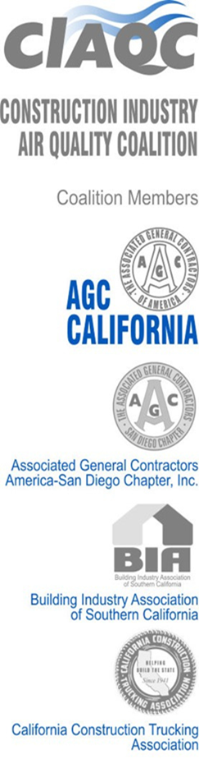

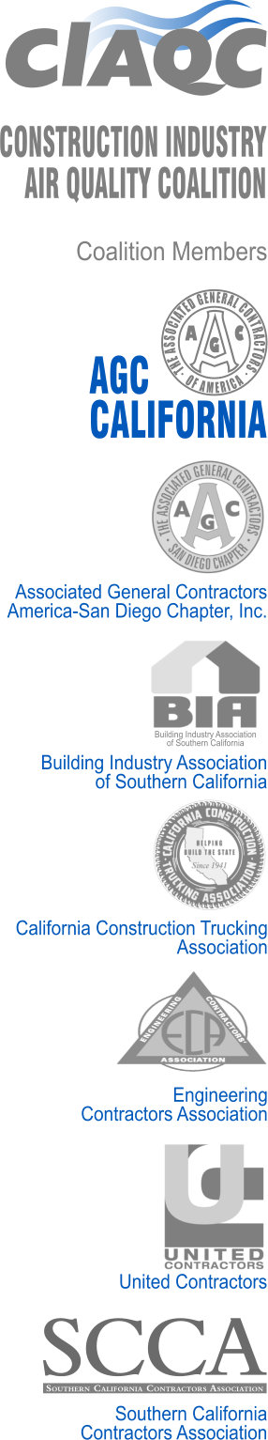
December 21, 2023
Clerk of the Board
California Air Resources Board
1001 I Street
Sacramento, California 95814

Re: Zero-Emission Forklift Proposed Regulation Comments – December 2023

Dear Chair Randolph, and CARB Board Members:

The members of the Construction Industry Air Quality Coalition have reviewed the latest proposed draft of the Zero-Emission Forklift regulation and are concerned about the substantial changes made to the March 2023 version and the limited amount of time allowed in which to comment on those changes. Further we are confused as to why the 45-day comment period is being conducted without a public workshop AND seven months before the matter is to be heard by the Governing Board.

With the expanded breadth of this newly proposed rule, it would seem more important to extend the outreach to newly covered entities, and workshop for equipment owners, the serious and costly new impacts of the expanded proposal.

When this process began, CIAQC surveyed 50 of our members with forklifts and learned a great deal about the utilization and types of equipment operated by our members. We also learned about the barriers they encounter when using this new equipment on construction sites. We have conveyed that information to CARB previously.

We do have a number of concerns as a result of the new revisions to the proposed regulation that remain unresolved.

The sections of the proposed regulation that attempt to limit the purchase of new diesel forklifts is a clear violation of the provisions of the Clean Air Act that prohibit the State’s abilities to regulate new nonroad diesel vehicles smaller than 175 horsepower. These sections also conflict with the off-road diesel mobile regulation. In fact, as stated at least a dozen times in the ISOR, CARB states this proposed regulation is excluding diesel forklifts, yet, clearly the opposite of that intent is found in this proposal before the Governing Board. These sections must be removed.

In addition, banning sales of ANY prior year model year new LSI forklifts after 1/1/26 is unworkable. New equipment often remains in inventory for longer than one year, often for reasons beyond the control of the owner/dealer. This ban on prior model year new LSI forklifts must be removed.

In determining ‘Useful Life” timelines the definition of model year should be based on the calendar year in which the forklift was manufactured, not the engine model year.

A Cap needs to be set for the phase out requirements. For companies with substantial fleets of forklifts it will become infeasible to replace them and provide new charging infrastructure. We would recommend that no more than 25% per year of the applicable model year forklifts be phased out.



The electrical and structural infrastructure and equipment delivery delay extensions requirement needs to be reconsidered and re-written. It does not include consideration for the fire-safety requirement for this new equipment; inadequate time is allowed for planning, permitting and construction of the needed facilities; the purchase order timing requirement is excessive and the suggestion that equipment should be moved to sites where utilities can provide infrastructure rather than where the equipment is needed is ridiculous.

We also fully support the comments made by the Caterpillar dealers that provide more detail to the concerns we raise in this letter.

We hope you will consider these comments and provide staff direction to appropriately modify the regulation to conform with these suggestions. We have a number of members who are very interested in this regulation and making sure that it is something that will be possible for the industry to achieve.

Thank you for your consideration.

Sincerely,
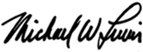
Michael Lewis
Senior vice President
951-206-4420
mike@lewisandco.net

