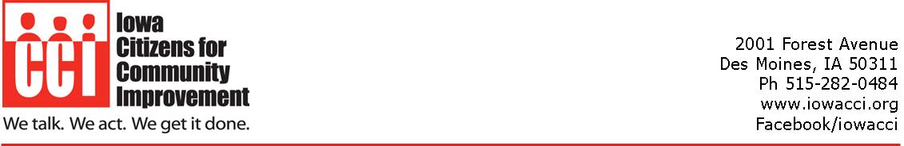

To: California Air Resources Board
1001 I Street
Sacramento, CA 95814

From: Lisa Whelan, Iowa CCI Executive Director on behalf of Iowa CCI members

Date: February 20, 2024

Re: Reform the LCFS

Iowa Citizens for Community Improvement urges the Air Resources Board to grant the recent Petition for Rulemaking to Exclude All Fuels Derived from Biomethane from Dairy and Swine Manure and amend the LCFS accordingly. Iowa CCI is a statewide organization with a communication base of 15,000 everyday Iowans working to win social, environmental, economic and racial justice. We want to reform our food and farm systems to work for farmers, workers, eaters, and the planet. Amending the LCFS to exclude fuels from methane captured from factory farms is an important step toward this critical reform.
The current flaws in the LCFS, such as “avoided methane crediting” and inaccurate life cycle assessments, not only enable pollution but disproportionately harm low-income communities and communities of color. Factory farms, predominantly situated in these marginalized areas, inflict severe damage on air, water, public health, rural economies, and overall quality of life.
I urge you to consider and prioritize the following reforms to the LCFS:
1. Eliminate "avoided methane crediting" in 2024.
2. Address inaccuracies in the Life Cycle Assessment that ignore associated up and downstream greenhouse gas emissions from factory farm gas production.
3. Remove the 10-year "grace period" for factory farm gas producers.
4. Stop double counting by allowing factory farm gas projects paid for and claimed by other programs to sell LCFS credits as well.

We are extremely concerned that the LCFS, which the ARB adopted with the intention to reduce greenhouse gases from California transportation fuels, will perversely incentivize more and larger hog and dairy confinements in Iowa. Over the last several decades, the number of permitted livestock facilities has increased dramatically from 722 (93% hog) in 2001 to over 10,000 in 2017. But recently, the Iowa legislature exempted confinement operations from a permitting requirement for operations greater than 8,500 animal units if an operation installs an anaerobic digester system to capture biogas. The Cedar Rapids Gazette reports that nine Iowa dairies have applied for permits for anaerobic digesters, seven are expanding herd sizes as part of the process, and two are utilizing the exemption because their herd sizes will exceed 8,500 animal units.
The LCFS program has drawn significant interest from factory farms in California and other states with many factory farms taking advantage of lucrative LCFS credits. We do not want to see your transportation fuel policy entrench and enrich corporations like Iowa Select, Smithfield, Tyson, JBS, and Prestage Farms at the expense of our communities, land, air, and water. Even worse, we are extremely concerned that the value of LCFS credits for biomethane from hog and dairy waste will incentivize expansions and even more confinement operations. Right now, Iowa agricultural runoff is contributing approximately 30 percent of the nitrogen load feeding the Gulf Dead Zone off the coast of Louisiana, and that amount has been increasing. And this runoff is polluting our drinking water as well. Turning Iowa factory farms into sources of credits to offset California transportation fuel emissions will inevitably generate more incentives to increase more manure which will further degrade our communities and water quality.
We hope that you recognize the consequences that your policy choice has inflicted and will inflict. We urge you to amend the LCFS to stop utilizing out-of-state factory farms as a source of offsets for your pollution trading scheme. We also ask that, at a minimum, you amend the LCFS to correct the over-valuation of manure-based credits to include all climate pollution associated with the factory farm system and ensure that credits from non-additional reductions do not continue.
Instead of pitting our states and residents against each other, we should be working together to implement real solutions that protect our communities, our farmers, our workers, and our planet. Thank you for considering these comments.

Iowa Code § 459.206(2)(c).
Cedar Rapids Gazette, Nine Iowa dairies get digester permits since new law, seven plan expansion, December 3, 2021, available at https://www.thegazette.com/agriculture/nine-iowa-dairies-get-digester-permits-since-new-law-seven-plan-expansion/.
Chris Jones, Grading on a Curve, May 6, 2021, available at https://cjones.iihr.uiowa.edu/blog/2021/05/grading-curve.
Associated Press, Des Moines faces extreme measures to find clean water, July 4, 2021, available at https://apnews.com/article/des-moines-business-environment-and-nature-b7f1e431a601dfb6536452d743012948.

