August 30, 2024

Liane Randolph
Chair
California Air Resources Board
P.O. Box 2815
Sacramento, CA 95812
Via electronic submission

RE: Kansas Corn Growers Association Comments on April 10th LCFS Workshop

Chair Randolph:

Thank you for the opportunity to provide written comments regarding the proposed Low Carbon Fuel Standard (LCFS) amendments. The Kansas Corn Growers Association (KCGA) represents more than 1,100 members on state and national legislative and regulatory issues and actively works with other organizations to maximize the voice of Kansas corn producers.

KCGA has previously submitted comments highlighting the vital role of biofuels, and flex-fuel vehicles (FFVs) in reducing carbon emissions in transportation fuel and meeting California’s climate goals. Biofuels have played a significant role in reducing carbon emissions under the LCFS program thus far and are poised to continue this trend into the future. Biofuels can play an even larger role, further reducing carbon emissions if the correct blend of policies are put into place.

Reiterating the National Corn Growers Association (NCGA) comments from the April Workshop, we appreciate CARB’s additional modeling and consideration of increased step-downs of 7% and 9% in carbon intensity (CI). Increasing the step-down to 9%, instead of the originally proposed 5%, is an appropriate value that can reset the current credit-to-deficit ratio and make use of the existing credit bank. The 9% step-down is necessary, as it will remove about 16 million credits from the program, a needed adjustment to stabilize the market and leave an adequate number of deficits in the bank.

However, KCGA has serious concerns over the proposed amendments to the LCFS. Growth Energy’s comments in this round of input, as well as their comments on the April workshop, and the NCGA comments on the April workshop demonstrate these concerns. While we appreciate the California Air Resources Board’s (CARB) efforts to decarbonize California’s transportation sector, these undue requirements are not based on sound science and actively work against CARB’s goal. Some of these proposed amendments will result in slower decarbonization, increased adoption costs, or both.

Of particular concern are the proposals on sustainability certification, land use change (LUC) penalties, and indirect land use change (ILUC) penalties. Once again, past and current comments from Growth Energy and NCGA are pertinent here.

Neither CARB’s Economic Impact Analysis (EIA) from the April Workshop, nor their recirculated EIA addresses the issue of the sustainability certification requirement’s financial burden. Further, the inclusion of LUC and ILUC penalties on corn production, alongside the sustainability certification requirements, means corn farmers are double penalized. Such requirements will impose significant regulatory burdens on credit generators, the costs of which will ultimately fall on farmers. Production agriculture is a high-risk, low-margin industry. These types of burdens will force small-to-mid-size family farms out of the industry.

To this end, KCGA echoes NCGA’s recommendation that CARB considers a domestic aggregate compliance approach similar to the Renewable Fuel Standard (RFS), enforced by the U.S. Environmental Protection Agency (EPA). Developing an on-farm crediting system that rewards innovative practices proven to reduce carbon emissions would be a much more effective solution. Our members feel that such a system should be practice-neutral and be flexible enough for farmers to be innovative in finding solutions that work for their operation and the climate. This would lead to more tangible reductions in CI and support the continuing goal of the LCFS.

Unfortunately, CARB is ignoring historical data in their scoring of LUC and ILUC. As has been pointed out by numerous organizations, increasing biofuel production does not result in food system impacts. The two images below are from NCGA and Growth Energy comments. Both demonstrate the significant increases in yield that farmers have achieved over the past century, all while maintaining or decreasing total planted acres while growing the crop more sustainably. It is hard to come up with a logical reason for such harsh LUC and ILUC penalties when corn acres are indisputably unchanged over the past century.

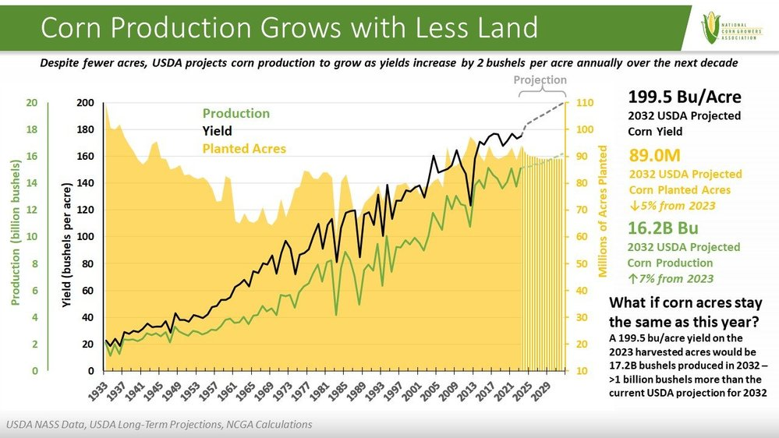

The increases in corn yield can be directly attributed to advancements in genetics and plant breeding, and improvements in sustainable production practices. The development of better hybrids and corn seed has enabled farmers to use less water, fertilizer, and other inputs, all while increasing yield. Meanwhile, farmers have adopted better agronomic practices that have improved soil fertility, reduced runoff, improved water and soil retention, and better withstand climate change. Further, yield and production are expected to continue to increase over the next decade, despite flatlining planting acres, as USDA’s long-term projections show a two bushel per acre increase every year through 2032. These facts have been routinely ignored by CARB’s policy makers.

Higher blends of ethanol have already been pivotal in reducing California’s transportation sector’s carbon emissions. This comes despite ethanol’s capabilities being limited due to CARB’s inability to approve E15 in the state, making California the only state not to approve its sale. Not only is E15 better for the environment than the baseline fuel with lower carbon emissions, it comes with significant savings to California consumers. Studies show that E15 can save consumers an average of 16 cents per gallon, a significant amount of savings given California’s high retail gasoline prices. As Growth Energy states in their comment, if CARB not only approved E15 but used it to replace E10, this switch would be responsible for the GHG-reduction equivalent of removing more than 400,000 ICE vehicles from California’s roads without negatively impacting California drivers or changing the number of planted acres. This is a common sense approach that should be approved without controversy if CARB wants to achieve its greenhouse gas (GHG) reduction goals.

Further demonstration of ethanol’s potential role in achieving CARB’s goal is the success of E85 in the state. We appreciate CARB’s update of the California Transportation Supply (CATS) Model that recognizes the value of carbon capture utilization and sequestration (CCUS) in reducing the CI of E85. More than 118 million gallons of E85 were sold in California in 2023 alone. CARB would be showing a strong commitment to achieving their goals, regardless of the technology, by further incentivizing additional gallons of E85.

One such method of incentivization is pursuing greater adoption of FFVs. California already has the largest fleet of FFVs in the country. Given the significant benefits of higher blends of ethanol, KCGA encourages CARB to explore ways to fully take advantage of these benefits. As stated in our comments on the Advanced Clean Cars II (ACC II) Amendments in January, CARB should consider making FFVs the standard internal combustion engine (ICE) vehicle in the state, creating new incentives for stations to sell more E85, and other incentives or standards that would fully utilize the benefits of E85 and FFVs. These actions would reduce the state’s dependence on fossil fuels, improve air quality, reduce GHG emissions, and save significant money for the consumers.

Thank you for the opportunity to provide input on the recently proposed amendments. The LCFS Program could significantly improve its success in addressing climate change by fully leaning into full utilization of ethanol in transportation fuel. This would make California’s fuel mix more sustainable and help the state achieve its progressive climate goals through the expanded use of bioethanol. We look forward to working with CARB as we address these opportunities.

Sincerely,


J.D. Hanna
President
Kansas Corn Growers Association

