
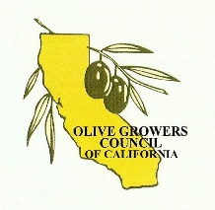
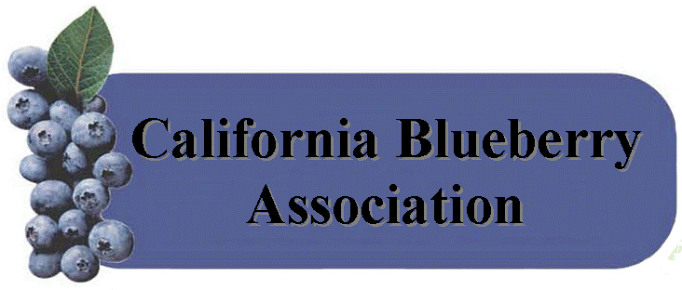
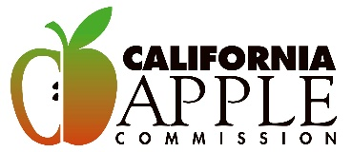

May 31, 2022

California Air Resources Chair Liane M. Randolph and Board Members
1001 I Street
Sacramento, CA 95814

Dear Board Members,

The undersigned organizations, who represent apple, blueberry, and ripe table olive producers and handlers in California oppose the Advanced Clean Cars II (ACC II). We all want to lower emissions, but this is the wrong way to go about it. Bans and mandates are not feasible for most of California, especially farmers who will have to make significant adjustments to essential equipment needed to grow and transport food safely and in a timely manner.

Forcing farmers to utilize equipment that is heavily reliant on the grid for transportation will ultimately increase energy usage and raise the cost of food to pay for increased costs associated with higher rates of energy consumption.

Policies addressing climate change should be cost-effective in order to allow everyone to participate. ACC II will ultimately have a negative impact on both California farmers and consumers.

Sincerely,


Todd Sanders
Executive Director
California Apple Commission
California Blueberry Association
Olive Growers Council of California
California Blueberry Commission

