
28 May 2020
Clerk’s Office, California Air Resources Board
1001 I Street, Sacramento, California 95814

RE: Support for a Strong Advanced Clean Truck Rule

Dear Chair Nichols, California Air Resource Board Members, and Staff,
On behalf of the Clean Coalition, I am writing to applaud the Board for considering a more stringent version of the Advanced Clean Truck (ACT) rule and to request an affirmative vote, with the modification that the rule be revisited in three years. While the CARB is required to consider these regulations every five years, the ACT rule should be considered again in three, to accelerate the timeline. Battery storage prices have dropped by 50% in the past three years and estimates suggest that nonresidential battery prices could drop by at least 27% in the next five years. Such significant price decreases will make electric trucks more affordable, providing the Board a reason to revise the ACT rule and require a more strict target. The newly proposed, more strict ACT rule — proposes a requirement of 30% of trucks electrified by 2030 as opposed to 4%— will help legislators, regulators, and businesses understand the urgency of California’s greenhouse gas (GHG) reduction goals. In three years, it is reasonable to expect a similar increase, depending of course, on the progress made between 2020 and 2023.
Transportation remains the largest contributor to GHG emissions in the state, despite past reductions, and reducing the state’s GHG emissions by cutting truck emissions will bring significant environmental, economic, and resilience benefits.

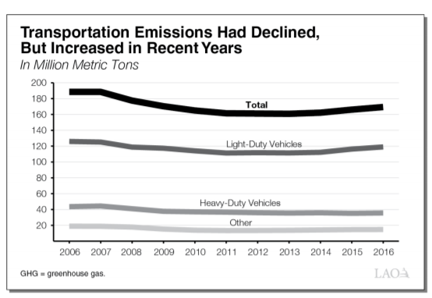
The road to reducing emissions by 40% of 1990 levels by 2030, as called for in Senate Bill 350, must be led by transportation in the state — particularly trucks, which are the largest polluters in that sector. Though heavy trucks represent only 4% of all vehicles on the road, they emit 10% of all the emissions of the transportation sector. A 2020 report by the Legislative Analyst’s Office (LAO) assessing California’s Climate Policies on Transportation found that programs targeting heavy-duty vehicles could potentially have significant benefits for local air quality. Considering the positive effect that the COVID-19 shutdown has had on air pollution throughout California, permanently reducing the number of significant fossil fuel emitters will no doubt have an extended impact on air quality. When the economy recovers fully from the COVID-19 pandemic, there will be some two million trucks on the roads, the vast majority of which should transition to electric in the near future.
The Clean Coalition supports the aspect of this rule aimed at ensuring that truck sellers increase the stock of zero-emission vehicles they sell to 50% by 2030. The 50% rule should be applied to all medium and heavy class trucks being used for business; that means including class 2b and 3, not just classes 4-8. In concert with the ACT requirement for large employers to report on the status of their truck fleet, this will help the state transition to cleaner trucks, while also providing the Board with important information about the status of that transition and the effect on GHG emissions. To create the most granular picture of the situation, the Board should modify the definition of a “large fleet” to anything over 50.
California needs to be ambitious in our goals and standards. As is true for other sectors, when it comes to climate change and transportation, other states (and even other nations) look to California to set precedent. The same LAO report concludes, “California is about 1 percent of global GHG emissions. Legislature might want to consider the degree to which each program encourages emission reductions in other jurisdictions. These could include (1) policies that serve as demonstration for other jurisdictions and/or (2) policies that promote advancements in technologies that could be used in other jurisdictions.” Passing the Advanced Clean Truck Rule would achieve both.

Thank you,

Craig Lewis
Executive Director
Clean Coalition
Santa Barbara | Menlo Park | Denver
650-796-2353 mobile
craig@clean-coalition.org

https://www.utilitydive.com/news/battery-prices-fall-nearly-50-in-3-years-spurring-more-electrification-b/568363/ https://www.woodmac.com/press-releases/balance-of-systems-costs-for-us-non-residential-storage-to-drop/
https://lao.ca.gov/handouts/resources/2020/Assessing-California's-Climate-Policies-03042020.pdf
https://www.sfchronicle.com/news/article/Heavy-trucks-are-among-California-s-biggest-14885931.php
https://lao.ca.gov/handouts/resources/2020/Assessing-California's-Climate-Policies-03042020.pdf The report also goes on to state that “Heavy-duty vehicles are the largest source of nitrogen oxides in South Coast and San Joaquin Valley, and 70 percent of total known cancer risk is from diesel particulate matter” (page 5).
https://ww2.arb.ca.gov/resources/fact-sheets/advanced-clean-trucks-fact-sheet

