

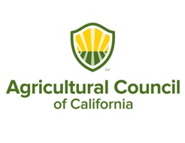



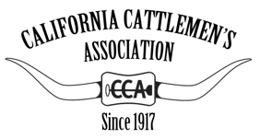
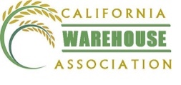



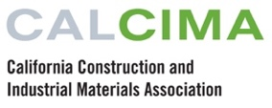








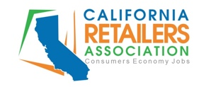
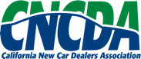

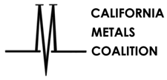
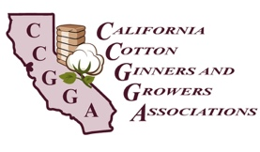
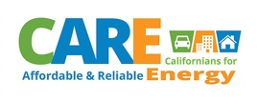


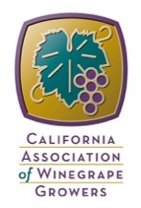




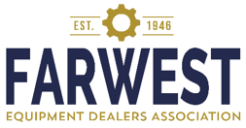
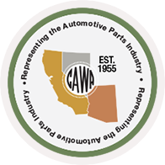


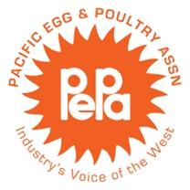
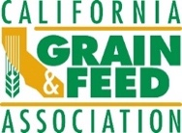
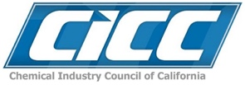
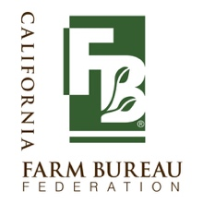



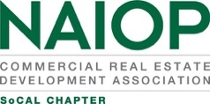









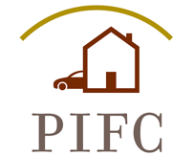




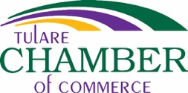








November 27, 2019

Clerk of the Board
California Air Resources Board
1001 I Street
Sacramento, CA 95814

Via Electronic Submittal

SUBJECT: COMMENTS ON THE PROPOSED ADVANCED CLEAN TRUCKS REGULATION—LARGE ENTITY AND FLEET REPORTING REQUIREMENT

The undersigned coalition, representing dozens of organizations and the thousands of businesses they represent is alarmed by the proposed large entity reporting requirement of the Advanced Clean Trucks draft regulation first published on October 22, 2019 and set for hearing before the California Air Resources Board (CARB) on December 12, 2019. The draft regulation will impose new costly and burdensome reporting requirements on entities, many of which have never been regulated by CARB before, and should be thoroughly vetted before adoption. While we appreciate the efforts of CARB at data collection prior to implementation of an end-user purchase mandate, we urge you to slow down the effort and create a meaningful process that provides important dialogue and engagement with the businesses directly impacted by the reporting requirement to develop a policy that works for all impacted parties and is tailored to meet CARB’s goals of cost-effective electric vehicle rollouts.

Specifically, we request CARB:

- Bifurcate the large entity reporting requirement from the manufacturer requirement
- Schedule a series of public workshops to solicit feedback and data from the additional 10,000 businesses that are estimated by CARB to be affected by this new concept

The Large Entity Reporting Requirement at Section 2012-2012.2 is tacked onto the end of a complex truck manufacturing production mandate. Despite ongoing workshops on the manufacturer requirement since late 2016, the first conceptual document outlining CARB’s ideas around a reporting requirement were not made available until the end of the final public workshop on the Advanced Clean Trucks rule on August 21, 2019, roughly three years later. Rushing the regulation process (just three months), and the lack of public process, has resulted in fundamental flaws in the regulation that must be addressed prior to adoption to ensure a successful outcome for all parties.

Below is a partial list of our concerns on the reporting requirements.

BURDENSOME REPORTING

- Terms are vague, and require businesses to make guesses, “estimate,” and “use best judgement” and “approximate” the data they submit. As a result, the regulation may not result in usable or useful data, much of which can be gathered by other means.
- The compliance period for this rule begins on January 1, 2020, but the regulation will not be finalized until mid-2020. Businesses will not have time to develop a system for data collection or implement a record retention policy based on these date. Moreover, CARB cannot impose duties on regulated entities prior to finalizing of a rule.
- Many businesses do not maintain these types of records. How does CARB anticipate these businesses will comply? Using a “good faith effort” or guessing, as suggested by the Initial Statement of Reasons, cannot support valid data collection to be used for future rulemaking.

VAGUE ENFORCEMENT

- Violations of the Advanced Clean Trucks Large Entity Reporting Requirement are subject to general Civil Penalties of up to $37,500 per day for a data gathering exercise.
- How will the rule be enforced? How will we know that our best guesses are enough?

INCREASED COSTS

- CARB did not solicit feedback, and therefore significantly underestimated the cost of regulatory reporting compliance, especially when considering the regulation is subject to enforcement and there is no limit on civil penalties. Companies, especially those with many facilities, 24/7 operations, and multiple points of facility entry will be required to develop a tracking system to meet this rule.

DATA SECURITY RISKS

- Data gathering through a vague, hard to enforce regulation subject to significant civil penalties will not result in effective or useful data and will simply burden the business community without any real benefit to CARB or the public.

UNCLEAR GOALS

- Why is the regulation asking about cars, SUVs, and mini-vans?
- Why is CARB not asking about existing electric vehicles or other low-emissions technology?
- How do these guesses help with EV rollout?

Thank you for the opportunity to comment on the proposed reporting requirements. We again urge you to bifurcate the large entity reporting requirement from the manufacturer requirement and schedule a series of public workshops to solicit feedback and data from affected businesses like ours. We plan to submit a more detailed list of our concerns during the comment period, and many or all of our coalition plans to attend the CARB meeting on December 12 to express these concerns. However, we look forward to working with you to address our concerns and discuss our reasonable recommendations prior to the first board meeting.

Sincerely,

Leah Silverthorn, Policy Advocate
California Chamber of Commerce

On behalf of the following organizations:

African-American Farmers of California
Agricultural Council of California
American Pistachio Growers
Associated California Loggers
Brawley Chamber of Commerce
Burbank Chamber of Commerce
Calforests
California Association of Winegrape Growers
California Attractions and Parks Association
California Automotive Wholesalers Association – Representing the Automotive Parts Industry
California Business Roundtable
California Cattlemen’s Association
California Citrus Mutual
California Construction and Industrial Materials Association
California Cotton Alliance
California Cotton Ginners and Growers Association
California Farm Bureau Federation
California Fresh Fruit Association
California Fuels and Convenience Alliance
California Grain and Feed Association
California Metals Coalition
California New Car Dealers Association
California Retailers Association
California Seed Association
California Warehouse Association
CARE - Californians for Affordable and Reliable Energy
Chemistry Industry Council of California
Clean Energy Fuels
Coastal Energy Alliance
El Centro Chamber of Commerce
Farwest Equipment Dealers Association
Greater Coachella Valley Chamber of Commerce
Industrial Environmental Association
Kern County Farm Bureau
Long Beach Area Chamber of Commerce
Murrieta/Wildomar Chamber of Commerce
NAIOP Southern California Chapter
Nisei Farmers League
Northern District of the California Refuse Recycling Council
Oceanside Chamber of Commerce
Pacific Egg and Poultry Association
Personal Insurance Federation of California
San Diego Regional Chamber of Commerce
San Gabriel Valley Economic Partnership
San Mateo Area Chamber of Commerce
Santa Clarita Valley Chamber of Commerce
Santa Maria Valley Chamber of Commerce
Torrance Area Chamber of Commerce
Trillium
Tulare Chamber of Commerce
Ventura County Taxpayers Association
West Coast Lumber & Building Material Association
Western Agricultural Processors Association
Western Growers Association
Western Independent Refiners Association
Western Plant Health Association
Western States Petroleum Association
Western Wood Preservers’ Institute

cc: Alice Reynolds, Office of the Governor
Richard Corey, California Air Resources Board
Steven Cliff, California Air Resources Board
California Air Resources Board c/o Evan.Kersnar@arb.ca.gov

