November 19, 2021

Liane Randolph, Chair
California Air Resources Board
1001 I Street
Sacramento, California 95814
Via Electronic submittal
Evan.Kersnar@arb.ca.gov

RE: CARB’s Commercial Harbor Craft Rule

Dear Chair Randolph,

ABB encourages the California Air Resources Board (CARB) to set an ambitious, long-term statewide plan to achieve zero emissions for vessels, as well as support the growth of the sustainable maritime industry. Specifically, we urge CARB to require 100% zero-emissions deadline for all vessel segments of the Commercial Harbor Craft Rule by 2035.

With a history of innovation spanning more than 130 years, ABB has been an electrification leader for over a century. With about 147,000 employees across the globe and 24,000 here in the US, we are a market leader in power grids, advanced manufacturing technology, and electric transportation. This includes electric vehicle charging infrastructure as well as marine and port electrification solutions.

As a company that is set to invest around $23 billion in innovation between the signing of the Paris Agreement and 2030, ABB urges California to adopt sound climate policies to encourage innovation and create secure investment conditions. ABB’s commitment to combatting climate change includes limiting the environmental impact of its own operations, with the target to reduce its GHG emissions by 40 percent by 2020 from a 2013 baseline.

Sustainable transportation has a crucial role in the fight against climate change, with shipping accounting for 2 to 3 percent of the world’s total greenhouse gas emissions. The marine industry in the midst of a transition towards low and zero emissions technologies. Electric, digital and connected solutions are already transforming today’s shipping, and there will be a variety of solutions to suit different vessel types and operational profiles for reducing marine emissions.

The proposed Commercial Harbor Craft rule as written is not ambitious enough. The rule does not reduce greenhouse gas emissions and risks creating a stranded asset scenario for harbor craft owners who may pay to retrofit to Tier 3 and 4 engines only to be forced to make a full zero-emission transition in quickly proceeding years later.

ABB’s proven solutions for sustainable marine transportation are being used around the world.

Road and Passenger Ferries
Ferries have become one of the pioneering vessel types for zero-emission battery deployment because they combine generally shorter routes with regular port visits. The shorter routes allow installation of battery packs that can fully power the vessels on their journeys while the predictable routes and turnaround times enable efficient deployment of shoreside charging infrastructure.

From small to large, most ferry boats and routes can be electrified. In 2018, two ForSea Ferries, operating between Denmark and Sweden, became the largest battery powered ferries, following an ABB-led conversion. In 2020, the first all-electric vessels ever built in the US – the Niagara Falls tour operator Maid of the Mist tour boats started operation, powered by ABB’s zero-emission technology.

Tugs
Like ferries, tugboats operate on short routes and typically return to the same port every evening. However, unlike ferries, they have significant idling time and higher power demands.
Zero emissions solution for harbor tugs include battery-electric or fuel cell-electric, propulsion motor to propeller. Despite higher upfront capital costs, the lower operating costs of an electric propulsion system can save the ship owner operator over $6m over the life of the vessel.

ABB will deliver an integrated electric propulsion system and advanced vessel control
technology for Crowley’s pioneering eWolf tug, built for sustainable and safe operations at the Port of San Diego. The solution will include a six-megawatt-hour energy storage system (ESS), allowing Crowley’s eWolf tug to achieve 70 short-tons of bollard pull emissions-free. The battery allows the tug to complete a full day of typical work before there is a need to charge.
Achieving lower operational costs on a through-life basis than an equivalent vessel running a conventional engine, the all-electric propulsion solution holds the potential to eliminate the equivalent of over 100 cars worth of CO2 pollution every year.

While zero emission boats tend to have higher capital costs, operational costs are much lower than diesel powered ships, making them more cost-effective over the lifetime of the vessel. Vessels with electric powertrains and direct current (DC) electrical systems typically cost less to operate over their lifetime due to higher energy efficiency, lower maintenance, and reduced fuel costs. However, their upfront capital costs tend to be higher. This challenge is similar to other recent energy technology breakthroughs, like wind and solar power and electric vehicles. However, through a myriad of research, development, and deployment policies and incentives, those upfront costs have come down considerably and have reached or are approaching cost parity. With appropriate support, the same will happen with zero emission marine technologies.

Below is an example for an existing ferry opportunity where the battery electric option is more expensive up front, but because it costs less to operate, the ship owner or operator ends up saving $800,000 over the life the vessel.

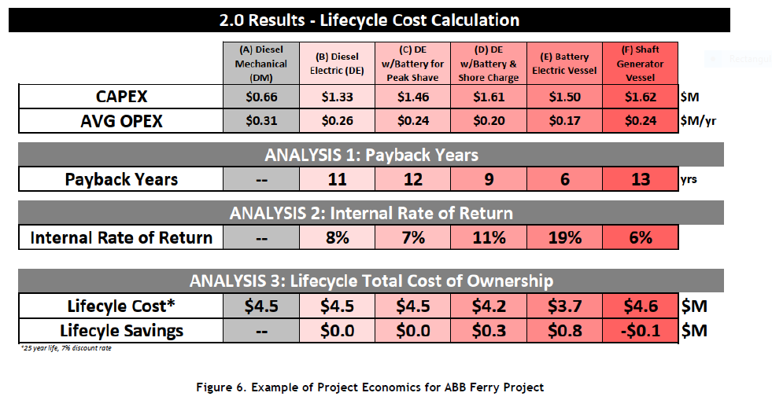
The world is undergoing a period of significant change unlike anything in human history. All of us must work together to reduce fossil fuel emissions. Policies should focus on setting sustainability targets for shipping, allowing the industry to assemble the best technologies and solutions for enabling emission reduction, and provide support to the marine industry as it meets those targets. For the marine sector, a strong but achievable standard would be that all harbor craft operating in the state (e.g. ferries, tugs) must be zero emission, for example phase the requirement in for all new builds that go under contract on or after 1/1/2022, and all operating vessels by 2035 to allow for repowerings and fleet planning.

We would be happy to discuss our technology further with you.

Sincerely,

Dave Lee
Senior Account Manager
New Sales

ABB Marine & Ports
Tel: +1 812 946-0578
email: david.lee@us.abb.com

cc:
CARB Board members
Secretary Jared Blumenfeld, CalEPA

