

November 7, 2022

Ms. Johanna Levine
Off-Road Implementation Section
California Air Resources Board
P.O. Box 2815, Mail Stop 5B
Sacramento, CA 95812-2815

RE: Teichert Comments: Proposed Amendments to the In-Use Off-Road Diesel Rule

Dear Ms. Levine:

I offer sincere thanks to ARB staff as we have considered the proposals, comments, and insights provided during public workshops and discussions related to the current proposed Amendments to the In-Use Off-Road Diesel-Fueled Fleets Regulation. While staff has considered several of the construction and mining industries comments related to proposed requirements of prime contractors and the availability of renewable diesel, several other issues remain unresolved. Please see below for a summary of two issues that Teichert sees and our proposed fixes.

Issue 1: Proposed rule does not currently address cold intolerance of Renewable diesel.

Key technical assumptions related to currently available renewable diesel in California:
(1) the operational temperature ranges for renewable diesel are variable depending on the manufacturer and are dependent on the refinery where the product was manufactured, raw feed stocks, and any formulations/blending that the manufacturers or distributers use to prepare fuel for market(s);
(2) The operational low temperature threshold of typical commercially available renewable diesel, defined by cloud point, can be anticipated to be between -20ºC (-4 ºF) to -9ºC (16 ºF);
(3) additives are not currently available to raise the operational temperature threshold of renewable diesel and such additives are not expected in the near future (and possibly longer);
(4) distributers of renewable diesel typically blend regular diesel to raise the operational temperature threshold to ensure safe use and operation of fuel in cold climates.

Proposed language to address areas where cold weather and non-attainment could pose significant risk to the operation of off-road equipment:

2449 (c) Definitions
(##?) “Cold Weather” means daytime low temperatures for any location in the State where temperatures can reasonably be expected to fall below 20ºF, based on history, or where daytime low temperatures are reasonably expected to fall below 20ºF within 15 calendar days of planned operation of equipment subject to this section based on forecasts from the National Weather Service specific to the equipment and area in question.

2449.1 (f)(2) Exemptions
The following fleets are exempt from the renewable diesel requirements in section 2449.1(f)(1):
(C) Any equipment that can reasonably be expected to operate in areas where cold weather can reasonably be expected, or during periods in any part of the State where cold weather is reasonably forecast to occur within 15 days of planned operation.

Reasons for considering a broad exemption like the proposed language above:
- Technical assumptions provided above.
- Off-road diesel equipment is fueled in many cases well before a typical weather forecast can reasonably predict cold temperatures at certain elevations and certain times of the year. In most cases at high elevation an operator can reasonably know to expect nighttime lows at or below 20ºF. In the medium and higher elevations, this will not be the case. Cold fronts can move in and bring nighttime lows to 20ºF or lower. In most cases, one can only reasonably know this is coming by using accurate weather forecasting which can be relied on in many cases with only 7 days or less accuracy.
- If renewable diesel is in tanks or fuel lines of equipment and the temperatures reach the cloud point and freeze point, equipment can be rendered inoperable and/or can be damaged. In most cases, this equipment is needed to conduct business such as highway construction and maintenance, general contracting, mining, safety, and a myriad of other important and beneficial services. For this reason, 20ºF is a reasonable safe threshold to ensure that fuel does not cloud/freeze and business and the welfare of the general public is not unduly put at risk.

Issue #2: The “Captive Attainment Fleets” exemption is not sufficient to address the cold tolerance issue.
Current exemptions related to the requirement to use renewable diesel are limited to (1) fleets with full Tier 4F or EV, and (2) fleets designated as captive attainment fleet (see screen shot below). The major issue here that ARB staff is relying on this Captive Attainment Area Fleet designation to provide a safety valve to NOT require renewable diesel in attainment areas. Staff inferred that this insulates the higher elevations and east side of the Sierra from the requirement to use renewable diesel. Note that a fleet is NOT a captive attainment fleet if even ONE vehicle is operated in non-attainment area (see definition below and map).
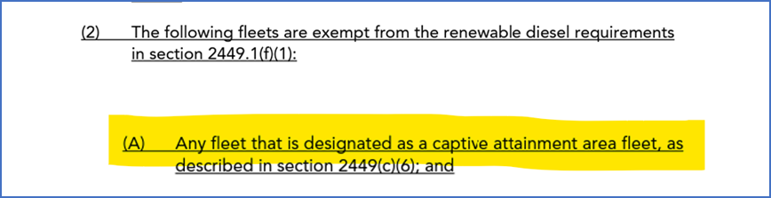

The assumption by ARB staff is that most fleets that operate in attainment areas will be located and operate within the attainment area in which they are based. This may well be the case for small private operators but for most operators who perform work for Caltrans or work for Counties doing road repair and maintenance, it is likely, if not probable, that these fleets DO have at least one piece of equipment registered in a non-attainment area. This would be the case for Teichert, Granite, DeSilva Gates, Bay Cities, and many other contractors. Picture all the work being done by these companies on the East side, North Coast and up the I-5 corridor into Oregon. This work is being performed in attainment areas, but these fleets do not meet the definition of captive attainment fleets.

If these operators are required to use renewable diesel AND the cold tolerance issue is not adequately resolved, then these fleets will face significant challenges and risk to operating their equipment and conducting the necessary work to roads, highways, infrastructure, and general commerce in areas susceptible to cold.
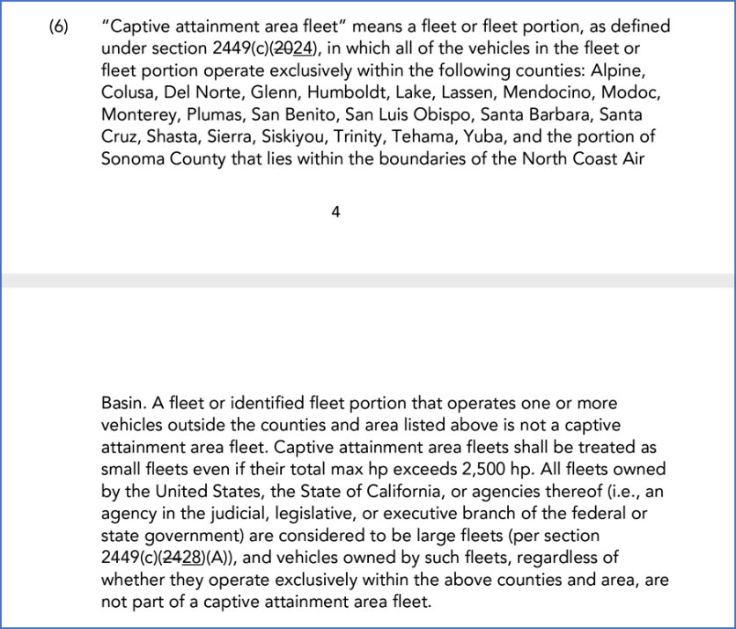

The remaining issue related to the use of the Captive Attainment Area Fleet definition as an exemption is that there are significant areas of the state where roads, highways, infrastructure, and commerce occur and where temperatures can be expected to fall below the operational threshold for renewable diesel (see map below). Consider that in Nevada, Placer, and El Dorado Counties alone the following highways and areas are located: Highway 89, Interstate 80, Highway 50, Town of Truckee, Lake Tahoe, South Lake Tahoe, numerous ski resorts, and each County’s own off-road equipment fleets.
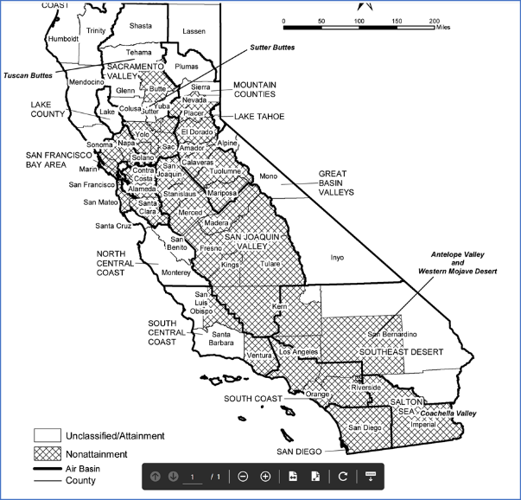

For reasons stated above, we urge that staff consider the proposed language provided in Issue #1 above.

Issue #3: Recordkeeping related to the required use renewable diesel create an unnecessary regulatory burden.

In a recent call with CARB staff related to the cold tolerance issue, a statement was made by ARB staff that the requirement to use renewable diesel was a critical element within the proposed rule because renewable diesel provided significant emission reductions in all older off-road equipment. The statement, and related implications, implies that the emission reductions related to renewable diesel are incorporated in the use of Tier 0, 1, and 2 off-road equipment but seemingly ignores that the proposed rule will quickly phase out this same equipment.

Before requiring the use and tracking of renewable diesel, consider these facts:
- Ensure that the proposed rule has accounted for the fact that it appears that the rapid phase out of Tier 0, 1, and 2 equipment is accounted for in the justification.
- Recognize that renewable diesel is approximately the same price as regular diesel in California and that equipment runs cleaner and more efficient. For this reason, operators prefer renewable diesel and market prefer to supply renewable diesel.
- Recordkeeping of the use of renewable diesel in each piece of equipment is a significant administrative burden.

Using the above considerations, ARB proposed requirement that all off-road equipment use and track renewable diesel is not necessary to meet the proposed stated purpose of NOx and PM reduction. ARB may ask what the harm would be then of requiring renewable diesel use when operators are going to use it regardless and manufacturers are going to produce it. The harm comes from the recordkeeping provisions that require all operators to track renewable diesel use in each piece of equipment and then certify annually that tracking has been performed in such a manner. This is not a trivial exercise and adds to the burden on business. This is a trend at many of the agencies in California and represents death by a thousand cuts. When one considers the recordkeeping and reporting elements added in recent years by ARB, the Water Board, Regional Boards, DTSC, Cal Recycle, and others the new data and reporting are cumulatively extensive.

For the reasons stated above, I sincerely request that ARB reconsider the requirement to track and report renewable diesel use.

I hope that these comments are found to be constructive and useful. If staff has any questions or would like to meet further, please contact me at any time. I would be happy to provide more data and/or insight to help staff meet their needs in reduction NOx and PM emissions while also accurately weighing and considering the real impacts to business and commerce.

Sincerely,

Submitted electronically via email.

John Lane
Environmental Manager, Teichert Materials

Cc: Adam Harper, California Construction and Industrial Materials Association
Mary Rancier, Association of General Contractors of California
Honorable Phil Serna, California Air Resources Board Member

