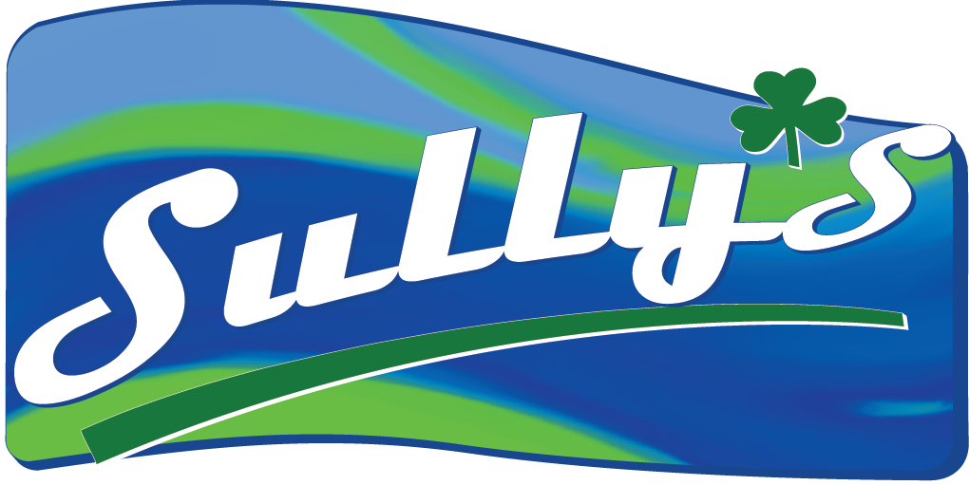

10/17/2022

Clerk of the Board
California Air Resources Board
1001 I Street, Sacramento, California 95814

RE: Title 13. Public Hearing to Consider Proposed Advanced Clean Fleets Regulation

Sullivan Petroleum Company LLC is a wholesale fuel distributor located in Bakersfield that has 50 customer accounts and employees 20 people. Sully’s Food Stores owns and operates 6 Chevron branded gas station and convenient stores, employing over 130 people.

Sullivan Petroleum Company LLC and Sully’s Food Stores LLC respectfully opposes the adoption of the Advanced Clean Fleets rule as it attempts to transition the transportation and goods movement economy much too quickly without sufficient regard for the necessary infrastructure overhaul in the state, a realistic consideration of the state’s power grid capabilities, and the lack of an adequate and accurate cost analysis.

The regulation’s proposed timeline will place significant strain on the transportation industry and gravely hamper goods movement in the state. Additionally, the cost of replacing fleets with entirely zero emissions vehicles will unduly harm small businesses in the state, many of which are family- and minority-owned. With the limited supply and options for heavy duty ZEVs, large companies with greater capital will be prioritized by manufacturers as compared to their small business counterparts. The highly restrictive timeline that has been proposed will only serve to further exacerbate this problem in the market.

Additionally, significantly increasing the operating costs of the transportation and goods movement sector within the state will ultimately harm our most vulnerable communities and residents the most. Low-income households in the state are already bearing the brunt of increased electricity costs, which will only be further intensified by the adoption of this regulation as our unreliable grid continues to be strained beyond capacity. As a small business who takes great pride in serving our community, the impacts of the proposed regulation on the costs of goods and necessities, such as food, water, and fuel, are of grave concern.

Sullivan Petroleum Company LLC and Sully’s Food Stores LLC also has significant concerns because the regulation does not sufficiently consider the current and future needs of the transportation industry within the state. The range of the vehicles that are currently offered on the market will not ensure a seamless transition, as many heavy-duty vehicles are often used nearly continuously to ensure the timely delivery of goods to other businesses and consumers. Moreover, the infrastructure necessary to support a full transition to zero emission fleets is not prevalent enough to serve the vast number of vehicles CARB intends to replace. This regulation will be a major disruptor to the state’s supply chains, which will increase the cost of goods at every level.

We urge the Board to consider the deeply unsettling ramifications of bottlenecks in our fuel, food, water, and medical supplies, in addition to every industry that moves goods on heavy duty vehicles within the state.

For these reasons, we must respectfully oppose the adoption of the Advanced Clean Fleets rule.

Sincerely,

Vincent D. Sullivan

Sullivan Petroleum Company LLC
VP Sales & Marketing
&
Sully’s Food Stores LLC
COO

https://www.next10.org/publications/electricity-rates-2

