

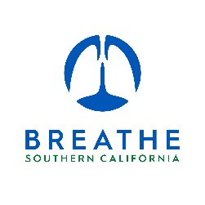



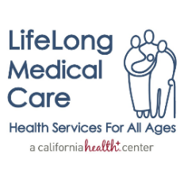

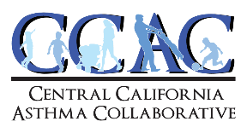



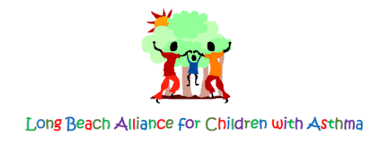

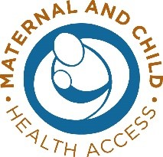
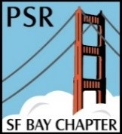







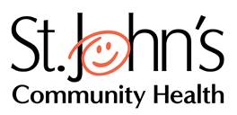

October 14, 2022

Liane Randolph, Chair
California Air Resources Board
1001 I Street
Sacramento, CA 95814

Health Community Support for a Stronger Zero-Emission Advanced Clean Fleets Rule

Dear Chair Randolph and Board Members:

On behalf of the undersigned health and medical organizations, we write to urge the California Air Resources Board (CARB) to approve a stronger Advanced Clean Fleets (ACF) rule that accelerates and expands on the life-saving benefits outlined in the staff proposal. The transportation sector is a major source of air pollution in California, and combustion trucks are a major source within this category. Adopting the strongest possible zero-emission ACF rule is a critical public health intervention for California’s most vulnerable and highly polluted communities.

Over 90 percent of Californians continue to breathe unhealthy air. The American Lung Association’s State of the Air 2022 report found that California is home to eight of the ten most particle-polluted (soot) cities in the United States, and six of the American cities most impacted by ozone (“smog”). Air pollution can cause a wide range of negative health impacts such as asthma attacks, heart attacks, strokes, as well as premature death. Breathing particle pollution, including diesel particulate matter, can cause lung cancer. This is especially true for communities of color – the report also noted that a person of color in the United States is 61 percent more likely to live in a community with a failing air pollution grade and over 3 times more likely to live in a community with the worst air quality. The transition to zero-emission trucking is a critical factor in meeting California’s requirements under the Clean Air Act as evidenced by CARB’s recently adopted 2022 State Implementation Plan for Ozone.

As proposed, the rule features critical pathways to reducing health burdens throughout California, including in our most trucking-impacted communities. Notably, the rule includes a 100 percent standard for zero-emission truck sales in California, sets increasing standards for integration of zero-emission trucks into California fleets; establishes a useful life retirement schedule for drayage trucks as they are transitioned to zero-emission and other elements that will promote health and protect communities most impacted by trucking pollution burdens today. We encourage CARB to build upon this foundation and strengthen the final rule to maximize health benefits.

We appreciate that the CARB staff has analyzed a stronger zero-emission fleet standard that could generate over $90 billion in health benefits and save more than 8,000 lives due to cleaner air from this rule - more than 2,400 additional lives saved and over $30 billion in health benefits achieved above the base staff proposal. CARB must seize the opportunity to set a stronger zero-emissions fleet standard to accelerate the real-world emission reductions needed for highly impacted communities to breathe cleaner air sooner. CARB should adopt provisions within the staff-analyzed Alternative 2 to expand and accelerate the health benefits of the rule by:

- Moving the 100 percent requirement for zero-emission medium- and heavy-duty truck sales from 2040 to 2036.
- Applying the standards to high priority fleets with 10 or more Class 7 and 8 tractors (rather than the proposed fleets of 50) to ensure a more comprehensive transition to zero-emissions and bring all Class 7 and 8 tractors onto the same timeline beginning in 2027.

Californians breathe the worst air quality in the nation, and we need to lead in the transition to zero-emission trucks for cleaner air to meet health-protective air quality standards. The early adoption of zero-emission technology will reduce emissions and provide critical health benefits by helping move California more quickly to attain health-protective clean air standards. In addition, to the extent that flexibilities are included in the rule, we urge the Board to narrowly tailor and limit the scope of exemptions and to catalog the lost or delayed emissions reductions and health benefits at the state level and within highly impacted communities.

Despite the ongoing challenges facing Californians, the Lung Association’s Zeroing on Healthy Air report found that California has the most to gain in the nation from a transition to non-combustion electricity and zero-emission vehicles. From 2020 to 2050, California could gain $169 billion in public health benefits and 15,300 lives saved due to the air quality benefits of zero-emission technologies, including the trucking sector shifting to zero-emissions. The ACF rule must maintain a zero-emission focus and build upon past efforts to reduce health impacts and disparities caused by trucking pollution in California.

We call on the California Air Resources Board to keep community health at the forefront by setting 100 percent zero-emission standards for medium and heavy-duty trucks and accelerating the benefits of the proposed ACF rule. We urge you and the Board members to approve the strongest possible zero-emission ACF rule to achieve these goals. We thank you for all the work you do for California. Please contact William Barrett at the American Lung Association with any questions at William.Barrett@lung.org.

Sincerely,

Katie Huffling, DNP, RN, CNM, FAAN, Executive Director
Melanie Schimpf, RN, CA Nurse Organizer
Alliance of Nurses for Healthy Environments
Will Barrett, National Senior Director, Clean Air Advocacy
Mariela Ruacho, California Manager, Clean Air Advocacy
American Lung Association

Carlos A. Bello, MPH, CHES, Treasurer
Asha Chandy, Communication and Outreach Coordinator
Asthma Coalition of Kern County

Marghot Carabali, MPA, Asthma Coalition Coordinator
Asthma Coalition of Los Angeles County

Marc Carrel, President and CEO
Breathe Southern California

Barbara Sattler RN, MPH, DrPH, Leadership Council Member
California Nurses for Environmental Health and Justice

Linda Rudolph, MD, MPH, Senior Advisor
Center for Climate Change and Health

Kevin D. Hamilton, RRT, ACS, Co-Executive Director
Central California Asthma Collaborative

Amanda Millstein, MD, Co-Founder, Pediatrician
Ashley McClure, MD, Co-Founder, Internal Medicine
Climate Health Now

Lucinda Bazile, MPH, Deputy Director
LifeLong Medical Care

Sylvia Betancourt, Program Manager
Long Beach Alliance for Children with Asthma

Henry E. Rogers, MBA, Government Affairs
Los Angeles County Medical Association

Lynn H. Kersey, MA, MPH, CLE, Executive Director
Maternal and Child Health Access

Harry Wang, MD, President
Physicians for Social Responsibility/Sacramento

Robert M. Gould, MD, President
San Francisco Bay Physicians for Social Responsibility

Juliet Sims, RD, MPH, Associate Program Director
Vince Leus, MURP, Program Coordinator
Prevention Institute

Oussama Mokeddem, Director of State Policy
Public Health Advocates

Matthew Marsom, Vice President for Policy and Programs
Public Health Institute

Joel Ervice, Associate Director
Regional Asthma Management and Prevention (RAMP)

Sharina Sanchez, Program Director
SBX Youth & Family Services

Jim Mangia, MPH, President & CEO
St. John’s Community Health

California Air Resources Board. Proposed Advanced Clean Fleets Regulation Staff Report: Initial Statement of Reasons. Analysis of Alternative 2 at pp. 248-254. https://ww2.arb.ca.gov/sites/default/files/barcu/regact/2022/acf22/isor2.pdf

