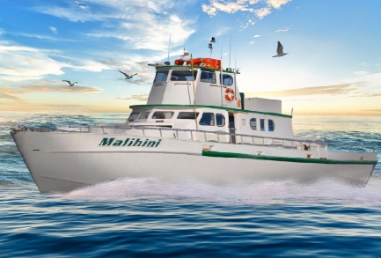
B M Sportfishing inc
3403 Del Este Way
Oceanside California 92056
Phone: 619-985-5179

12/15/2020

David Quiros
Manager, Freight Technology Section
California Air Resources Board
1001 I St #2828,
Sacramento, CA 95814

Re: Letter of Recommendation Regarding the CARB's Amended CHC Regulation, and In-Use Compliance Deadlines for Commercial Passenger Fishing Vessels

Dear David Quiros and CARB,

On behalf of B M Sportfishing/malihinisportfishing INC. I want to express my concern for the proposed amendments to the California Air Resources Board's (CARB) Commercial Harbor Craft Regulation (CHC Regulation). Under the amended CHC, beginning January 1, 2023, Commercial Passenger Fishing Vessels (CPFV) will be required to replace engines with cleaner tiered engines, perform opacity testing and pay annual fees.
I have been a fisherman for 30+ years, and I know my colleagues, our communities, and the benefits and challenges of our industry very well. We act as stewards of the land and water, not only for our benefit but for the benefit of our future generations. We make this active choice to bear much of the cost and responsibility of protecting our natural resources.
While we value the importance of quality air, we also believe in the importance of the three pillars of sustainability - economic viability, environmental protection, and social equity. As the current amendments stand, the regulation is not a sustainable option for our industry and is not equitable for CPFV operators.
If the is enacted, it will put me out of business. I have been in the Sportfishing industry for 30 + years, as I said earlier. I will be in my I am currently in my 14th year as an owner-operator. We have been a member of SAC Since 2006. We run ½ day,3/4 day, and full-day fishing charters. Out of San Diego Bay. Some of the charters that I do are for the inner city kids. And are funded thru me and some good-hearted people who sponsor these trips. If these regulations are enacted, it will put me out of business. People think I make a lot of money. I make an average living. To support my wife and me. It will take me seven years to save up the money to put three new mains into the malihini. And that's not feasible if it will have to be done by 2023 based on the regulation that is being proposed; Tier 4 engines are not a viable option at this time for me.

I, William Wilkerson Of B M Sportfishing, align with the SAC and GGFA recommendations to modify the following elements of the proposed CHC Regulation.
- That CPFV continues to be considered a "Fishing Vessel" and receive the same compliance deadlines as the Commercial Fishing Vessels, with Tier 2 serving as final compliance. Tier 0 and Tier 1 engines will follow the proposed replacement and low usage exemption requirements.
- That Opacity testing requirements be eliminated for CPFV's. These requirements are cumbersome, and a majority of our operators will not have the capacity, resources, or wherewithal to complete this task.
- That Fee Schedules be removed from CPFV obligation.
- Those CARB initiatives a thorough outreach campaign for all California Fishing Vessels. SAC and GGFA have several recommendations on how this can be completed more effectively.

I believe I am not the only owner/operator in Southern California's fishing community with the same issues as me if this regulation were made a reality.

Sincerely,

William Wilkerson
B M Sportfishing Inc

