April 26, 2023

California Air Resources Board
1001 I Street
Sacramento, CA 95814

Re: Proposed Advanced Clean Fleet Regulation Comments

Dear Chair Randolph and Board Members,

The Nisei Farmers League is a non-profit organization representing over 500 members. These members are growers, farm workers, packers, processors and farm labor contractors. Trucking is a huge part of growers getting their product to market. Many of the trucks necessary to carry out goods-movement equipment may not be available in a timely manner to achieve zero-emission vehicles (ZEV) being proposed.

The rapid conversion requirements necessary may not be available by manufacturers who must achieve these goals. Our members are already experiencing wait times ranging from 6 months to 18 months. This has caused considerable damage to their normal operations. Additionally, not only are vehicles and equipment on delay, but replacement parts, tractors, etc. are also experiencing wait times. This adds to more problems of products getting to market in a timely manner.

Mandatory power shutoffs in various parts of California have made a lack of available energy to power the grid. In addition, we transport goods to numerous states. We do not know if other states will have powering stations available to charge our electric fleets. Do we have the assurance that we can leave Reedley, California headed to New York and be able to accomplish that? We must have assurances that power will be available throughout the United States by 2035 before converting over to zero emission vehicles. Our food reliability depends on it.

Sincerely,

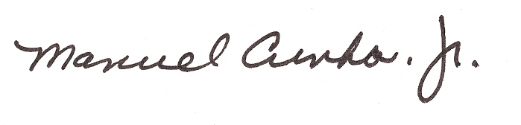
Manuel Cunha, Jr.
President

1775 North Fine Avenue, Fresno, CA 93727 Office 559-251-8468 Fax 559-251-8430

1775 N. Fine Avenue
Fresno, CA 93727
(559) 251-8468

Manuel Cunha, Jr.
President

Board of Directors

League Area 1
Maurice DiBuduo, Paul LanFranco

League Area 2
Bobby Sano

League Area 3
James Oliver

League Area 4
Bill Boos, Leland Herman,

Mitch Bagdasarian

League Area 5
Blake Carlson

League Area 6
Doug Benik, Scott Peters

Executive Board
Maurice DiBudio 1st Vice President
Doug Benik-2nd Vice President
Scott Peters, Secretary
Paul LanFranco-Treasurer

