December 9, 2019

The Honorable Mary D Nichols, Chair
California Air Resource Board
1001 “I” Street
Sacramento, CA 95814

RE: Comments on the Proposed Advanced Clean Truck Regulations

Dear Chair Nichols:

The California Compost Coalition (CCC) is a statewide organization representing operators of permitted facilities involved in the collection, hauling, processing and composting of green and food waste materials throughout California. CCC members collect organic waste and the curb, and employ a fleet of Class 7 vehicles. After processing the organics that are diverted form the landfill to achieve SB 1383 mandates to reduce short lived, climate pollutants, CCC members haul the compost, digestate, and wood chips to markets in Class 8 heavy-duty vehicles to regional markets. CCC members recognized the importance of SB 1383 years ago where they have an opportunity to fuel their fleet with the biomethane from the organics waste and produce a renewable natural gas (RNG).

CCC supports the goals of reducing climate emissions from vehicles and from fossil fuels, as CCC members can produce our own RNG from organic waste that would have been deposited of in landfill and fuel our own fleet, generally and offers the suggestions below to ensure that the state reduces climate emissions from these sources as quickly as possible while maintaining reliable and resilient energy supplies.

This clean heavy-duty near-zero NOx RNG transportation proposition did not emerge suddenly nor in a vacuum. As described in Game Changer – Technical White Paper – Next Generation Heavy-Duty Natural Gas Engines Fueled by Renewable Natural Gas, a wide array of public and private heavy-duty fleet operators and the natural gas vehicles (NGV) industry stakeholders spent billions of dollars to purchase the CNG fleet, build fueling infrastructure, upgrade maintenance facilities, and train personnel. Today, the NGV refuse fleet displaces a significant volume of diesel and reduced NOx by over 90% (compared to diesel engines available today). The NGV industry can go Deep Carbon Now and not wait until 2045 to be carbon neutral. CARB is ACTing out in their Advanced Clean Truck Regulations by promoting a regulation to replace the NGV industry and leave billions of dollars in stranded investment. This ACT long-term strategy that will not achieve the same near-term NOx and carbon reductions that NGVs are delivering today, and will not create a demand for the RNG fuel that needs to be produced to implement SB 1383.

Refuse Industry Support
We support the comments submitted by the Solid Waste Association of North America (SWANA) and the California Refuse Recycling Council (CRRC). With the California Compost Coalition, we represent the refuse collection, processing and hauling industry that are concerned about our stranded CNG infrastruture investment having transitioned off diesel as CARB pushes electrification on the refuse industry without relevant technology. We can make our own RNG and place it in our own fleet while meeting short-lived climate pollutant SB 1383 strategies. This is an elegant carbon-negative solution with near-zero NOx that CARB should be supporting and funding.

Air District Support
Both the South Coast Air Quality Management District and the San Joaquin Valley Air Pollution Control District have support programs and funding to reduce heavy-duty NOx emission now.

The State and the California Air Resources Board (CARB) asked the energy and transportation sector to get off petroleum products to be carbon neutral by 2045, and also told the waste sector to get off diesel and landfills. Fifteen years ago the South Coast Air Quality Management District passed technology-forcing regulations to mandate refuse transition to natural gas vehicles and the industry responded by replacing their diesel fleet. With SB 1383, removing organics from landfills and producing a renewable natural gas to reduce short-lived climate pollutants creates a carbon neutral RNG for the CNG fleet and continues the pathway of getting off diesel. CARB is now leapfrogging the local air districts and Short-Lived Climate Pollution Strategies to pursue an Advanced Clean Trucks regulation that will not achieve the same near-term NOx and carbon intensity reductions. CARB and the California Energy Commission are considering policies and envisioning Deep Carbon plans to 2045 and 2050, where their long-term climate change goals are getting in way of greenhouse gas reductions today.

The California Legislature has enacted several statutes that clearly reflect the intent to establish low NOx engines as ‘near-zero’ and they have invested billions of dollars of Cap-and-Trade revenue intended for Low Carbon Transportation and Short-Lived Climate Pollutant Reduction. CARB opted to focus on ‘zero tailpipe’ emissions with electrification without the same life-cycle analysis. It is time to reinforce the existing ‘near-zero’ definition in statute coupled with an in-state RNG requirement to restore the HVIP funding that was discontinued at the October 2019 CARB meeting. Refuse fleet owners have experienced large infrastructure transitionary costs moving from diesel to NGV over the last decade and are not convinced by heavy-duty ZEV technology readiness now nor in the future due to the duty cycle of collection trucks and the weight penalty that is an enormous barrier to an efficient collection system. There are concerns about the State’s existing electrical infrastructure with blackouts and its ability to address a broader deployment of ZEVs. Refuse fleet owners that may have been on their way to convert to NGV and produce and/or procure RNG are staying on the diesel platform.

There was hope last year that SB 44 (Skinner) could have done more than provide a comprehensive strategy by 2021, and every five years thereafter, to deploy near-zero heavy-duty vehicles with reasonable and achievable goals. With the proposed ACT regulations, the refuse fleet owners need assurance that their NGV investment is not stranded. Using the concepts of SB 44, CARB should not be able to force ZEV heavy-duty technology upon the refuse industry, should the ZEV technology not be reasonable, achievable, and cost-effective to handle the payload. CARB could report back every five years to the Legislature, and when ZEV is ready, the refuse fleet owner would have at least 10 years to transition off NGVs, and if they are an RNG producers, another 10 years to recover the capital invested in their anaerobic digestion facility.

SB 1383 RNG Producers and Procurement
We are the fleet owners that collect organics that fuel our trucks. We are organic waste processing facility operators that can produce renewable natural gas (RNG) from the collected organics. We are Net-Zero Facilities that can make carbon negative fuels from the collected organics, and we haul compost and wood chips to markets. We implement the circular economy in California. Recovered Organic Waste Products have regional markets for current tons and will soon have local government procurement SB 1383 requirements for the millions of new tons. A ton of organic waste can produce 21 diesel gallon equivalents of RNG and can fuel the entire refuse and recycling fleet. Much of the refuse industry has already transitioned off of diesel far before Governor Newson’s 2030 diesel pollution phase out and into a CNG fleet that uses RNG and/or will produce their own RNG. The Vehicle Fuel Study need to recognize this SB 1383 Short-lived Climate Pollutant strategy that is occurring by 2025, and not wait until 2045 to achieve deep carbon neutrality.

Procurement of Recovered Organic Waste Products is being proposed in Article 12 of the SB 1383 regulations. Recognizing the importance in developing RNG demand, CCC has been out in front supporting this inclusion in the regulation. CalRecycle presented a fair share calculation with flexibility of procuring these bio-products with an RNG option, where up to 74 million gallons of diesel gallon equivalents of RNG could be used each year and could fuel up to 6,000 CNG refuse trucks, of the State 15,000 refuse fleet. Local jurisdictions can delegate the RNG use to the local franchise hauler, and fulfill the procurement requirement. This is an elegant community-scale fit.

Refuse Fleets Winning the Race to Deep Carbon Intensity Now
The Low Carbon Fuel Standard (LCFS), which sets annual carbon intensity (CI) standards, takes into account the GHG emissions associated with all of the steps of producing, transporting, and consuming a fuel—also known as a complete lifecycle. The wide range of carbon intensities is due to variations in feedstock types, origin, raw material production processing efficiencies, and transportation, all of which contribute to an individual producer’s fuel pathway CI.
Replacing diesel with a lowest CI fuel should receive priority funding from CARB, when allocating GHG dollars. The solid waste industry has made great strides developing the CNG infrastructure and purchasing CNG fleets to get off diesel, as CARB has insisted for years. The industry viewed CNG as a bridge fuel that has been replaced by renewable natural gas (RNG) with much lower CIs, such as the case with current RNG use in California. Referencing the 2019 CARB Certified Pathways, out-of-state landfill gas averages 52.57 CI while in-state landfill gas averages 33.89 CI and can produce up to 417 million dge/year. Wastewater RNG has been 8.68 CI for larger facilities and 34.4 CI for smaller facilities and can produce up to 36 million dge/year, with some individual pathways heading toward carbon negative CI. Anaerobic digestion RNG is now certified as default ‘carbon neutral’ with specific pathway development to ‘carbon negative’ CI, and has the ability to produce 100 million dge/year. Dairy RNG can produce 50 million dge/year deep into ‘carbon negative’ CI.
Out-of-state landfill gas RNG is now being viewed as a bridge fuel, as in-state RNG is being developed. The solid waste industry is racing to ‘carbon neutral’ CI for their RNG fleet by 2025, with full implementation of SB 1383. Meanwhile ZEVs have a 38.9 CI and will not reach carbon neutral CI until 2045, when the California grid is expected to be carbon-free. Refuse fleets may be winning the race, but are losing the funding to ZEVs, as near-zero NOx and Deep Carbon Now is not enough for CARB. These Cal-EPA reports needs to recognize the CI and the in-state RNG supply

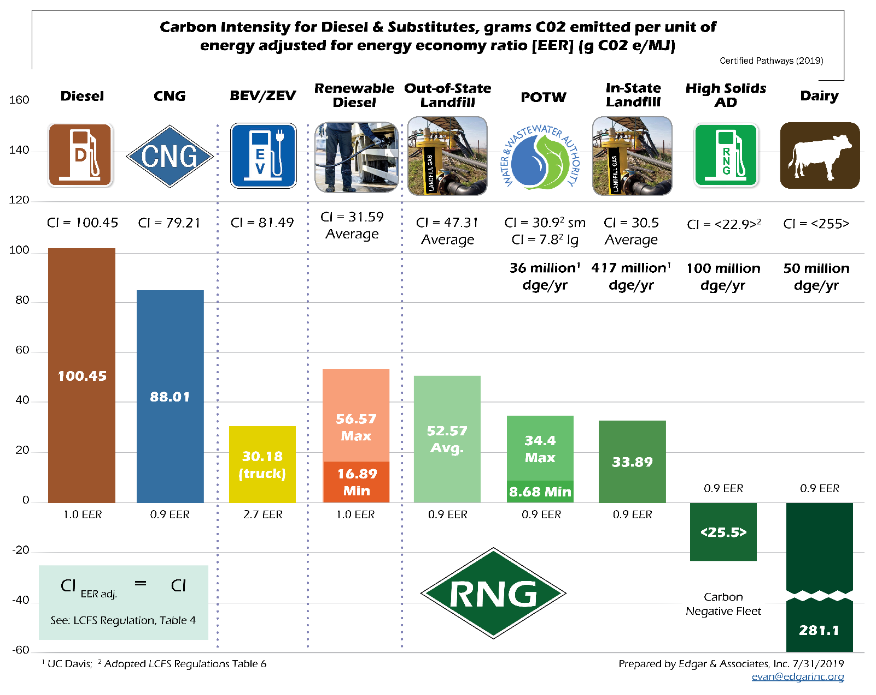

Refuse Fleet RNG Business Model for SB 1383
CCC and CleanFleets.net co-authored a White Paper for the California Energy Commission, Biomethane Transportation Fuel Powering the Solid Waste Industry: Community- Scale Distributed Fuel Production Facilities, applicable today in the SB 1383 era. CEC found this business model attractive: franchised organic feedstocks are taken to an anaerobic digestion facility that is co-located where the captive fleet is parked and fueled, in a community-scale system that could be replicated throughout California. A 30,000 ton per year anaerobic digestion renewable natural gas (AD-to-RNG) project can be designed without a PUC pipeline as a community-scale model, and can serve a population of approximately 100,000 people. This model can produce 400,000 diesel gallon equivalents per year of RNG with a default carbon intensity of neutral to 0.0 g CO2e/MJ, and could file for a site-specific intensity as low as negative 105 g CO2e/MJ, for a fleet of 50 heavy-duty trucks.

The solid waste and recycling industry of 14,000 heavy-duty vehicles uses over 182 million gallons per year of fuel and can produce its own fuel. Additional RNG could be procured from dairies, wastewater treatment plants, and in-state landfills with an estimated potential of over 36 million dge per year for wastewater treatment plants and an estimated production of 417 million dge per year from in-state landfills (Williams, et. al., 2014) and 50 million dge from dairies. The incremental cost differential between diesel and CNG heavy-duty trucks is about $50,000, and both the CEC and CARB have been requested to maintain funding the difference following the Hybrid Voucher Incentive Program model. With nearly 5,200 refuse trucks already using CNG/RNG, approximately 7,000 waste collection vehicles and 1,800 transfer trucks are still operating on diesel in California’s solid waste management industry. It would take a $440 million over the next 4 years to have the refuse fleet be carbon neutral with near-zero NOx engines.

CARB should recognize the need to preserve the HVIP funding for a CNG fleet with the Near-Zero NOx engine to transition from diesel, and create a demand for the in-state RNG from SB 1383 organic waste diversion facilities.

Should you have any questions, please contact me at (916) 739-1200.

Sincerely,

Evan W.R. Edgar
Regulatory Affairs Engineer

