Remote Residential Solar: the concept and benefits
of a new solar option

By
R.C. Harkness, BSEE, PhD
DRAFT March, 2024

Abstract:

In California it costs about 6 times more to produce renewable electric power using residential rooftop arrays than using utility-scale solar farms. A potential new service concept called Remote Residential Solar, or Remote-solar for short, is introduced to take advantage of this. Remote-solar would offer homeowners and renters, the option to purchase solar panels and battery storage in utility-scale solar farms and have the energy they produce inserted into the grid on their behalf. That would offset energy their home takes from the grid and be reflected in a lower utility bill. Technically this is nothing new because utility-solar has long been delivered to homes thru the grid; however, the financial arrangements for remote-solar are different, and would require regulatory approval by the CPUC and others.

A computer model was developed to estimate a customer’s approximate up-front capital cost, payback period and return-on-investment for remote-solar. The results vary depending on a variety of factors including array and battery size, and how much the utility charges for grid use. However, a remote-solar system sized to produce as much annual power as the average California residence uses, pared with a 5.3-kWh battery, would cost about $4200 after tax credits. This financial analysis assumes that utility companies like PG&E would charge about $0.20/kWh to -in effect- transport the customers energy from the remote solar farm to the customers residence because that’s how much PG&E charges now for transmission and distribution. If so this remote-solar system would payback in 3.3 years and have an ROI of 30%/yr. A comparable rooftop system would cost about $24,000.

Because remote-solar would be an attractive investment it would be voluntarily funded by its customers thereby offering a new, rapid and painless way to fund more solar, as opposed to raising electricity rates for everyone. And thus remote-solar could significantly accelerate the deployment of renewable solar power and help California achieve its ambitious and necessary goals for reducing greenhouse gas. Not being tied to any particular address and being relatively inexpensive makes remote-solar accessible and affordable to renters and lower income residents. With battery storage it could help reduce the need to ramp-up gas generation plants after sunset.

Remote-solar is only a concept at this point. The author hopes experts will vet it, and if found feasible suggest it for policy-level consideration by Cal Energy, CARB, CPUC, legislators, and others concerned with climate-change.

Table of contents:

Abstract
Executive summary (9 pages)

Main report (83 pages)
1) Definition, objectives and methodology

1.1 Definition of remote-solar
1.2 Objectives:
1.3 Methodology for estimating the financial benefits

2) Overview

2.1 Basic concept
2.2 Fundamental philosophy of remote-solar
2.3 Fundamental driver behind remote-solar
2.4 Difference from status quo
2.5 Current Statis
2.6 Authors Motivation
2.7 What’s needed to implement remote-solar

3) Broader benefits of remote-solar

3.1 Remote-solar addresses California’s climate goals.
3.2 Remote-solar could provide a large, new and painless way to fund California’s growing need for renewable power.
3.3 Remote-solar reaches those unable to install rooftop solar.
3.4 Remote-solar could lower electricity bills for lower income residents.
3.5 Remote-solar could reduce home prices.
3.6 Remote-solar would reduce the complexity of getting residential solar.
3.7 Remote-solar could help mitigate the “duck curve problem”.

4. The basic steps for enabling, ordering, delivering and billing remote-solar

5. How MONTH financial model works, plus data sources
5.1 Overview
5.2 Capital cost calculations
5.3 Benefit calculations
5.4 Payback and ROI calculations

6. Financial results from MONTH model
6.1 Introduction
6.2 Results for an average California home
6.3 Results for author’s house
6.4 Results for a friend’s house
6.5 More actual samples are desirable
6.6 Sensitivity analyses:
6.6.1 T&D fee
6.6.2 Federal tax credit
6.6.3 Size of total annual home load
6.6.4 Unit cost of remote-solar array

7. Greenhouse gas savings

8. Conclusions

Appendix 1: The HOUR model, how it works and the results (16 pages)

Executive Summary

What remote-solar is and how it would work
Rather than install panels on the roof a remote-solar customer buys panels (and probably battery capacity) in a utility-scale solar farm built and operated by a Remote-Solar Provider or (RSP). The customer contracts with the RSP for the size of the array and battery he wants based on how much he wants or is able to invest, and his desired ROI. Any given RSP solar farm may host hundreds or perhaps thousands of remote-solar customers.

Some companies that now build utility-scale solar farms would probably elect to become RSP’s and would compete for customers. When enough potential customers had placed funds in an escrow account the RSP would build the requisite solar farm with battery storage and operate it henceforth. Utility companies (IOUs) like PG&E would advertise the availably of remote solar, provide contact information for RSP’s, and continue to issue utility bills as they do today.

The RSP exports the customer’s remote-solar power into the grid and reports the amount in (kWh) exported each month to the relevant utility company or IOU. Within the IOU’s billing process, solar power from the customer’s remote-solar system offsets some or all the power taken from the grid during that same month as measured by the customer’s electric meter. When power from the customer’s remote array falls short of satisfying the home load the customer is charged the usual retail rate (typically about 40 to 50 cents/kWh) for any grid power used. When solar output exceeds home load the customer receives NEM 3.0 credits (worth about 3-cents/kWh on average) for that excess. Generally during the winter some grid power will be needed because the solar won’t supply enough, while in summer the solar will supply more than the customer uses as shown in the chart below.

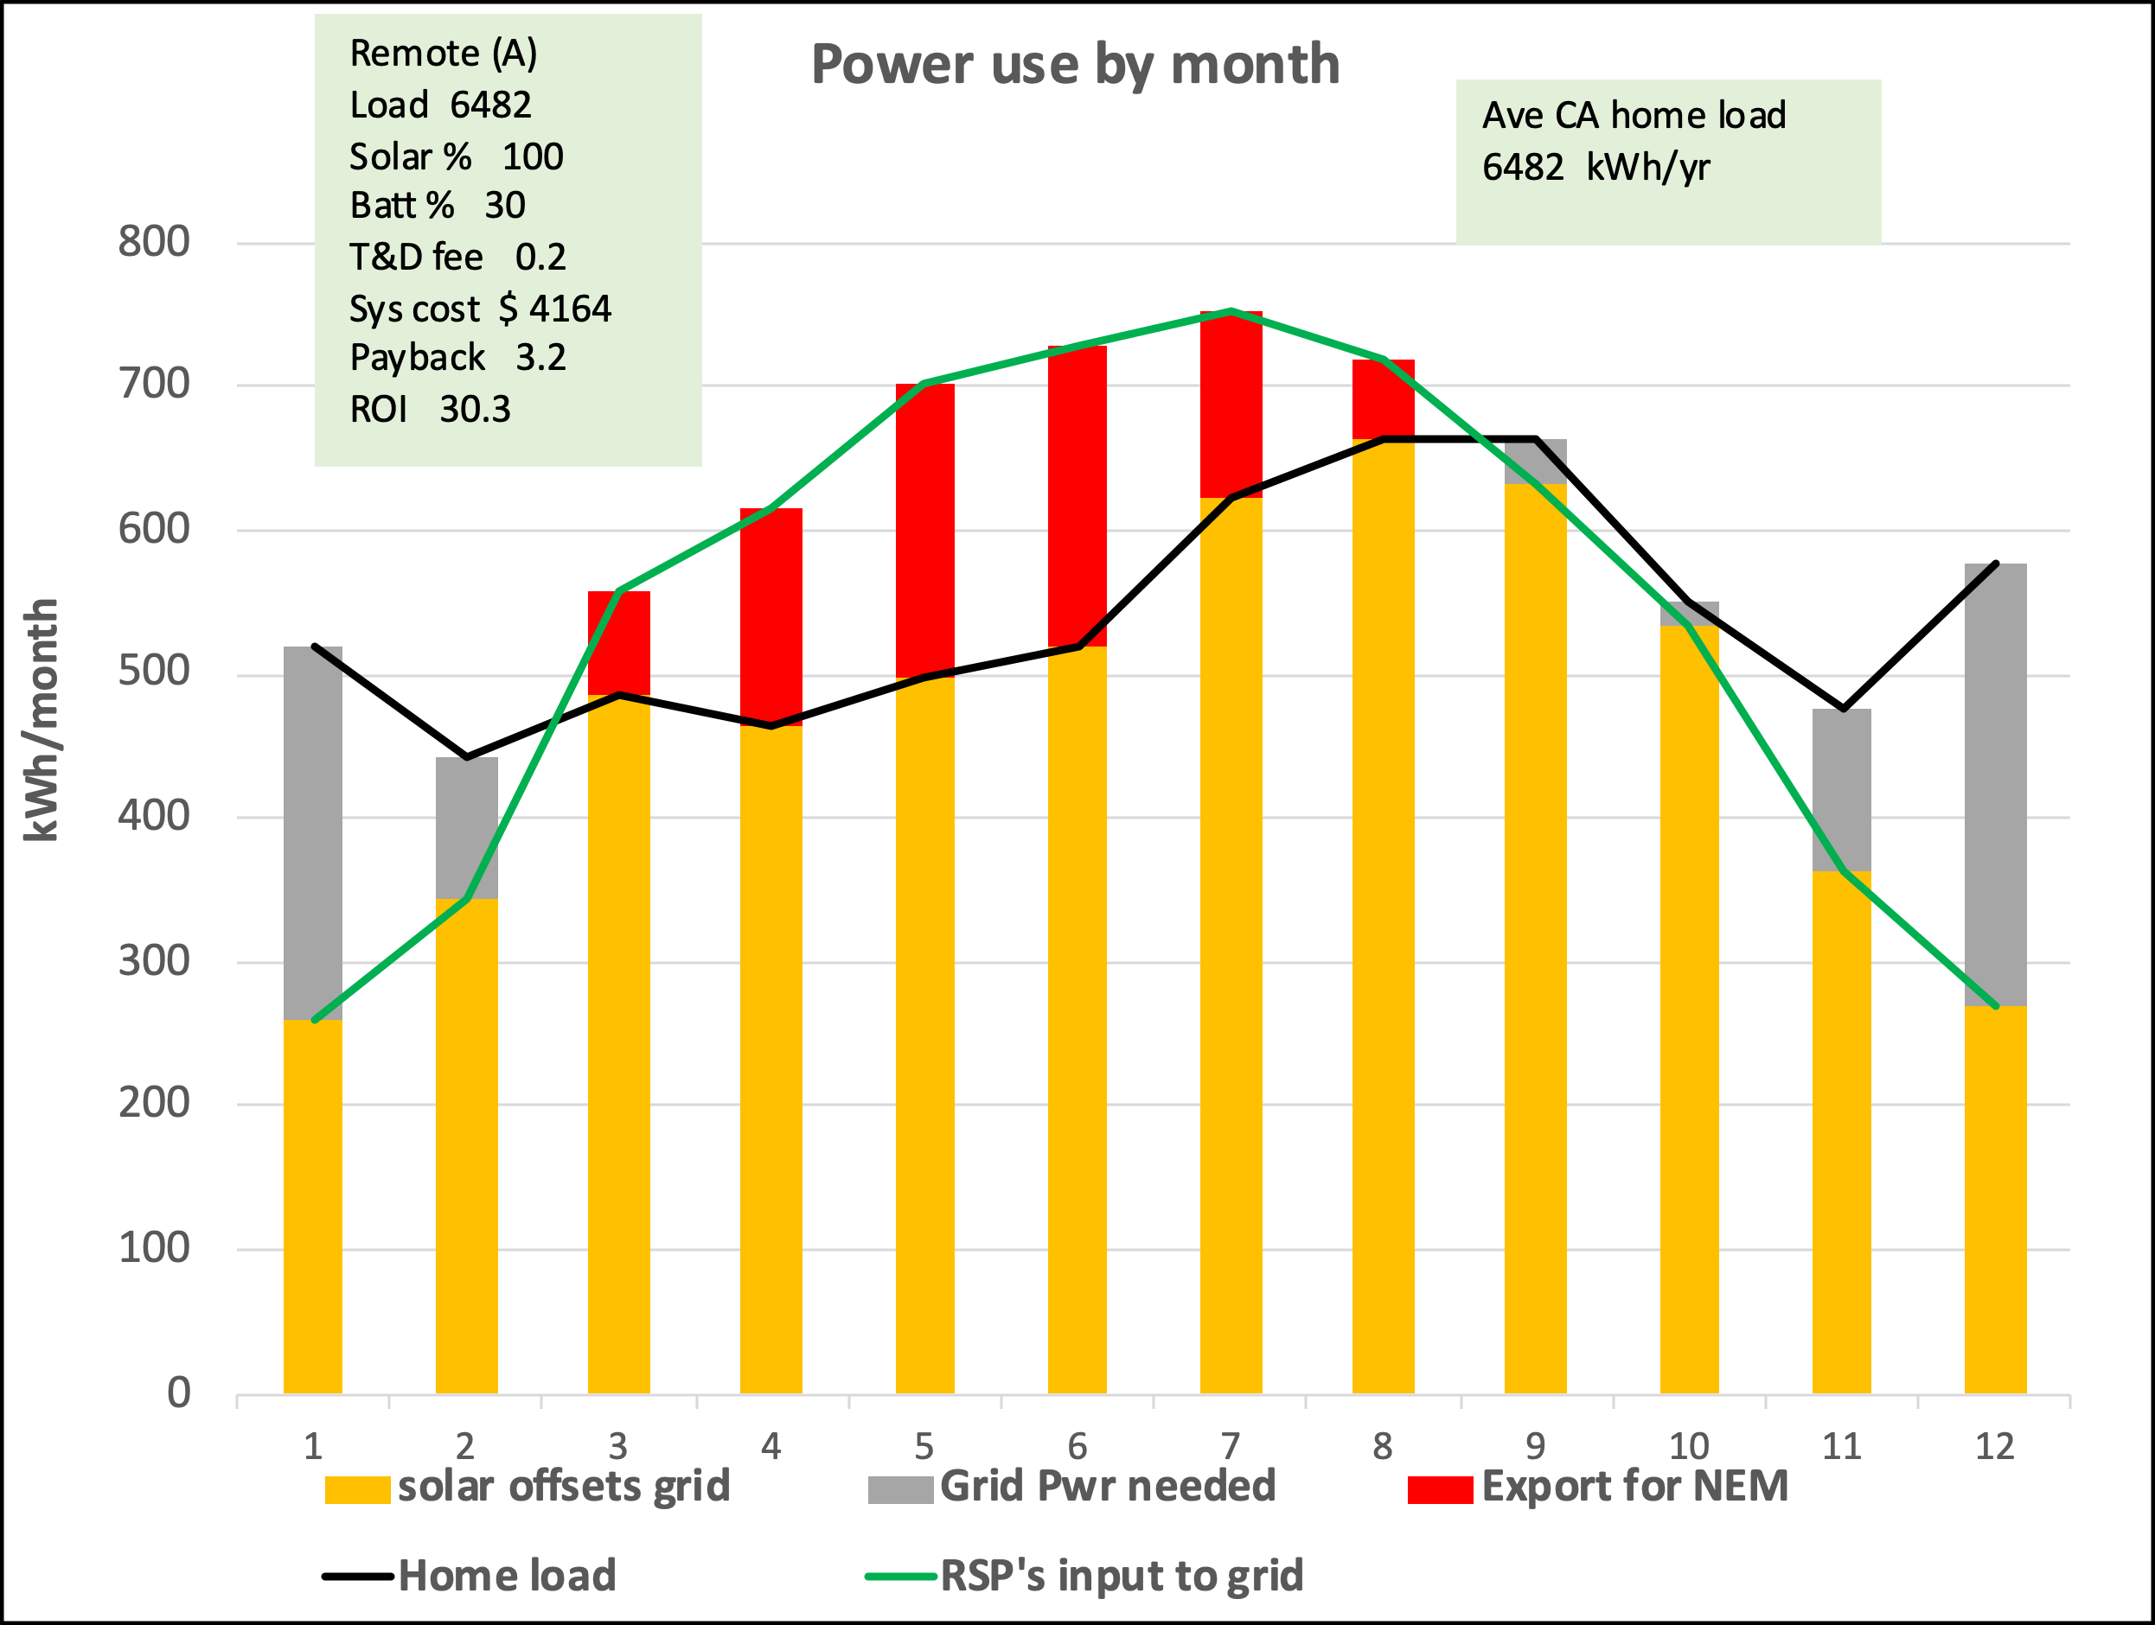

In addition, the IOU adds a transmission and distribution (T&D) fee to -figuratively speaking- transport the customers electricity from the RSP’s solar farm to his residence. In reality the RSP inserts power into the grid (a common pool) in one place and the customer withdraws power from the pool somewhere else.

Remote-solar is not tied to a specific address as is roof-top solar. Thus a remote-solar account and its benefits can move with its owner and be tied to a new electric meter if he relocates.

The diagram below illustrates the basic concepts all on one page. The values in the diagram are for one illustrative situation; namely where the remote-solar system is sized to produce as much annual power as the average California household uses in a year (6500 kWh).

The diagram is explained as follows. A 2.6 kW array -consisting of several panels- in the RSP’s large farm is sufficient to generate 6500 kWh/year. The remote-solar customer in this example has chosen to have a 5.3-kWh battery; probably but not necessarily co-located with the remote-solar farm. One customer’s battery would just be a fraction of a much larger battery shared with others. The diagram shows that the power produced by the customers remote-solar system would be sent thru the grid to the customer, and the customer would pay the utility a transmission and distribution fee (T&D) for grid use. In this example it comes to $1100 per year.

The small chart in the middle shows the amount of power the remote-solar system exports into the grid varies over a year’s period (red line) as well as how the average home’s electrical load varies (black line). It’s obvious that solar production falls off during the winter and peaks mid-summer. Both also vary by hour of day.

The bars in the small chart at lower left compare what the monthly electric bill would be without any solar versus with remote-solar.

The small bar chart at lower right shows the annual utility bill if the customer had no solar compared with his or her bill with remote-solar. The black portion is the charge for grid power since the array does not fully meet his needs, while the orange portion shows the T&D fee. It’s readily apparent that if the utility charged 20-cents/kWh for grid use (as this example assumes) that fee would constitute a large fraction of the customer’s bill. The author now pays 20-cents/kWh for T&D, and that value is used in the model. In practice the T&D fee for remote-solar would be a policy matter for the CPUC to decide. Of all the variables in this whitepaper the T&D fee is the most uncertain at this time and has the greatest effect on the economic attractiveness of remote-solar.

In this example having remote-solar would save the customer about $1300 per year. This, along with the capital cost of $4200, are used to calculate the payback period and ROI.

To reiterate, a key defining characteristic of remote-solar as evaluated in this whitepaper is that during the billing process the total amount of electricity a customer used each month will be compared with the total power produced by his or her remote solar system that same month. In technical parlance the author thinks this means the “netting interval” for remote solar would be one month. Apparently under NEM 1 and 2 the netting interval was far longer (perhaps a year), which benefited the customer greatly, whereas under NEM 3.0 its far less than an hour. The author feels a netting interval of one month would be appropriate for remote-solar so the financials in this whitepaper are based on that. However, it would be up to the CPUC to decide the most appropriate netting interval for remote-solar.

Objectives of this whitepaper
The objectives of this whitepaper are to introduce and describe the concept of remote-solar, explain how it would work, estimate its approximate financial benefits, and highlight relevant issues like T&D fees. It short, the objective is to provide a strawman proposal for those far more familiar with the power industry than I, hoping they will check for any errors, and if none of significance are found, forward this idea to policymakers at Cal Energy, CARB, CPUC, climate focused legislators, and other relevant players. Hopefully they will make remote-solar a reality.

Methodology for estimating the financial benefits
An excel spreadsheet model was developed to calculate the approximate capital cost, payback and ROI for an average remote-solar customer, the authors residence and that of a friend. The model was run for a range of remote-solar designs, which mainly differed in terms of array size and battery size. Key model inputs were values for parameters like unit costs for solar arrays and batteries, array capacity factor, and PG&E rates. Another key input variable was the T&D fee. All the input variables where set at values found in the literature or thought reasonable. Screenshots of those data sources are included.

A variety of sensitivity tests were made to see how different values for variables like the T&D rate, or the unit costs of a remote-solar array would affect the capital cost, payback and ROI. The results were similar to that for the average California home as reported in the table below.

Although the approximate capital cost of a comparable rooftop system was calculated in the model, the author was not able to determine how a technical measure called the “netting interval” in NEM 3.0 would affect the billing calculations for rooftop solar. Therefore, the payback and ROI for rooftop could not be estimated with confidence. Nor was estimating the financials of rooftop a primary objective in this whitepaper. However, its certain that the initial capital cost of rooftop solar is much higher than a comparable remote-solar system.

The overall spreadsheet model contained an HOUR model and a MONTH model. The former compared solar generation with household load every hour of the day and estimated the customer financials accordingly. It was ultimately deemed impractical to use this hourly approach so a MONTH model was added which compared total monthly solar generation with total monthly load. The month model was used that to estimate the financials reported in this whitepaper. The combined model had 425 rows, 95 columns and produced numerous charts. The HOUR model was useful in informing the MONTH model what power was subject to TOU peak period pricing vs. off-peak pricing, and for showing how remote solar could help mitigate the need to ramp up gas generation plants when the sun went down. This required making two versions of the HOUR model: Remote(A) and Remote(B).

Key financial results
The table below shows the key results of this modeling. This is the core finding of this entire effort. Its recommended the reader take a careful look at these numbers and think about what they mean to someone interested in solar for themselves, or those wanting to see more solar generated in order to help mitigate climate change.

Numerous model runs were made to evaluate a range of array and battery sizes. Numbers down the left side show the array size as what percentage of total annual residential load the array was sized to offset. 100% meant the array was large enough to generate as much annual power as the house consumed. The battery size options in % are across the top. A 50% battery meant the battery was capable of storing 50% of the energy the solar array produced that day.

The top value in each cell is the initial capital cost in dollars of the remote solar system (array + battery) assuming the federal tax credit of 30% will apply to remote solar. Next down is the number of years that annual savings in the customers utility bill would take to payback the initial capital cost. The third value is the ROI in %/yr. The results largely speak for themselves: Low initial costs, rapid payback and high ROI.

While the concept of remote-solar is fairly simple no one has actually estimated its costs and financial performance before. Thus these numbers are important in establishing that remote-solar seems financially feasible and attractive. The numerous runs reported in the table were made simply to explore the territory by finding out how different size arrays and batteries would affect the financials. Are there design sweetspots within the range of choices? What is the range of results? In theory a remote solar customer could select any of these combinations depending on how much he or she is willing to invest and how much ROI he or she wants. In practice the choices may be limited by whatever tariff governs remote-solar.

Similar runs were made for two homes that had very different pattens of electricity consumption than the average California residence in the table above; namely the author’s home and a friend’s home. They both showed similar financial performance and helped confirm this analysis was realistic.

Sensitivity analyses were performed to see how higher values for key variables like the T&D fee, the unit cost of panels in a utility-scale solar farm, the size of the household load, and loss of the federal tax credit would affect financial performance. It turned out that the inherent 6 to 1 cost effectiveness advantage that utility-scale solar has over rooftop solar was large enough so that residential solar was still attractive even using pessimistic values for those variables. In short, there appears to be wiggle room.

It's obvious from this table that adding battery capacity significantly increases the capital cost of the system, increases the payback period, and reduces the ROI. Still, all these alternatives are far less expensive than rooftop solar and should be accessible to lower income residents.

The author has highlighted the 100% solar with a 30% battery configuration as his preferred alternative because it seems an attractive compromise between moderate capital cost with good ROI, and a battery that can help mitigate the need to ramp up gas generation after sunset. However, because it does cost more and have a lower ROI than the no-battery option, while yielding no obvious benefit to the customer, the tariff for remote-solar may need to include some incentive or requirement for adding a battery if that is deemed desirable in the broader context.

Why is remote-solar desirable?
Remote-solar would be beneficial in the following ways:

- Help meet California’s climate goals by making solar much more affordable and thus more widely implemented.
- Provide a large, new, painless, and voluntary source of funding for renewable energy which doesn’t require raising everyone’s bills.
- Get more renewable energy from the limited money available to fight climate change.
- Make solar more accessible to lower income residents due to its lower costs.
- Make solar practical for renters because their remote-solar account is not tied to any particular address and can move with them if they move.
- Make new homes more affordable by not mandating they have expensive rooftop solar.
- Be an alternative to rooftop solar where rooftop installation is not practical due to shade, an aging roof, or not controlling the property.
- Simplify the process and complexity of getting solar
- Help remedy the inequity wherein rooftop solar doesn’t pay its fair share for using the utility grid.
- With battery storage remote-solar could reduce the need to ramp-up GHG producing gas generation power plants when the sun sets.
- Get more production from solar over time because panels in a solar farm are easier to clean and maintain.

The fundamental driver behind remote-solar
The entire concept of remote-solar is driven or motivated by the basic 6 to 1 advantage in cost-effectiveness that utility-scale solar has over rooftop solar. As noted before every dollar spent on utility scale solar can generate about six times as much renewable power as a dollar spent on rooftop solar. That was documented in a prior whitepaper by this author.

Difference from status quo
Remote solar requires nothing new technically since we all get power from utility-scale solar farms today. Remote-solar is just a different way to fund and deliver it. It should be easy for the IOUs like PG&E to compute and issue bills since they have measured consumption and billed monthly for usage all along. Remote-solar probably needs a different tariff and some promotion by the IOU’s as a new service option. And, of course, it needs a few companies that now build utility-scale solar farms to become RSPs.

Authors Motivation
I’m writing this whitepaper because of a deep concern for the existential crisis of global warming or climate change. The level of effort required to slow climate change is so great and the shortage of funding so daunting that society should prioritize the most cost-effective ways to reduce GHG. I believe remote-solar may qualify. This is an independent voluntary effort since the author is not affiliated with any stakeholder except the general public and is receiving no compensation. But admittedly this research and analysis has been interesting and challenging. With this whitepaper I handoff this idea and hope it will be pursued by others.

Current Statis of remote-solar
Remote-solar is a new and virtually unknown concept as of April 2024. The author plans to send this whitepaper soon to those he thinks may be interested. The author can be reached via his personal website: http://www.richard-c-harkness.com/

Desired next steps
The author hopes that those concerned with the goals that remote-solar seems to address will take action to have this analysis vetted by experts, and if it survives that vetting, I hope they will take it to the relevant state agencies and public officials for possible implementation. I also hope the idea of remote-solar will be considered when the CPUC evaluates other renewable energy proposals, such as community solar, as thoroughly as was done in the NEM 3.0 proceedings.

Need for a pilot project
If remote-solar passes the above hurdles and is deemed worthy of broad use a logical next step would be to implement a pilot program involving perhaps a few hundred customers. A sponsor and funding would be needed; perhaps Cal Energy?

Some make excuses for why something can’t be done,
but progress depends on true leaders finding “excuses” for why it can be done.

Main report

1) Definition, objectives and methodology

1.1 Quick definition: Residential remote solar (or remote-solar for short) is a term coined by the author to describe a potential new way that homeowners and renters could obtain the benefits of solar by buying panels and battery storage at utility scale solar farms as opposed to installing panels on their rooftops. Analysis shows remote-solar would be far less expensive, payback in just a few years and have a return-on-investment in the 30% per year range. Besides being financially attractive to homeowners and renters, making solar this inexpensive should lead to more solar generation with its environmental and power system advantages. It could also reduce electric costs for lower income residents and since it’s not linked to any particular address a remote solar account is portable and could move could move with whomever buys it; a particular advantage for renters.

1.2 Objectives: The objectives of this whitepaper are to introduce and describe the concept of remote-solar, explain how it would work, estimate its approximate financial benefits, and discuss relevant issues like T&D fees. It short, the objective is to provide a strawman proposal for those far more familiar with the power industry than I, hoping they will check it for any errors, and if none of significance are found, forward it to policymakers at Cal Energy, CARB, CPUC, climate focused legislators, and other relevant stakeholders.

1.3 Methodology for estimating the financial benefits: An excel spreadsheet model was developed to calculate the approximate capital cost, payback and ROI from the perspective of a remote-solar customer. The model was run for a range of remote-solar designs, which differed in terms of array size and battery size. Key model inputs were values for parameters like unit costs for solar arrays and batteries, array capacity factor, and PG&E rates. Another key input variable was the T&D fee. All the input variables where set at values found in the literature or thought reasonable.

The models estimated financial results for remote-solar systems with a storage battery and without one.

Two basic models were developed; an HOUR model and a MONTH model. The hour model compared the amount of solar energy the customers remote solar system would produce every hour of the day with what his or household consumed every hour. It then assumed the utility company would calculate a charge or credit every hour and sum them to produce the usual monthly bill. It would charge the normal retail rate for any grid energy needed if consumption exceeded solar production during that hour, or give a net metering credit (NEM 3.0 credit) for any solar energy produced in excess of consumption during that hour. It was discovered that computing the utility charges every hour resulted in a series of charges and credits that in sum appeared to reduce the benefits of remote-solar, was arguably unreasonable, and was not consistent with prior solar billing practices under NEM 1 and 2.
So both traditional rooftop solar and remote solar could be compared, The HOUR model estimated the cost of a rooftop solar system capable of producing the same amount of annual solar power as the remote solar system. It was fairly easy to calculate the cost of the solar array itself but the way residential batteries are sized and priced makes it problematic to estimate the price of a rooftop system with a battery. Thus a shortcut based on the Tesla power cell was used. As a result it’s clear that the capital cost of rooftop solar is much greater than the capital cost of remote solar. The on-going electric bill for rooftop depends on the way NEM 3.0 handles rooftop solar grid charges and NEM credits. That’s not obvious without more effort than was warranted for the purpose of this whitepaper. As a result, the payback and ROI for rooftop solar was only estimated by assuming it would be treated in the HOUR model just like remote solar.

Two variations of the HOUR model were developed; Remote(A) and Remote(B). The only difference was that Remote(A) was programmed to discharge its battery energy in a way that maximizes the amount of home load it offset, whereas Remote(B) was programmed to discharge all its energy in the 5 hours after sunset in order to reduce the need to rapidly ramp up gas generation plants. That’s a recognized industry problem CASIO has called the “duck curve” problem.

In the HOUR model both remote(A) and remote(B) suffered from the same series of charges and credits that degraded its financial benefits in what was felt an unreasonable and unnecessary manner. For instance, if a remote-solar customer used 2 kWh’s more than his solar produced between 10 to 11 am then used 2 kWh’s less than his solar produced between 11 and noon the utility could charge about 80 cents for the grid power used between 10 and 11 and give a NEM 3.0 credit of about 6 cents for the excess solar produced and exported into the grid between 11 and noon. The customer would end up with a net charge of 74 cents for those two hours even though his net use of grid power was zero. That is the essential problem, and arguably unfair result, of computing charges and credits every hour. Averaging these ups and downs over a month largely eliminates this problem. (The 80 cents is based on the off-peak TOU rate of about 40 cents/kWh and the 6 cents comes from NEM 3.0 surplus energy credit of about 3 cents/kWh)

Therefore, a MONTH model was developed that compared the total solar energy produced each month with the customers total electrical consumption during that month.

Both models computed the customers electric bill assuming no-solar and then assuming the customer had remote-solar. Remote -solar was of course much cheaper and that difference was the main financial benefit of remote-solar, which in concert with the initial up-font capital cost was used to estimate the payback and ROI.

The model assumed the utility could charge to -figuratively speaking- transport the customers power thru the grid from the remote-solar farm to his or her residence. It’s called a transmission and distribution or T&D fee in this whitepaper. Its relatively large and reduces the financial benefits of remote solar relative to a hypothetical situation where the utility would transport the customers energy for nothing. But a T&D fee is entirely fair because the grid must be maintained and improved. There is a separate fee of about 20 cents/kWh for T&D on everyone’s electric bill today. (Apparently rooftop systems grandfathered under NEM 1 and 2 do not pay anything of significance toward grid maintenance if their array is large enough to zero-out their electric bills. Nevertheless they use the grid heavily when the sun is not shining.)

Both the HOUR and MONTH models took into account the fact that solar generation varies significantly from season to season.

The amount of solar energy an array will produce each hour of the day and each day of the year is well known and follows a known curve or profile. However, what any given customer’s household will consume is highly variable. Therefore, the model was run for a few different profiles of actual household consumption: the so-called average household, the authors household and a friend’s household. These were deemed sufficient to see if these different profiles produced very different financial results. With the HOUR model they seemed to do so, although more extensive testing would be needed to be certain. With the MONTH model they did not. Thus, the main results in this whitepaper came from use of the MONTH model with some details flowing from the HOUR model since they were both combined on the same spreadsheet and ran simultaneously. More specifically the HOUR model told the MONTH model how much energy was subject to TOU peak vs. off-peak rates since the MONTH model is otherwise indifferent to when power is generated or consumed during any given 24-hour day.

2) Overview

2.1 Basic concept: Remote-solar is a far less expensive alternative to rooftop solar. Rather than install panels on the roof a remote-solar customer buys panels (and probably battery capacity) in a utility-scale solar farm built and operated by a Remote-Solar Provider or (RSP). The customer contracts with the RSP for the size of the array and battery he wants based on how much he wants or is able to invest, and his desired ROI. Any given RSP solar farm may host hundreds or perhaps thousands of remote-solar customers.

Some companies that now build utility-scale solar farms would probably elect to become RSP’s and would compete for customers. When enough potential customers had placed funds in an escrow account the RSP would build the requisite solar farm with battery storage and operate in henceforth. Utility companies (IOUs) like PG&E would advertise the availably of remote solar, provide the names of RSP’s, and continue to issue utility bills as they do today.

The RSP exports the customers remote-solar power into the grid on the customers behalf and every hour reports the amount in (kWh) to the relevant utility company (an IOU like PG&E). Within the IOU’s billing process, solar power from the customers remote-solar system offsets some or all the power taken from the grid as measured by the customer’s electric meter. When power from the customers remote array falls short of satisfying the load the customer is charged the usual retail rate (typically about 40 to 50 cents/kWh) for any grid power used that hour. When solar output exceeds home load the customer receives NEM 3.0 credits (worth about 3-cents/kWh on average) for that excess. Generally during the winter grid power will be needed because the solar won’t supply enough, while in summer the solar will supply more than the customer uses. This series of hourly charges and credits is similar to what’s done today and is summed over a month for the monthly utility bill. In addition, the IOU adds a transmission and distribution (T&D) fee to -figuratively speaking- to transport the customers electricity from the RSP’s solar farm to his residence.

The customers remote solar array and battery belong to the customer, and the electricity they produce can be sent through the grid -figuratively speaking- to anywhere the customer lives and has an electric meter. Remote-solar is not tied to a specific address as is roof-top solar. Thus, a remote-solar account and its benefits can move with its owner and be tied to a new electric meter if he relocates.

The diagram below illustrates these basic concepts all on one page. The values in the diagram are for one illustrative situation; namely one where the remote-solar system is sized to produce as much annual power as the average California household uses in a year (6500 kWh).

A 2.6 kWac array in the remote-solar farm would be needed to generate this much power. It would comprise several whole panels and fractions of panels within the RSP’s large utility-scale solar farm hosting many other remote-solar customers. The remote-solar customer in this example has chosen to have a 5-kWh battery, probably but not necessarily co-located with the remote-solar farm. Again, one customer’s battery would just be a fraction of a much larger battery shared with others. The diagram shows that the power produced by the customers remote-solar system would be sent thru the grid to the customer, and the customer would pay the utility a transmission and distribution fee (T&D) for grid use. In this example it comes to $1100 per year. In reality the power would just go into the common grid pool, not be literally conveyed to his residence.

The small chart in the middle shows the amount of power the remote-solar system exports into the grid varies over a year’s period (red line) as well as how the average home’s electrical load varies (black line). It’s obvious that solar production falls off during the winter and peaks mid-summer. Both also vary by hour of day.

The gray bars in the small chart are not to scale but simply indicate that the utility company would bill every month as it does today.

The bar chart at lower right totals the annual utility bill if the customer had no solar and if he had remote-solar. The black portion is the charge for grid power since the array does not fully meet his needs, while the orange portion shows the T&D fee. Its readily apparent that if the utility charged 20-cents/kWh for grid use (as this example assumes) that fee would constitute a large fraction of the customer’s bill. However, a value of 20 cents/kWh is what the author now pays but is somewhat speculative for remote-solar since the T&D fee for remote-solar would be a policy matter for the CPUC to decide. Of all the variables in this whitepaper the T&D fee is the most uncertain and has the greatest effect on the economic attractiveness of remote-solar.

In this example having remote-solar would save the customer $1100 per year. This, along with the capital cost of $4100, are used to calculate the payback period and ROI.

To reiterate, a key defining characteristic of remote-solar as evaluated in this whitepaper is that during the billing process the total amount of electricity a customer uses each hour will be compared with the total power produced by his or her remote solar system that same hour. In technical parlance the author thinks this means the “netting interval” for remote solar would be an hour. Apparently under NEM 1 and 2 it was far longer (perhaps a year), which benefits the customer, whereas under NEM 3.0 its far less than an hour. Remote-solar would certainly work with a longer netting interval and the benefits to the customer would be greater. However, it will be up to the CPUC to decide the most appropriate netting interval for remote-solar.

2.2 Fundamental philosophy of remote-solar: Rooftop solar and remote solar are similar in that the homeowner has bought the means of production (ie: the solar array) and therefore owns the power it produces. The utility company did not buy the means of production nor owns the product of that production. The only difference then is that the owner of remote-solar needs to transport his or her product from where it’s produced to where it’s used. That distance could be across the street or 100 miles away. The remote solar owner puts X kWh into the grid and takes X kWh out someplace else. The role of the utility company is therefore to transport the customer owned power thru the grid. That’s the utilities “value added”, and of course they should be paid for doing it. This seems like a subtle point but it avoids getting confused with the idea that the utility is buying or selling the power the remote-solar customer’s system produces. The key idea is offset. The remote-solar power input into the grid offsets the grid power kWh by kWh that’s drawn from the grid and measured by the electric meter. At no point is there any need to put a price on the offset power. The only time pricing gets involved is when the customer is charged for any grid power he uses that is not offset, or credited for any excess power not used to offset his load. (These show up as gray or red bars in the various charts in this whitepaper.)

2.3 Driver: The fundamental fact driving the concept of remote solar is that a dollar spent on utility scale solar produces about 6 times as much electricity and presumably saves about 6 times as much GHG as a dollar spent on residential roof top solar*. This huge difference in cost-effectiveness could be taken advantage of in several ways. This paper will describe just one possibility I call remote-solar.

*The 6 to 1 cost-effectiveness ratio was found to be true for solar systems in the general San Francisco bay area extending east into the central valley and is documented in a separate white-paper by this author. It’s suspected a roughly similar ratio would apply throughout California. The main reasons that utility-scale solar is more cost-effective are that it enjoys economies of scale, and -since the panels are optimally aligned- it’s also more efficient in converting its nameplate capacity into actual power generated. On other words it has a better “capacity factor” (29% vs. 17%).

2.4 Difference from status quo: Remote solar requires nothing new technically since we all get power from utility scale solar farms today. Remote-solar is just a different way to fund and delivers solar power. It should be easy for the IOUs like PG&E to compute and issue bills since they have measured and billed for monthly usage all along. It probably needs a different tariff and mention by the IOU’s as a new service option. And, of course, it needs a few companies that now build utility scale solar farms to become RSPs.

2.5 Current Statis: Remote-solar just a concept at this point; known only to the author until this whitepaper gets out.

2.6 Authors Motivation: I’m doing this analysis because of a deep concern for the existential crisis of global warming or climate change. The level of effort required to slow climate change is so great and the shortage of funding so daunting that society should prioritize the most cost-effective ways to reduce GHG. I believe remote-solar may qualify. And admittedly this research and analysis has been interesting and challenging. I hope this idea will be pursued by others. This is an independent voluntary effort since the author is not affiliated with any stakeholder except the general public and is receiving no compensation.

2.7 What’s needed to implement remote-solar: While the basic concept of “remote solar” is simple, its actual implementation could be complex. Utilities like PG&E would need to modify their billing practices; some companies that now build and operate large utility scale solar farms would need to become RSP’s and offer remote solar; the way RSP’s would recover ongoing O&M costs needs to be worked out; some regulations may need to be changed; the effect on the overall grid must be determined; the priorities that CAISO uses to dispatch power may be affected; the impacts, if any, on tax credits, net metering credits, and other renewable incentives must be considered; the CPUC would need to approve remote-solar and make any modifications to net metering rules and rates; the CPUC may need to issue a new tariff especially for remote-solar; and so forth. Thinking thru and dealing with those complexities is no doubt a barrier that requires climate champions in the state legislature to promote remote-solar. But the fact that remote solar is roughly 6 times more cost-effective than roof top solar is a fundamental fact that can’t be ignored and demands serious efforts to take advantage of it. That’s because the climate crisis is so overwhelming that any way to reduce GHG emissions at a lower cost should be pursued.

As with any new idea some will make excuses for why remote-solar couldn’t work.
But progress depends on leaders finding “excuses” for why it can work.

3) Broader benefits of remote-solar

3.1 Remote-solar addresses California’s climate goals

Governor Newsom and the state legislature have established aggressive and necessary goals, plus supporting legislation, for increasing the use of renewable energy in California. For example see : https://www.energy.ca.gov/sb100 and https://ww2.arb.ca.gov/our-work/programs/ab-32-climate-change-scoping-plan

In response the California Energy Commission, California Air Resources Board (CARB), California Air Resources Board (CARB), California Public Utility Commission (CPUC), California Independent System Operator (CAISO) and the utility companies have all developed detailed goals and plans to achieve those high-level goals. They all require a significant increase in solar generation as the following screenshots illustrate.

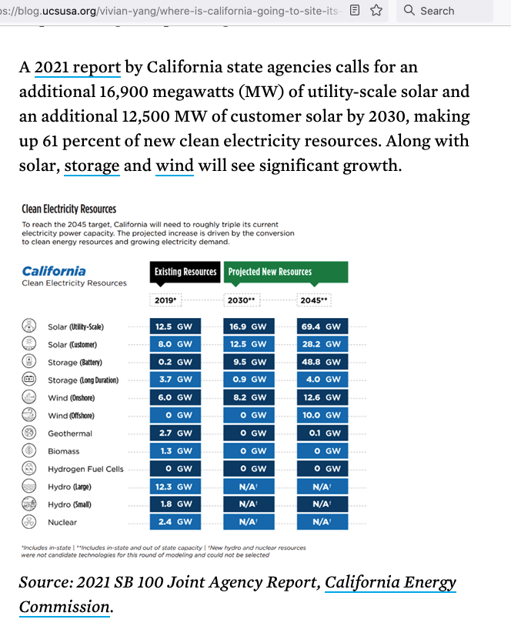

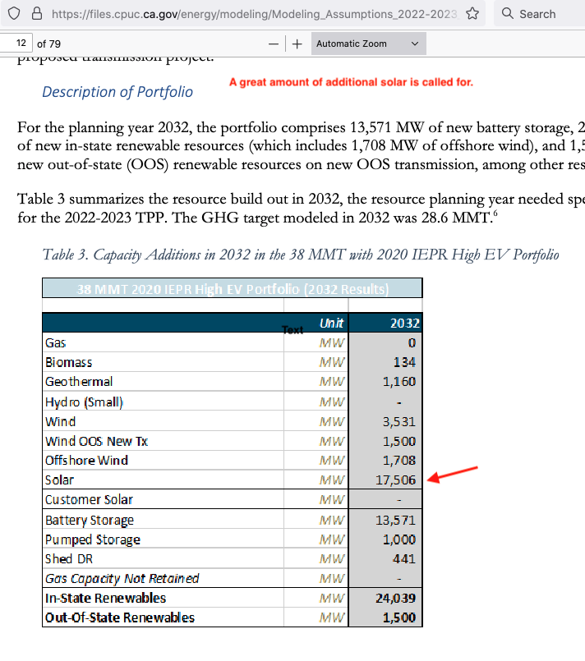

Remote-solar can help meet those goals by providing a significantly less expensive alternative to rooftop solar, or investment opportunity for those with no special interest in solar, which should increase the amount of solar being generated by homeowners and renters.

The Cal Energy screenshot below mentions efficiency and doing more for less. Because the utility scale solar farms that would host remote solar customers are about 6 times more cost-effective than rooftop solar that fact speaks to their efficiency. Why would society spend six times more for a way to increase renewable power and mitigate climate change than it needs to?

Finally, the screenshot says the California Energy Commission makes policy and seeks policy solutions. Seeing that remote-solar gets properly vetted by CARB and CPUC, and supporting it if it passes muster, would be such a policy.

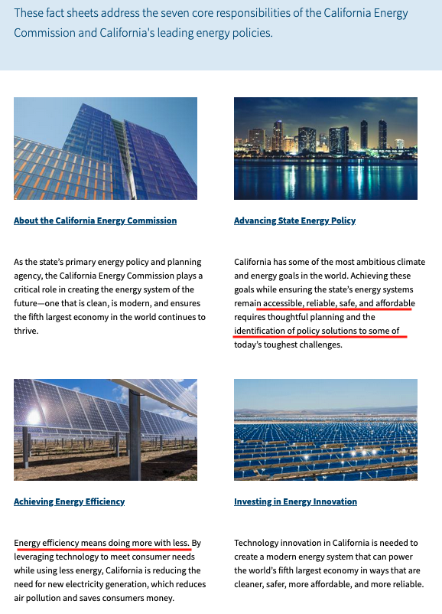

The screenshot below shows that CASIO is very much involved in achieving California’s goals for renewable energy. The high-level goals have tiered down to the level of detailed and specific plans to achieve them. For instance, the author has seen specific plans, cost estimates and schedules for upgrading various transmission lines in the California grid. (The author wishes the rest of the US had such impressive and detailed plans.)

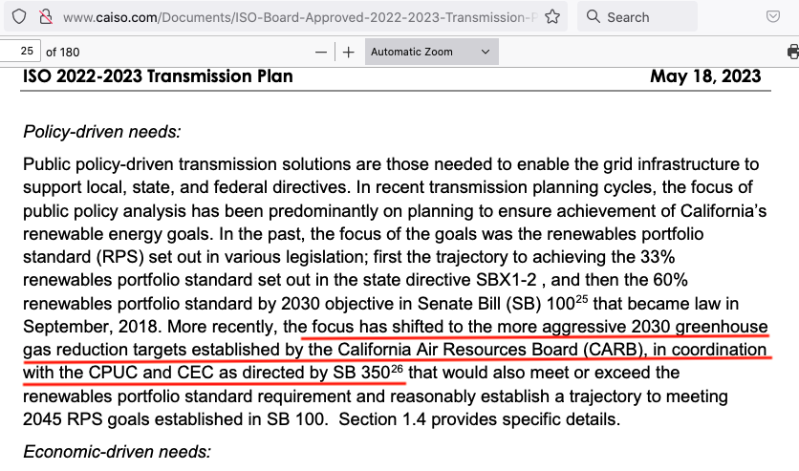

3.2 Remote-solar could provide a large, new funding source for California’s growing need for renewable power. By having a high ROI remote-solar could out-compete many other investments such as stocks, bonds, and real-estate. Therefore, it should attract funds from individual savings and retirement accounts that obviously contain large amounts of money. Thus remote-solar is a way to fund solar as opposed to having utilities raise rates for everyone to provide the money. It that sense remote solar is a painless way to raise funds since its voluntary and other ratepayers would not be negatively affected. This alternate way of funding solar might be one of the most important benefits of remote-solar from a policy perspective.

3.3 Remote solar addresses accessibility: One of the screenshots above cites accessibility as a policy goal. Besides its lower costs remote-solar addresses accessibility in several ways.

a) Providing that a future tariff for remote-solar so decrees, remote solar could be available to renters and condo owners unable to put solar panels on their roof.

b) Since remote-solar is not tied to any particular structure or address a customer’s remote solar account could move with the customer and be tied to the customer’s new electric meter if the customer moves.

c) Its more accessible in the sense that remote-solar would be practical for persons who have roofs that may need replacement in the next 15 years or so.

d) Finally, its accessible to those with shaded roofs.

3.4 Remote solar could lower electricity bills for lower income residents: Plans to raise electric rates are currently being opposed on the grounds “people can’t afford it”. Here is one recent quote.

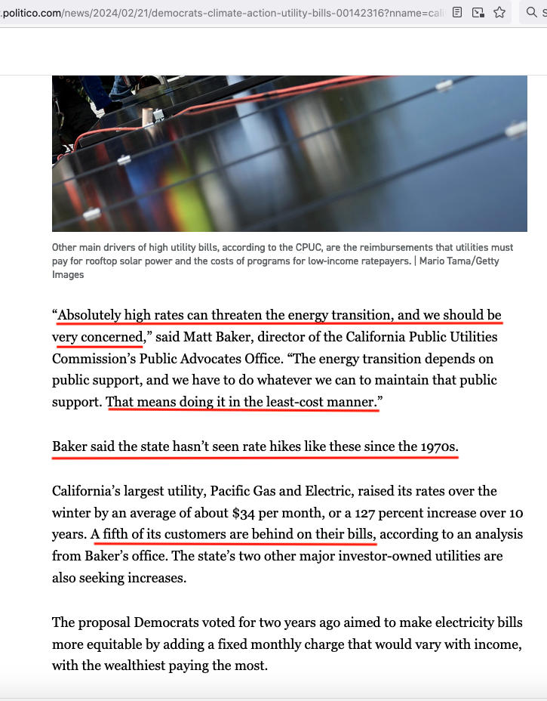

And here is another:



Remote solar addresses affordability simply because its much less expensive than rooftop solar. Whereas rooftop systems typically cost tens of thousands of dollars the remote-solar systems described in this whitepaper should cost just a few thousand. In terms of the ongoing costs here is a chart from the model that compares the electric bills for an average household with and without remote solar. It shows that the utility bill would be reduced about $1300 per year.

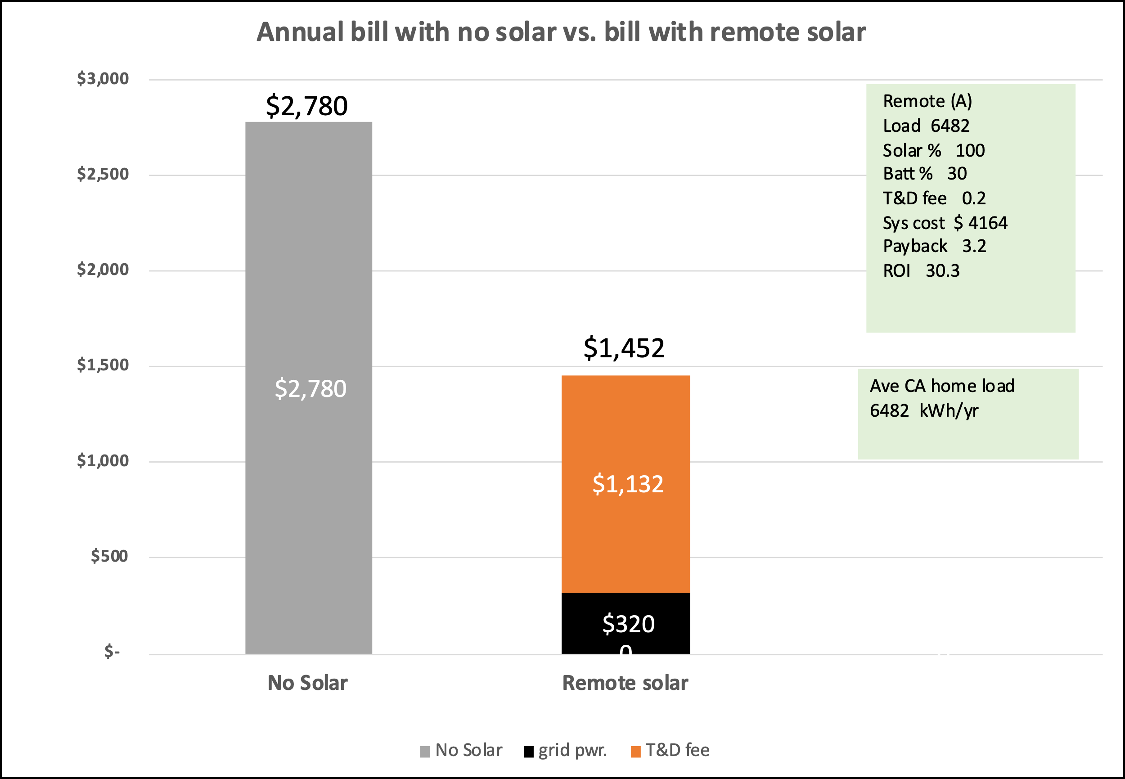

3.5 Remote-solar could reduce home prices. The mandate to have solar installed on new homes increases home prices by tens of thousands of dollars. Home prices are widely viewed as unaffordable for many in California and are often mentioned as a state wide problem. Remote-solar could be an alternative way to satisfy the goal behind this mandate that would not raise home prices.

3.6 Remote-solar would reduce the complexity of getting residential solar: User stories on Reddit provide insight into the practical problems some homeowners face with rooftop solar. www.reddit.com/r/solar/comments
They include obtaining and knowing how to compare installation quotes; understanding the financial benefits; knowing how to handle a loan, how to price a home with solar or handle a solar loan when moving; knowing about financing options, configuring the system controller to operate as intended; aesthetic concerns; arranging maintenance; and getting responsive help with problems. Several screenshots below give testimony to these issues.

In contrast getting remote-solar should be simpler than getting rooftop solar for these reasons: remote-solar customers would only be dealing with a few large RSP’s; the remote-solar tariff would be easier to understand because it simply offsets monthly load with monthly solar generation; before the sale it should be easy to estimate the financial benefits with a model much like that in this whitepaper; the sums involved are smaller and thus less risky; the remote-solar system does not complicate the home selling process because it’s not tied to one particular address; no actual construction at the residence is involved; and there is no need for the customer to get involved in programming his system nor in maintaining it.
These screenshots from Reddit indicate how complex or confusing that process has been for some folks.

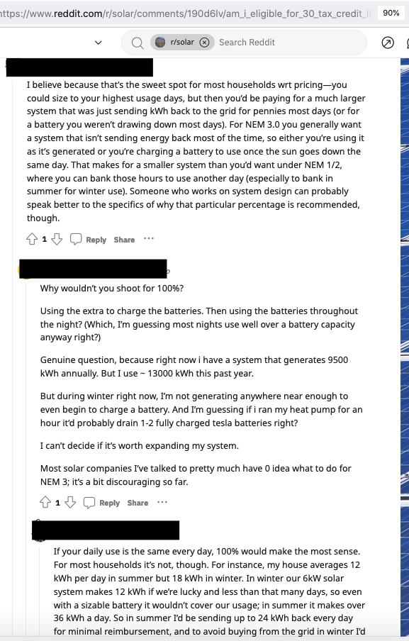
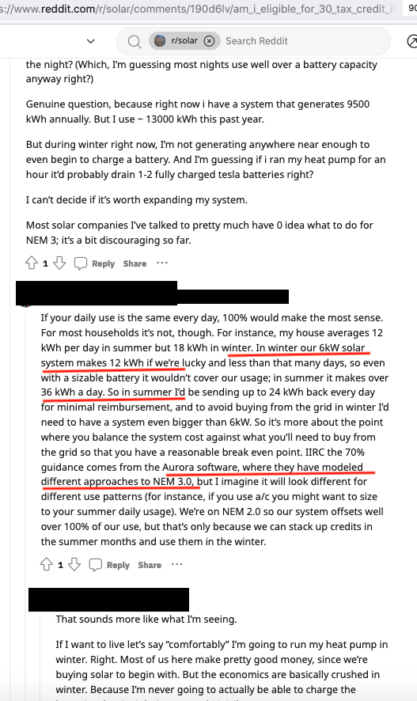
I’ve recorded many more Reddit posts similar to the above but don’t want to lengthen this whitepaper by including them.

3.7 How Remote solar could help mitigate the “duck curve problem”

The duck curve problem: The two charts below indicate that when solar production drops off sharply at sun-set it’s mostly natural gas generators (hatched blue area) and power imported from other states that are used to meet demand. That’s because gas is cheap and because some gas plants use gas-turbine generators (ie: modified jet engines) that can be ramped up quickly. But, among other problems, gas generators emit considerable greenhouse gas and imported power is also dirty.

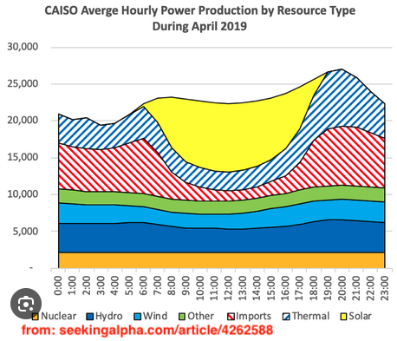

The chart below also shows that when -largely solar- renewables (green line) decline, natural gas (orange line) increases. The reverse problem occurs at sunrise, but its less dramatic. This chart is just for one day, but those for other days convey the same message.

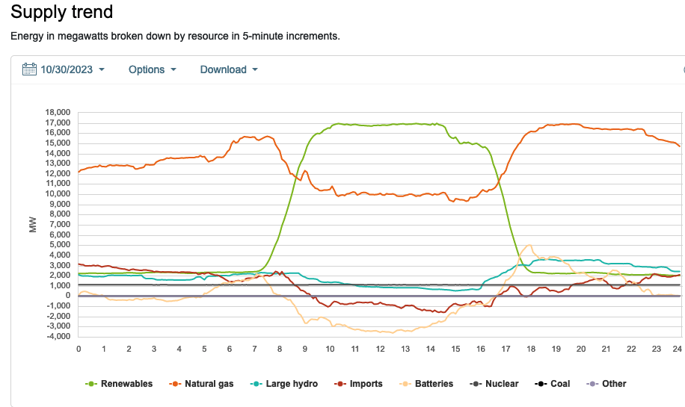

As the amount of solar has grown over time the problem of rapidly ramping up other sources after sunset has also grown. The solar production curves have deepened over the years to now resemble a duck, and CASIO has so named it. I will call this the “duck curve problem”.

“With the growing penetration of renewables on the grid, there are higher levels of non-controllable, variable generation resources….The duck chart shows the system requirement to supply an additional 13,000 MW, all within approximately three hours, to replace the electricity lost by solar power as the sun sets”. Source of quote and duck chart below is: https://www.caiso.com/documents/flexibleresourceshelprenewables_fastfacts.pdf

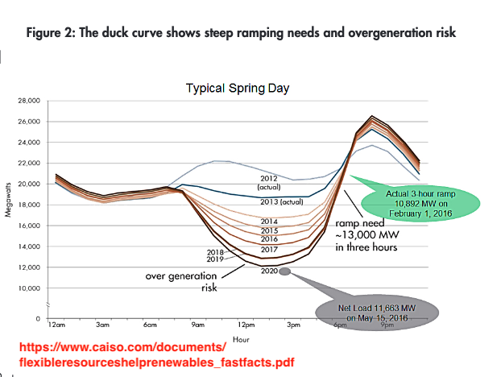

This screenshot explains why the duck curve is also an economic problem for the owners of gas generators.

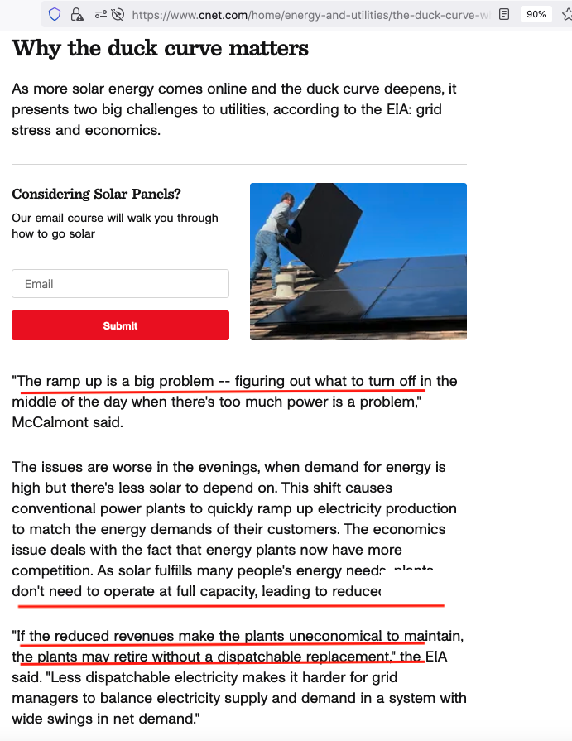

How remote solar could help: Remote-solar could help mitigate the duck curve problem because it can include battery storage and still be a very attractive investment that presumably will be widely purchased. With battery storage remote-solar can time the battery discharge to help mitigate the duck curve problem. In other words, remote solar is a way to get more battery storage into the power system and thus reduce the need to ramp up alternate sources of energy so rapidly after sunset.

Part of the HOUR financial model, called Remote(B), was developed to explore this. Whereas Remote(A) was designed to discharge the customers battery so to best offset load, Remote(B) was designed to discharge the battery completely in the 5 hours just after sunset when it would be most helpful in mitigating the duck curve problem. Here are the relevant charts from the model.

This first pair of charts apply to an average home that uses 6482 kWh/year and has a remote solar system with a 100% array and 30% battery. Using the MONTH model it had a capital cost of $4164 a payback of 3.2 years, and an ROI of 30.3%. Ignore the payback and ROI values in the text boxes since they came from the HOUR model and not the MONTH model recommended by this whitepaper.

The green bars in the upper chart for Remote(A) show that battery power was discharged in the evening so as to offset as much of the home load as possible. This pair of charts was done for March solar generation and household load.

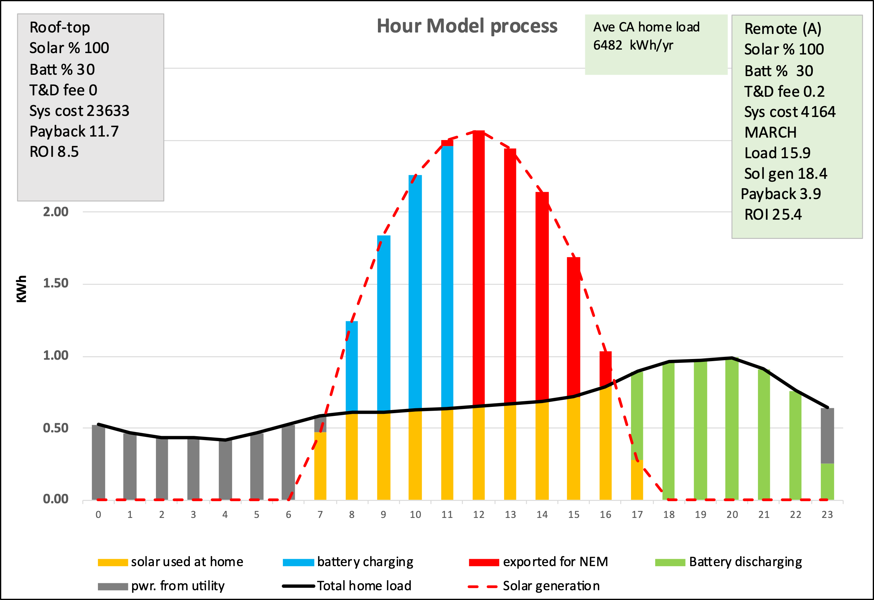

The green bars in the Remote(B) chart below show that less of the evening load was offset by battery charge so that more of the battery energy could be discharged shortly after sunset where it would best help mitigate the duck curve problem. That extra battery discharge is shown by the brown bars.

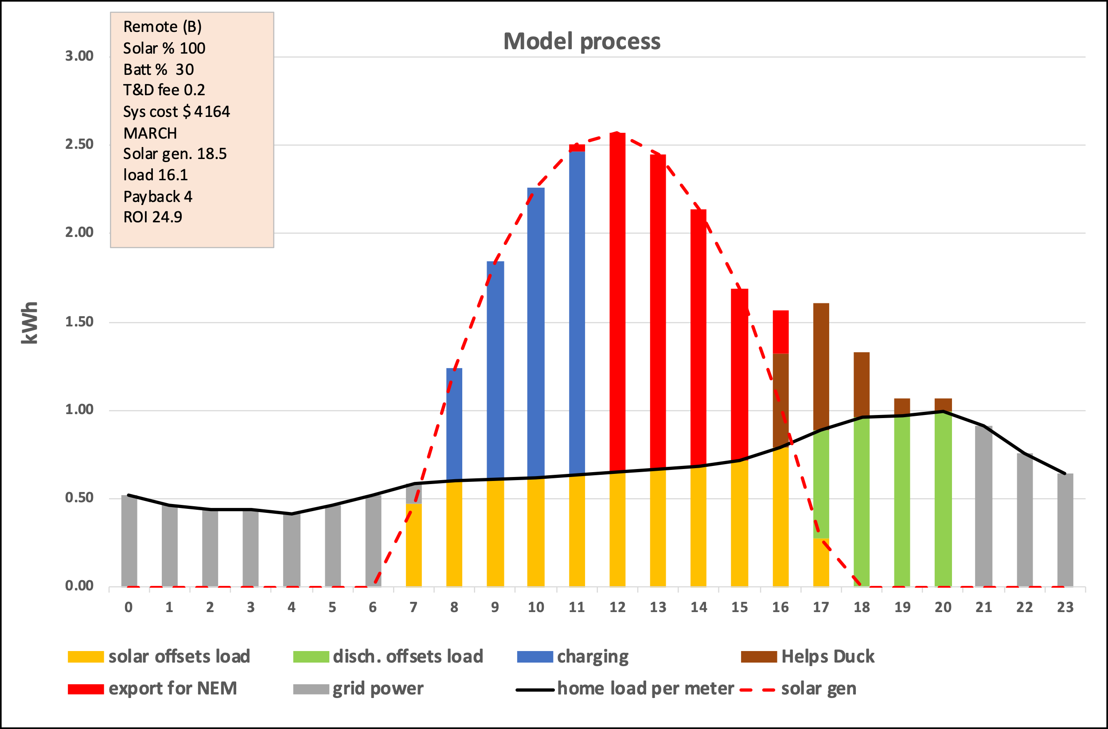

Both Remote(A) and Remote(B) help the duck curve problem because both use a battery to shift solar power so a significant share of it is placed on the grid after sunset (green bars). However, Remote(B) discharges even more of it after sunset than usual (the brown bars) and therefore helps even more than Remote(A).

It would be important for the billing system place proper value on the energy in these brown bars because, depending on what netting interval is ultimately applied to remote-solar they might have more value if that power was just used to offset more of the load. Certainly, the energy in the brown bars should not be considered as NEM excess because it exceeds that needed to offset load. In other words, the customer should be incentivized, not penalized, to discharge the battery in the Remote(B) manner.

This next pair of charts has a larger battery (50% rather than 30%) and shows that in June the brown bars contain substantially more energy that could help the duck problem. The larger battery did however raise the system cost about $1100, increase the payback to 4.1 years and lower the ROI to 24%.

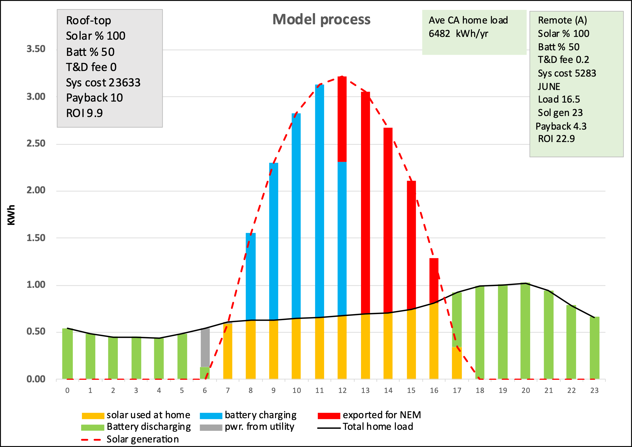

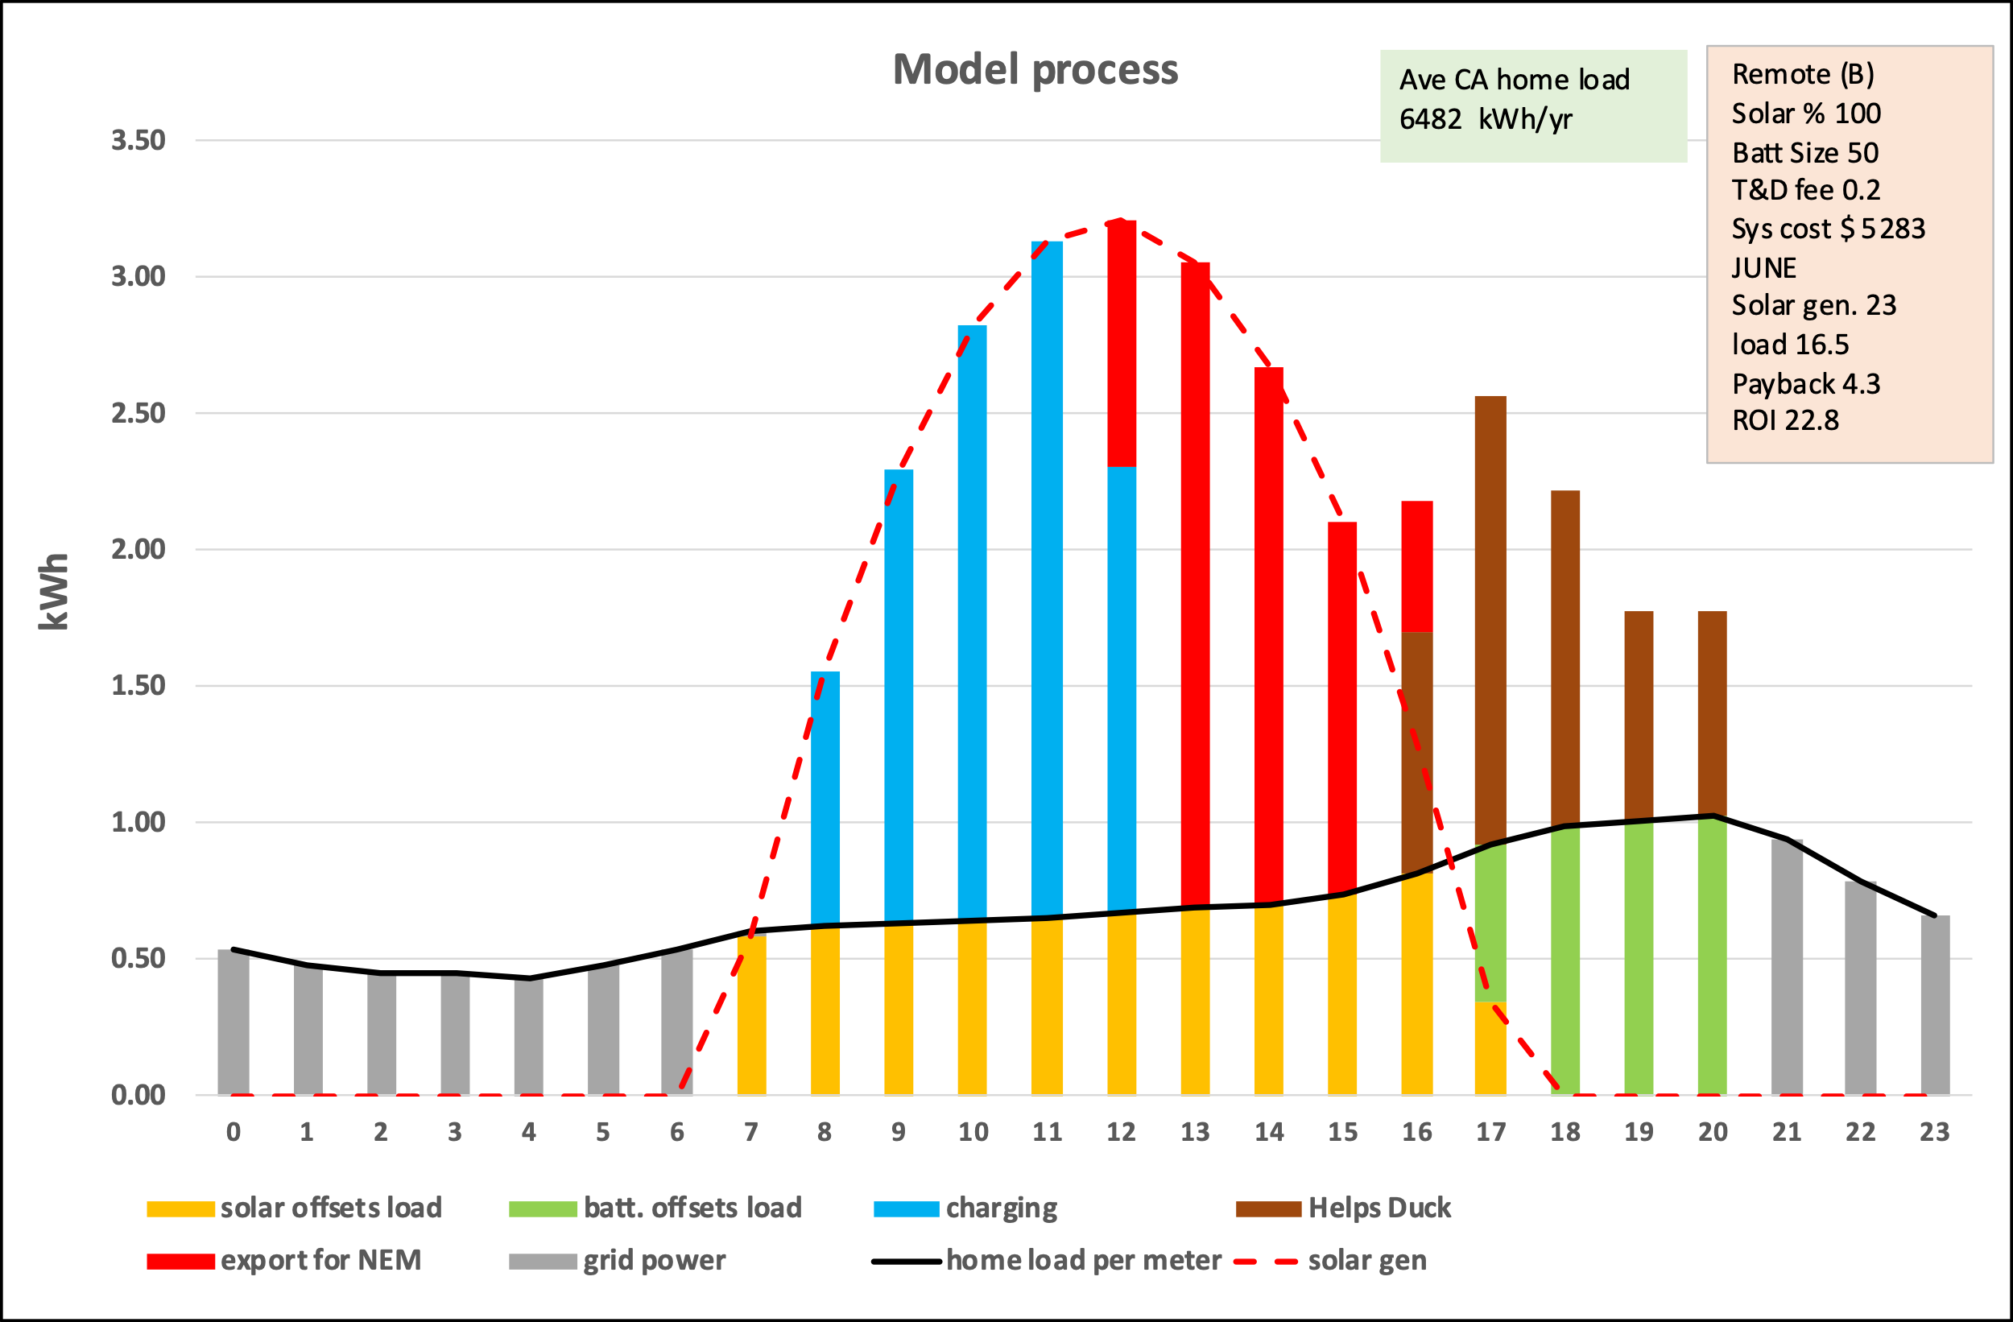

The chart below shows that even with a 50% battery Remote(B) the solar panels did not generate enough power in December to produce any brown bars. Nevertheless, the green discharge in the evening still helped mitigate the duck curve problem.

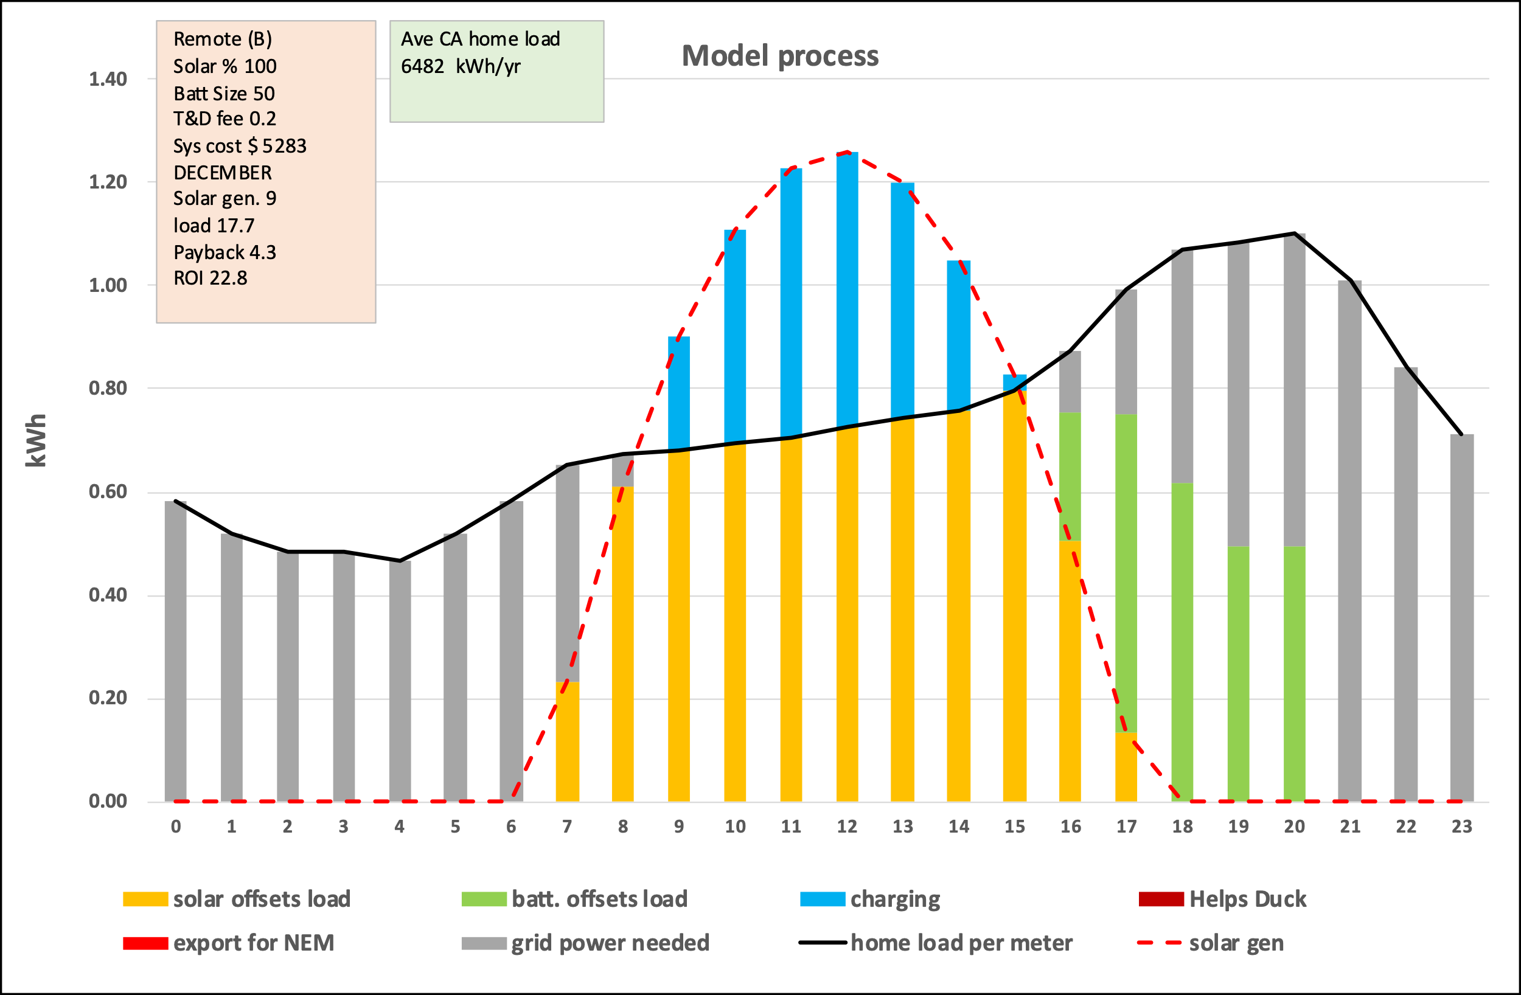

Buying a battery so power can be discharged in the evening not only raises the customers up-front capital costs but may yield no reduction in his or her utility bills. Unless some way is found to incentivize battery storage few remote-solar customers would probably choose it. On the other hand, the CPUC could require some amount of battery storage as an intrinsic part of remote-solar. This topic requires detailed analysis.

An important observation?: The table of results showed that the customer receives no benefit from adding battery storage. For instance, with 100% solar and NO battery he would get an amazing payback in just 2.2 years with an ROI of 44%. Whereas with a 50% battery the payback increases to 4.1 years and the ROI drops to 24% because batteries comprise about half the total system cost.

Is there another way of looking at this given the system-wide benefit of having battery storage to mitigate the duck curve problem? One might argue that the CPUC rules should require remote-solar be offered only as a package comprised of array plus battery. Solar actually delivers all the financial benefit but if the customer wants that benefit, he or she is forced to buy the entire package, which includes a battery. The key then is to make the price of that package so attractive that the customer is willing to buy it even if the battery part provides no benefit to the customer himself. Remote-solar makes offering such a package possible because that package is still very attractive financially. For example, even the 100% solar+50% battery package has a low capital cost (about $5300), very attractive payback period of 4.1 years and an ROI of 24%. If we wish to get more battery storage into the grid, and not raise everyone’s rates to do it, is there a better option?

4. The basic steps for ordering, delivering and billing remote-solar
1) The CPUC working with the utility companies like PG&E, SCE, and SDGE would establish the rules for remote-solar, perhaps in a tariff specific to remote-solar. This would probably need to specify the following:

a) the T&G rate
b) the allowable choices in terms of array and battery sizes
c) the financial incentive the IOU should provide, if any, to incentivize a customer to have a battery when his highest ROI would come from having none.
d) the netting interval, preferably one month
e) the relevant NEM rate to be used for any energy the customers remote solar system exports in excess of his load. (It may be sensible to just have one NEM value, like 3 cents/kWh, rather than the current scheme where the NEM value varies every hour of every day of the year.)
f) the manner in which the customers battery is to be managed by the RSP. For instance, is it to be discharged in a way the best offsets the customers load or discharged in a way that helps mitigate the duck curve problem best?
g) the way the customer should be billed in regards to the way the battery is discharged. The billing should probably be designed to encourage the customer to time his battery discharge so as to best mitigate the duck curve problem. It will take some study to see how best to do that.

2) With the tariff ground-rules in place a prospective customer, referring to his past utility bills, tells the RSP what his annual electric consumption has been in kWh/yr.

3) The RSP informs the customer what his options are in terms of array and battery sizes, their capital cost and a rough estimate of the expected the payback and ROI. The RSP would use a model similar to the one in this whitepaper, and make runs for a number of array and battery sizes to produce a customer specific table like this:

4) After consultation the customer contracts with an RSP to buy a certain array* and battery size at the RSP’s solar farm and puts the full up-front payment in an escrow account. The customer may prefer a system with a very low capital cost or may prefer one with a battery. Or the CPUC may set the tariff so only certain choices are acceptable. For instance, to reduce the Duck curve problem the CPUC may require all remote solar systems to have a battery even if that means a lower ROI. (*It might be best if the customer contracted for a certain amount of annual solar generation rather than a panel size.)

5) The RSP builds a utility scale solar farm with battery storage when enough customers have signed up and put their money down to make it feasible. To improve reliability, it may be advantageous to locate the batteries closer to the customers than the solar farm is.

6) The RSP calculates how much power each customers remote-solar system will export to the grid each hour of the day on an average day. That’s his individual daily export profile. This will depend on how large an array and battery the customer purchased and any CPUC rules governing how the battery is to be discharged.

7) The RSP adds all the individual customer daily export profiles together to get a master export profile showing the total amount of energy the RSP will export into the grid each hour of the day. That’s because CAISO may need it, and that’s how the RSP will manage the output of the entire solar farm.

One can see that the individual export profiles differ in shape and size each customer probably has a different size arrays and battery. In essence each remote solar customer will own a % of the total export profile. That’s a key number. And in practice, since the output of the total solar farm will vary by season and cloud cover, the absolute amount of energy each customers individual system generates will vary. The customer ultimately gets credit for only his % of the total solar farm’s output that is actually produced.

This is how that summing process might look:
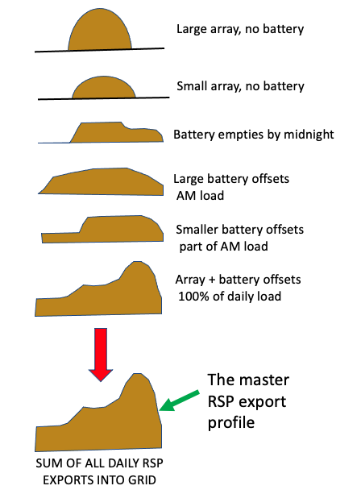

8) During operation, the RSP will manage the total solar power generated in the solar farm and the total battery storage in the solar farm so as to best export energy per the master export profile.

9) At the end of the month the RSP will report to the relevant utility company how much energy in kWh was actually exported on behalf of each customer. That will be a simple percentage of the total energy placed on the grid by the RSP. It will be broken down into peak period and off-peak period exports. With monthly netting there is no need to break it down by hour.

10) The IOU compares the power actually used each month by a customer (as measured by the customers electric meter) from the actual power the RSP supplied on his or her behalf that same month and calculates the customer’s electric bill. The bulk of what the RSP exports will probably be used to offset the customers load but if the total monthly load exceeds the total monthly supply from the RSP the customer is charged for the difference at the TOU retail rate. Conversely If the RSP supply exceeds the load the excess is given a NEM 3.0 credit. (The model in this whitepaper simulates this process as it computes the customer’s bill electric bill.)

11) The IOU finalizes the utility bill. As a final step in the billing process the utility adds the T&D fee and passes through the RSP’s O&M fee.

5. How the MONTH financial model works, and data sources

5.1 Overview

As noted previously the author started this analysis by developing what he calls an HOUR model, which began with the solar production or generation each hour of the 24-hour day. When solar production started in the morning it was first used to satisfy the load of what would be an average customer’s load, and then any excess was used to charge the battery. If the battery became fully charged the solar in excess of load was exported for NEM credit. Then after sunset the battery was discharged to offset the evening load and the load the following morning. When the authors actual load profile was used in this model -as opposed to that of the average household the payback and ROI suffered as so it was decided that total solar generation over a month-long period should be compared with load over that same month rather than using the hour-by-hour approach. A MONTH model was developed to do this.

Technically it appears that the HOUR model had a “netting interval of one hour, whereas the MONTH model has a netting interval of one month. That MONTH model was tested not only against the average household load profile but also the authors actual load profiles for 2022 and 2023 plus that of a friend’s home. The MONTH model gave a somewhat higher ROI, seemed reasonable since the IOUs bill monthly, seemed consistent with how solar was billed under NEM 1 and 2, and would be simpler to implement by both the RSPs and IOUs. Therefore, the MONTH model was used to calculate the payback and ROI results reported in this whitepaper.

The older HOUR model and the newer MONTH model were placed on the same spreadsheet so the HOUR model could inform the MONTH how much power was subject to TOU peak hour prices versus off-peak prices.

The hour model is also useful in better understanding how remote-solar could help mitigate the “duck curve” problem by discharging all or almost all the energy stored in the battery just after sunset so there is less need to rapidly ramp up gas generating plants.

The basic logic of the MONTH model is to compare amount of power the customer’s remote solar system produces and places on the grid each month with how much electricity the customer actually uses; then bill for any grid power needed at the usual TOU rates, or credit any excess solar at the average NEM 3.0 rate.

To accomplish this an excel spreadsheet model was developed to estimate a customer’s approximate up-front capital cost, payback period and return-on investment (ROI). These were calculated on the basis of a number of independent variables such as unit costs for solar arrays and batteries, array capacity factors, what a utility would charge to transport a customer’s remote power thru the network (T&D fee), whether or not the Federal tax credit (FTC) applies to remote solar, EV use, and so forth. These inputs were all set at values found in the literature, or deemed reasonable by the author. Screenshots showing these sources are included below. Many of the input variables are adjustable by the model’s user so various what-if or sensitivity analyses were easily conducted.

Caveat: This model is not and cannot be entirely accurate because many of the input variables are situation specific and range in value. More important is the fact that some values -especially the T&D fee- would be set by the CPUC or other regulators and the author can only use what seem like reasonable values. Also, some simplifying assumptions have been made.

It is felt that these shortcomings do not invalidate the general conclusions based on this model. It’s felt these financial estimates are accurate enough to warrant review of this concept by experts at the CPUC and elsewhere. It is also felt they are accurate enough at this point so policymakers should proactively ask for that review and keep the option of remote solar in mind until that vetting is complete. All this seems reasonable since the up-front investment, payback and ROI appear so much better than rooftop solar that even if these results are overly optimistic, they can be moderated quite a bit and remote-solar would still remain very attractive.

The two main input variables explored in this whitepaper were the array size and battery size. The array size was specified in terms of what percentage of the total annual household load it was sized to produce. Putting 100% in that input cell meant the array would be sized to deliver as many annual kWh as the household consumed. Array sizes of 30, 50, 70, 90, 100, 110 and 120% were systematically explored along with battery sizes. The input for battery size was the % of total daily solar generation the battery was sized to store. For instance, if the solar array generated 10 kWh per day, then a 50% battery would be able to store 5 kWh.

The subsections below run thru the modeling step by step and show sources for the various values, such as unit cost of a utility-scale solar array.

5.2 Capital cost calculations:

The first input variable on the model’s spreadsheet is annual household load in kWh/yr. For the base runs it was set at the average California household consumption of 6482 kWh/year, which is an average daily consumption of 17.76 kWh. Other values were input when modeling the authors home load and that of a friend’s home load.

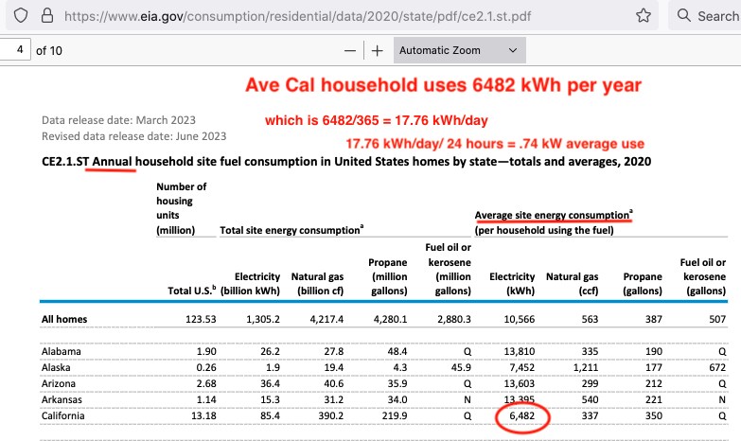

The next step is to size and cost the array and battery needed to service this load. The two charts below inspired this entire idea of remote solar by showing that utility scale solar is considerably less expensive in $/kW of array capacity than rooftop solar. The components of total cost are interesting. It can be seen that even if the cost of solar panels (“PV modules”) dropped to zero it would not reduce total costs by much. And the so-called soft costs of rooftop solar dominate its total cost. These were national numbers, not the ones used in this whitepaper.

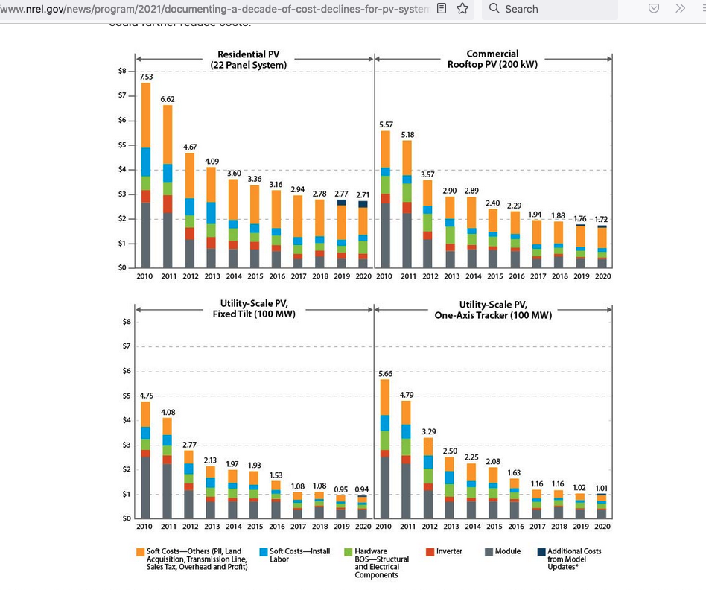

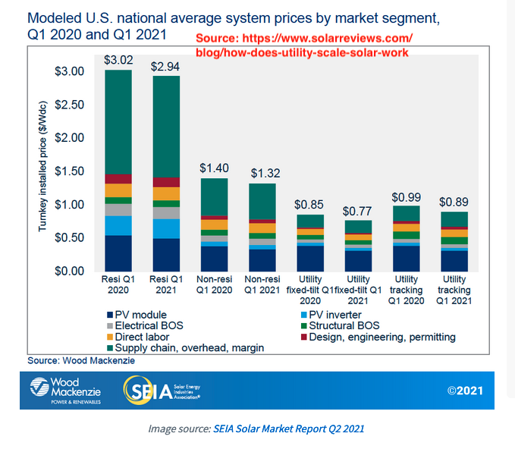
Given this contextual overview the unit costs of rooftop and remote solar are calculated in the model using the following sources of unit cost per kW of capacity and “capacity factor”. Capacity factor is a measure of how efficiently capacity is converted into actual generation. More detail can be found in the authors prior whitepaper but these charts show the essence. This data is California specific.

Summary of capital cost and capacity factor information:
This model will use the following cost and performance values that were found and reported in detail in my prior whitepaper, which compared the cost-effectiveness of utility-scale solar with residential roof-top solar:

$4.77/Wac for the capital cost of residential roof top solar systems built in California in 2022. Source was the California Distributed Generation Statistics data base. This converts to $4770/kWac. Source: https://www.californiadgstats.ca.gov/downloads/

$1.28/Wac for the capital cost of California utility-scale solar in 2022. Source: Lawrence Berkeley Lab at https://emp.lbl.gov/utility-scale-solar/ This converts to $1280/kWac.

A capacity factor of 17% for residential solar based on a sample of installed systems in the general San Francisco Bay Area. Source: the website PVOutput. https://pvoutput.org/

A capacity factor of 29% for large utility-scale solar in California. Source: Lawrence Berkley Lab at https://emp.lbl.gov/utility-scale-solar/

Here are screenshots of the data sources:

Cost per Kw of residential solar PV:

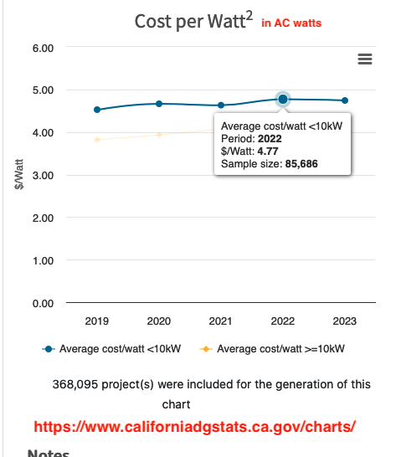

Capacity factor of residential solar PV:
This data was surprisingly hard to find so the author calculated one based on a sample of residential systems in the general SF bay area taken from a website called PVOutput: https://pvoutput.org/ The resulting capacity factor was 17%, as shown in this screenshot from the calculations.

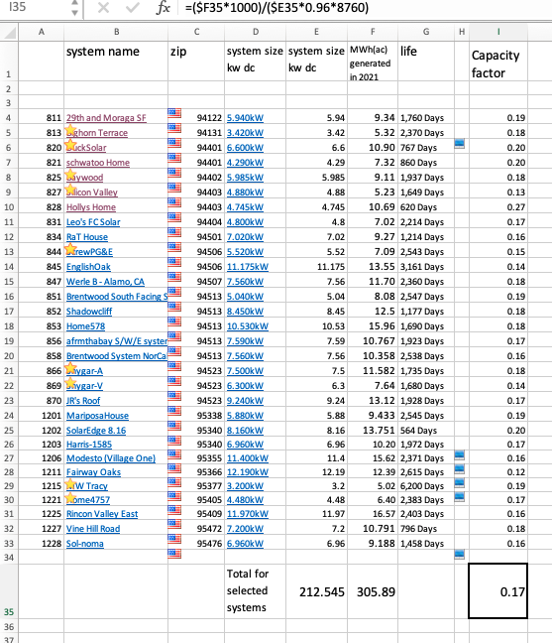

The author also examined the performance of several individual residential systems on the PVoutput web site. https://pvoutput.org/ One in Santa Rosa had a capacity factor of 15.8% and one near Merced had a capacity factor of 16.7%.

Since then, the author found 17% cited in a footnote deep within a PGE document, as well as elsewhere.

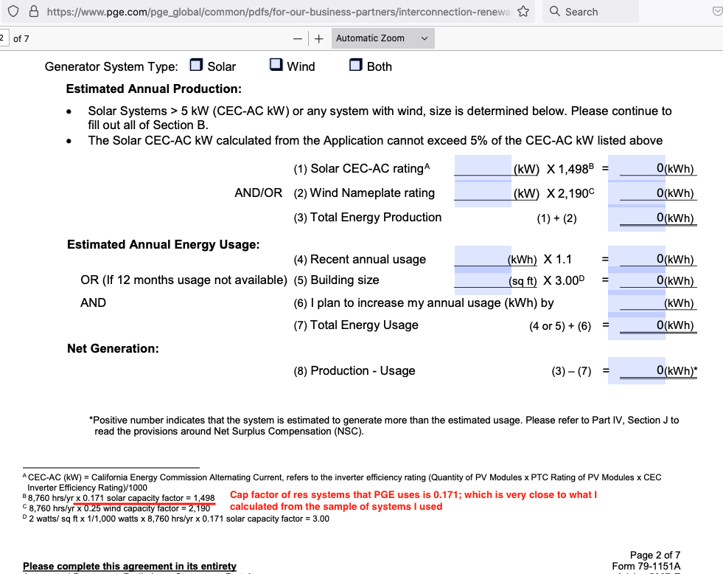

Given these two sources it seemed appropriate to use a capacity factor of 17% in this whitepaper to compute the array size of rooftop solar.

Cost per kW of utility scale solar PV:
Determining the cost in $/kWac for utility scale solar in California was tricky because some sources used dc values while others used ac values, and some used average costs while others used median costs. My first whitepaper considered these in detail and concluded that a cost of $1.28/kWac was appropriate, and that value was used in this whitepaper. A single screenshot with that value does not exist but here is one of the Lawrence Berkeley Lab inputs I worked with.
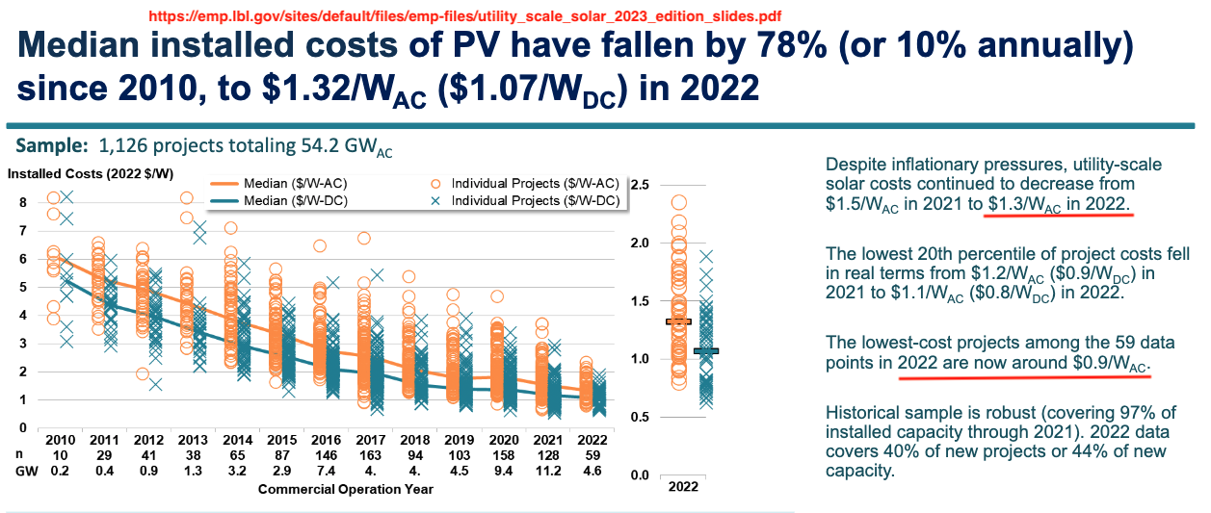

Its assumed that the above cost is the cost for actually building the remote solar farm and includes the contractor’s profit for doing that work. Since the RSP isn’t making an investment -the customers do that- the RSP company that constructs the solar farm hosting remote-solar customers would not seek a return on investment on top of these costs.

Capacity factor of utility scale solar PV:
This chart reports that the average capacity factor of utility scale tracking solar in CASIO (essentially California) is 28.8%, which was rounded to 29% for use in this whitepaper to compute the array size needed for remote solar. Source was: https://emp.lbl.gov/sites/default/files/utility_scale_solar_2023_edition_slides.pdf Elsewhere it was reported that most new utility scale solar farms use tracking arrays.

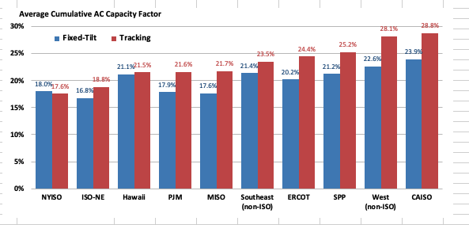

The 29% figure is also backed by the National Renewable Energy Lab (NREL) chart below.

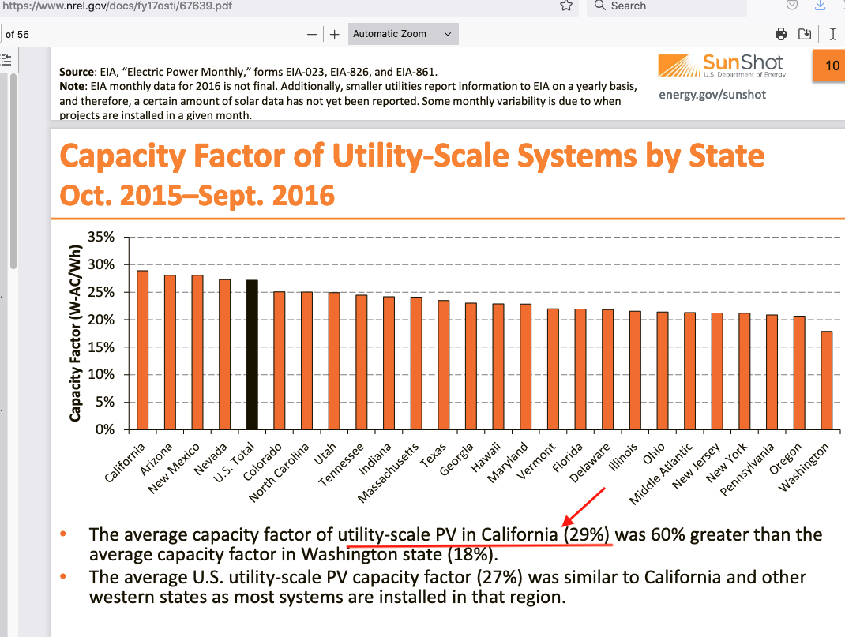

The attractiveness of remote solar -and the inspiration for writing this whitepaper- is largely based on the fact that utility scale solar is about 6 times more cost-effective in generating renewable solar power than is rooftop solar. This is the relevant calculation.

Cost-effectiveness Ratio = Cost per watt ratio / Capacity factor ratio

The actual numbers used were:

Cost per watt ratio: ( $4.77/watt ac for residential solar) / ( $1.28/watt ac for utility scale solar)= 3.73

Capacity factor ratio: (17% for residential) / (29% for utility scale) = 0.586

Cost-effectiveness ratio: 3.73/0.586 = 6.37

Cost of residential batteries:
For simplicity this whitepaper only used the prices and specs for Tesla’s “Powerwall” batteries although other brands are available. The prices customers actually pay for installed Tesla Powerwalls seem to vary widely per comments on Reddit, but this whitepaper assumes the installed price is $13,000 before tax credit for a single 10-KWh Powerwall and $26,000 for two of them.

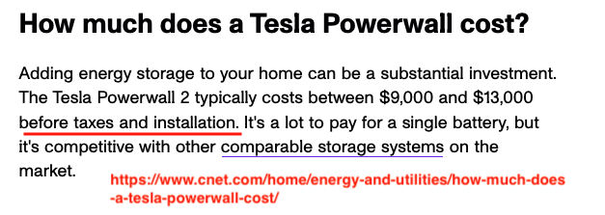

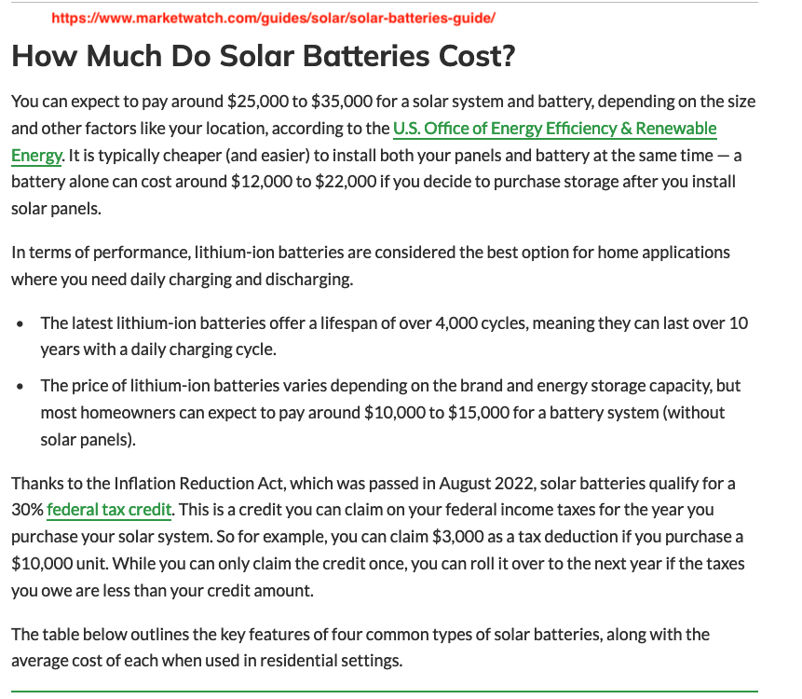

Cost of utility-scale batteries:
The model used a value of $450/kWh based on the NREL chart below.

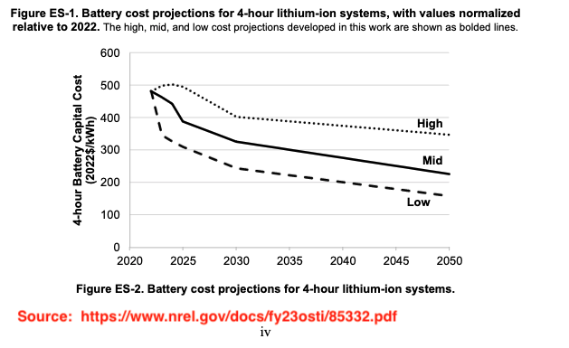

The Federal Tax credit:
The model allows the user to select whether or not the 30% FTC applies to remote-solar. The results in this whitepaper assume it does apply because it achieves the same social benefit as rooftop solar by increasing the amount of renewable solar produced. The author has not studied the FTC criteria in detail so as to say definably whether it does or doesn’t. Elsewhere in this whitepaper its shown that applying the 30% FTC to remote solar would stimulate more solar generation than applying it to rooftop. Two screenshots follow.
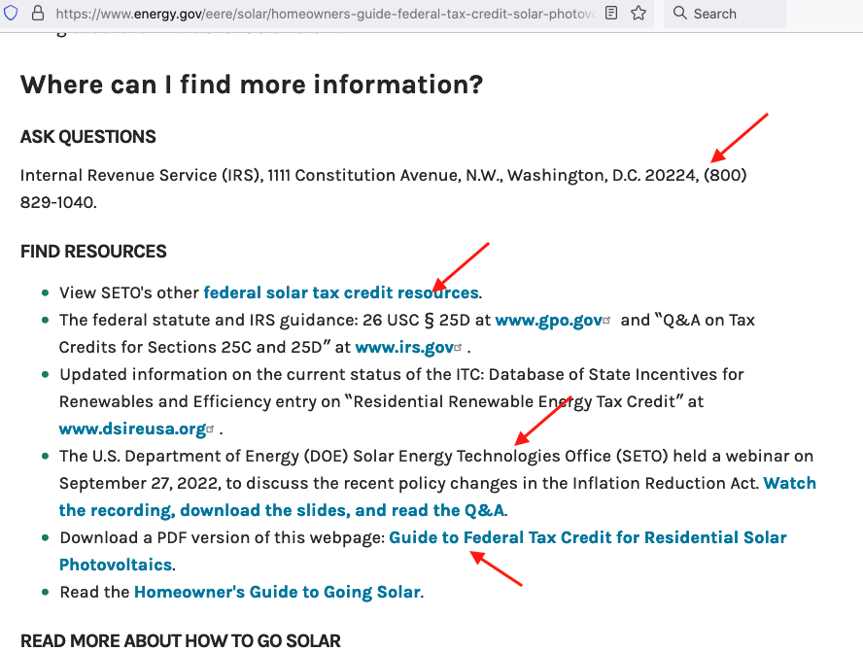

Relevant parts of model:
The three segments in screenshot below show where the array and battery sizes and their costs are dealt with in the model. An escrow fee is added to the array and battery costs because it’s assumed that a customer’s up-front payment for a remote-solar system would be held in escrow until enough customers sign up to make building a solar farm feasible for an RSP to accomplish. It would be dispersed to the RSP upon completion of the solar field and it starts exporting power into the grid.

The HOUR model had a provision to include an extra load for EV charging. Adding additional load for EV charging would have no effect on the overall payback and ROI results. It would simply require a larger and more expensive array and battery.

The PG&E TOU rates used in the model came from the following. For simplification the model used an off-peak rate of 40 cents/kWh and a peak period rate of 50 cents/kWh.

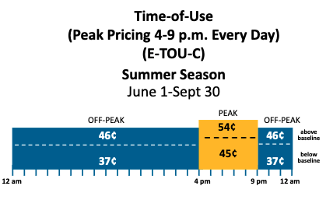

The NEM 3.0 rate (aka: net surplus compensation rate) is shown in the chart below as “roughly” 3-cents/kWh. Actually, it varies every hour of every day reaching roughly 7 cents/kWh in the evening. For simplification 3 cents/kWh is used in the model regardless of when the surplus occurs. And the exact value doesn’t matter since NEM credits are low and play such a minor role in the payback and ROI calculations.
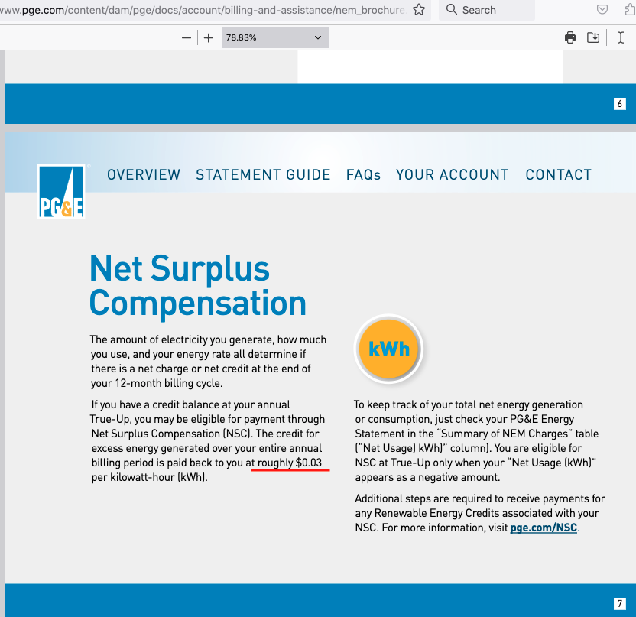

The screenshot below explains more about NEM 3.0. Its from: https://support.opensolar.com/hc/en-us/articles/6037827371919-Understanding-California-s-NEM-3-0-Latest-Update

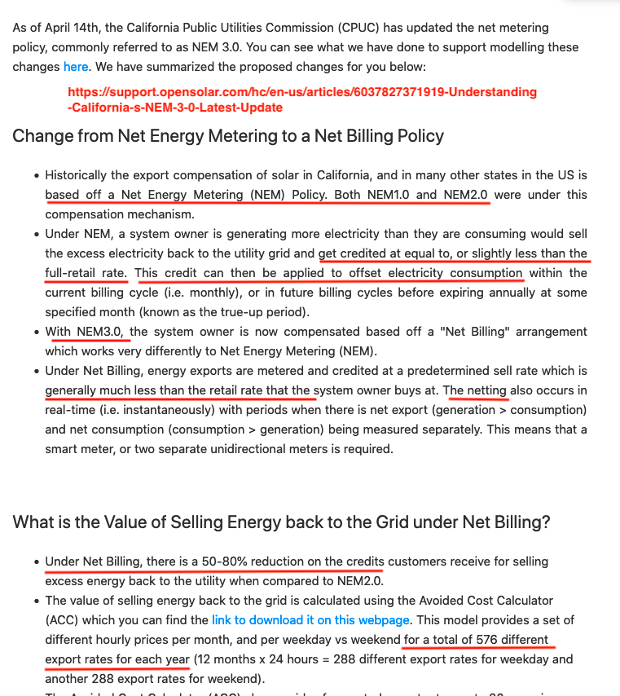

5.3 Benefit calculations:

Core benefit calculations:
The core calculations in the MONTH model appear in the following screenshot. The values are from the 100% array, 30% battery run for an average CA. home load.

Solar generation profiles:
The calculations begin by taking the total annual solar production needed and spreading it according to the percentages that will be generated each month given the total required per year. Those percentages came from a model produced by the National Renewable Energy Lab called PVWatts, which was programmed by the author to model solar generation in the Sacramento area. It produced the following result. The AC Energy values in this PVWatts table were converted into percentages for use in the model.

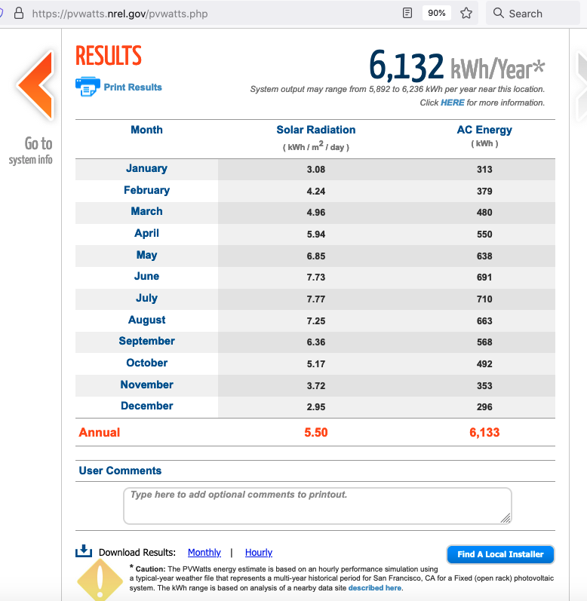

The following chart shows the actual monthly generation profiles of three California utility-scale solar farms, and confirms that the monthly generation profile from the PVWatts calculation used in this whitepaper is realistic.

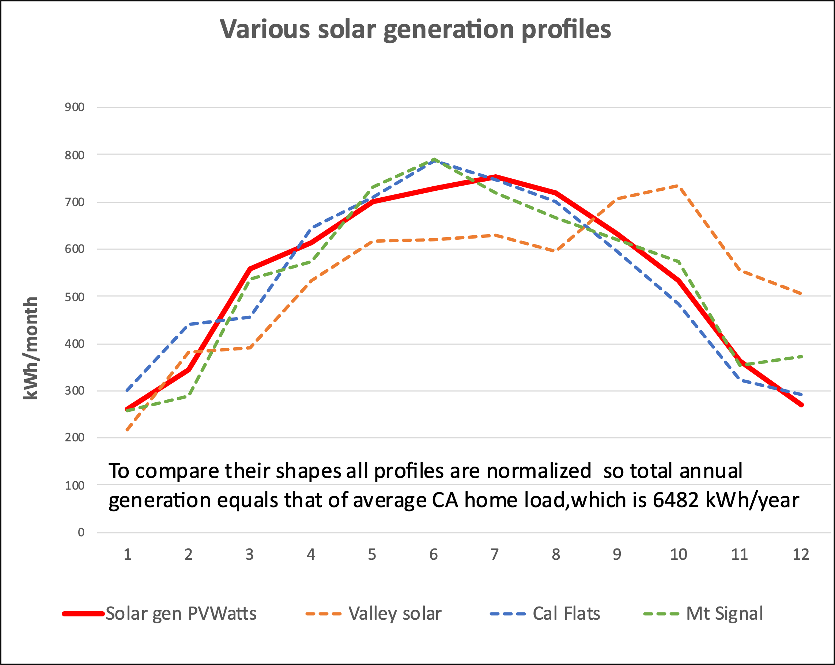

Load profiles:
The next column in the model was where the customer load profile was entered. This chart shows the four load profiles that were modeled. In other words, the payback and ROI for each was computed. Two of these profiles were those for the authors home which has a high reflectivity roof, oversize vents, large eves, and thus uses no air conditioning. My friend’s home has a much different profile since he has air conditioning. Our profiles were taken from the usage section on our P&G account web sites.

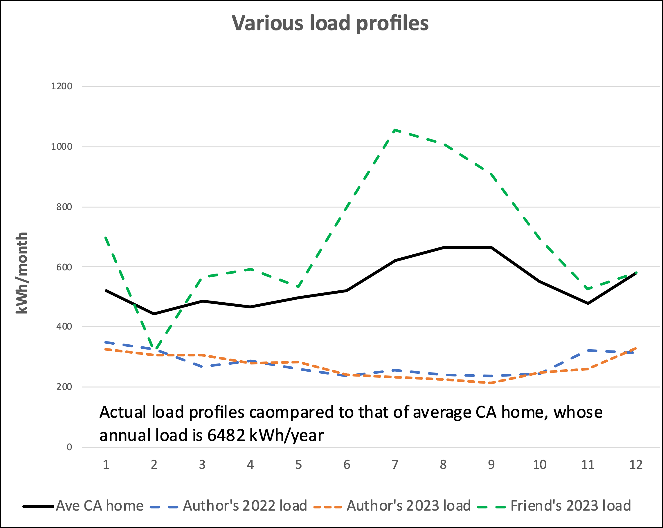

This chart shows that homes with AC will likely have large afternoon loads. When the sun sets that will increase the demand for alternate sources of power, which is often gas generation.

The main table of results is based on using the average residential load profile, which was scaled by eye from the following chart produced by ADL for Cal Energy. Despite much searching and several requests this author was unable to find another source for this information. Nevertheless, this chart is adequate since the general point is to show that monthly generation and consumption are quite different and make sure the model accounts for that.

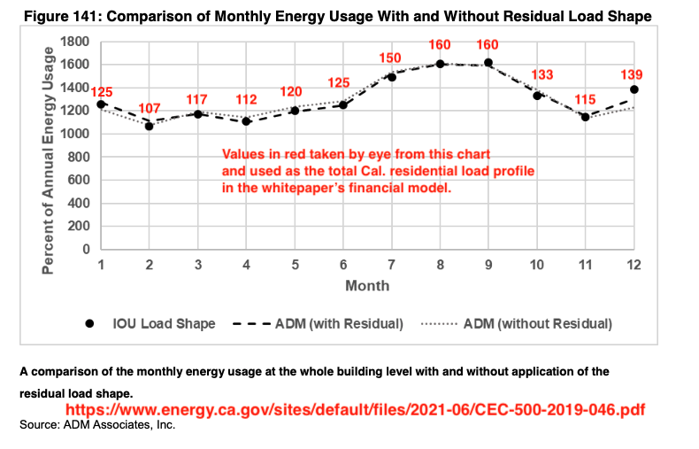
Both the solar generation and residential load profiles above on the chart below. Since we only want to compare shapes here, the actual values are normalized so all the solar generation profiles produce the same annual amount of power and all the residential load profiles consumes that same annual amount. It would be nice if the solar generation profiles matched the household consumption profiles because that would minimize the amount of grid power needed in the winter and excess solar power produced in the summer.

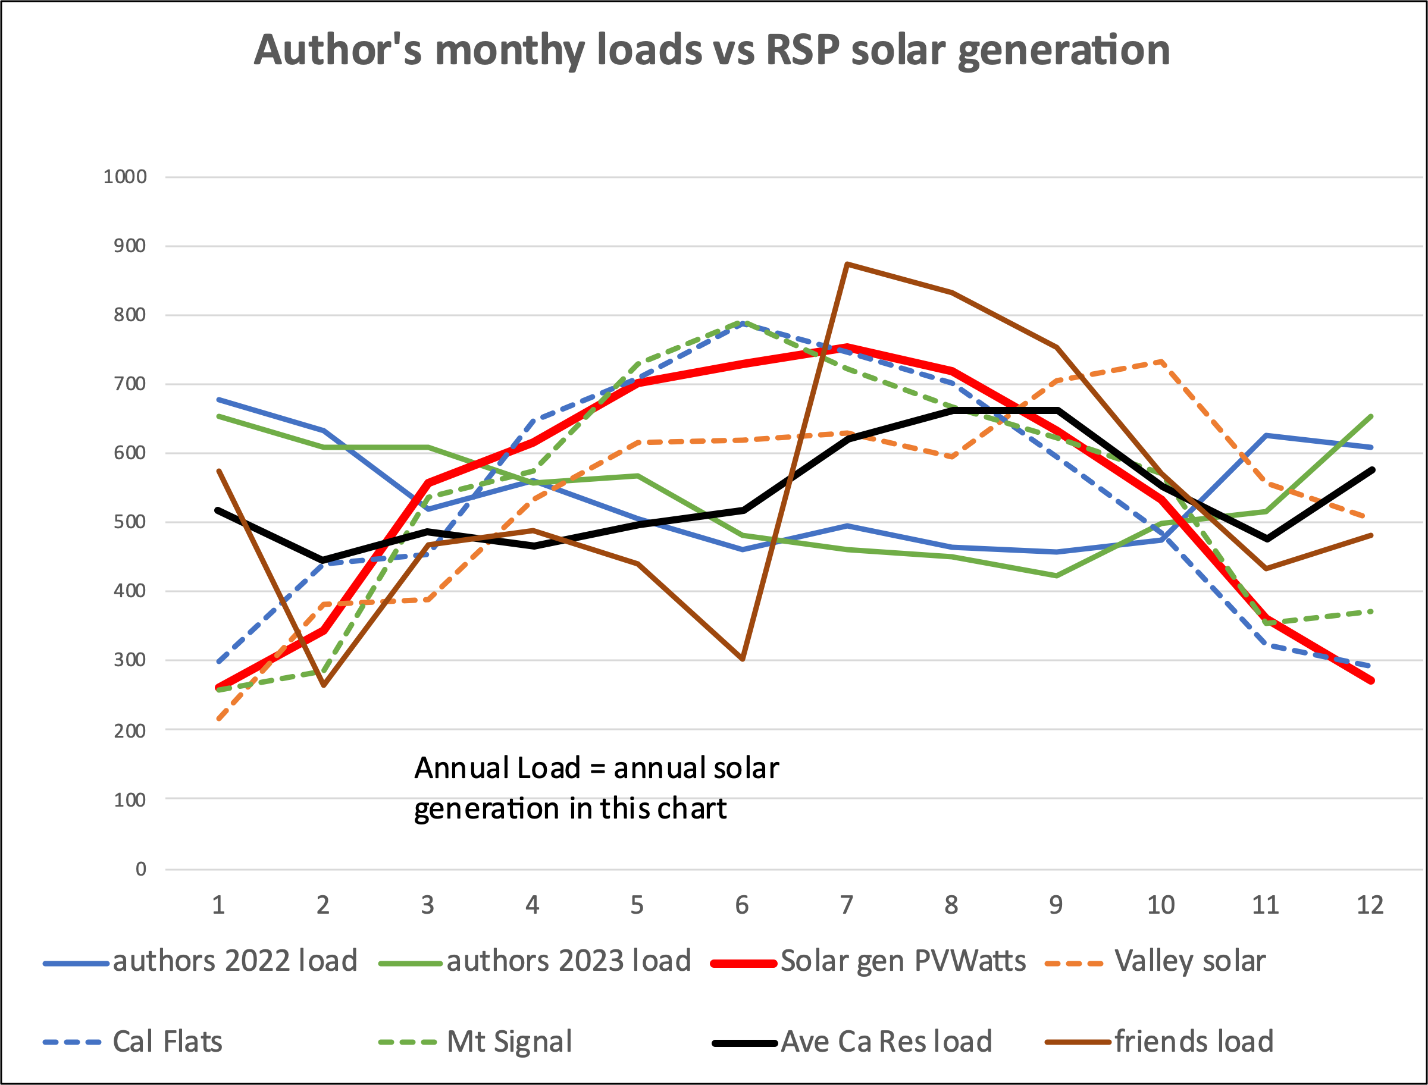

The chart below shows the actual profiles used to produce the main payback and ROI tables in the results section of this paper, and also copied into the executive summary. The solar generation profile was the PVWatts profile and the consumer load profile was that from the AMD chart shown just above. Ignore the green text box.

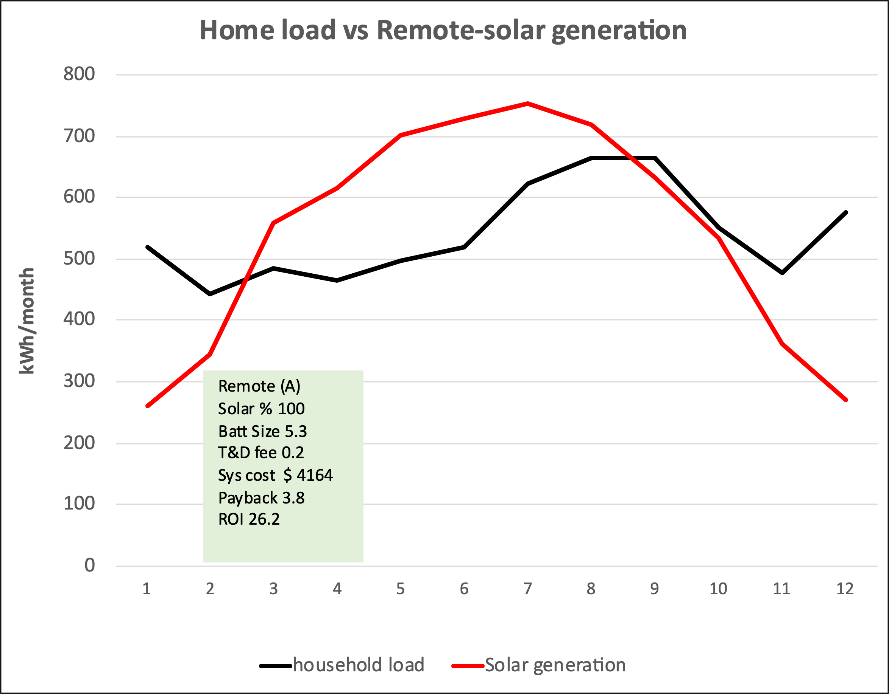

Next several modeling steps:
Comparing the amount of solar generated each month with the amount of power the customer consumes each month the model simply charges the customer the applicable TOU rate (40 cents/kWh off peak or 50 cents/kWh peak) for any grid power needed when the customer’s solar energy placed on the grid by the RSP falls short of offsetting load, and credits the customer at the NEM 3.0 rate of 3 cents/kWh for any extra energy the RSP exports in excess of load.

Power exported for NEM credit was not charged a T&D fee because the utility company essentially bought it for the NEM credit of 3 cents/kWh and could resell it to others for the full retail rate part of which was a T&D fee. NEM exports where however charged the RSP’s O&M fee.

At the same time the model computes what the customers electric bill would be if he had no solar. This is simply load in kWh times the relevant TOU rates.

The MONTH model gets a breakdown of how much power is peak-period (4 to 9pm) vs. off-peak from the HOUR model which runs simultaneously.

The bulk of the solar energy offsets load. These two charts illustrate these types of power in slightly different formats. They are specific to the result high-lighted with a red boarder in the main table of results. These charts are in kWh, so keep in mind that the gray grid power is expensive whereas the red NEM exports are not worth much.

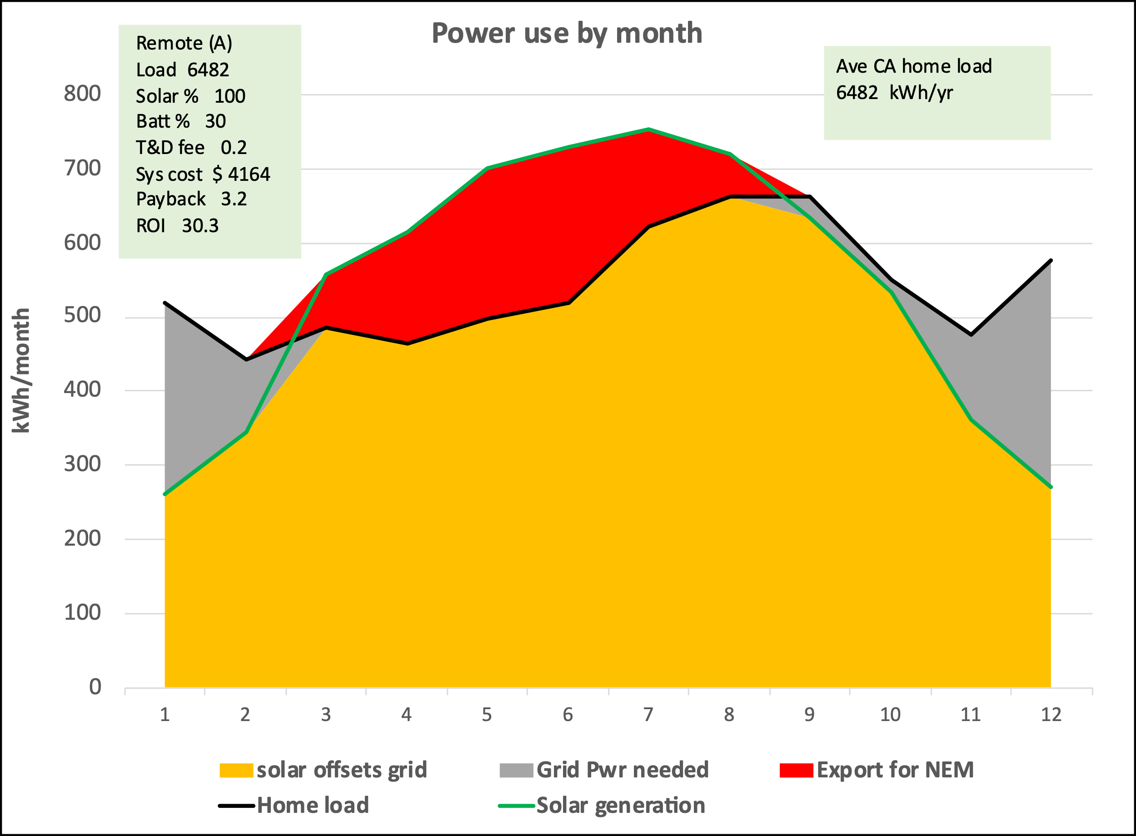

5.4 Payback and ROI calculations:

Use of the grid:
One final step before computing the payback and ROI for the average customer modeled herein is to add the utilities charge for transporting the customers electricity from the remote solar farm to his residence. The combined fee for using the high voltage long distance part of the grid called “transmission” and the fee for using the lower-voltage more-local part of the grid called “distribution” is called the T&D fee in this whitepaper. Transporting remote-solar power is not done in a literal sense since the RSP inputs the customers electrons into the grid in one place and the customer withdraws electrons his home uses from the grid somewhere else. The same electrons input at the RSP’s solar farm do not literally flow through to the customer’s residence.

The T&D fee is likely to be large enough to have a major influence on the economics of remote solar. Despite much searching the author was unable to find a PG&E web page clearly stating PG&E’s T&D fee. However, the author feels there is reason to assume it could be about 20 cents/kWh so that value is used throughout this whitepaper. This photo of the authors PG&E electric bill supports that assumption.

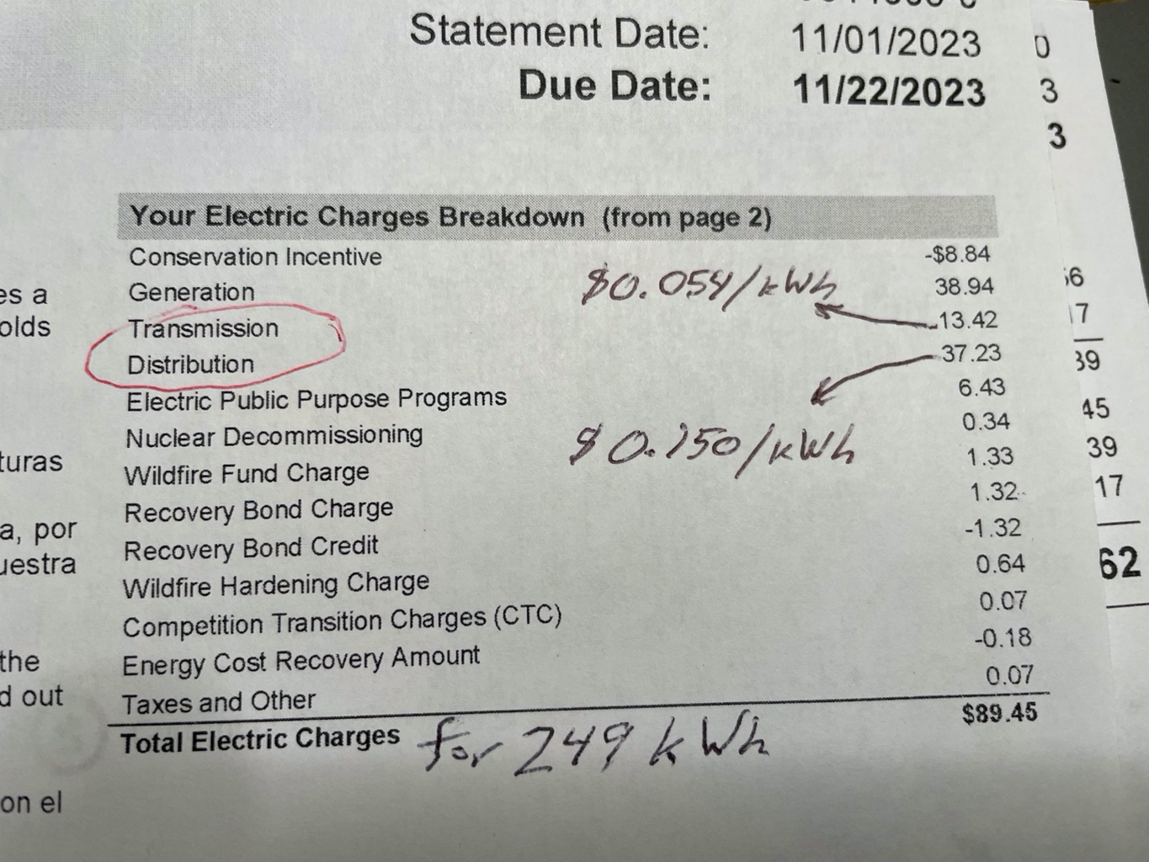

This screenshot equates the transmission and distribution charges to the price for having a product shipped or delivered, which is exactly what happens when the customer’s electricity is delivered via the grid from the RSP’s solar farm.

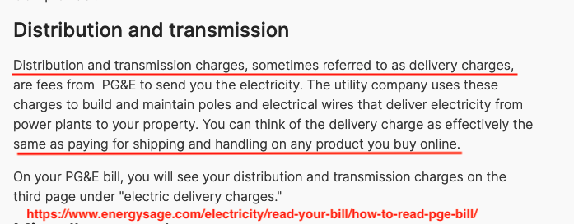

Setting the T&D fee for remote-solar will be one of the most important decisions the CPUC would need to make about remote-solar because it has so much influence on the financial benefits.

RSP’s operating and maintenance costs:
Maintenance costs should be low, but whatever they are they could be relayed from the RSP to the utility company and then on to the customer as a charge on his bill. O&M cost might include: ground maintenance, panel cleaning and repair, site security, insurance, property tax, and administration.

In compensation for these on-going RSP charges the customer would not face the costs of maintaining his own roof top system, or replacing it when his roof wares out. He may also avoid any insurance and property taxes otherwise paid for his roof-top solar.

The RSP’s fee for operating and maintaining the remote solar farm is set at 1-cent/kWh in these runs. This chart from Lawrence Berkley Lab is one justification for setting that value.

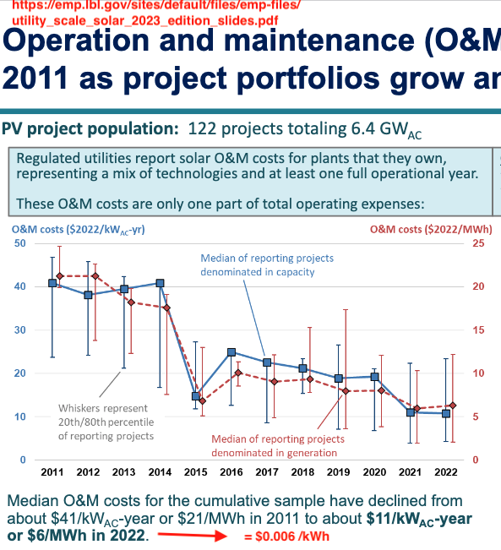

Payback and ROI calculations:
The estimates of a customer’s electric bill with remote-solar and without solar are sent to a section of the model where key parameters are summarized and the payback and ROI are calculated. The annual reduction in the customer’s electric bill from having remote solar is the main savings. However, the net benefit requires subtracting the T&D fee and the RSP’s fee for operating and maintaining the remote-solar farm. Dividing net benefit by total system cost yields the ROI, and dividing the total system cost by the net benefit yields the payback period in years. The system cost, payback and ROI from multiple runs are shown in the result tables and are also shown in the chart text boxes along with other key input variables.

Here is the section of the model where payback and ROI are calculated.

This concludes an explanation of how the MONTH model works along with the sources of data used. A brief description of how the much more complex HOUR model works is found in Appendix 1.

6. Financial Results

6.1 Introduction:
This section reports the results of using the MONTH model to estimate the capital cost, payback period and ROI for 1) an average California home, which consumes 6482 kWh per year, 2) the authors home with its load in 2022, and 3) a friend’s home with its load in 2023. Few actual homes probably have the same actual load profile as the average California home so modeling the profiles from the authors and a friend’s actual load profile adds realism to this exercise.

Recall that the Month model compares the total amount of solar energy generated by the customers remote-solar system over a month with the customers actual electrical consumption or load over that same month. To estimate the payback and ROI the model then applies the relevant TOU rates (40-cents/kWh off-peak, and 50-cents/kWh during the peak hours from 4 to 9 pm) for any grid power needed when load exceeds solar. Or when solar exceeds load it has the IOU give a NEM 3.0 credit (of 3-cents/kWh) for that excess.

If the author understands the billing term “netting interval” correctly the MONTH model in this whitepaper uses a netting interval of one month. That’s important since apparently NEM 3.0 uses a very short netting interval where solar generation is compared with load every hour or even much less, whereas with a month-long netting interval its compared every month. Apparently under NEM 1 and 2 the netting interval was at least a month and may have effectively been a year. Longer netting intervals benefit both rooftop and remote solar because they mitigate the number of times where a temporary surplus of solar is only given a small NEM credit whereas any deficit of solar racks up a charge for expensive grid power.

The author started by developing and using an HOUR model where the amount of solar generated was compared with the customers load every hour; and then the customer was charged retail TOU rates (40 or 50 cents/kWh) if load exceeded solar generation and given NEM credits (3-cents/kWh) when the reverse was true. The result was that the customer would incur a series of grid charges and NEM credits during a 24-hour day even when if his total solar generation equaled his total load during those 24-hours. This significantly reduced the financial benefits of solar and caused the author to propose that a tariff for remote-solar be based on a month-long netting interval rather than an hour-long interval.

Both the HOUR model and the MONTH model were combined and linked on one spreadsheet because the MONTH model needed to know how much of the power was subject to peak period rates vs. off-peak rates. The HOUR model generated that information and fed it to the MONTH model. Aside from that refinement the month MODEL is indifferent to what time of day the RSP injects the customers power into the grid because it cares only about the monthly total. However, to the overall power system it does make a significant difference. With a battery the customer could opt to have the battery discharge any time the sun was not shining. However, there is benefit in programming it to completely discharge just after sun-set in order to reduce the need to ramp up gas generation so rapidly. That issue is called the “duck curve” problem and was discussed earlier. The point here is that the HOUR model is most useful in showing how remote-solar could help mitigate the duck curve problem.

6.2 Results for an average California home

The table below shows the results from numerous runs of the MONTH model evaluating a range of array and battery sizes. The array size is the percentage of total annual residential load the remote-solar array was sized to offset. 100% meant the array was large enough to generate as much power annually as the house consumed. The battery size options in % are across the top. There was no-load for EV charging included in these runs.

The top value in each cell is the initial capital cost in dollars of the remote solar system assuming the federal tax credit of 30% will apply to remote solar. It includes the array and a battery if its selected. Next down is the number of years that annual savings take to payback the initial capital cost. The third value is the ROI in %/yr. The results largely speak for themselves: Low initial costs, rapid payback and high ROI.

This table is probably the most important exhibit in this whitepaper. The reader is urged to focus carefully on what those numbers imply in terms of affordably and in terms of how attractive an investment in remote-solar may be in comparison with other ways to invest.

It's obvious from this table that adding battery capacity significantly increases the capital cost of remote-solar, increases the payback period, and reduces the ROI. Still, all these alternatives are far less expensive than roof-top solar and should be accessible to lower income residents.

The author has highlighted the 100% solar with 30% battery (5.3-kWh in this case) battery configuration as his preferred alternative because it seems an attractive compromise between moderate capital cost with good ROI, and a battery large enough to help mitigate the need to ramp up gas generation after sunset. However, because it does cost more and have a lower ROI than the no-battery option while yielding no obvious benefit to the customer, the tariff may need to include some incentive or requirement for adding a battery if that is deemed desirable in the broader context.

It’s possible that locating some remote-solar batteries close to dense residential areas rather than out toward the central valley might make electrical service more resilient. That merits study.

The charts below show details from the 100% / 30% run in the cell with a red boarder. The green text boxes in these charts summarize the key variables used in that run.

Solar vs. load: The black line shows the average home consumption or load each month. The green line shows the power input to the grid by the RSP. In this case the remote solar array is sized to generate as much annual power as the home uses; namely 6482 kWh/yr. The battery is sized to store 30% of what the solar array generates daily. In this case the solar generates 17.7 kWh daily so the battery size is 5.3 kWh.

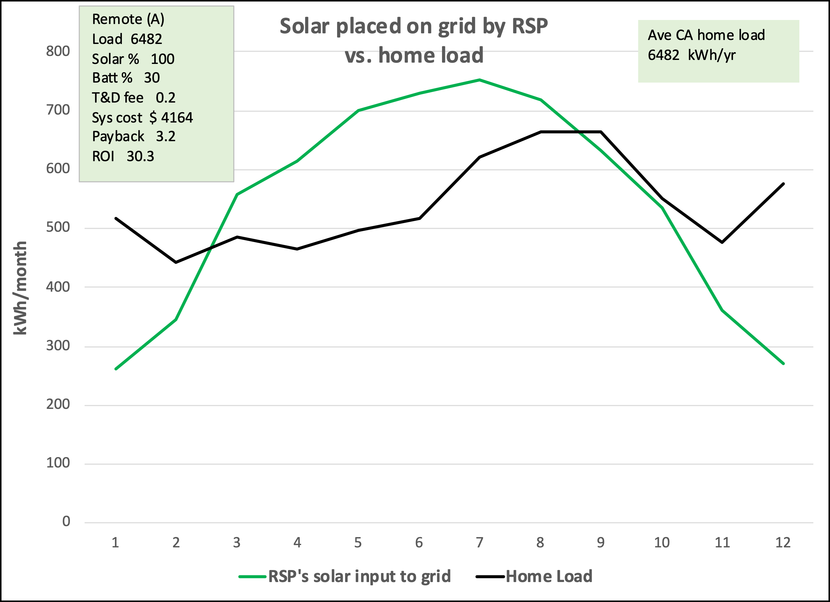

IOU treatment: This chart shows how the customers remote solar power -as reported by the RSP- was categorized when compared to the readings of load as reported by the customers electric meter. The IOU charged the regular rates for the grid power needed and gave NEM 3 credits for the NEM exports.

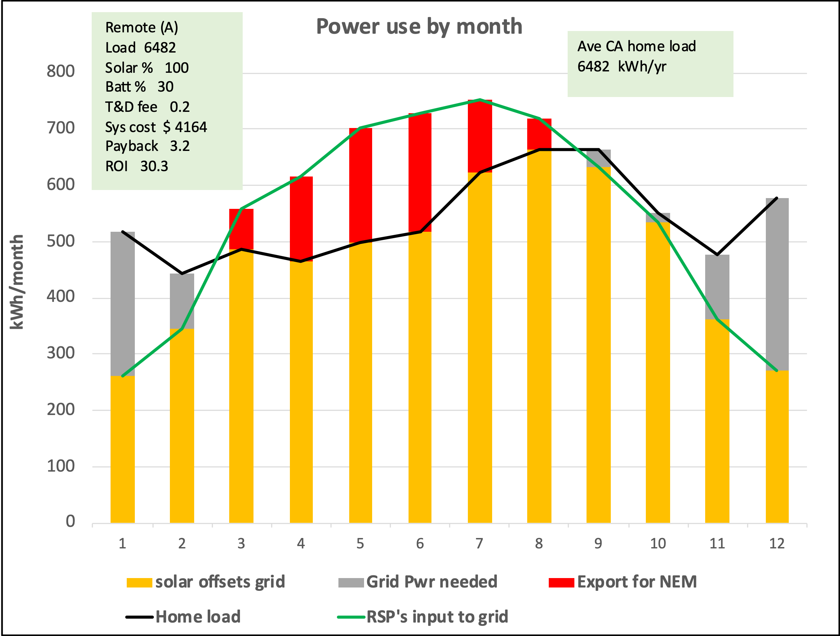

Monthly bills: This chart compares the monthly bills for remote-solar with what this average customer would have paid without any solar.

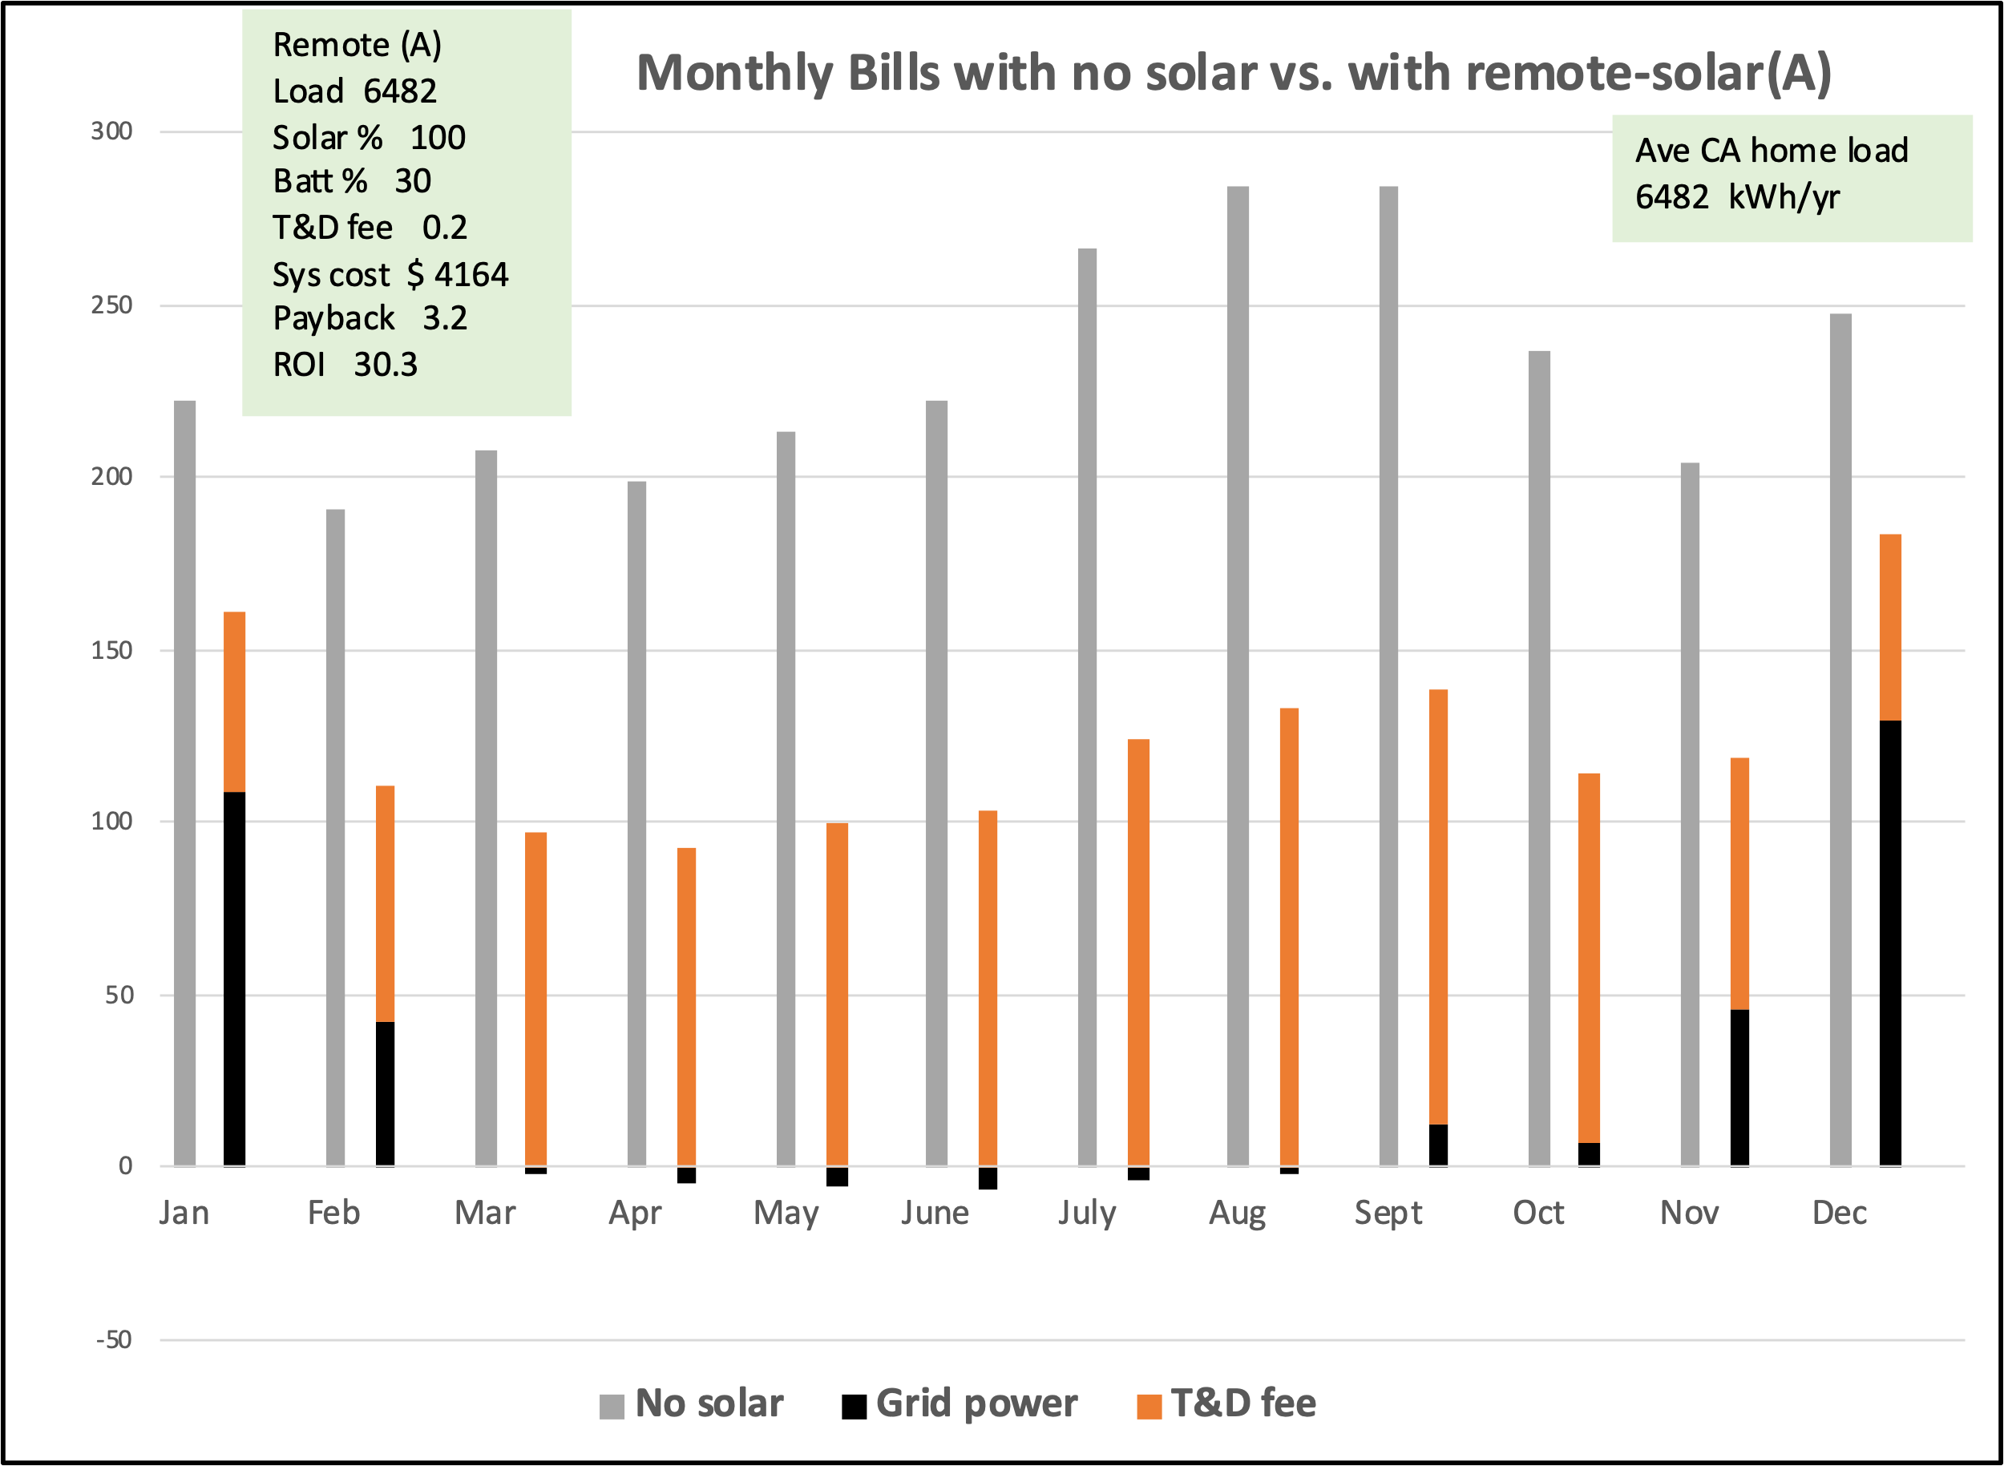

Annual bill: This chart compares the annual bills.

Cost breakdown: The total system cost of $4164 breaks down as follows: $2286 for the solar array, $1678 for the battery, and $200 for an escrow fee. Escrow is needed to hold prospective customers money until the RSP has enough customers to build solar farm.

Its readily apparent that the battery constitutes a large fraction of total system cost if indeed the customer elects to have one, or regulations require it. That’s why the configurations with no battery have a much higher ROI.

6.3 Results for author’s house

Our house has high reflection roof shingles, oversize attic vents, a whole-house fan and thus needs no air-conditioning. In 2022 we used 3338 kWh of electricity. A manual process is needed to populate these tables after each run. The trends are obvious so not all runs were made.

Comparing the cell with the red boarder with the same cell in the table for the average CA home shows this house had a similar payback and ROI, but since our home had a lower annual consumption (3338 vs. 6482 kWh/yr.) the array and battery were smaller and less expensive.

The charts below show details from the model run in the cell with a red boarder.

The black line shows our consumption or load each month. The green line shows the power input to the grid by the RSP on his behalf.

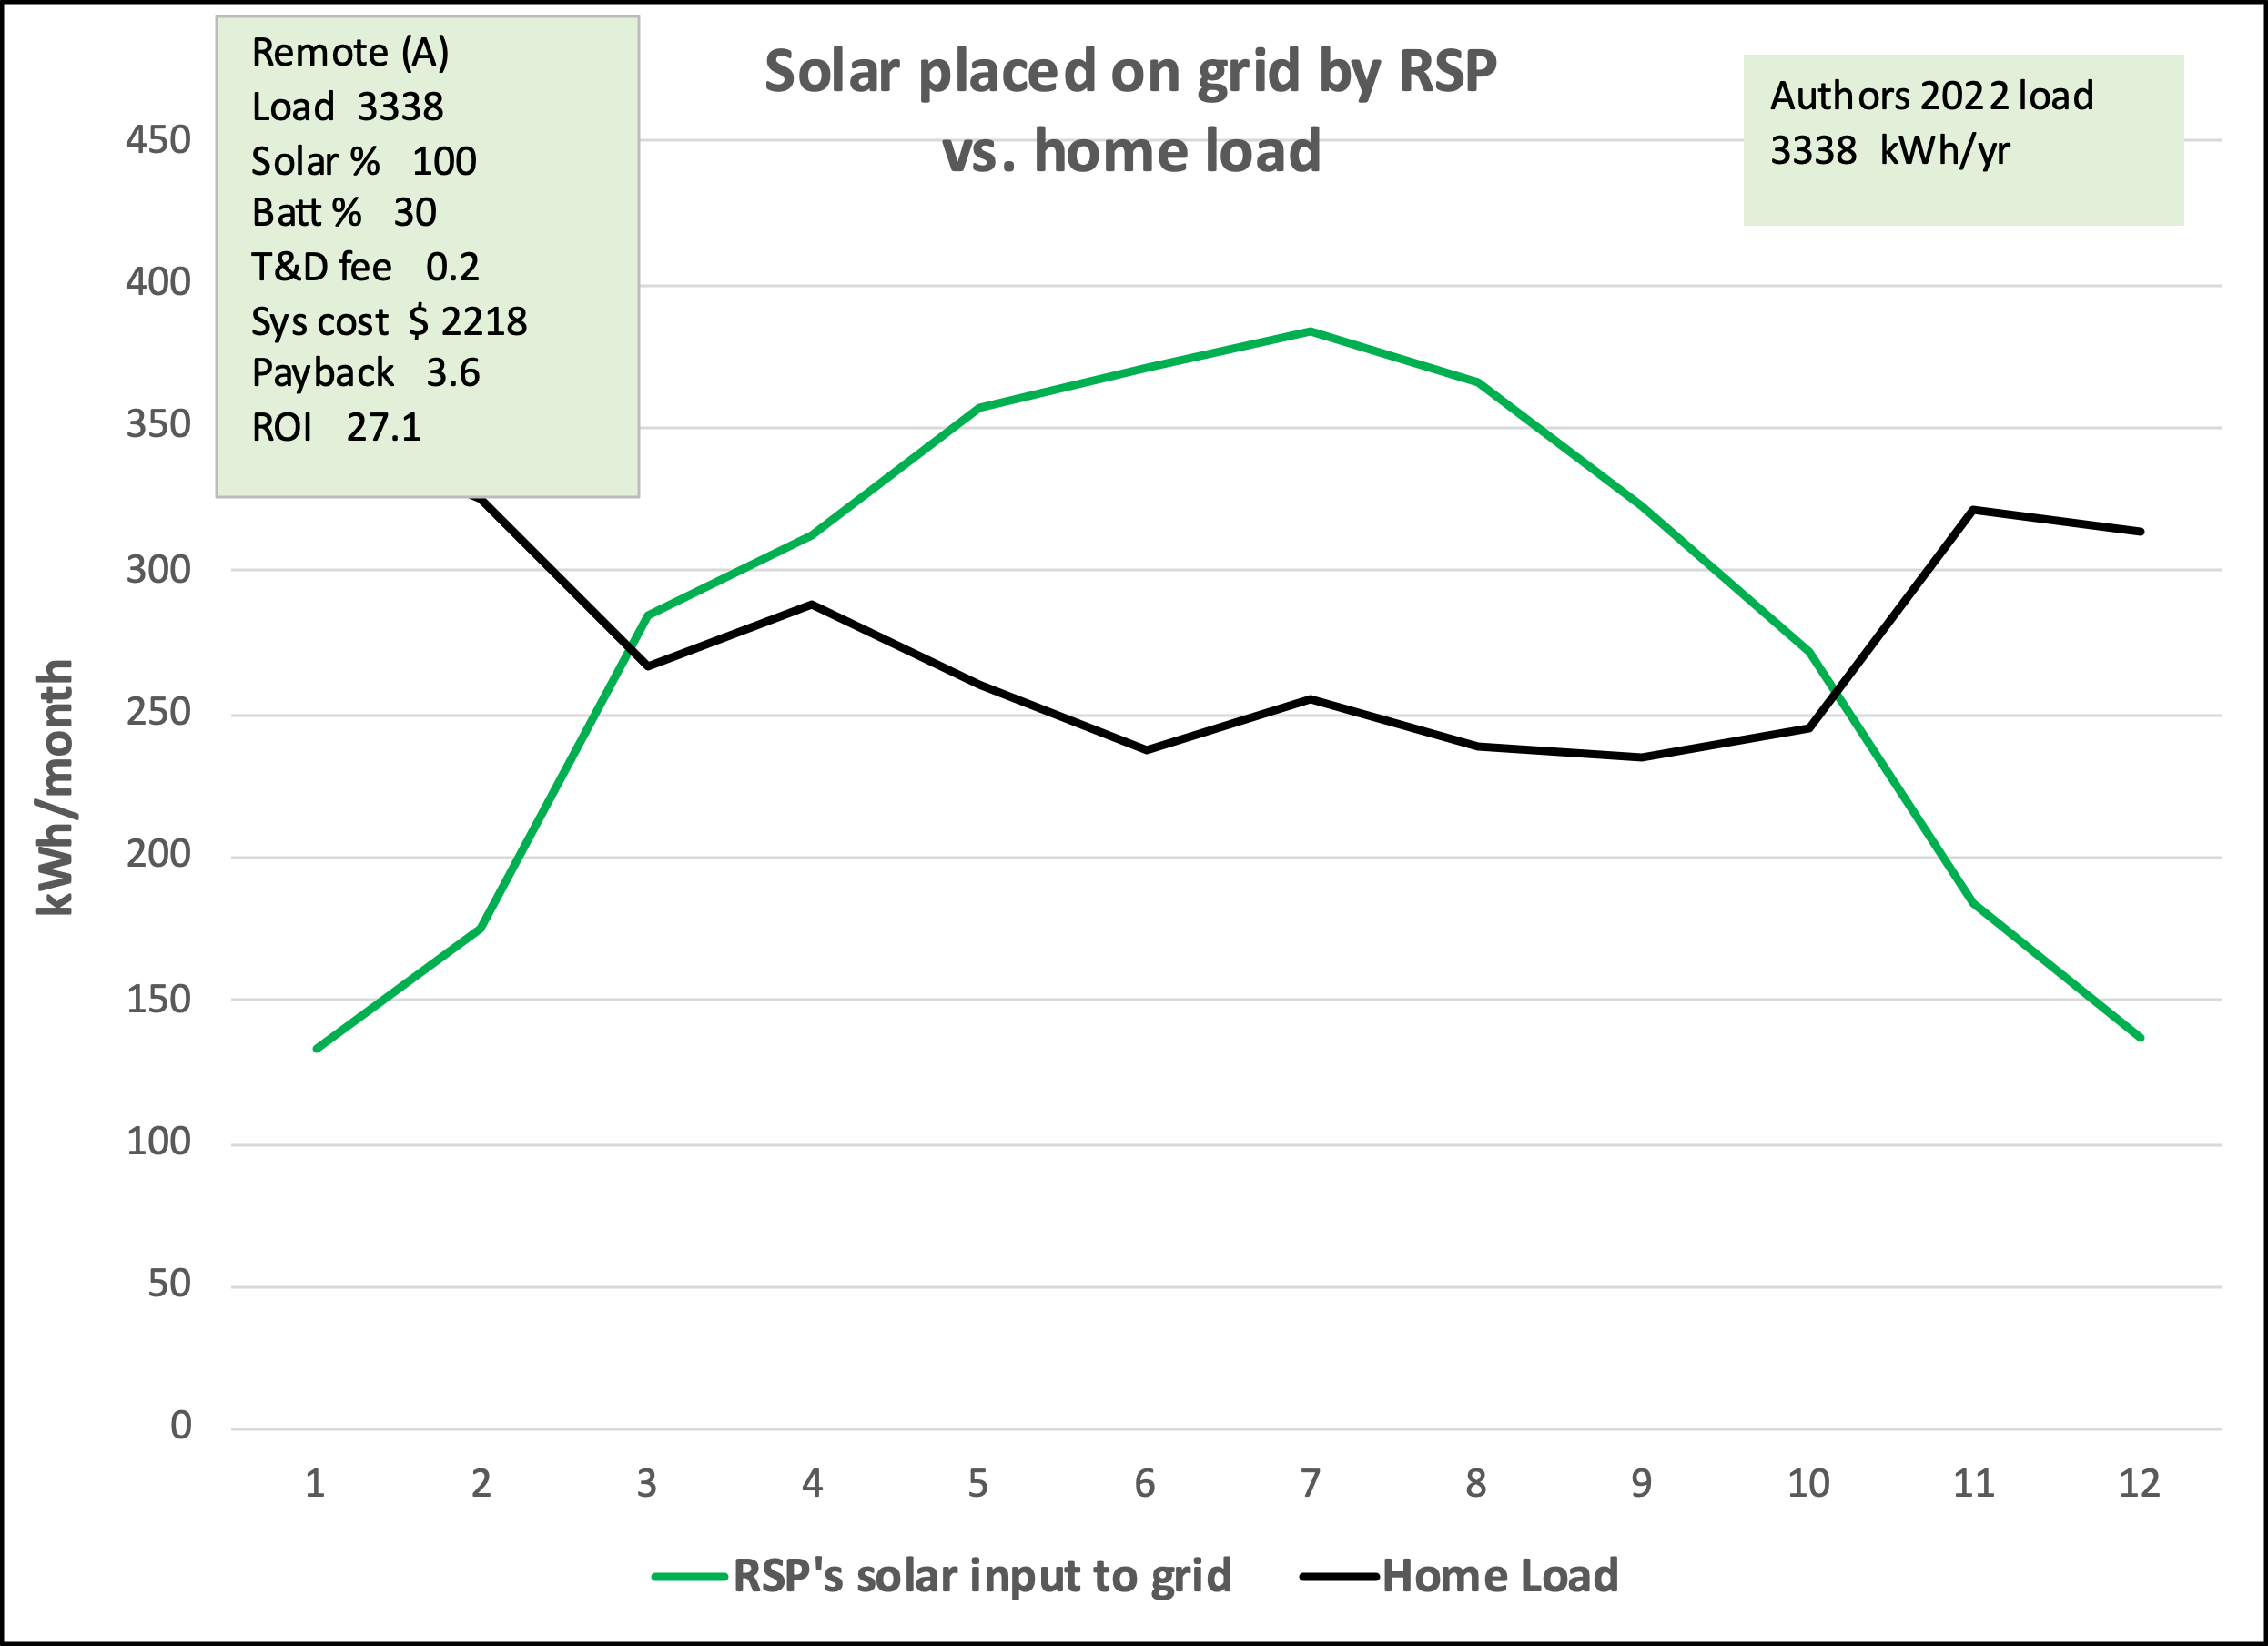

This chart shows how the customers remote solar power -as reported by the RSP- was categorized when compared to the readings of load or consumption as reported by the customers electric meter. The IOU charged the regular rates for the grid power needed and gave NEM 3 credits for the NEM exports.

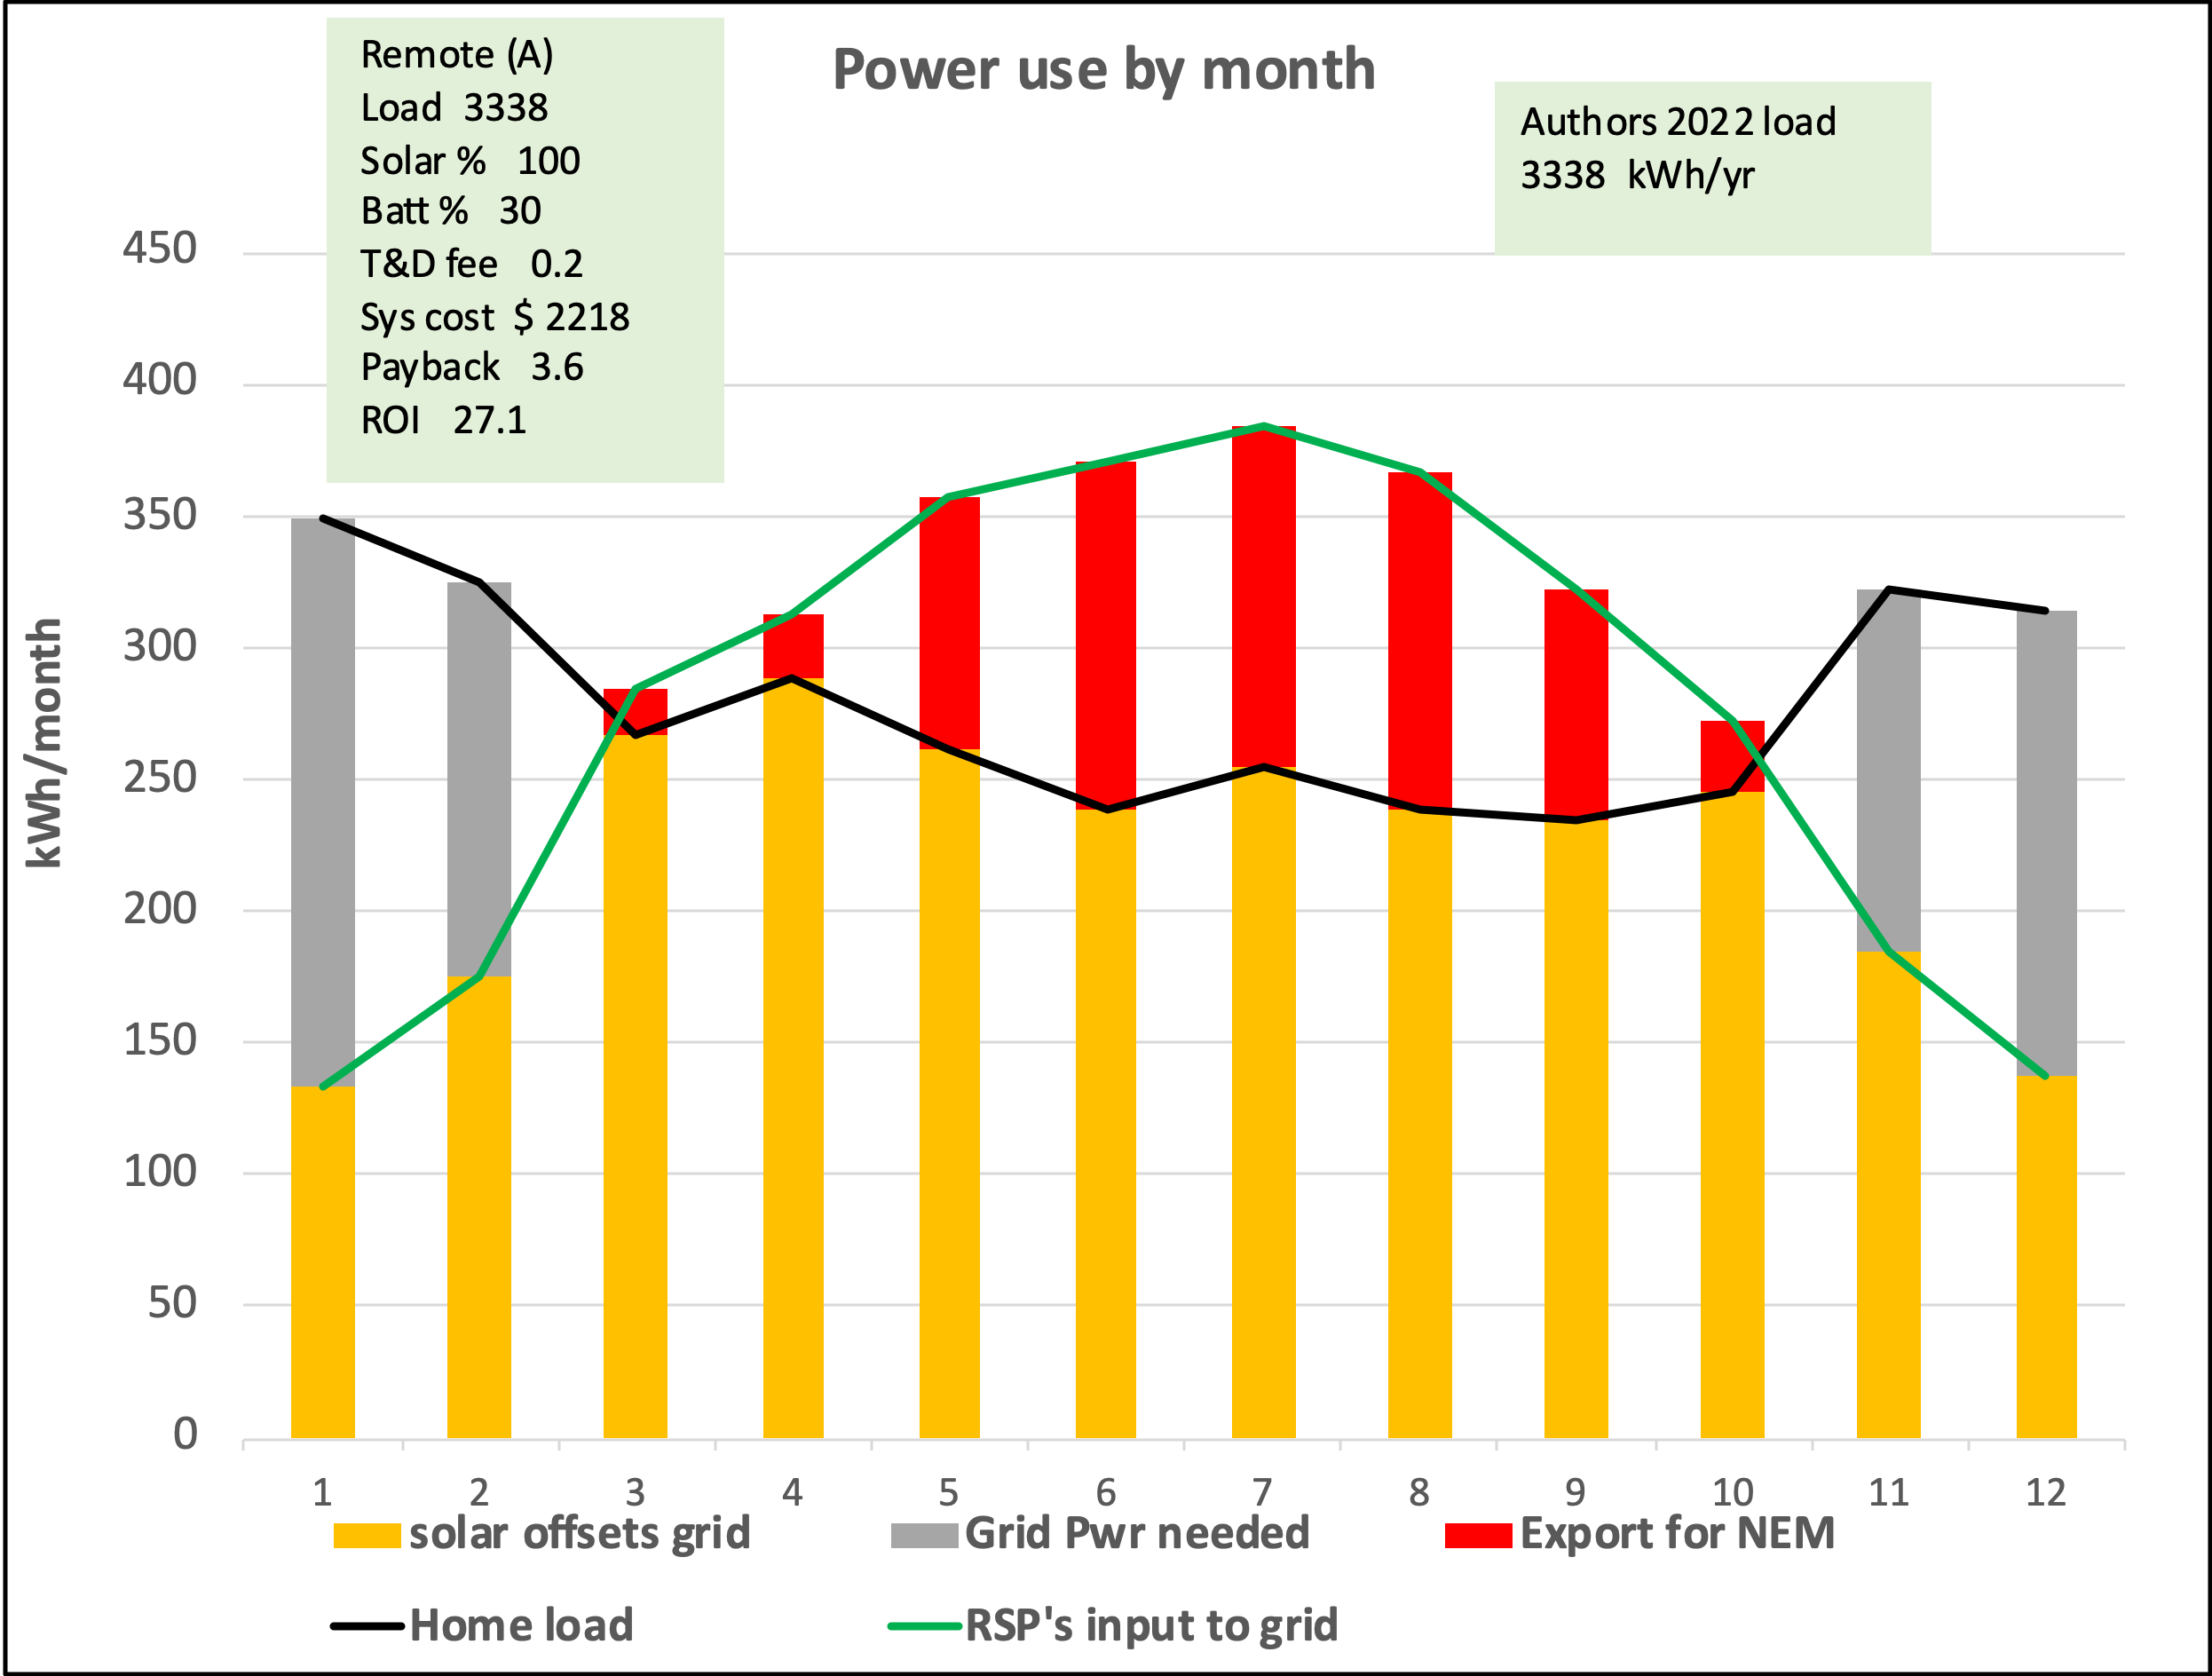

This chart shows the monthly bills from doing this as compared with what this customer would have paid without any solar.

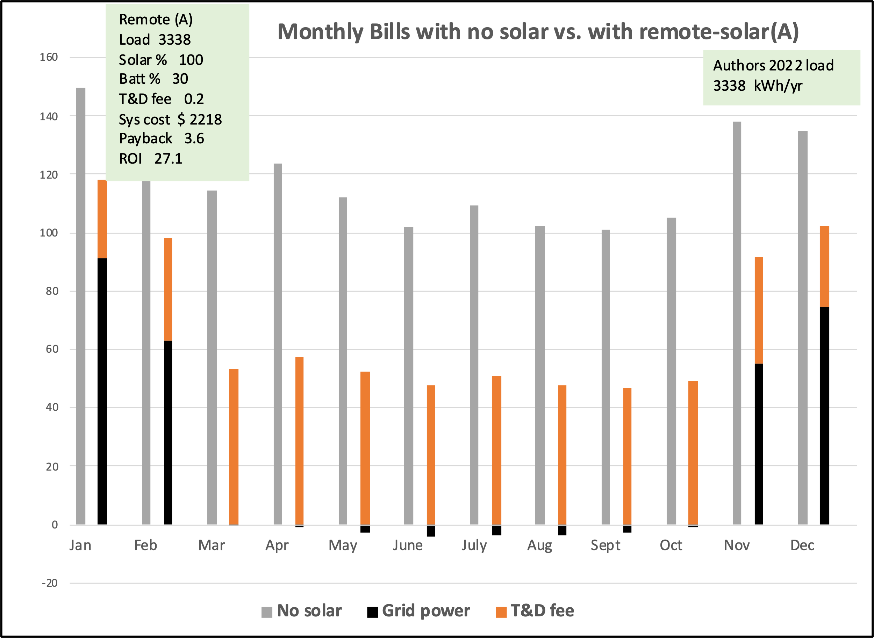

This chart compares the annual bills.

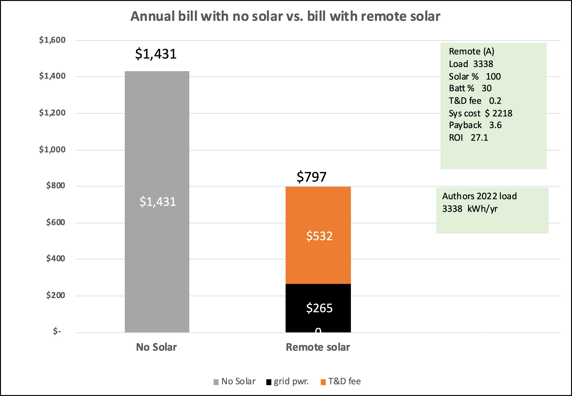

6.4 Results for a friend’s house

My friend’s house has air-conditioning. In 2023 his house used 8269 kWh of electricity.

The table below shows the results of modeling his situation.

Comparing the cell with the red boarder with the same cell in the table for the average CA home shows this house had a similar payback and ROI, but since the friend’s home had a higher annual consumption (8269 vs. 6482 kWh/yr.) the array and battery were larger and more expensive.

The charts below show details from the model run with a red boarder.

The black line shows the friend’s consumption or load each month. The green line shows the power input to the grid by the RSP on his behalf.

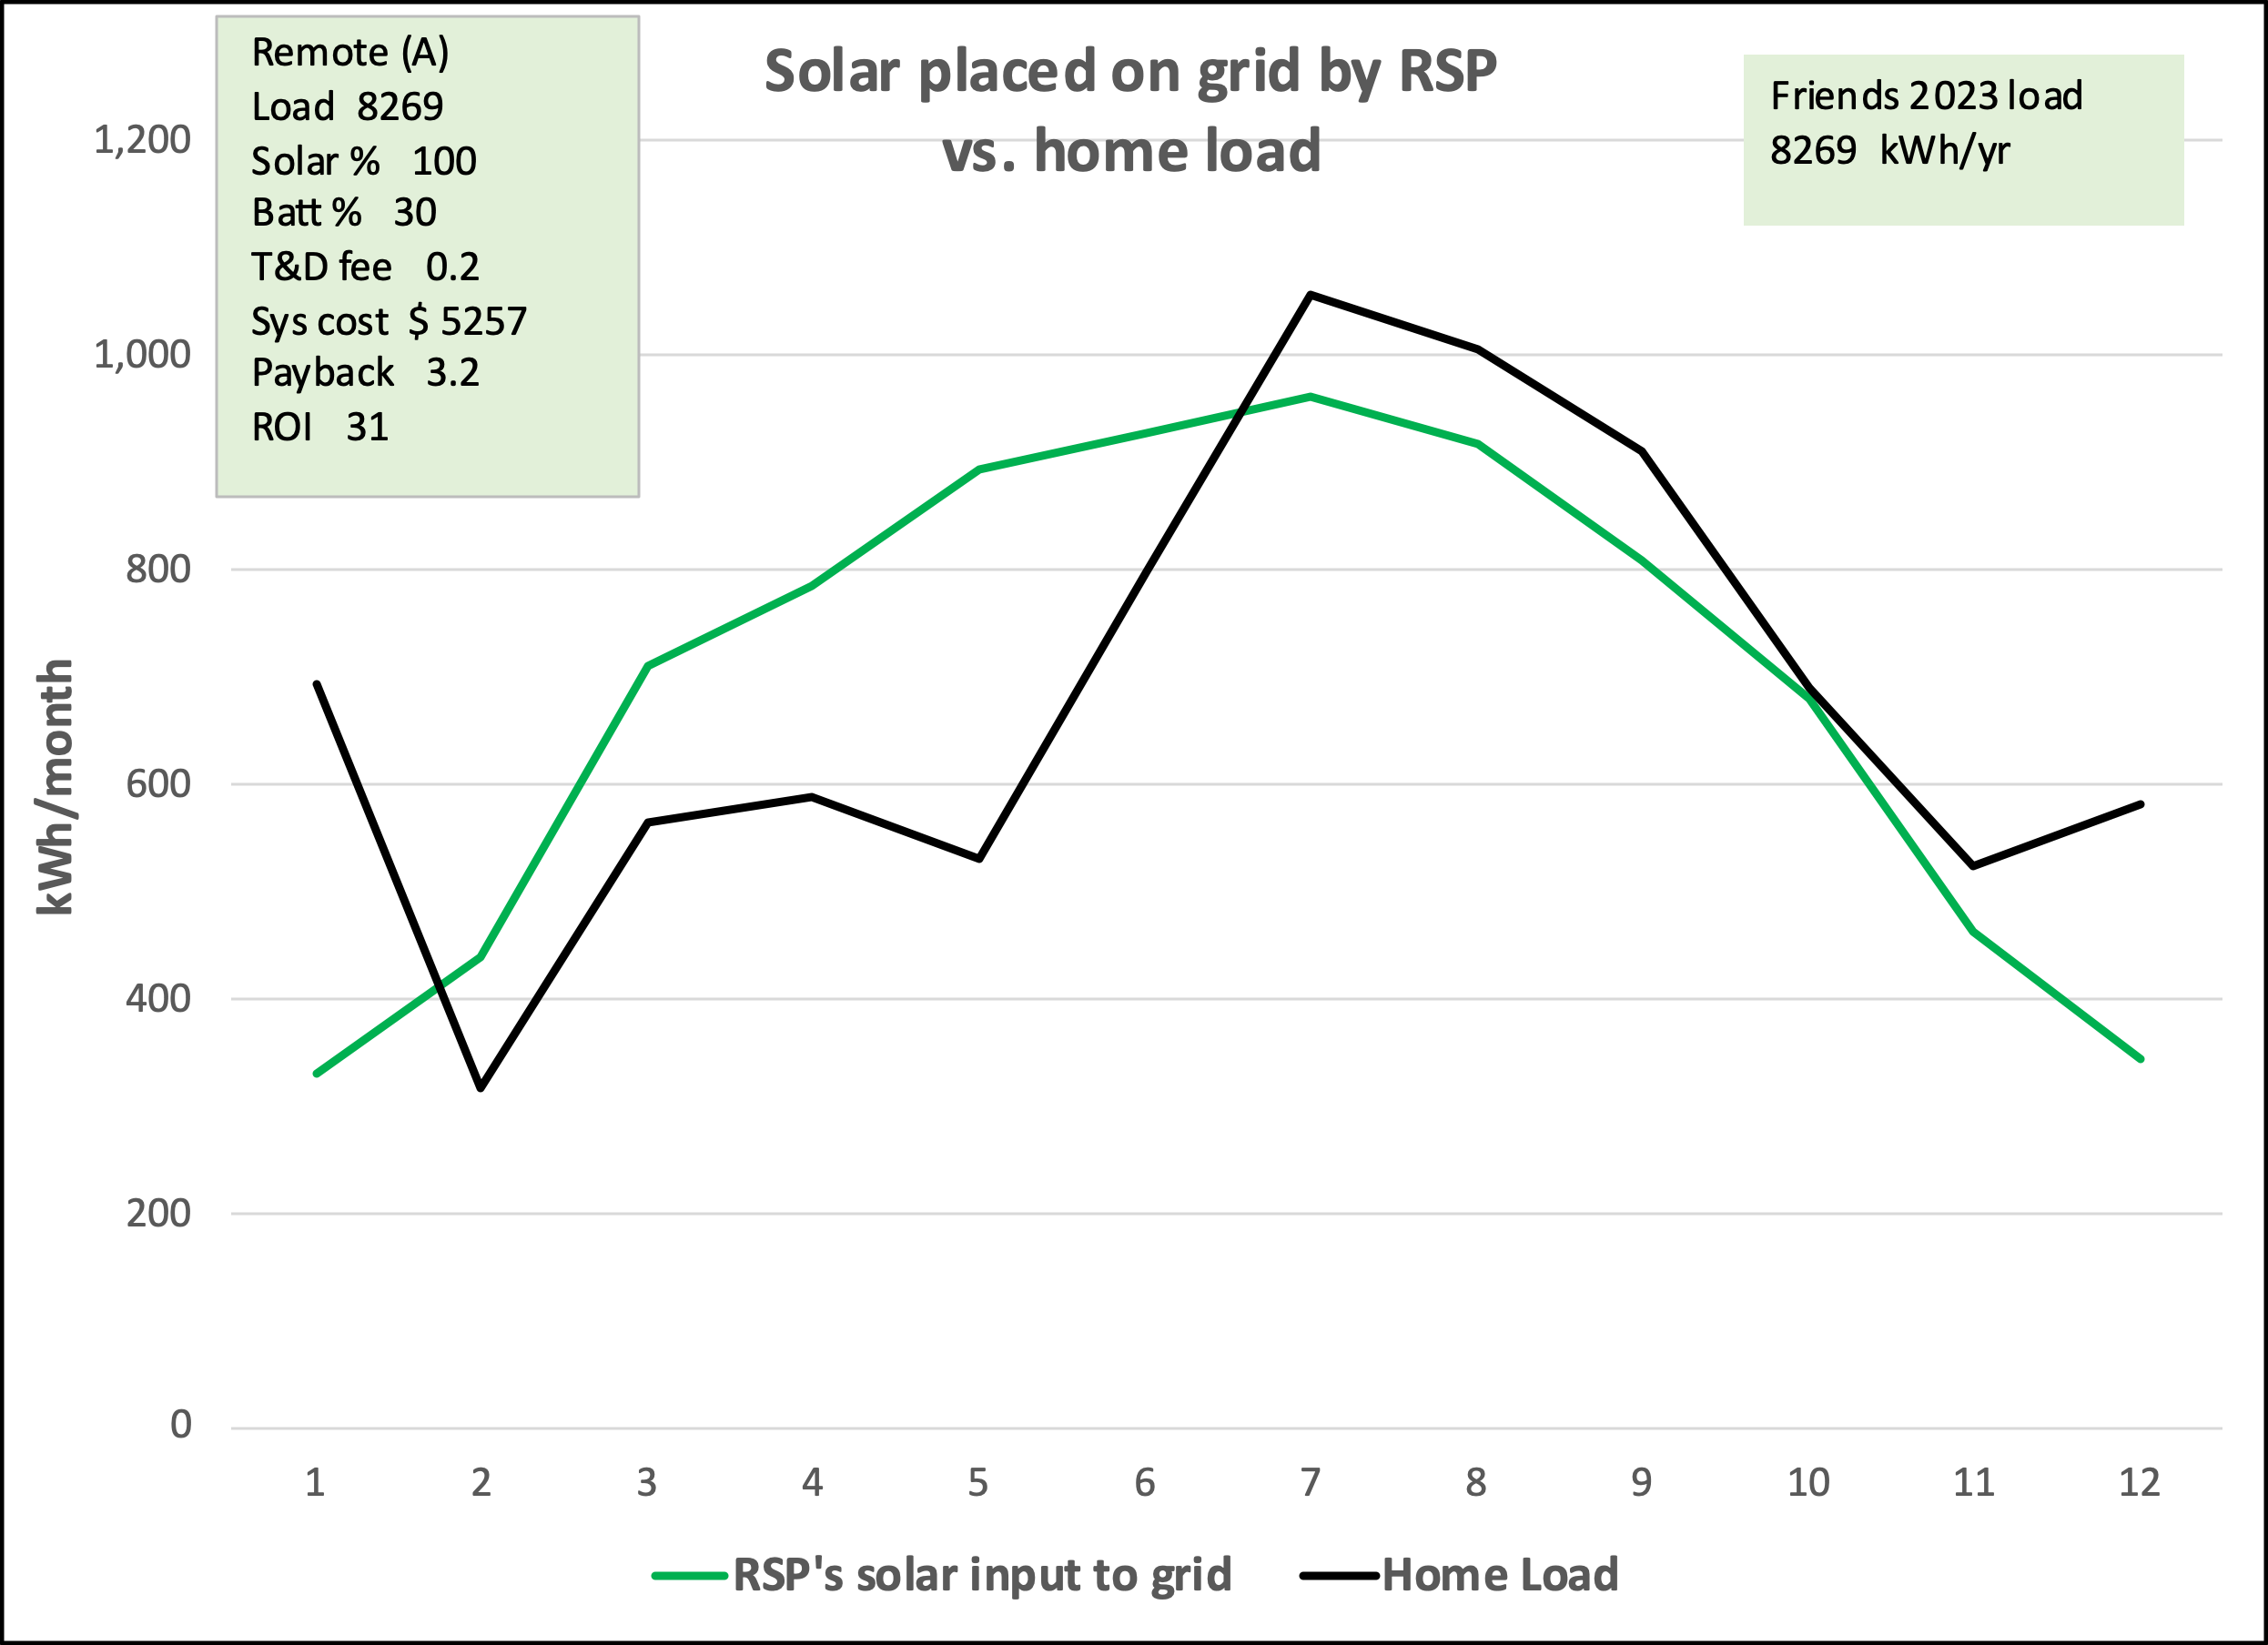

This chart shows how the customers remote solar power -as reported by the RSP- was categorized when compared to the readings of load or consumption as reported by the customers electric meter. The IOU charged the regular rates for the grid power needed and gave NEM 3 credits for the NEM exports.

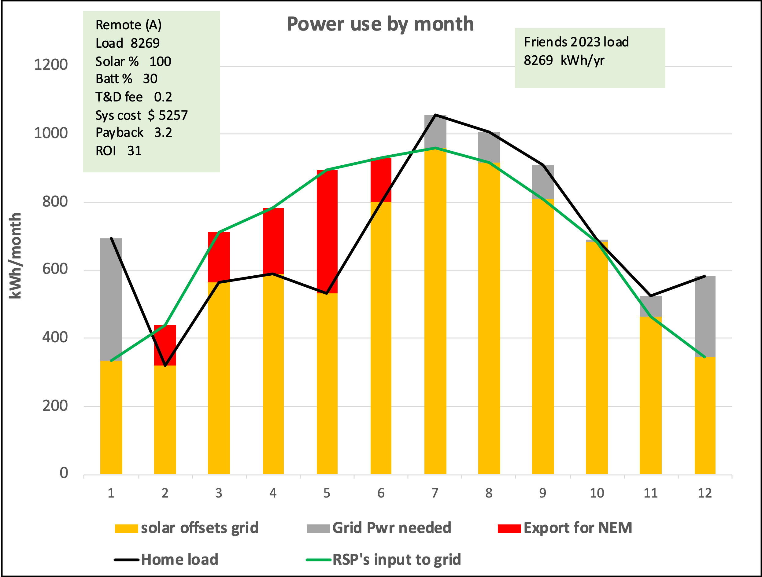

This chart shows the monthly bills from doing this as compared with what this customer would have paid without any solar.

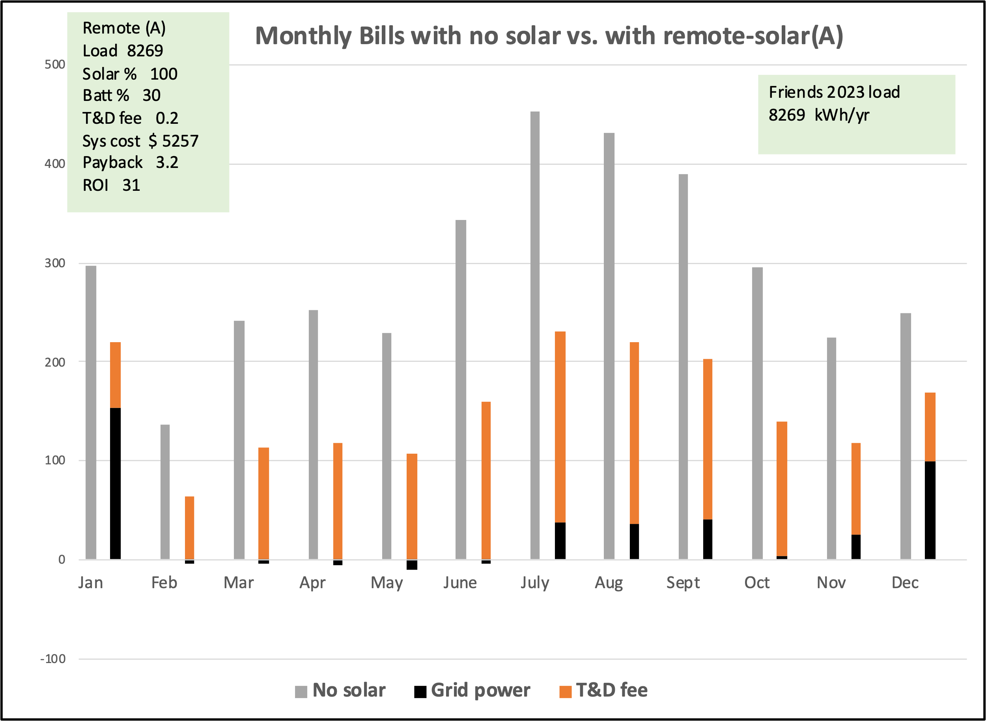

This chart compares the annual bills.

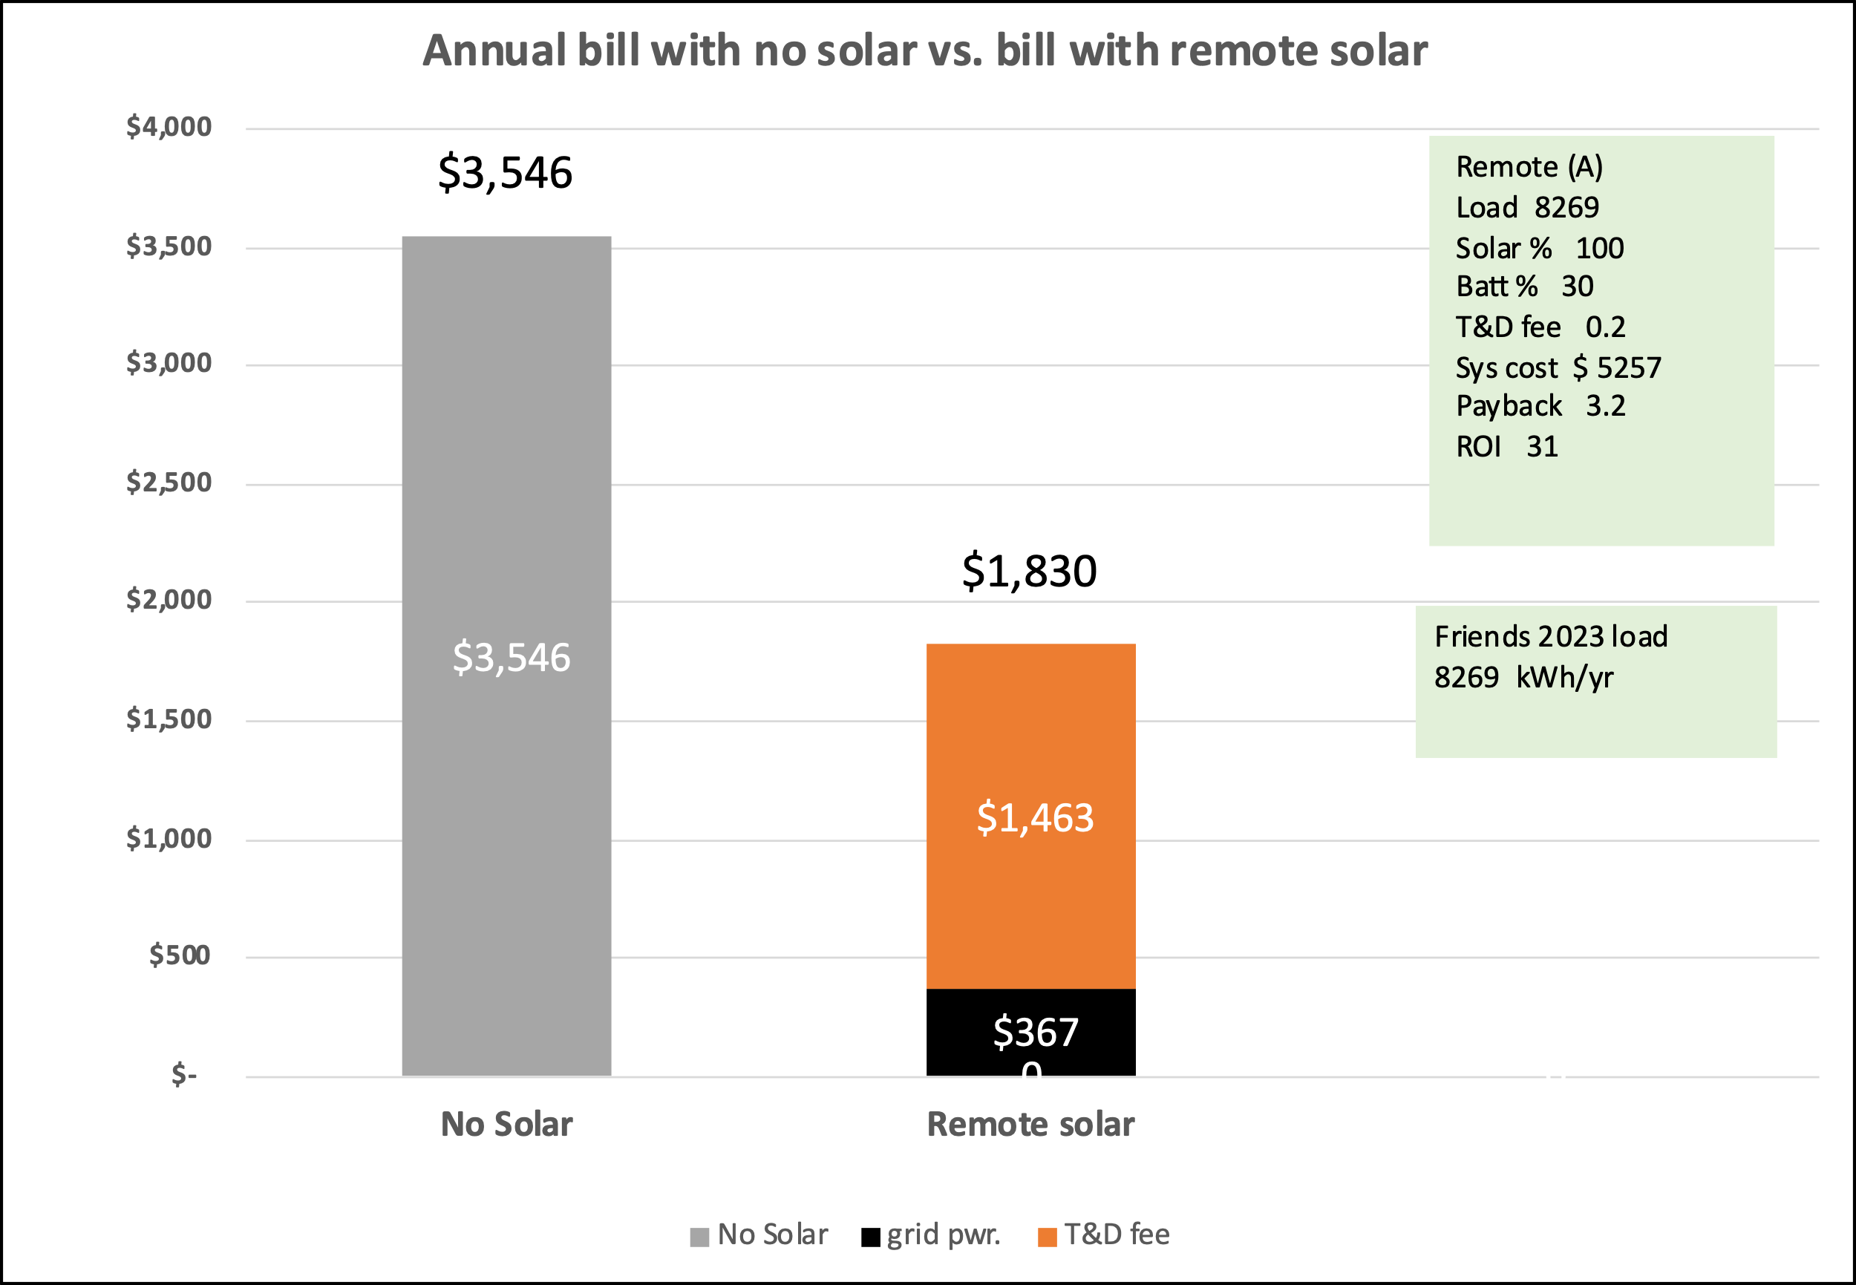

6.5 More actual samples desirable:

In vetting this concept of remote solar it would be desirable to run a model like this for a moderately large sample of actual home consumption profiles to see how much individual paybacks and ROIs would differ from the results in this whitepaper. Anyone can obtain their own profile by going into the usage statistics in their IOU account, but only the IOU’s can access usage date from multiple accounts so their help would be needed.

6.6 Sensitivity analyses:

6.6.1 T&D fee:
All runs reported in this whitepaper used a T&D fee of 20 cents/kWh. This table shows the results of using different T&D rates. Its apparent that the magnitude of the T&D fee has a large impact on the financial attractiveness of remote-solar. To put this in context under NEM 1 and 2 rooftop customers apparently pay little or nothing toward the utilities cost of maintaining the grid if their system is sized large enough -as many apparently are- to zero-out their electric bill.

Applies to system with ave. CA load of 6482 kWh/yr, with 100% array and 30% battery
0 | 5 | 10 | 15 | 20 cents/kWh | 25 | 30
$ 4164 1.7 yrs 57.4 % | $ 4164 1.9 yrs 50.7 % | $ 4164 2.2 yrs 43.9 % | $ 4164 2.6 yrs 37.1 % | $ 4164 3.2 yrs 30.3 % | $ 4164 4.2 yrs 23.5 % | $ 4164 5.9 yrs 16.7 %

6.6.2 Federal tax credit
All run results reported in this whitepaper assume the federal tax credit of 30% would apply to the remote-solar array and battery. This shows the financials if it does not apply.

Applies to system with ave. CA load of 6482 kWh/yr, with 100% array and 30% battery
Federal Tax credit of 30% does apply to remote-solar array and battery | FTC of 30% does not apply to remote-solar
$ 4164 3.2 yrs 30.3 % | $ 5863 4.6 yrs 21.5 %

6.6.3 Size of annual home load

Only the financial results for a home load of 6482 kWh/yr. (the average CA home), 3328 kWh/yr. (my home) and 8269 kWh/yr. (a friend’s home) are reported in this whitepaper. Here are the results of using several other size loads assuming each has the same monthly load profile as the average CA. household. They will differ from the results from modeling my load and a friends load because our monthly load profiles were different from that of an average CA household. The base case is shaded blue.

Applies to system with 100% array and 30% battery. Results with different total annual household loads in kWh/yr., but all with the same monthly profile as average CA house.
1000 | 2000 | 3000 | 4000 | 5000 | 6000
$ 811 4.1 yrs 24 % | $ 1423 3.6 yrs 27.3 % | $ 2034 3.4 yrs 28.7 % | $ 2646 3.3 yrs 29.4 % | $ 3258 3.3 yrs 29.9 % | $ 3869 3.3 yrs 30.2 %
6482 | 8000 | 10,000 | 12,000 | 15,000 | 20,000
$ 4164 3.2 yrs 30.3 % | $ 5092 3.2 yrs 30.6 % | $ 6316 3.2 yrs 30.8 % | $ 7539 3.2 yrs 31 % | $ 9374 3.2 yrs 31.1 % | $ 12432 3.1 yrs 31.3 %

6.6.4 Unit cost of remote-solar array

All the runs reported in this whitepaper used a cost for the remote-solar array in the utility-scale solar farm of $1280/kWac or $1.28/Wac. This table shows results if that cost were 30% higher ($1.66/Wac, or 30% lower ($0.90/Wac).

For household with average CA total load of 6482 kWh/yr. 100% array and 30% battery
$0.90/Wac | $1.28/Wac | $1.66/Wac
$ 3485 2.7 yrs 36.2 % | $ 4164 3.2 yrs 30.3 % | $ 4843 3.8 yrs 26 %

7. Greenhouse gas savings

It’s well known that increasing the amount of electric power generated by renewable sources like solar, wind, and geothermal reduces the need to use greenhouse gas (GHG) emitting sources like natural gas or coal fired generation. Since remote-solar promises to be an attractive investment it should increase the amount of solar in California’s power mix. This leaves two less obvious points to make. First, applying the Federal Tax Credit of 30% to remote-solar would provide much more bang for the buck than applying it to rooftop solar. Second, when remote-solar includes battery storage it not only helps mitigate the aforementioned “duck curve problem” but in addition saves more GHG than remote-solar without a battery.

The Federal Tax Credit: This is best explained by an example. The 100% array + 30% battery run featured in this whitepaper estimated the capital cost of both a rooftop and remote-solar system that would generate the same amount of solar energy the average California residence uses in a year; namely about 6482 kWh. The result is that a rooftop array capable of producing 6482 kWh/yr. would cost about $21,000 and a 10-kWh battery to go with it would cost about $13,000 more for a total cost of $34,000 before applying any tax credit. A 30% Federal Tax Credit on that amount would cost the taxpayers about $10,200. In short, by spending $10,200 taxpayers could incentivize a homeowner to install a rooftop system that generated 6482 kWh of clean power per year, and saved whatever amount of GHG that would accomplish.

In contrast the array for a remote-solar system sized to generate 6482 kWh/yr. would cost about $3300 and the 30% battery an additional $2400 for a total system cost before tax credit of about $5700. A 30% tax credit on that system would cost taxpayers about $1700.

Thus spending $1700 to incentivize a remote-solar system would save the same amount of GHG as spending $10,200 to incentivize a rooftop solar system. This means taxpayers could get about 6 times more bang (ie: GHG savings) for the buck by applying tax incentives to remote-solar as they get from the current scheme of applying the FTC to rooftop solar. The same ratio would apply to any similar California state incentives.

Greenhouse gas and the duck curve problem: It was mentioned earlier that remote-solar with battery storage could reduce the need to rapidly ramp-up other sources of power as the sun-sets, and among other benefits that would save GHG. Here is a closer look at the GHG aspects. The first CAISO chart below shows that natural-gas fired power plants rapidly increase production as the sun sets, and so does California’s import of electricity from the northwest and southwest. All of the natural gas emits GHG, but the second CAISO chart shows that imported power is also dirty and emits about as much GHG as the in-state natural gas plants do. The critical hours when this switchover occurs are highlighted by the dotted-line box. The dim yellow line shows that the state’s power system is already using discharge from large-scale batteries to reduce the need for natural gas generation and imports. Remote-solar makes the package of array+ battery inexpensive enough and attractive enough as an investment so that if remote-solar becomes a reality it could supplement what those existing utility-scale batteries are accomplishing in terms of reducing GHG emissions. The key to making this happen is to make solar arrays and battery storage attractive enough financially so that much more of both will enter the states electrical system. Thus the idea of making remote-solar a packages of array+battery.

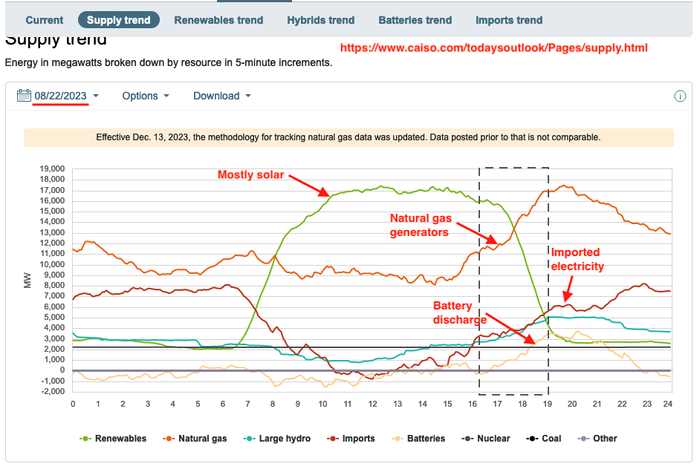

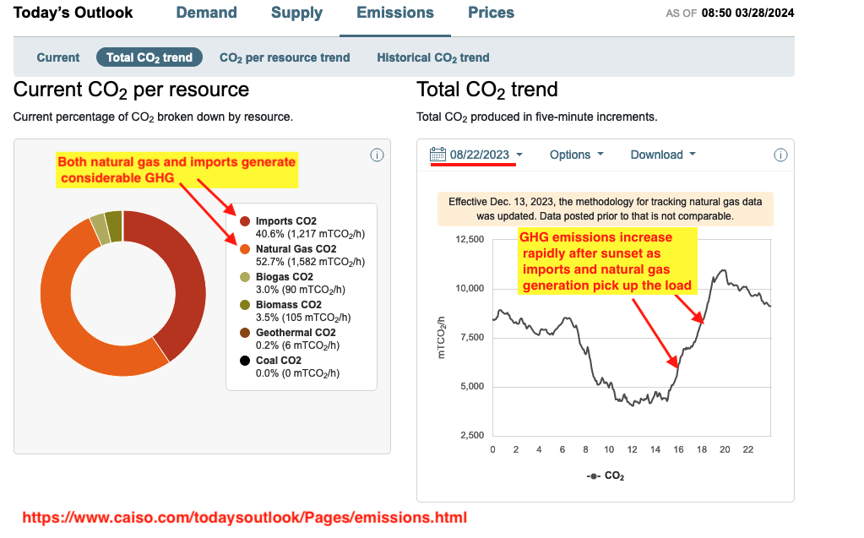

8. Conclusions:

Remote-solar’s low up-front cost, rapid payback and high ROI would likely motivate many if not most homeowners to purchase it, thus leading to far more solar power being generated and presumably far more GHG being saved.

Remote-solar could help achieve a number of stated California goals beside increasing the amount of renewable energy. They include making solar more accessible and affordable to lower income residents and renters, and lowering the cost of new homes.

By virtue of its low cost remote-solar could be deployed widely enough to reduce the need to rapidly ramp-up GHG emitting natural-gas fired power plants and import GHG intensive power from other states.

The fee that utilities would charge to -in effect- transport the remote solar customers electricity thru the grid could have a large impact on the financial attractiveness of remote-solar and would need to be set by the CPUC.

Remote-solar is nothing new technically since power is currently being generated in utility-scale solar farms and sent thru the grid to consumers. And utility companies like PG&E, SCE, and SDGE already have processes for billing solar that could be easily adapted for remote-solar.

Remote-solar may require a new tariff to set the appropriate rules and rates.

Remote-solar is just a concept at this time. As a retired person working alone and without compensation the author has no resources to promote this concept beyond sending it to hopefully interested parties. I put this whitepaper in their hands for any further action.

The next step would be for experts in the power industry to vet this concept or ROM level whitepaper and if no significant errors in fact or logic are found forward it to policy-makers at the California Energy Commission, CARB, CPUC, and state legislators for their consideration as a new offering.

Beyond that a pilot trial of remote-solar -involving perhaps several hundred customers- may be appropriate.

As with any new idea some will make excuses why it can’t be done,
but progress depends on leaders finding excuses for why it CAN be done.

---------------- end of main report --------------
Appendix 1: The HOUR model and results from using it.

Overall structure:
The HOUR model has two main components: Remote(A) and Remote(B). Remote(A) discharges any battery energy to best offset the customer’s load. Remote(B) discharges all the battery energy just as the sun sets in order to best reduce the need to ramp up alternate and GHG intensive power sources.

Remote(A) has four sub-components: One models a two-day load sample in March, the others do the same for June, September and December.

The screenshot below shows part of the March subcomponents of Remote(A) to indicate the complexity of the HOUR model. This part is used to calculate the amount of remote-solar energy the RSP will put on the grid on the customers behalf as the RSP tried to satisfy the customers usual daily load while assuming that load has the hourly profile of the average California residence. It does that because the RSP has no visibility of the customers actual load profile. Thus the RSP exports what it thinks most customers would find a good average. This RSP export will be compared with the actual customer load later in the model.

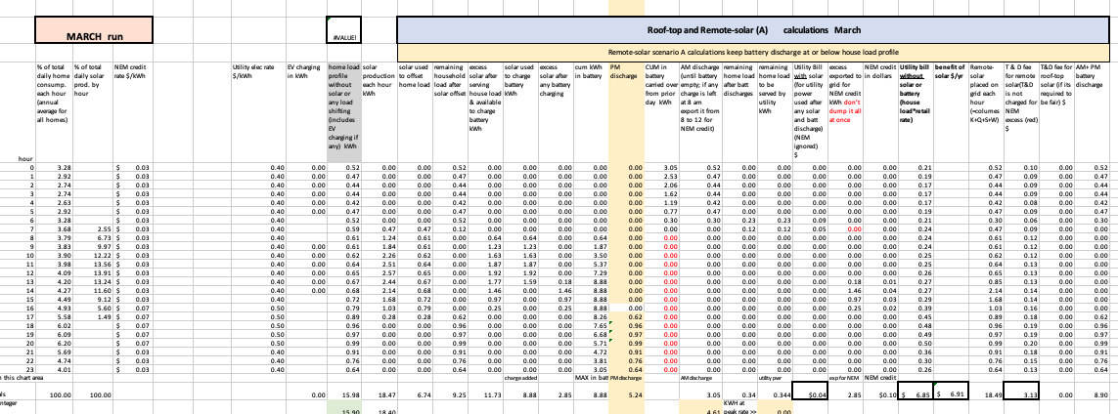
Basic logic of HOUR model: The model proceeds in these steps

1) 24-hour profiles of solar generation in kWh/hr. are input for the months of March, June, September and December.

2) 24-hour profiles of the household consumption or load in kWh/hr. of the average California residence are input for the months of March, June, September and December.

3) The model proceeds hour by hour to determine how the load is satisfied by solar and grid power as follows.

- in the morning when no solar is being generated the model satisfies the load using grid power
- when the array starts generating power its used to help satisfy the load and grid power is used to make up any shortfall
- if and when solar completely satisfies the load midday the excess is used to charge the battery
-when the battery is full any excess solar is exported into the grid for NEM credits
-when the sun begins setting the load is satisfied first by whatever solar is available and then by battery discharge. This evening battery discharge continues into the evening until the battery is exhausted. Then grid power is used again.
-If the battery still has energy after satisfying the evening load it is used to satisfy load the next morning.

4) The model computes what the customers electricity charge would be if he or she had no solar. It’s based on the TOU off-peak and peak rates. (simplified as 40 and 50 cents/kWh)

5) The model determines how much grid power is used each hour with remote-solar and computes what the utility would charge for it, again using the TOU rates. It also determines how much excess power is exported into the grid to receive NEM 3.0 credits.

6) The model totals up the amount of power in kWh that the RSP imports to the grid each hour on behalf of the customer. That’s a combination of solar power directly from the array plus any discharged from the battery. In reality the RSP would report this via a data feed to the utility company. This total is also used to compute the customers T&D and O&M charges.

7) An hour-by-hour profile of the energy the customer actually consumes is input to the model. The base case assumed it was the same as the average California residence, but another run was made using the authors actual consumption for the 1st and 15th of March, June, September and December.

8) The model mimics what the utility would do to compute the customers electric bill by comparing each hour the customers actual consumption or load -as read by the electric meter- with the power input by the RSP on that customers behalf.

9) The model computes hour by hour the charge for any grid power used, or give a NEM 3.0 credit for any RSP power exported in excess of what the customer used. The HOUR model used a NEM credit of 3 cents/kWh for off peak power and 7 cents/kWh for peak period power.

10) These hourly charges or credits from the March, June, September and December sub-models are multiplied to compute the customers total annal electric bill.

11) The difference between the customers electric bill with remote solar and without is considered his or her annual electric bill savings from having remote-solar.

12) The model multiplies the total KWH that the RSP imports to the grid on the customers behalf by the applicable T&D and O&M fees to get a total annual value for the T&D and O&M charges.

13) The annual T&D and O&M charges are deducted from the annual savings in electric bill to get a net annual savings from having remote-solar.

14) The net annual savings are divided into the total system cost to get the payback period. The reverse is done to get the ROI.

The charts used in the above process are shown below.

1) A 24-hour profile of solar generation in kWh/hr. is input for the applicable month; March, June, September or December.

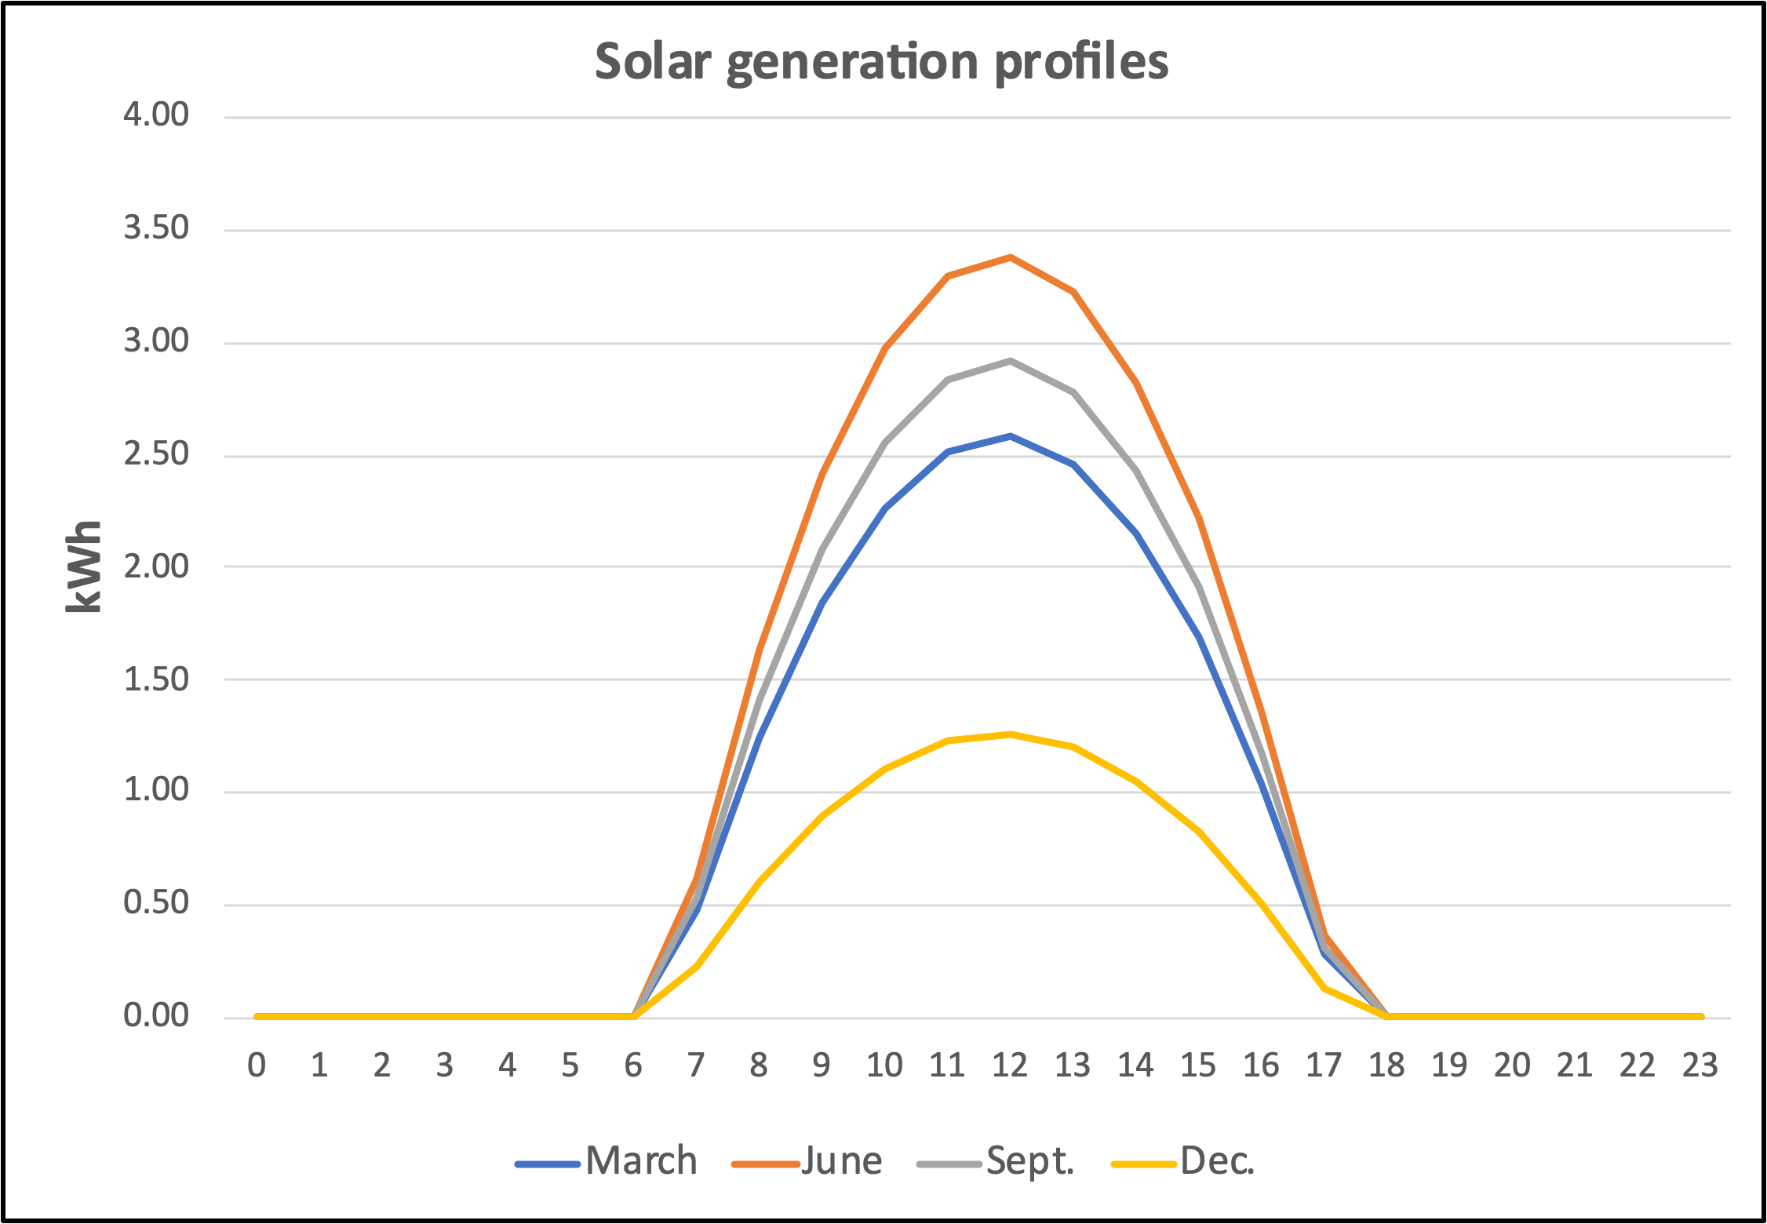

2) A 24-hour profile of the consumption or load in kWh/hr. of the average California residence is input for the applicable month; March, June, September or December.

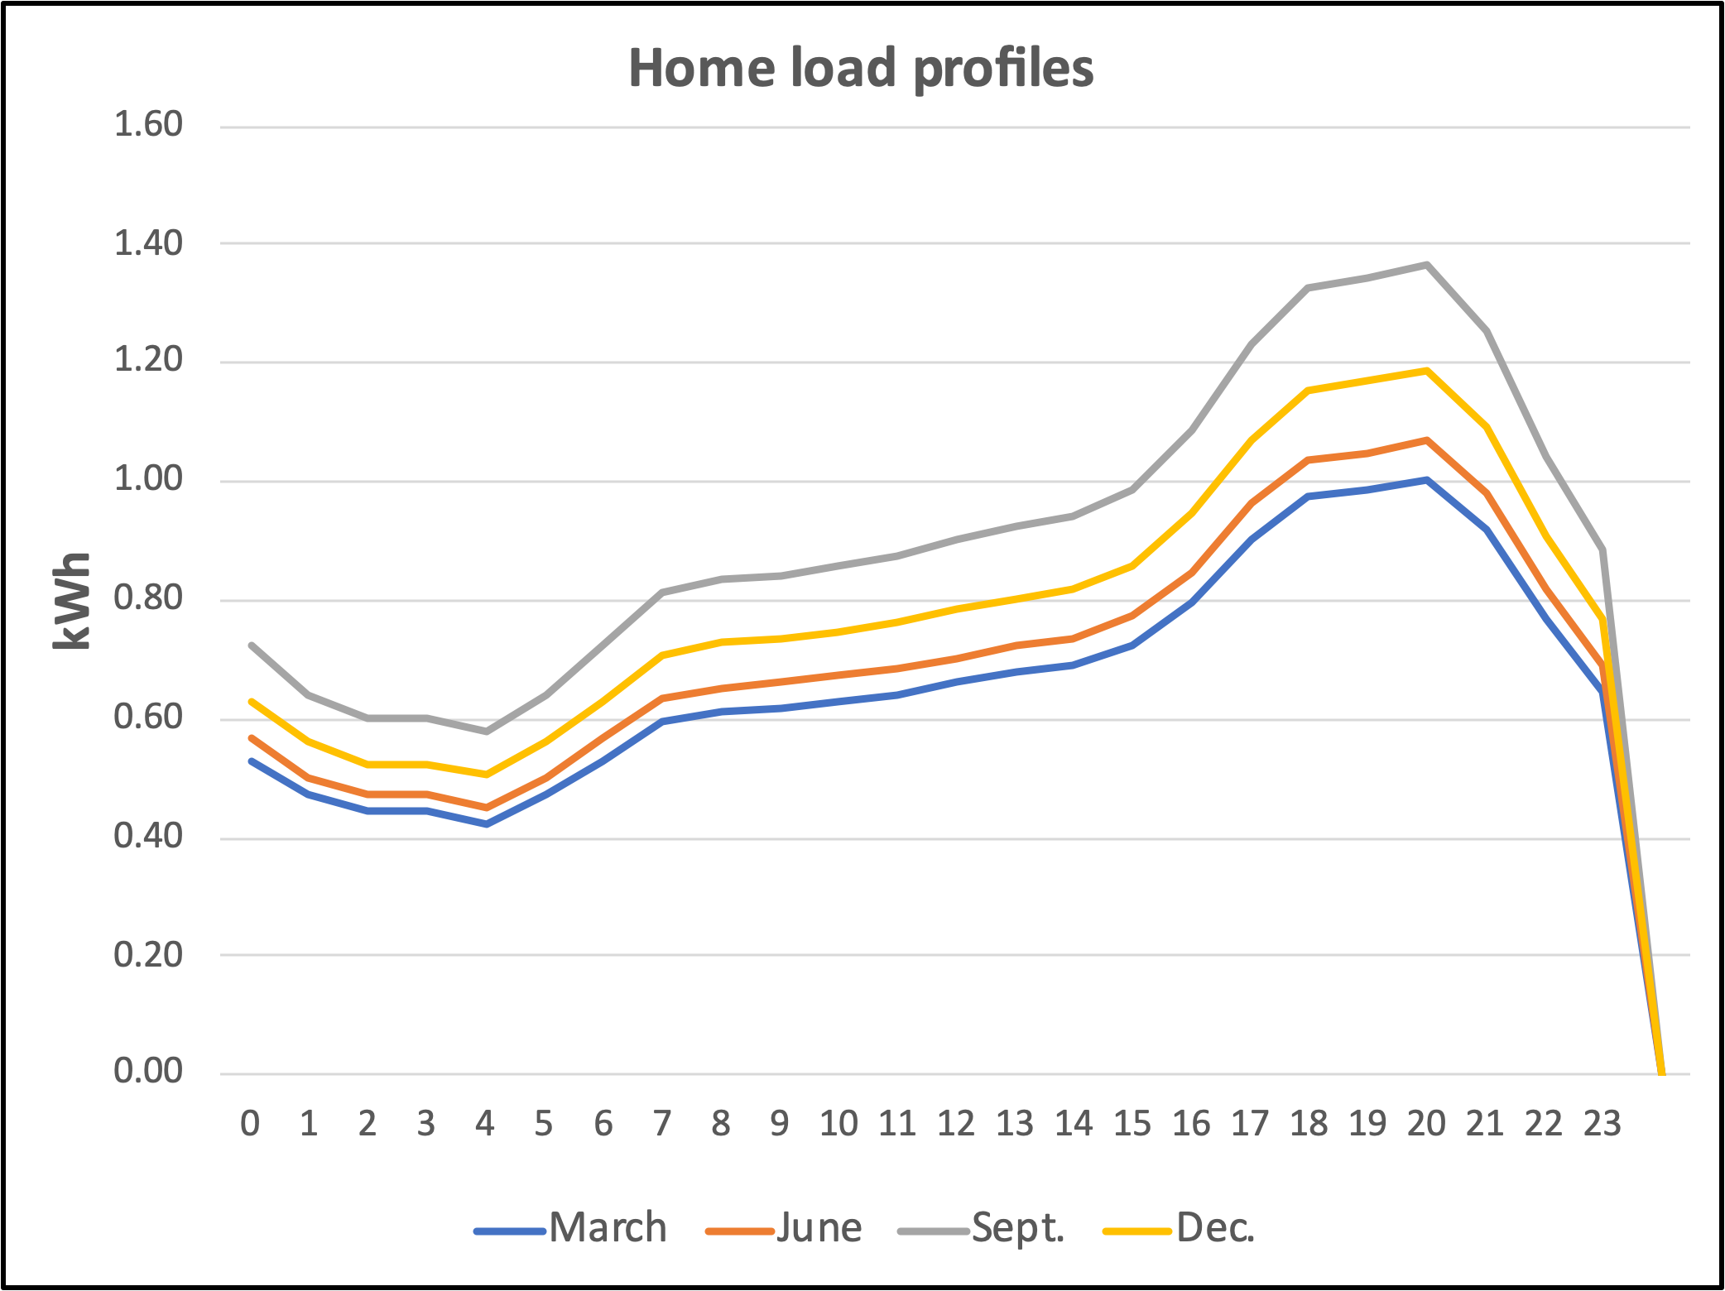

This next chart shows the source used for determining the shape of the above load profile curves.

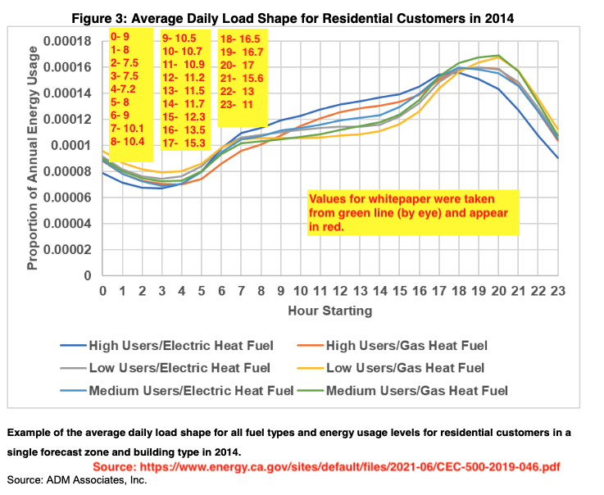

And this chart shows that the total daily load varied by season. These shapes were not used in the model because they were not specifically for residential load. Instead, the average residential load curve above was simply adjusted up or down to reflect the seasonal variation.

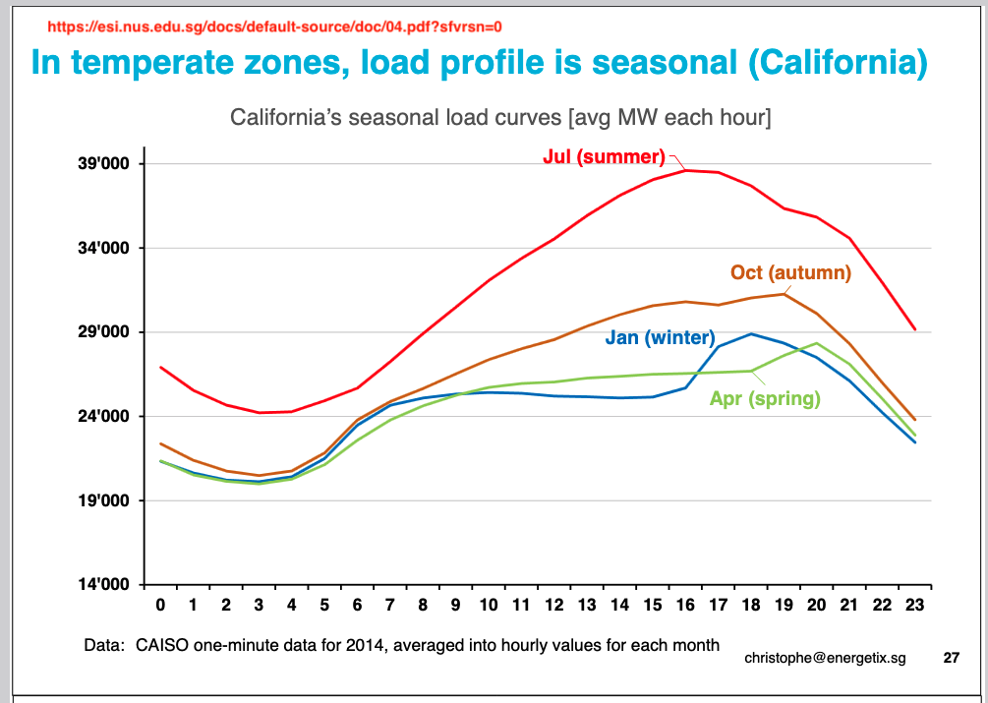

3) The model proceeds hour by hour to determine how the average residential load is satisfied by solar and grid power.

This screenshot is a closeup of part of the calculations for Rooftop and Remote(A). Information about benefits in $/day are in the lower right cells.

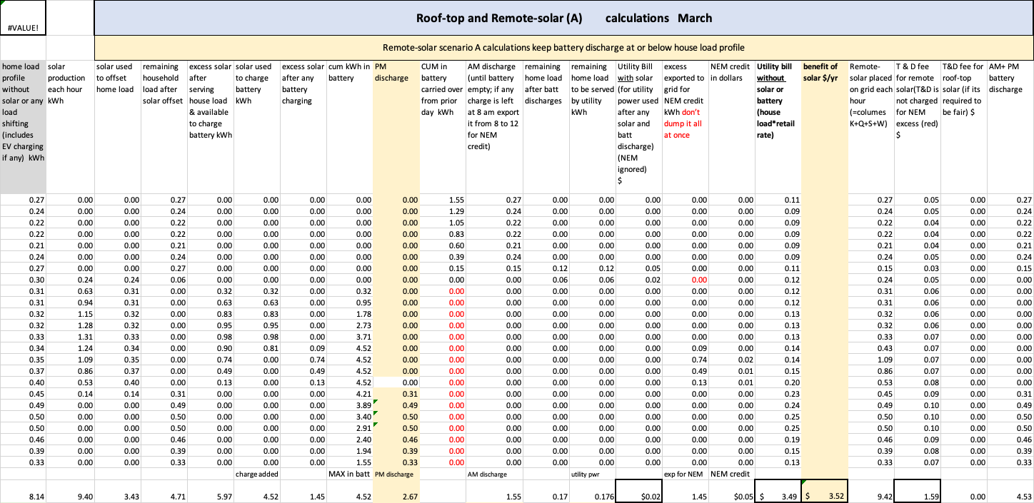

Modeling process: The modeling process proceeds in the following steps. Refer to the charts below to follow it. This first chart shows that in March the battery discharge was able to offset almost all the evening lad and most of the next morning load. Recall that these charts are from the run that estimated financials for the author’s home.

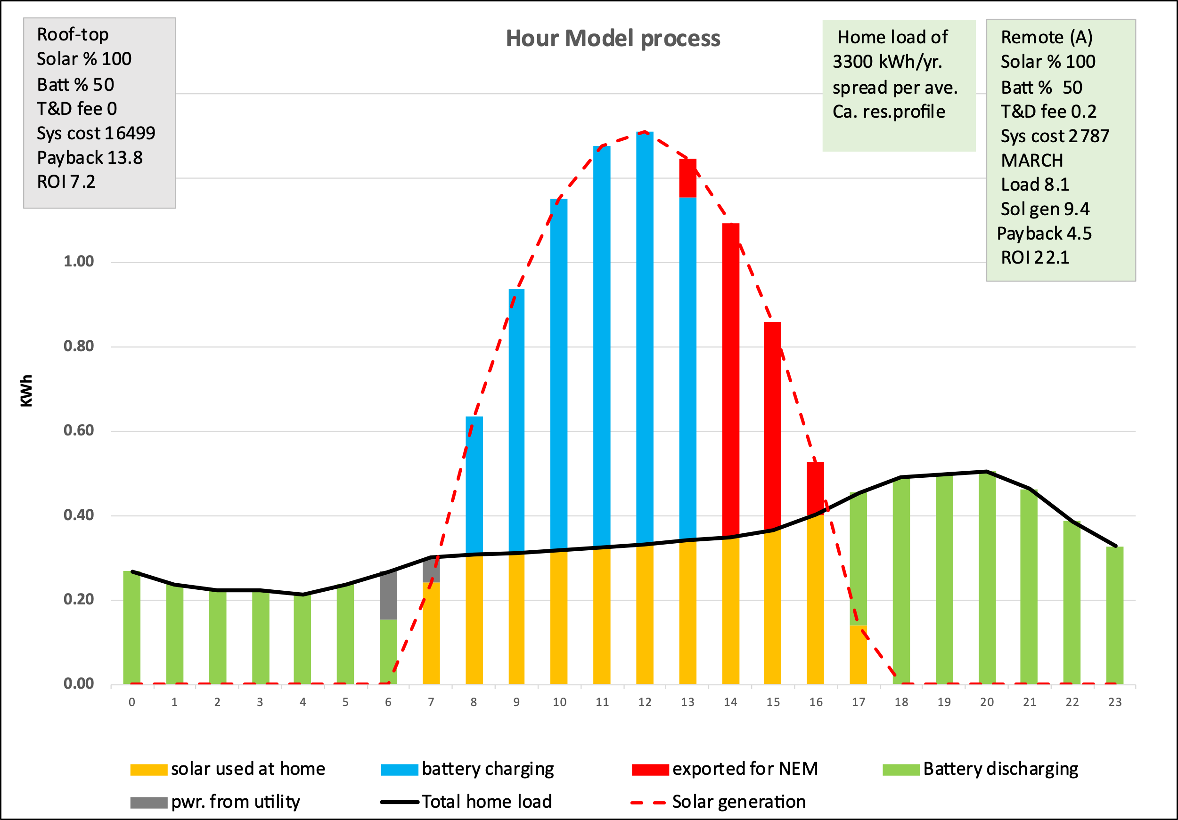

Reading the text boxes: Key aspects of each run appear in the text boxes. For instance, the 100% solar means the solar array is sized to produce as much annual electricity as the home consumes. The battery was sized to store 50% of the total daily solar generated. The text box shows that the T&D fee is 0 for rooftop but 20 cents/kWh for remote-solar. After FTC the rooftop system has an up-front capital cost of $16,500, whereas the comparable remote solar system would cost $ 2787. That total is for the array plus battery. Recall that both the rooftop and remote-solar systems generate the same amount of annual electricity. The load this March day is 8.1 kWh while the solar system generates 9.4 kWh. The payback and ROI in the green text box are based on assuming the home load had the same profile as the average Ca. home. Later below the final ROI based on the authors actual load profile will be reported. Now the focus is just on an interim step in the modeling process, namely what happens at the RSP’s location.

In September there was less battery storage available to meet load so more grid power was used the next morning.

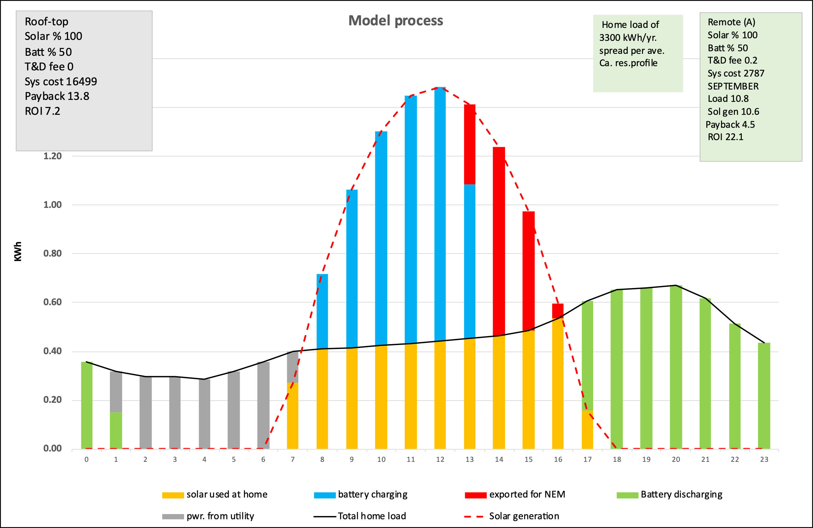

Here is an explanation of the bar charts.

1) After sunrise the available solar generation from the array is used to begin offsetting the home load. (orange bars) The home load and solar production profiles used are those for that particular month.

2) Any solar left after load offsetting is used to begin charging the battery. (blue bars) The rate of charging is the lesser of what solar is available, the maximum charge rate of the battery, or what’s needed to finish charging the battery. The max charge rate is equal to one half the battery’s capacity in these runs. That’s based on Tesla’s Powerwall specs and assumed to apply to utility-scale batteries as well. For example, the model won’t allow an 8-kWh remote-solar battery to charge or discharge faster than 4 kWh/hr.

3) Any solar left after charging the battery is of no use at the solar farm and is exported for NEM credit. (red bars)

4) As the sun begins to set solar generation is unable to fully offset the afternoon load so the battery is programmed to discharge enough to make up the difference until it becomes empty. (green bars). If the battery is able to fully offset the afternoon and evening load any excess is used to help satisfy the early morning load next day. (Its wrapped around to show in these charts)

5) The model then satisfies any remaining load with grid power. (gray)

6) The same process is used for Remote solar (B) except in order to help mitigate the duck curve problem the remote solar battery is programmed to fully discharge during the 5 evening hours as shown by the brown bars in the following chart. The evening discharge rates in this model are chosen somewhat arbitrary and could easily be adjusted in practice to export the power at the optimum rate from a grid perspective.

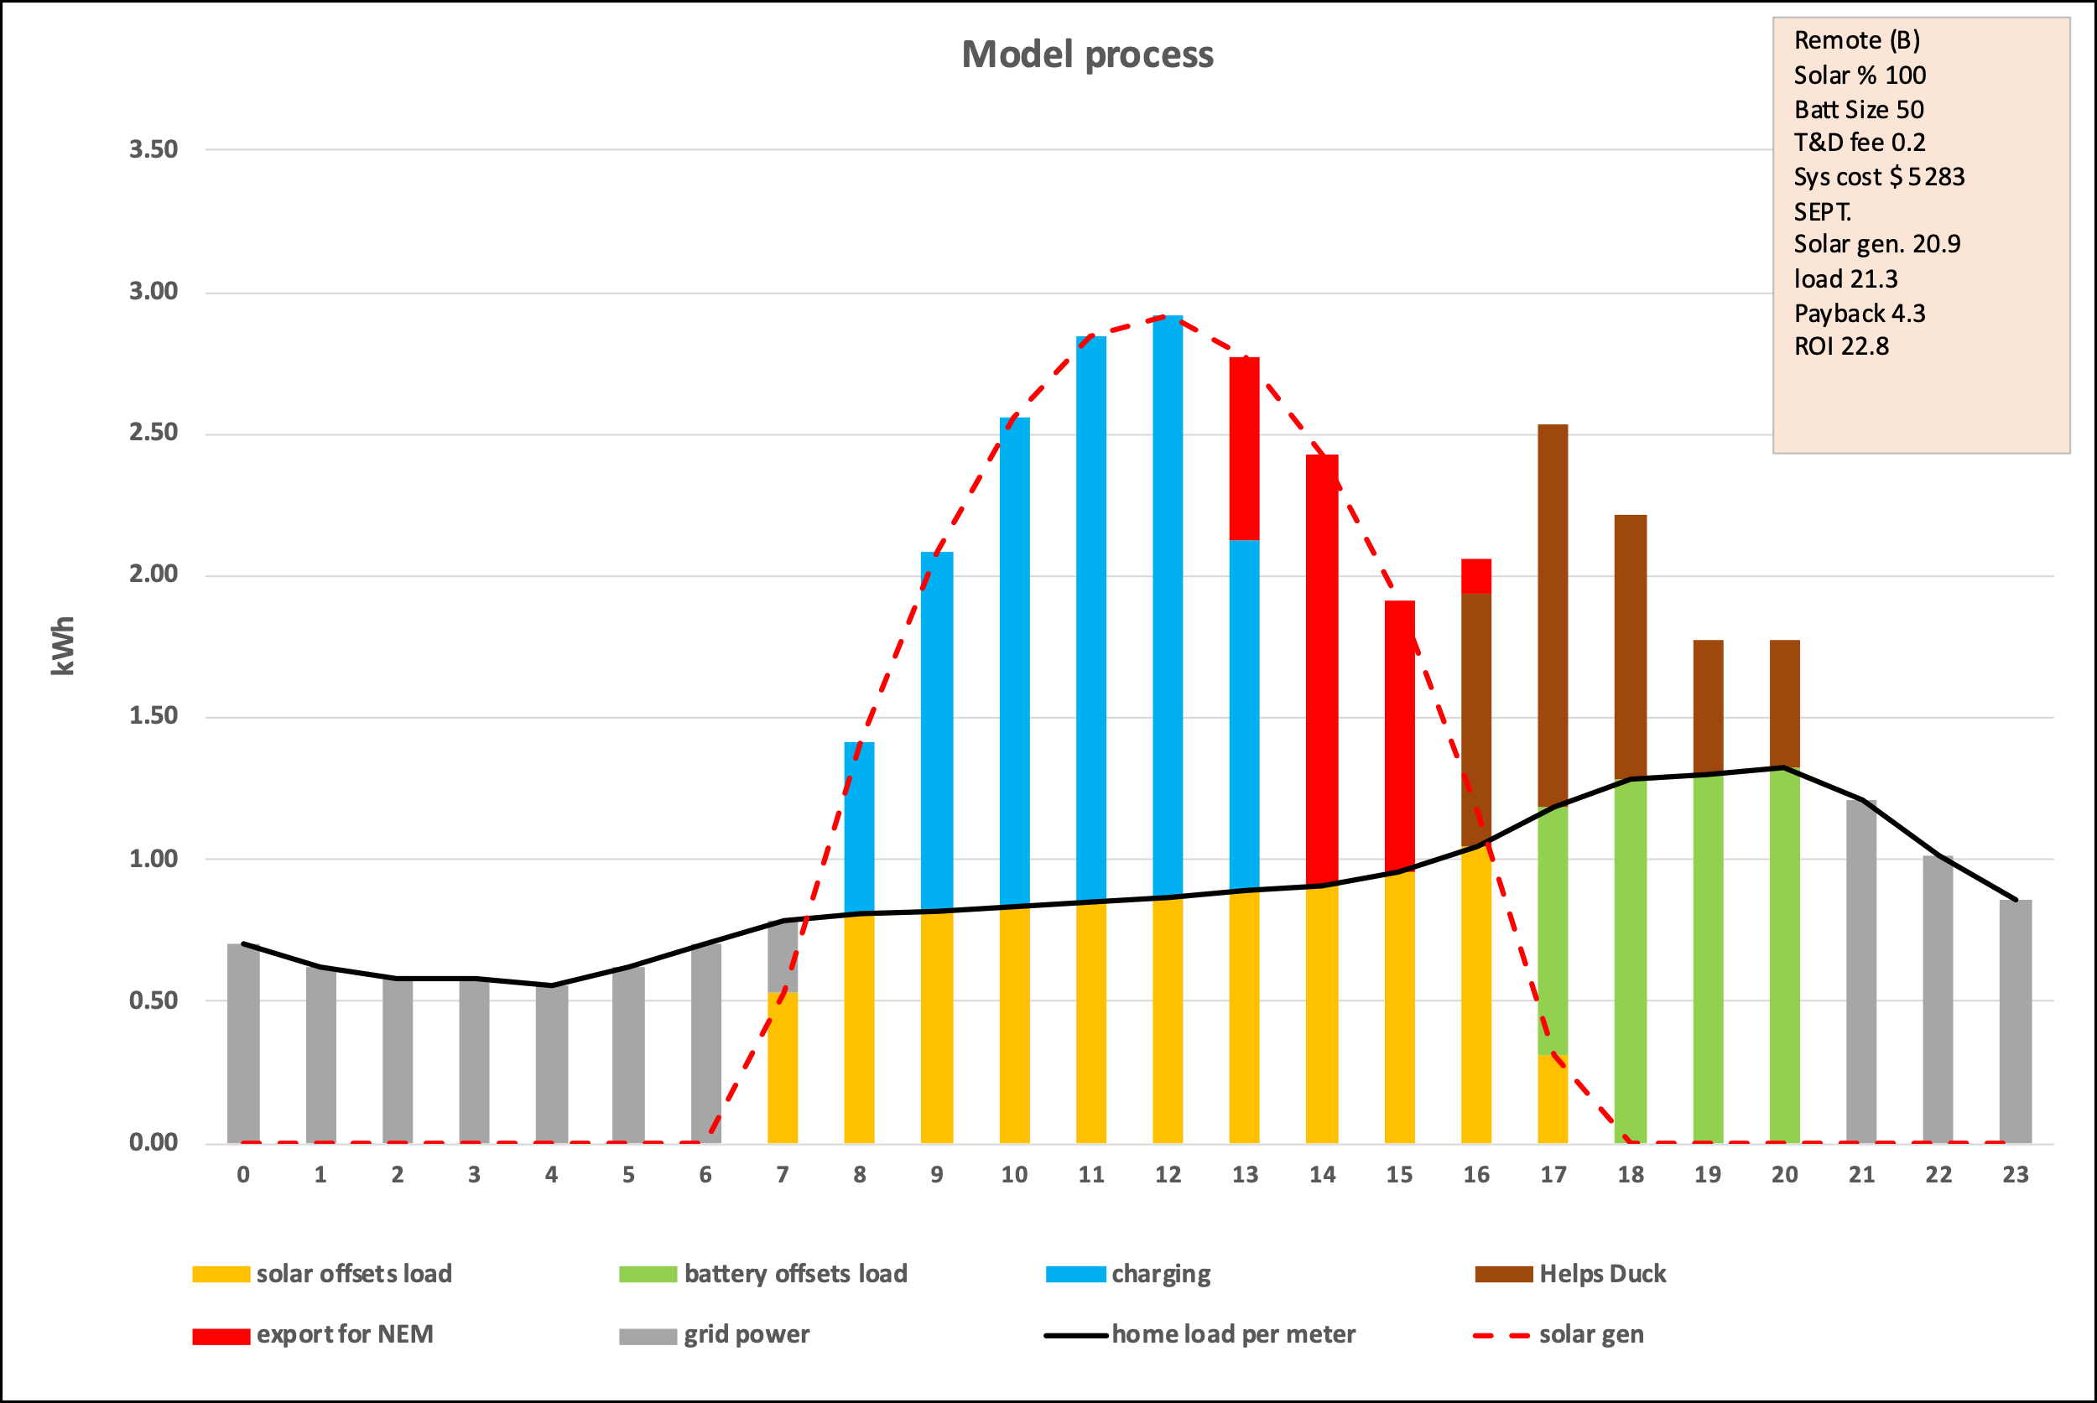

Power RSP exports into grid: The power input to the grid each hour by the RSP shows up as brown bars in the Remote(A) chart below. The black line shows the residential load profile for an average California home while the yellow and blue lines show the authors actual home load for March 1st and 15th. They are obviously quite different than the average CA residential load profile.

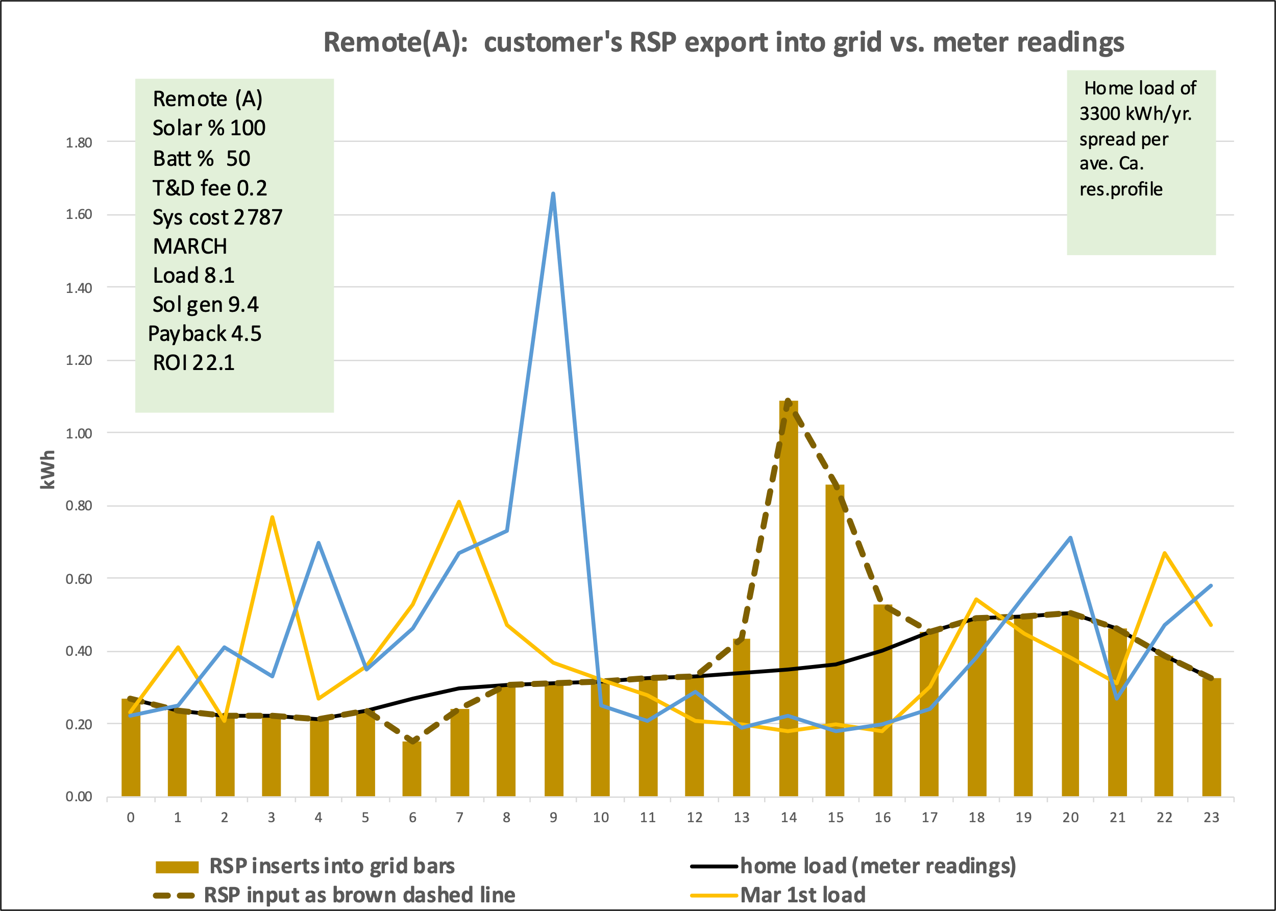

Its important to note that the RSP has no visibility of the customers actual hourly load so can only export power per a profile that would best satisfy the average residential load profile. Ideally what the RSP exports would exactly match the customers actual load, but that’s not practical. Still a refinement on remote-solar would be to determine from historical data what the customers actual approximate profile is likely to be and tailor the RSP output to best satisfy that rather than the average residential load profile. Had that been done it might have improved the authors ROI from using the HOUR model.

(In the combined model the HOUR model knows what grid power is subject to TOU peak and off-peak power rates. That data is linked to the MONTH model.)

In this case the mismatch between the profile of power input by the RSP and my actual load created a series of grid charges and NEM credits. These are probably why the HOUR model produced a lower ROI for the author than did the MONTH model.

Below are the author’s actual load profiles on the 1st of the month. Another set of profiles was added for the author’s loads on the 15th of the month. This was done to produce a more -but certainly not perfect- picture of the authors loads. In any case the daily grid charges and NEM credits were summed over a year’s period by multiplying the one-day results for March by 365/4 days and doing likewise for the June, September and December results.

To be clear the HOUR model is far from perfect. Ideally it should process every day of every month. But for simplicity it just processes an arbitrary two-day sample from four months.

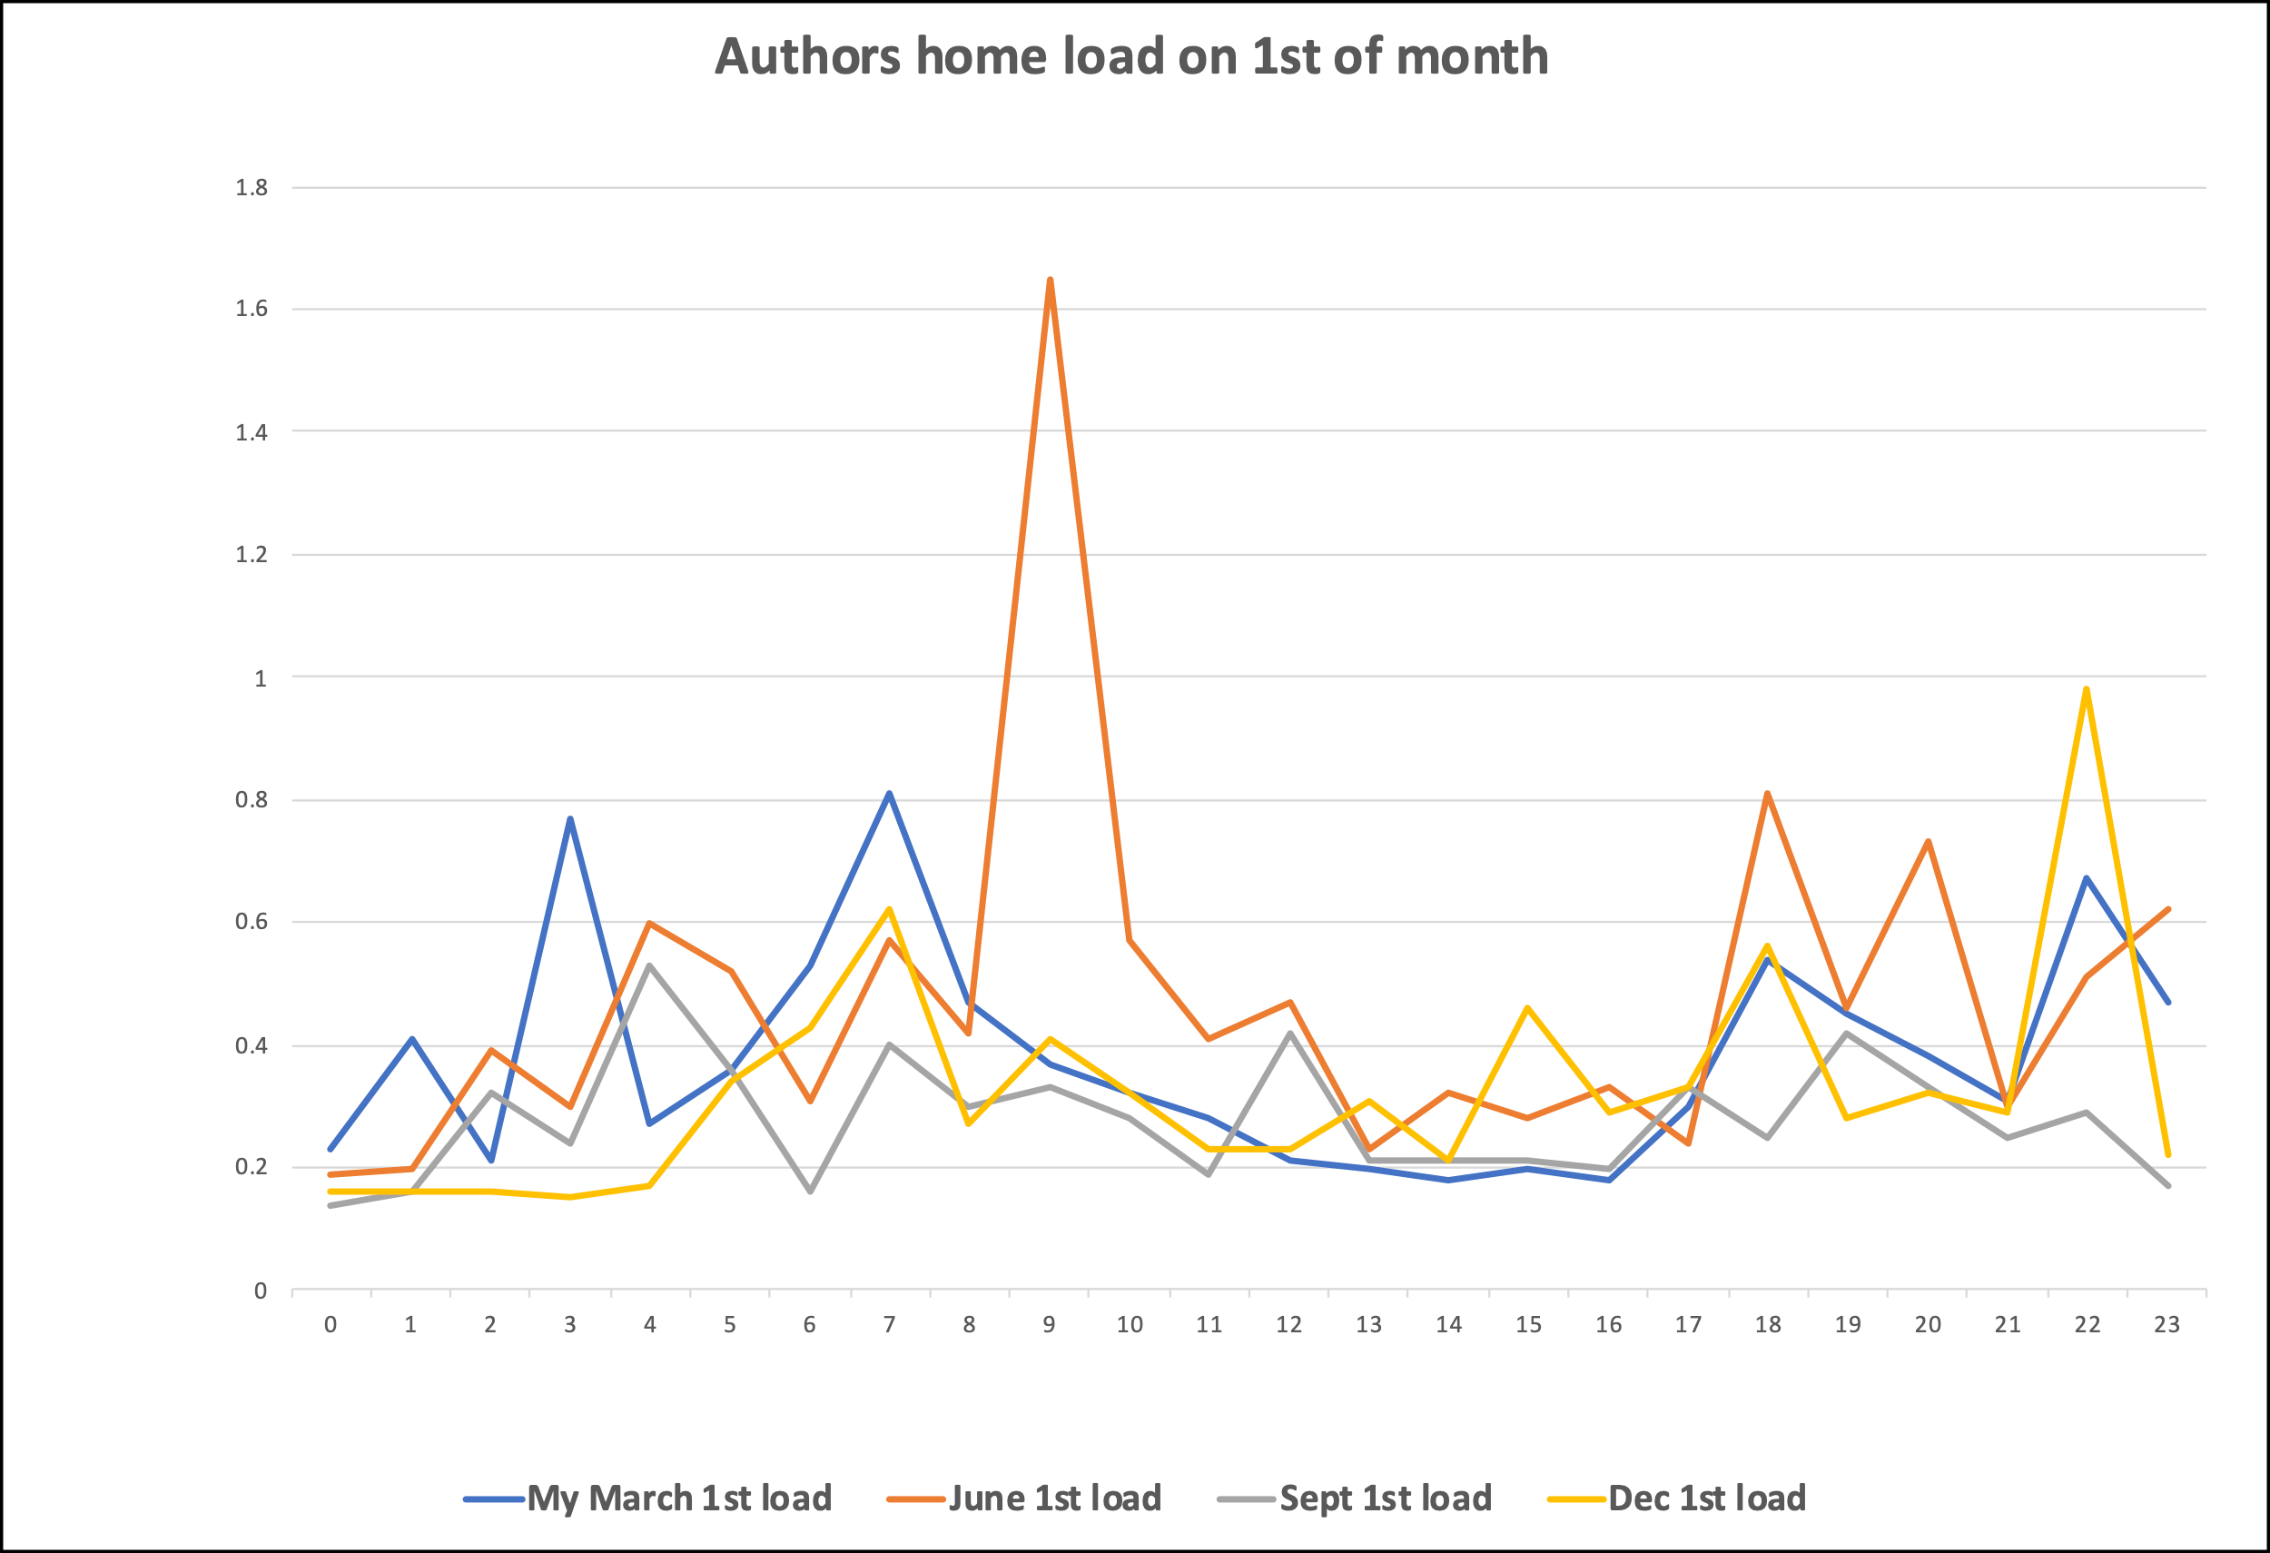

8) The model mimics what the utility would do to compute the customers electric bill by comparing each hour the customers actual consumption or load -as read by the electric meter- with the power input by the RSP on that customers behalf.

This part of the model shows where that occurs, and where the March charges and credits were estimated. Similar parts make those calculations for June, September and December.

9) The model computes hour by hour the charge for any grid power used, or give a NEM 3.0 credit for any RSP power exported in excess of what the customer used. The HOUR model applied a NEM credit of 3 cents/kWh for off peak power and 7 cents/kWh for peak period power.

The screenshot below shows the amounts of energy that will be charged at grid rates (gray) vs. what will be credited at NEM rates (red) during the March 1st calculations.

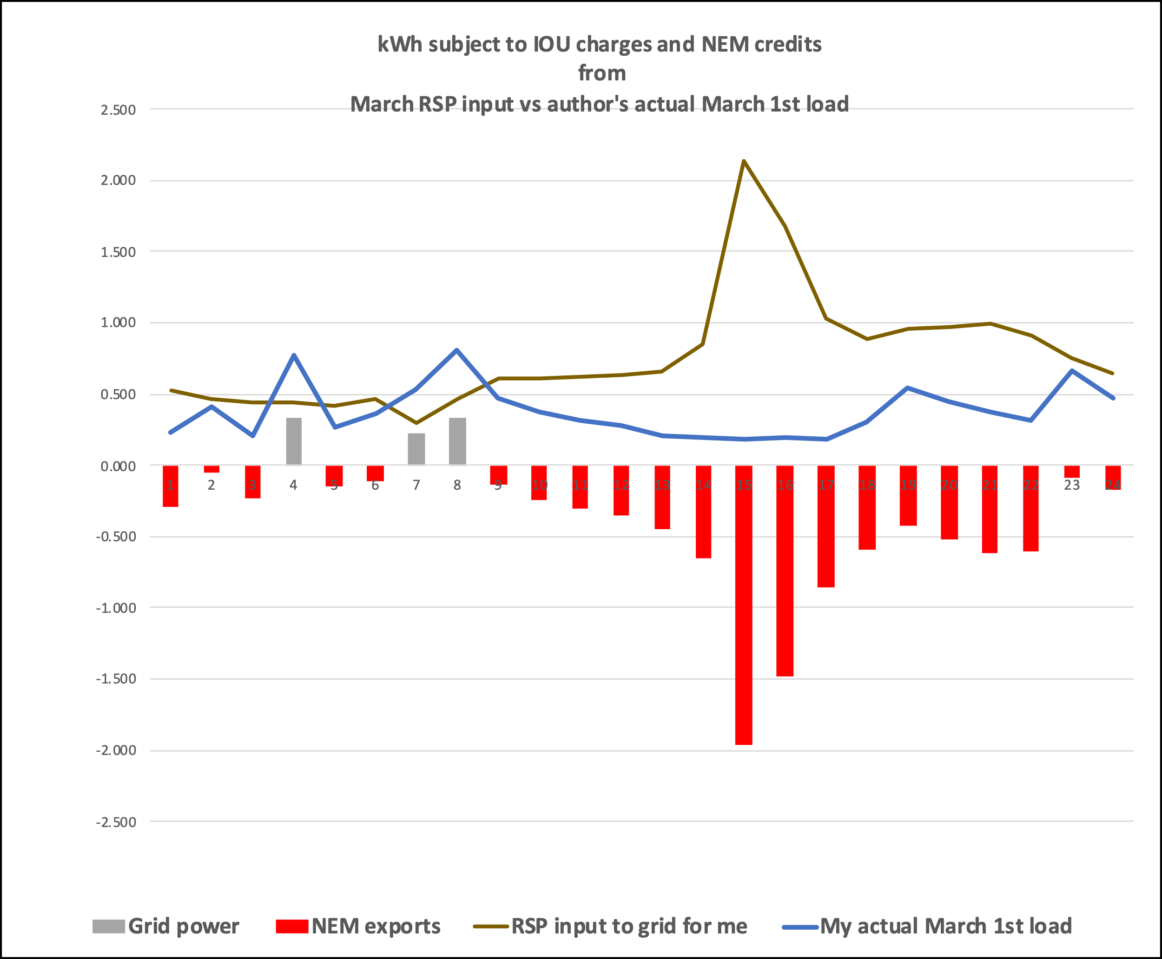

The HOUR model completes the following steps on the way to producing a final estimate of the payback and ROI for remote solar:

10) These hourly charges or credits from the March, June, September and December sub-models are added to compute the customers total annal electric bill.

11) The difference between the customers electric bill with remote solar and without is considered his or her annual electric bill savings from having remote-solar.

12) The model multiplies the total kWh that the RSP imports to the grid on the customers behalf by the applicable T&D and O&M fees to get the total annual charges for T&D and O&M.

13) The annual T&D and O&M charges are deducted from the annual electric bill savings to get the net annual savings from having remote-solar.

14) The net annual savings are divided into the total system cost to get the payback period. The reverse is done to get an ROI.

This table shows the final calculations of the authors’ ROI using the Hour model with an 100% array and 50% battery. The resulting ROI was 19.3 %, whereas the MONTH model produced an ROI of about 28% for the author. Because the HOUR model produced a lower ROI, was more complex than the MONTH model, the MONTH model had a long netting interval consistent with NEM 1 and 2, apparently fit better with the utilities monthly billing cycle, and was easier for the RSP to send data to the utility once a month rather than every hour, the author decided to propose that monthly reports of a customer’s RSP inputs to the grid be compared with a customer’s monthly consumption as a defining characteristic of remote-solar. Again, if I understand the term “netting interval” correctly I think this amounts to a netting interval of one-month. What netting interval is actually adopted is up to the CPUC.

In any case here is the HOUR models estimate of what the authors ROI would be if he had remote solar that was subject to hourly netting.

This concludes an explanation of how the HOUR model works and the results of using it for one particular customer situation; namely the author’s.

------- end of Appendix A ---------

