Speciation of Organic Gas Emissions
California Light-Duty Vehicle Exhaust

Prepared by:

Technical Support Division
Air Resources Board
For
Public Workshop to Discuss Proposed Revisions to ARB’s
Organic Gas Speciation Profiles Held
September 10, 1998

This report has been reviewed by the staff of the Air Resources Board and approved for release. Approval does not signify that the contents necessarily reflect the views and policies of the Air Resources Board. Mention of trade names or commercial products does not constitute endorsement or recommendation for use.

ACKNOWLEDGMENTS

This document was prepared by the staff of the
Control Strategy Modeling Section, Technical Support Division.

Principal Author:

Paul D. Allen

Contributing ARB Staff

Dr. Jerry Ho
Jack Horrocks
Muriel Strand

Reviewed and Approved by:

John DaMassa, Manager, Control Strategy Modeling Section
Don McNerny, Chief, Modeling and Meteorology Branch
Terry McGuire, Chief, Technical Support Division

PREFACE

The California Air Resources Board (ARB) measures air pollutants emitted from California motor vehicles. One class of pollutants is termed “total organic gases” (TOG). TOG emissions are composed of many individual organic gas compounds, such as methane, butane, and formaldehyde. The resolution of TOG to individual chemical species (hereafter called “speciation”) is done using laboratory analyses of organic gas emissions captured in a teflon bag or stainless steel canister. Speciation profiles of TOG emissions are needed for each TOG emission source category to estimate emissions of individual compounds as well as to estimate emissions of reactive organic gases (ROG) and non-methane organic gases (NMOG). The primary purpose of this paper is to document a study undertaken to improve the speciation of motor vehicle exhaust. This research covers only emissions from vehicles burning gasolines sold prior to the introduction of California’s cleaner burning gasoline in 1996.

The first section of this document contains an overview of the study and its findings. The remainder of the document contains the full technical discussion of the study. The appendices contain listings of the detailed exhaust speciation profiles developed in this study.

ABSTRACT

The ARB began speciating organic gas exhaust emissions from randomly selected vehicles in 1994. Speciation profiles derived from vehicles tested during the summer of 1994 agree very well with the speciation of organic gases measured in the Caldecott tunnel in the summer of 1994. The speciation that has been used in many photochemical modeling simulations appears to be incorrect according to the 1994 measurements. Methane emissions were overpredicted resulting in underprediction of reactive organic gas species.

Further investigation using ARB motor vehicle surveillance data, shows that the percentage of exhaust methane increases with decreasing organic gas emissions. This finding means that the emission rate distribution must be carefully considered when preparing speciation profiles to represent the in-use fleet. Also, as the in-use fleet emission rates have decreased over the years the methane percentage has increased. Exhaust speciation profiles will need to be developed for each calendar year. California exhaust speciation profiles were prepared for 1987, 1990, and 1994 using procedures discussed in this document. California in-use fleet methane percentages are estimated to increase from 11.1 to 15.7 percent of stabilized exhaust TOG emissions from 1987 to 1994.

TABLE OF CONTENTS

OVERVIEW

Introduction 1
Current Speciation Profiles 1
Recent Vehicle Emissions Testing 1
Methane and THC exhaust Emissions 3
Speciation of Surveillance Vehicle TOG Emissions 5
Speciation Profiles for 1987 and 1990 5

TECHNICAL DISCUSSION

Introduction 6
Caldecott Tunnel Emissions 7
In-Use Surveillance Vehicle Testing 8
Parameters Affecting the Methane Content in Motor Vehicle Exhaust 9
Procedure for Estimating California In-Use Fleet Average Exhaust THC
Methane Percentages from Surveillance Data 9
Comparison to Caldecott Tunnel 11
Surveillance Vehicle Organic Gas Speciation Measurements 11
FTP Composite Exhaust Emissions 12
Incremental Start Emissions 13
Speciation Profiles for 1987 and 1990 13
Conclusions 14
Recommendations 15
References 16

Appendix A - Summer 1994 Catalyst Exhaust Light-Duty Vehicle TOG Speciation A-1
Appendix B - Summer 1987 Catalyst Exhaust Light-Duty Vehicle TOG Speciation B-1
Appendix C - Summer 1990 Catalyst Exhaust Light-Duty Vehicle TOG Speciation C-1

LIST OF TABLES

1 Comparison of TOG Methane Percentages for Catalyst Light-Duty Vehicle Exhaust 2
2 Comparison of TOG Methane Percentages for Catalyst Light-Duty Vehicle Exhaust
With Fleet Corrections 4
3 Estimated Composition of Caldecott Tunnel TOG Emissions 8
4 THC Emission Rate Intervals for Methane Estimates 10
5 - Methane Fraction of Light-Duty Vehicle THC Exhaust Emissions, 1994 Surveillance
Vehicles Weighted by 1994 California Annual Mileage by THC Emission Rate 17
6 Average Exhaust Methane, 1994 Summer Light Duty Vehicle Surveillance Program
Weighted by 1994 California Mileage Estimates 19
7 Methane Fraction of Light-Duty Vehicle THC Exhaust Emissions, 1988 Surveillance
Vehicles Weighted by 1987 California Annual Mileage by THC Emission Rate 20
8 Average Exhaust Methane, 1988 Summer Light Duty Vehicle Surveillance Program
Weighted by 1987 California Mileage Estimates 22
9 Methane Fraction of Light-Duty Vehicle THC Exhaust Emissions, 1992 Surveillance
Vehicles Weighted by 1990 California Annual Mileage by THC Emission Rate 23
10 Average Exhaust Methane, 1992 Summer Light Duty Vehicle Surveillance Program
Weighted by 1990 California Mileage Estimates 25

LIST OF FIGURES

1 1994 Caldecott Tunnel and Estimated Speciation Using 1990 Auto/Oil LDV 26
2 FTP Bag 1 1994 ARB In-Use Surveillance Data-April through September 27
3 FTP Bag 2 1994 ARB In-Use Surveillance Data-April through September 28
4 FTP Bag 3 1994 ARB In-Use Surveillance Data-April through September 29
5 1994 Surveillance Vehicles-FTP Bag 1 Methane Percent vs. Vehicle Age 30
6 1994 Surveillance Vehicles-FTP Bag 1 Methane Percent vs. Mileage 30
7 1994 Surveillance Vehicles-FTP Bag 2 Methane Percent vs. Vehicle Age 31
8 1994 Surveillance Vehicles-FTP Bag 2 Methane Percent vs. Mileage 31
9 1994 Surveillance Vehicles-FTP Bag 3 Methane Percent vs. Vehicle Age 32
10 1994 Surveillance Vehicles-FTP Bag 3 Methane Percent vs. Mileage 32
11 Comparison of 1994 Surveillance Fleet to On-Road Fleet-FTP Cold Starts 33
12 Comparison of 1994 Surveillance Fleet to On-Road Fleet-FTP Hot Stabilized 33
13 Comparison of 1994 Surveillance Fleet to On-Road Fleet-FTP Hot Starts 33
14 Comparison of 1994 Speciated Surveillance Fleet to On-Road Fleet 34
15 1994 Caldecott Tunnel and Estimated Inventory Composite TOG Speciation 35
16 1994 Caldecott Tunnel and ARB Stabilized Exhaust 36
17 1990 ARB and Auto/Oil Cold Start Exhaust - Excess 37
18 1990 ARB and Auto/Oil Stabilized Exhaust 38
19 1990 ARB and Auto/Oil Hot Start Exhaust - Excess 39
20 1987 Sigsby and 1987 ARB FTP Composite Exhaust Speciation 40
21 Exhaust LDV Methane Percentage of THC-
Surveillance Vehicles with Mileage Weighting 40
22 Exhaust LDV Methane Percentage of THC-
Surveillance Vehicles without Mileage Weighting 39

Speciation of Organic Gas Emissions
California Light-Duty Vehicle Exhaust:

Overview
Introduction

Speciation profiles are used to define the organic gas species emitted from each category of TOG emissions. Speciation profiles are used to estimate emissions of specific compounds such as benzene or formaldehyde. Speciation profiles are also used to estimate the reactive portion of TOG as well as to develop emission inputs to photochemical models. Since speciation profiles are relied on for many different reasons, it is important that they be accurate. The primary purpose of the study reported here, is to improve the speciation of motor vehicle exhaust. This report covers only the emissions from vehicles burning summer, unoxygenated pre-cleaner burning gasoline.

Current Speciation Profiles

Two sources of speciation have been used to characterize pre-cleaner burning gasoline catalyst TOG exhaust. The first is a 1987 USEPA speciation profile used to represent a composite of Federal Test Procedure (FTP) vehicle starts and stabilized exhaust emissions (Sigsby et al. 1987). This Sigsby speciation profile is used to estimate ROG for the official ARB emission inventory.

The second source is from a 1990 Auto/Oil study (Pollack et al. 1990). Instead of composite speciation, the 1990 Auto/Oil speciation is reported for each phase of the FTP measurements (cold start (bag 1), stabilized (bag 2), and hot start (bag 3) exhaust TOG emissions). The 1990 Auto/Oil speciation profiles have been used in photochemical modeling studies in California to improve the resolution of exhaust emissions.

Recent Vehicle Emissions Testing

A third source of speciation data has recently become available. Beginning in late 1993, vehicles from ARB’s light duty vehicle (LDV) surveillance program were selected for measuring speciated organic gases. Speciated emissions for 20 vehicles, tested during the summer of 1994, were available to develop speciation profiles for FTP composite and bag specific emissions. It was immediately apparent that large differences existed between the ARB and the Auto/Oil speciation--especially in the methane percentages. It is very important to estimate methane accurately, since errors in the methane percentage cause errors in estimates of the more reactive, non-methane compounds.

In addition, in-use vehicle emissions were measured in the Caldecott tunnel in the summer of 1994 (Kirchstetter et al. 1996). Since the tunnel traffic is dominated by stabilized catalyst LDV exhaust, the tunnel speciation serves as a valuable reference for comparison to laboratory measured emissions.

Table 1 shows a comparison of the methane percentages from each of the four sources of data. Methane was reported to be 9.9 percent of the Caldecott tunnel TOG emissions. The 1994 ARB stabilized exhaust methane (10.2 percent) agrees well with the tunnel measurements. The 1990 Auto/Oil methane (52.7 percent) is far too high. The Sigsby composite methane (14.9 percent) is higher than the ARB surveillance vehicles (9.3 percent).

Table 1

Comparison of TOG Methane Percentages for Catalyst Light-Duty Vehicle Exhaust.
Speciated Surveillance Vehicles
Summer Estimates
Methane (percent)

1994 ARB Surveillance - FTP Composite 9.3
1987 Sigsby - FTP Composite 14.9

1994 ARB Surveillance - FTP Cold Starts 6.7
1990 Auto/Oil - FTP Cold Starts 6.1

1994 ARB Surveillance - FTP Stabilized 10.2
1990 Auto/Oil - FTP Stabilized 52.7

1994 ARB Surveillance - FTP Hot Starts 10.3
1990 Auto/Oil - FTP Hot Starts 18.6

1994 Summer Caldecott Tunnel 9.9

Note: “ARB” methane percentage is from surveillance vehicles with speciation measurements.

The methane overestimate in the Auto/Oil speciation is a concern since the Auto/Oil profiles have been used for almost all ozone modeling for California air basins since 1989. The use of either the ARB or Caldecott tunnel speciation profile for stabilized exhaust will approximately double the estimates of stabilized motor vehicle ROG emissions. Since stabilized catalyst exhaust accounts for about 10 percent of statewide TOG emissions, the increased ROG emissions may be significant.

Even though the hot start emissions also show a large disagreement in methane content, these speciation profiles are not used in modeling simulations. The hot start emissions are low and have been speciated the same as stabilized exhaust emissions.

The 1987 Sigsby composite speciation is almost 6 percent higher in methane than the 1994 FTP composite surveillance vehicle speciation. This difference is also higher than desired, but much better than the agreement between the Auto/Oil and ARB stabilized speciation.

Methane and THC Exhaust Emissions

Out of more than 300 surveillance vehicles tested during the summer of 1994, only 20 had full speciation measurements. However, all 300 vehicles had exhaust methane and THC measured. Instead of relying on the 20 speciated vehicles for the methane estimates, methane emissions can be estimated from the complete summer 1994 surveillance fleet. Analysis of this database shows that the methane percentage decreases as the THC emission rate increases. This relationship is especially strong in the stabilized exhaust emissions.

In order to represent the in-use fleet, the surveillance vehicle THC emission rate distribution should either be representative of the in-use fleet or be corrected to represent the in-use fleet. Our analyses show that neither the 20 vehicle speciation fleet nor the 300+ vehicle surveillance fleet have THC emission rate distributions representatives of in-use vehicles.

A procedure to correct the surveillance fleet THC distribution to represent the in-use fleet distribution is presented in detail later in this report. To summarize, the average THC emission rate and the fraction of mileage driven by vehicles for six THC emission rate intervals are determined from the ARB Motor Vehicle Emission Inventory (MVEI) system. Methane percentages are determined for each THC emission rate interval from the surveillance vehicle emission tests. Methane percentages were then developed to represent the summer 1994 in-use fleet. Table 2 shows the methane comparisons with the ARB corrected percentages calculated using the above procedure. The previous uncorrected ARB methane percentages, from the speciated vehicles only, are shown in parentheses.

Table 2

Comparison of TOG Methane Percentages for Catalyst Light-Duty Vehicle Exhaust.
All Surveillance Vehicles
Summer Estimates

Methane (percent)

Summer 1994 ARB Surveillance - FTP Composite 10.9 (9.3)
Sigsby FTP - Composite 14.9

Summer 1994 ARB Surveillance - FTP Cold Starts 6.2 (6.7)
Auto/Oil - FTP Cold Starts 6.1

Summer 1994 ARB Surveillance - FTP Stabilized 15.7 (10.2)
Auto/Oil - FTP Stabilized 52.7

Summer 1994 ARB Surveillance - FTP Hot Starts 6.0 (10.3)
Auto/Oil - FTP Hot Starts 18.6

1994 Summer Caldecott Tunnel 9.9

Note: “ARB” methane represents all 1994 summer surveillance vehicles. Methane from only the speciated ARB vehicles is in parentheses.

With the corrections, the methane estimate for stabilized exhaust increased from 10.2 to 15.7 percent. Although this appears to degrade the agreement with the tunnel study, catalyst vehicle exhaust is not the only source of TOG emissions in the tunnel. According to the statewide emission inventory, about 60 percent of the tunnel TOG is from stabilized exhaust, 16 percent is evaporative emissions that have no methane, and the remainder is non-catalyst and diesel exhaust with methane emissions below 8 percent. The actual methane percentage from stabilized catayst exhaust must be higher than the 9.9 percent value measured in the tunnel. Using 15.7 percent for stabilized exhaust, the estimated methane for the tunnel emissions is 11.1 percent. This value for methane is only 1.2 percent higher than the 9.9 percent measured in the Caldecott tunnel.

These results indicate that modeling studies done for 1994 and earlier years with the Auto/Oil catalyst exhaust profiles have overestimated methane and therefore, underestimated NMOG emissions. It is important to note that only the model performance studies are directly affected by this methane overestimate. Attainment year modeling studies are done for 1999 to 2010. These simulations require speciation estimates for cleaner burning gasoline. Speciation estimates for cleaner burning gasoline will be developed in future work.

As shown in Table 2, the ARB composite FTP methane increased from 9.3 to 10.9 percent using the entire summer 1994 surveillance database. This reduces the difference between the 1987 Sigsby speciation and the ARB speciation for methane from 6 to 4 percent.

Speciation of Surveillance Vehicle TOG Emissions

While the methane percentage has been calculated from the entire summer 1994 surveillance fleet, the speciation test results from the 20 vehicle subset are the only data available to estimate the remaining NMOG speciation profiles. These complete speciation profiles can be used to replace both the Sigsby composite and the Auto/Oil bag specific speciation profiles. A speciation profile can be estimated for the Caldeccott tunnel by combining the stabilized exhaust speciation with the evaporative, non-catalyst,and diesel profiles for the emissions estimated for the Caldecott tunnel. Figure 15 (page 35) shows this combined speciation estimated for the Caldecott tunnel to the measured speciation. These speciation profiles are similar. If pentanes are added to the higher alkanes the profiles would be nearly identical. There are some small discrepancies; the tunnel seems to be higher in aromatic compounds and lower in alkene compounds, than our estimated speciation. Many of the differences are within the uncertainty inherent in such estimates.

Speciation Profiles for 1987 and 1990

Most model performance studies conducted for California areas simulate ozone episodes which occurred during the summer of 1987 or 1990. LDV fleet methane percentages can be estimated for 1987 and 1990 using the same procedure used for 1994 estimates. Surveillance data for 1987 and 1990 are used to estimated methane percentages for the six THC emission rate intervals. The fleet average (mileage weighted) methane percentages are used with the NMOG speciation profiles from the 1994 surveillance vehicles to produce the final fleet average TOG speciation for each year. The results indicate that the methane percentage, especially for stabilized exhaust, has been increasing over the years; from 11.1 percent in 1987, 12.6 percent in 1990, to the 15.7 percent estimated for 1994. The complete profiles for all three years are shown in Appendices A,B, and C.

The 1987 ARB FTP composite speciation is similar to the 1987 Sigsby FTP composite speciation, but there are several important differences. Methane, propane, and butanes are higher in the 1987 Sigsby profile, while many of the faster reacting compounds (1,3-butadiene, propylene, toluene, and C8+ aromatics) are higher in the ARB speciation. The differences have several explanations. Since detection limits have become lower over the years, the newer measurements may represent 1,3-butadiene and other compounds with lower concentration more accurately. The methane percentage in the Sigsby speciation is an average of the vehicles tested while the methane percentage in the ARB speciation is calculated to represent the 1987 California in-use fleet. Also, there were no California vehicles tested as part of the 1987 vehicle fleet used by Sigsby.

Speciation of Organic Gas Emissions
California Light-Duty Vehicle Exhaust:

Technical Discussion

Introduction

Photochemical grid modeling studies require temporally and spatially resolved emission inventories of ozone precursors. Total organic gas (TOG) emissions from all sources must be further resolved to emissions of individual chemical species (such as methane, butane, formaldehyde, etc.) for proper photochemical treatment by the model. This resolution of TOG to individual chemical species (hereafter called “speciation”) is done using analyses of organic gas emissions for every source category. Speciation profiles are also used to estimate reactive organic gas (ROG), non-methane organic gas (NMOG), and non-methane hydrocarbon (NMHC) emissions. Since speciation profiles are relied on for many different reasons, it is important that they be accurate. The primary purpose of the study reported here is to improve the speciation of motor vehicle exhaust emissions. This report covers only emissions from catalyst equipped vehicles using summer unoxygenated pre-cleaner burning gasoline.

Catalyst vehicle exhaust constitutes a significant portion of California’s anthropogenic TOG emissions (about 10 percent in 1994). Two sources of speciation profiles have been used to characterize TOG exhaust from catalyst vehicles using pre-cleaner burning gasoline. The first is a single 1987 USEPA profile used to represent a composite of vehicle cold and hot starts and stabilized exhaust emissions (Sigsby et al. 1987). The second is a set of speciation profiles resulting from a 1990 Auto/Oil study (Pollack et al. 1990). The 1990 Auto/Oil profiles were specified separately for the Federal Test Procedure (FTP) cold start (bag 1), stabilized (bag 2), and hot start (bag 3) exhaust TOG emissions. The Auto/Oil speciation profiles for cold starts and stabilized exhaust emissions have been used in photochemical modeling studies in California to maximize resolution in the spatial distribution of the exhaust emissions. The USEPA composite profile has been used for the ARB statewide annual average emission inventory, which is resolved only to county and air basin.

Recently, Kirchstetter has published results from a summer 1994 Caldecott tunnel study (Kirchstetter et al. 1996) which indicate that the 1990 Auto/Oil speciation profile for stabilized exhaust emissions contains too much methane. Methane is estimated to be 9.9 percent of the TOG emissions in the Caldecott tunnel, compared to 52.7 percent of the TOG emissions from stabilized exhaust according to the 1990 Auto/Oil speciation profile. According to the 1987 USEPA composite speciation profile, methane is 14.9 percent of TOG exhaust. If the 1990 Auto/Oil speciation stabilized exhaust profile contains too much methane, it contains too little NMOG and ROG emissions. As an indication of the importance of this emission category, stabilized exhaust TOG emissions from catalyst light-duty vehicles (LDV) account for about 10 percent of California’s 1994 anthropogenic TOG emissions. It is this fraction of the TOG emissions that may be speciated incorrectly in modeling studies.

The ARB maintains a database of vehicle exhaust emissions derived from dynamometer tests of randomly selected light duty vehicles registered within 25 miles of the ARB’s El Monte laboratory. This database contains results from over 300 LDVs tested for methane and total hydrocarbon (THC) exhaust emissions during the summer of 1994 (Devesh 1994). This is the most comprehensive database available to estimate methane emissions representative of the 1994 light-duty fleet.

Some of the summer 1994 surveillance vehicles also had organic gas speciation measurements performed for exhaust emissions. While we will estimate methane from the complete surveillance fleet (because of the much larger sample size), the remaining organic gas compounds will be estimated from the smaller speciated database. If the speciation profile for the surveillance vehicles is in agreement with the Caldecott tunnel results, the speciation profiles developed from the surveillance vehicle testing will be used to replace the 1990 Auto/Oil profiles used in photochemical modeling studies and the 1987 USEPA profiles used in the ARB official inventory estimates.

The results from this study will be appropriate for use in photochemical modeling simulations in California for 1994 and earlier years. Simulations for these years are used to evaluate model performance. Simulations of future years will require speciation of emissions from vehicles using cleaner burning gasoline. We intend to examine the speciation from emissions of cleaner burning gasoline-fueled vehicles using surveillance data collected during 1996 and 1997.

Caldecott Tunnel Emissions

The Caldecott tunnel is located in the San Francisco Bay Area, connecting Orinda and Oakland. The center bore is about 1100 meters long and has an eastbound uphill grade of 4.2 percent. The 1994 tunnel study was conducted from August 22 to September 2 between 4–6 pm, when the peak commute traffic moved in an eastbound, uphill direction. By observation, the vehicle fleet using the center bore was composed almost entirely of LDV. The traffic flow rates were about 4300 vehicles per hour. Due to the location of the tunnel, situated where few if any vehicle starts are expected, few vehicles were likely operating with cold catalysts. Concentrations of organic gas species from both the tunnel exhaust and air intakes were measured so that the contributions from the vehicles could be determined.

TOG emitted in the Caldecott tunnel is not all stabilized exhaust from catalyst light duty vehicles. There are also emissions from other source types. A statewide average light and medium duty vehicle mix, operating at stabilized conditions, would have the TOG emission category composition shown in Table 3 (based on a 1994 MVEI ozone planning statewide inventory 3/24/97). The 1990 Auto/Oil speciation is used for LDV catalyst gasoline exhaust and USEPA speciation for the other categories.

Table 3
Estimated Composition of Caldecott Tunnel TOG Emissions
 | TOG  Weight Percent | Methane  Weight Percent
LDV catalyst gasoline exhaust | 59.1 | 52.7
LDV non-catalyst gasoline exhaust | 20.5 | 7.6
Gasoline evaporation | 16.2 | 0.0
Medium duty vehicle exhaust | 3.8 | 7.6
Diesel vehicle exhaust | 0.4 | 4.3
 | 100.0 | Ave. 33.0

While the Caldecott tunnel emissions are dominated by catalyst exhaust, the dilution of catalyst exhaust with significant non-catalyst exhaust and evaporative TOG emissions should be considered when comparing speciation profiles. The comparison may be somewhat compromised because the FTP test simulates a specific cycle of accelerations, cruise, and decelerations, while vehicles in the tunnel are driven at a fairly constant speed.

Figure 1 compares the measured tunnel speciation to the composite speciation for the five categories above using the 1990 Auto/Oil stabilized, catalyst, LDV exhaust speciation profile. If the two speciation profiles were similar, the vertical bars shown in Figure 1 would be close to the same heights for most of the organic species. However, they are not very similar and many discrepancies can be found. The largest discrepancy is noted for methane, but many other compounds also show substantial disagreement. Methane is estimated at 9.9 percent of tunnel TOG emissions compared to 33.0 percent of vehicle emissions. The discrepancy is even greater when the tunnel emissions are compared directly to the 1990 Auto/Oil profile which has 52.7 percent methane. We conclude that that the 1990 Auto/Oil speciation overpredicts methane in catalyst LDV, stabilized exhaust emissions.

Since the methane percentage in the 1987 USEPA composite FTP speciation profile is 14.9 percent of TOG, using this speciation for LDV would lead to fairly good agreement with the tunnel methane. However, this is not a reasonable comparison because the composite speciation profile contains significant vehicle start emissions while the tunnel does not.

In-Use Surveillance Vehicle Testing

The ARB has conducted surveillance testing of randomly selected vehicles since 1976. A primary objective of the surveillance program is to acquire emission information from an unbiased set of vehicles tested in the same condition as they are driven by the owners. The vehicles are therefore tested “as received”. Even the gasoline purchased by the owner is used for testing, if a sufficient volume is available. Over 300 vehicles were tested during the summer of 1994. Methane and THC emissions were measured for the three phases of the FTP. These randomly selected vehicles comprise the available data to characterize in-use 1994 summer methane and THC emissions for comparison to the Caldecott tunnel measurements.

In the last section we referred to both TOG and THC emissions. The difference between them is that the THC does not include oxygenated hydrocarbons, such as formaldehyde or acetaldehyde. Based on the USEPA speciation profile (Sigsby 1987), the exhaust from non-oxygenated gasolines contains a total of about 3 percent by weight of oxygenated hydrocarbons, so the distinction between THC and TOG is small. If the gasoline contains an oxygenate, such as MTBE or ethanol, than the difference between THC and TOG can become significant. However, gasolines sold during the summer of 1994 in California were not oxygenated.

Since only a few of the 1994 surveillance vehicles were tested for exhaust speciation, we use the much larger methane/THC database from the surveillance fleet to estimate the methane percent.

Parameters Affecting the Methane Content in Motor Vehicle Exhaust

To ensure that the surveillance fleet methane percentage is representative of the in-use fleet, the two must match in terms of the factors that influence exhaust methane percentage. This section investigates factors that influence the exhaust THC methane percentage.

Figures 2 through 4 show the methane percentage plotted against THC emissions by FTP bag for the 1994 surveillance fleet. All three figures show that the methane percentage of THC emissions decreases with increased THC emissions, but the relationships shown in Figures 3 and 4 are most striking. This relationship between methane and THC in stabilized and hot-start exhaust emissions is strong. It appears that the methane fraction in the FTP bags is inversely related to the THC emissions.

Figures 5 through 10 show the methane percentage plotted against vehicle age and mileage, for each FTP bag. The methane percentage does tend to decrease as both mileage and vehicle age increase for FTP bags 2 and 3, but this relationship is not as strong as that for the THC emission rate (in Figures 3 and 4). The methane percentage in the FTP bag 1 emissions has little, if any, relationship to the mileage or vehicle age.

The THC emission rate is the most important factor influencing the exhaust methane percentage. Therefore, the surveillance fleet THC exhaust emission rate distribution should match the in-use fleet THC exhaust emission rate distribution. If these distributions do not match, the in-use LDV fleet THC exhaust emission distribution from the MVEI (CARB November 1996) can be used to adjust the surveillance fleet methane percentage as described below. The inspection and maintenance program has shown that newer vehicles are driven more than older vehicles (CARB November 1996); therefore, the in-use THC emission rate distribution should be weighted by estimates of mileage driven for different age vehicles.

Procedure for Estimating California In-Use Fleet Average Exhaust THC Methane Percentages from Surveillance Data

Based on the relationship between methane percentage and THC emission rate as shown in Figures 3 and 4, the methane percentage of THC exhaust is fairly uniform if averaged over small THC emission rate intervals. The intervals must be smallest for the lowest emission rates to minimize the variability of methane percentage within each interval. Six LDV THC emission rate ranges are used to determine the in-use fleet average methane percentage for each FTP bag (Table 4):

Table 4
THC Emission Rate Intervals for Methane Estimates
 | Grams THC/mile
1 | 0.0 < .25
2 | .25 < .50
3 | .50 < 1.0
4 | 1.0 < 2.0
5 | 2.0 < 3.0
6 | > 3.0

The average methane percentage is determined from the surveillance vehicle measurements. The fraction of mileage driven by California in-use vehicles, and the average THC emission rate within the six intervals are estimated from MVEI data (CARB November 1996) for each FTP bag. Figures 11-13 show the mileage-weighted emission rate distribution for both the 1994 in-use and surveillance fleets. In order to represent the 1994 California fleet, the percentage of the surveillance fleet should be close to the percentage for the California fleet for each emission rate range. As Figures 11 through 13 show, the two distributions are not the same for any of the FTP bags. Therefore, the methane percentages must be weighted by the mileage-weighted THC emission rate distributions estimated by the MVEI. The calculation of the average in-use methane fraction of THC exhaust for each FTP bag is expressed by:

Average methane fraction = 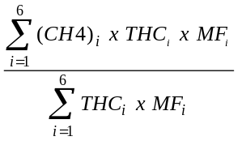 [1]

Where:

(CH4)_{i} = methane fraction for THC emission rate interval i, calculated from surveillance vehicles testing.
THC_{i} = average THC emission rate for interval i, calculated from the MVEI system, and
MF_{i} = mileage fraction driven by LDV in THC emission rate interval i as estimated from the MVEI system..

The resulting in-use fleet average methane reflects methane measurements of the 1994 surveillance vehicles and is also consistent with the vehicle use data in the California MVEI.

Table 5 shows the average surveillance fleet methane percentages, the average THC emission rates, and the mileage weighting factors for the six THC emission rate ranges, for each of the three FTP bags. Table 6 shows the average 1994 exhaust methane percentages for each FTP bag, with and without mileage weighting. The unweighted methane average reflects the average exhaust methane percentage for the surveillance vehicles. The cold start methane percentage is about the same whether weighting is used or not, but weighting is significant for determining the methane percentage of stabilized and hot start exhaust emissions.

Comparison to Caldecott Tunnel

The catalyst LDV, stabilized exhaust methane percentage calculated using the methodology in the previous section is 16.2 percent of THC emissions (or about 15.7 percent of TOG). Using the estimated composition of the tunnel emissions (shown in Table 3), the expected methane percentage in the tunnel is 11.1 percent compared to the 9.9 percent reported for Caldecott tunnel TOG emissions. The ARB speciation for stabilized LDV emissions leads to much better agreement with tunnel measurements than the 1990 Auto/Oil speciation:

Methane
(percent)
Caldecott (summer 1994) 9.9

Estimated using 1990 Auto/Oil LDV 33.0
Estimated using 1994 ARB LDV 11.1

Surveillance Vehicle Organic Gas Speciation Measurements

Even though surveillance measurements of motor vehicle methane and THC emissions have been made since 1976, high quality speciation measurements were not made until after the ARB adopted analytical procedures for measuring the concentration of organic compounds that comprise vehicle organic gas emissions on September 22, 1993 (CARB September 22, 1993). The first summer gasoline exhaust emissions were speciated during the summer of 1994. Since all gasoline sold in the South Coast after the summer of 1994 has been oxygenated, the 1994 surveillance data are the only surveillance data that can be used to compare to the 1994 Caldecott tunnel speciation as well as to replace the 1990 Auto/Oil speciation profiles.

Of the approximately 300 vehicles randomly selected for emission testing during the summer of 1994, speciation measurements were made on 57 vehicles, for each FTP bag. Data quality was assured with: (1) instrument performance quality control measures (control charting and replicate testing) and (2) comparisons of non-methane hydrocarbon (NMHC) concentrations obtained by gas chromatograph and flame ionization detection (FID) techniques (Shikiya 1997). These NMHC concentrations must agree within 20 percent for the test to be considered valid. Of the 57 vehicles with speciation measurements, valid speciation data for 20 catalyst light duty vehicles are available for analysis (Horrocks 1997). Since the THC emission rate distribution from the 300 surveillance vehicles did not match the MVEI estimated distribution there is little chance that the distribution from these 20 vehicles will match either. Figure 14 shows the distribution of the stabilized THC emission rates from the 20 surveillance vehicles compared to the estimated 1994 California mileage-weighted in-use fleet. As shown, there are too many surveillance vehicles in the lowest and highest THC emission rate ranges. There were no surveillance vehicles in the 0.5-1.0 grams THC/mile emission rate range. Ideally, one should use a methodology to estimate the NMOG speciation profile similar to that used for methane. However, speciation from 20 vehicles is inadequate to represent each THC emission rate range. The composite non-methane speciation profiles for the 20 vehicles were computed by summing the mg/mile for each species divided by the total organic gas emissions (in mg/mile) over all 20 tests for each FTP bag. Thus, the resulting NMOG speciation profiles represent the total emissions (per mile) of the 20 surveillance vehicles. The TOG speciation profiles include the appropriate methane fraction calculated in the previous section. The complete 1994 LDV exhaust speciation profiles for the three FTP bags are shown in Appendix A.

The expected speciation profile of the TOG emissions in the Caldecott tunnel, based on the MVEI, can be estimated by compositing the speciation profiles for the five source categories in the weight percentages discussed earlier (Table 3). This composite profile is compared to the Caldecott tunnel speciation profile in Figure 15. The bar patterns are similar. Pentanes are higher in the tunnel and C6+ alkanes are lower in the tunnel; summed together the alkanes agree very well. Benzene and C8+ aromatics are both a few percent higher in the tunnel. Overall, the organic gas speciation resulting from the 20 surveillance vehicles is in good agreement with the Caldecott Tunnel TOG emissions profile.

Considering the uncertainty over how much emissions from other categories are mixed with catalyst LDV stabilized exhaust, it is useful to compare only the catalyst LDV stabilized exhaust speciation to the tunnel speciation. Figure 16 shows this comparison. The biggest difference seen in Figure 15 is for methane. Without including the evaporative and non-catalyst emissions (with their lower methane content), the methane fraction in the estimated emissions is much higher than measured in the tunnel.

FTP Composite Exhaust Emissions

Emissions for the three FTP cycles (bags) are combined in a single emission factor to represent a specific mix (“composite”) of cold start, stabilized, and hot start emissions (CARB September 1993):

FTP Composite = 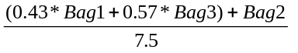 [2]

Where:

FTP Composite is in grams/mile;
Bag1 = the FTP cold start THC emissions in grams/cycle;
Bag2 = the FTP stabilized THC emissions in grams/cycle; and
Bag3 = the FTP hot start THC emissions in grams/cycle.

This calculation is performed for each organic gas species to develop a speciation profile consistent with the FTP composite TOG exhaust emissions. The USEPA speciation profile used in the ARB statewide inventory represents FTP composite exhaust emissions. The 1994 composite profile is shown in Appendix A.

Incremental Start Emissions

The ARB MVEI estimates emission factors for both cold and hot starts as an emission increment above hot stabilized emissions (McNair July 1994). In the FTP, the Bag 1 and Bag 3 measurements reflect the start emission increment as well as emissions accrued at the cold and hot stabilized rates, respectively. Thus, the Bag 2 result (which represents both cold and hot stabilized emissions) must be subtracted from the Bag 1 and Bag 3 results:

Cold Start = 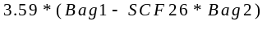 [3]

Where:

Cold Start = the EMFAC cold start emission increment in grams/start;
Bag1 = the cold transient emissions in grams/mile;
Bag2 = the FTP stabilized emissions in grams/mile;
3.59 = the mileage for the FTP Bag 1 stabilized emissions in miles/start; and
SCF26 = the EMFAC speed correction factor to adjust the Bag 2 average speed (16 mph) to the Bag 1 average speed (26 mph).

This calculation is performed for each organic gas species with negative values set to zero. The hot start emission increment calculation is performed in a similar manner. The complete cold and hot start incremental speciation profiles for 1994 are shown in Appendix A.

Speciation Profiles for 1987 and 1990

Most model performance studies conducted for California areas simulated ozone episodes which occurred during the summer of 1987 or 1990. Methane emissions for the 3 FTP bags can be estimated for 1987 and 1990 using the same methodology presented above to estimate 1994 methane emissions. However, insufficient surveillance vehicle tests were conducted during those years to estimate methane percentages for the six THC emission rate ranges. However, there were sufficient tests during 1988 to represent 1987 emissions, and in 1992 to represent 1990 emissions. Table 7 shows the 1988 surveillance methane averages and the 1987 weighting factors for the six THC emission rate ranges. Table 8 shows the resulting 1987 exhaust methane percentages for each FTP bag. Table 9 shows the 1992 surveillance methane averages and the 1990 weighting factors. Table 10 shows the resulting 1987 exhaust methane percentages for each FTP bag.

The weighted methane percentages for each FTP bag were used with the NMOG speciation profiles from the 1994 surveillance vehicles to produce composite speciation profiles for each FTP bag for both 1987 and 1990. The complete profiles are shown in appendices B and C, respectively. As expected the average methane is lowest for 1987. The estimated average stabilized THC exhaust emissions decrease from 1.185 grams/mile in 1987 to 0.767 grams/mile in 1994; as a result the average methane fraction increases from 11.4 to 16.2 percent.

Figures 17 through 19 show the 1990 surveillance speciation profiles compared to the 1990 Auto/Oil speciation profiles for the three FTP bags. Figure 17 shows that the cold start (bag 1) organic species composition is very similar for both data sources. The speciation profiles for stabilized exhaust, shown in Figure 18, are inconsistent. In addition to the obvious methane discrepancy, the 1990 Auto/Oil speciation profile is almost devoid of fast reacting olefins and aromatic compounds. This lowers the ozone forming potential of the stabilized NMOG emissions. The hot start emission speciation profiles (Figure 19) are also different, but since there is a high proportion of stabilized exhaust emissions in the hot start bag, these differences may also reflect the differences seen in the stabilized exhaust bag.

The 1987 ARB FTP composite speciation is compared to the 1987 Sigsby speciation in Figure 20. Several differences can be seen in Figure 20. Methane, propane and butanes are higher in the Sigsby profile. Propylene, 1,3-butadiene, aromatic compounds are higher in the ARB speciation. There are several reasons why the speciation may be different. The Sigsby speciation was not based on measurements of California vehicles. The methane in the ARB speciation has been estimated so that it represents the California in-use fleet for 1987. Also, detection limits have been lowered since 1987.

Figures 21 and 22 show the methane percentage trend in the ARB LDV exhaust speciation profiles from 1987 through 1994. The trend in Figure 21 includes mileage weighting while the trend in Figure 22 does not. It is interesting to note that the methane percentage trend for the surveillance vehicles unweighted by mileage actually shows a different trend than for weighted emissions. This difference is due to the influence of the very high TOG emitting vehicles, which are very important in the unweighted estimates. There are many more high-emitting vehicles in the surveillance program for 1994 than earlier years. This lowers the surveillance fleet’s average methane percentage. However, using the methodology presented here, the methane percentage is estimated for each THC emission rate range and weighted by in-use mileage driven. Thus, the number of vehicles tested in each range has little effect on the resulting in-use LDV average methane percentage.

Conclusions

The average methane percentage of TOG in catalyst LDV, stabilized exhaust decreases with increasing organic gas emissions. Results from this study indicate that the methane percentage of TOG from the average catalyst LDV, stabilized exhaust increases from 11.1 percent in 1987 to 15.7 percent in 1994, rather than the uniform 53 percent of TOG used in many previous photochemical modeling simulations in California. Thus the NMOG portion of TOG of stabilized exhaust should be increased from 47 percent to about 84 to 89 percent, depending on the year.

The percentages of fast-reacting olefins and aromatics have also been underpredicted. These conclusions are corroborated from the extensive methane/THC testing from the ARB’s surveillance program, speciation measurements performed for surveillance vehicles, and the summer 1994 Caldecott tunnel study. These conclusions do not apply to exhaust emissions from cleaner burning gasoline, introduced in 1996.

Recommendations

1. California motor vehicle emission estimates for 1987, 1990 and 1994, should use the TOG speciation profiles developed in this research. This will allow modeling and official inventory emission estimates to be based on a consistent set of speciation data. If needed, speciation profiles for other pre-1995 calendar years can be developed using the procedures presented here.

2. In addition to methane, emissions of other organic gas species may be dependent on motor vehicle TOG exhaust emission rates. Speciation data collected during 1996 and 1997 should be used to develop speciation profiles based on the methodology used here to estimate exhaust THC methane fractions representative of the California in-use LDV fleet.

3. Until the release of EMFAC7G, the ARB motor vehicle emission factor models have estimated emission factors for cold and hot start emissions as defined by the FTP methodology. EMFAC7G estimates vehicle start emissions for “continuous” starts. Further research should be undertaken to determine speciation profiles appropriate for continuous starts.
References

ARB Memorandum, Shikiya, J. To Loscutoff, B., January 16, 1997.

ARB Memorandum, Horrocks, J. To Shikiya, J., January 16, 1997.

ARB Memorandum, Hammond D. Through Cook J. & Secord D. to Loscutoff, B., September 13, 1996.

Black, F. and High L., Passenger Car Hydrocarbon Emissions Speciation, EPA-600/2-8--085, U.S. Environmental Protection Agency, Research Triangle Park, NC, May 1980.

California Air Resources Board: California Non-Methane Organic Gas (NMOG) Test Procedures, adopted September 22,1993.

California Air Resources Board: Methodology for Estimating Emissions from On-Road Motor Vehicles, Volume I: EMFAC7F, page D-1, September 1993.

California Air Resources Board: Methodology for Estimating Emissions from On-Road Motor Vehicles, EMFAC7G, November 1996.

Devesh, S.: Test Report of the Light-Duty Vehicle Surveillance Program, Series 12 (LDVSP 12), Mobile Source Division, California Air Resources Board, July 1994.

Kirchstetter, T. W., Singer, B. C., Harley, R. A., Kendall, G. R., and Chan W.: Impacts of Oxygenated Gasoline Use on Light-Duty Vehicle Emissions, Environmental Science & Technology, Volume 30 No. 2, pp 661:670, February 1996.

McNair, L.A., et al.: Airshed Model Evaluation of Reactivity Adjustment Factors Calculated with the Maximum Incremental Reactivity Scale for Transitional-Low Emission Vehicles, J. Air & Waste Manage. Assoc, 44: 900-907, July 1994.

Pollack, A. K., Cohen, J. P., and Noda, A. M.: Auto/Oil Air Quality Improvement Research Program: Description of Working Data Set, Systems Applications International, San Rafael, CA, 1990.

Sigsby, J.E., Jr., et al., Volatile Organic Compound Emissions from 46 In-Use passenger Cars, Environmental Science and Technology, Volume 21, N. 5, 1987, pp. 466-475.

Table 5
Methane Fraction of Light-Duty Vehicle THC Exhaust Emissions
1994 Surveillance Vehicles Weighted by
1994 California Annual Mileage by THC Emission Rate

FTP Cold Start (Bag 1)

THC Range  (grams/mile) | California  Average  (grams/mile) | California  Mileage  (fraction) | Surveillance  Average  Methane (%) | THC  for Range  (grams/mile) | Methane  for Range  (grams/mile)
0 - <.250 |  | 0.0
.250 - <.500 |  | 0.0
.500 - <1.00 | 0.937 | 0.054 | 11.00 | 0.051 | 0.006
1.00 - <2.00 | 1.346 | 0.082 | 9.32 | 0.110 | 0.010
2.00 - <3.00 | 2.705 | 0.493 | 9.09 | 1.334 | 0.121
>3.00 | 5.134 | 0.371 | 8.52 | 1.905 | 0.162
 | Totals | 1.000 |  | 3.400 | 0.299

Average Bag 1 Methane fraction = .299/3.400= .088

FTP Stabilized (Bag 2)

THC Range  (grams/mile) | California  Average  (grams/mile) | California  Mileage  (fraction) | Surveillance  Average  Methane (%) | THC  for Range  (grams/mile) | Methane  for Range  (grams/mile)
0 - <.250 | 0.149 | 0.182 | 43.08 | 0.027 | 0.012
.250 - <.500 | 0.459 | 0.295 | 24.59 | 0.135 | 0.033
.500 - <1.00 | 0.697 | 0.357 | 17.13 | 0.249 | 0.043
1.00 - <2.00 | 1.381 | 0.084 | 11.28 | 0.116 | 0.013
2.00 - <3.00 | 2.554 | 0.056 | 10.23 | 0.143 | 0.015
>3.00 | 3.680 | 0.026 | 9.22 | 0.096 | 0.009
 | Totals | 1.000 |  | 0.767 | 0.124

Average Bag 2 Methane fraction = 0.124/0.767= .162

Table 5 (continued)
Methane Fraction of Light-Duty Vehicle THC Exhaust Emissions
1994 Surveillance Vehicles Weighted by
1994 California Annual Mileage by THC Emission Rate

FTP Hot Start (Bag 3)

THC Range  (grams/mile) | California  Average  (grams/mile) | California  Mileage  (fraction) | Surveillance  Average  Methane (%) | THC  for Range  (grams/mile) | Methane  for Range  (grams/mile)
0 - <.250 | 0.144 | 0.054 | 29.86 | 0.008 | 0.002
.250 - <.500 | 0.262 | 0.082 | 18.36 | 0.022 | 0.004
.500 - <1.00 | 0.689 | 0.620 | 14.27 | 0.427 | 0.061
1.00 - <2.00 | 1.311 | 0.086 | 9.26 | 0.113 | 0.010
2.00 - <3.00 | 2.348 | 0.082 | 9.18 | 0.192 | 0.018
>3.00 | 3.552 | 0.077 | 7.62 | 0.272 | 0.021
 | Totals | 1.000 |  | 1.033 | 0.116

Average Bag 3 Methane fraction = 0.116/1.033= .112

Table 6

Average Exhaust Methane
1994 Summer Light Duty Vehicle Surveillance Program
Weighted by 1994 California Mileage Estimates
(percent of THC)

Cold Starts Hot Stabilized Hot Starts

8.8 16.2 11.2

Surveillance Fleet Exhaust Methane Without Weighting
by California Mileage Estimates

9.0 12.3 10.0

Table 7

Methane Fraction of Light-Duty Vehicle THC Exhaust Emissions
1988 Surveillance Vehicles Weighted by
1987 California Annual Mileage by THC Emission Rate

FTP Cold Start (Bag 1)

THC Range  (grams/mile) | California  Average  (grams/mile) | California  Mileage  (fraction) | Surveillance  Average  Methane (%) | THC  for Range  (grams/mile) | Methane  for Range  (grams/mile)
0 - <.250 |  | 0.0
.250 - <.500 |  | 0.0
.500 - <1.00 |  | 0.0
1.00 - <2.00 | 1.772 | 0.215 | 9.48 | 0.380 | 0.036
2.00 - <3.00 | 2.618 | 0.300 | 7.06 | 0.785 | 0.055
>3.00 | 6.035 | 0.485 | 6.72 | 2.927 | 0.197
 | Totals | 1.000 |  | 4.093 | 0.288

Average Bag 1 Methane fraction = .288/4.093= .070

FTP Hot Stabilized (Bag 2)

THC Range  (grams/mile) | California  Average  (grams/mile) | California  Mileage  (fraction) | Surveillance  Average  Methane (%) | THC  for Range  (grams/mile) | Methane  for Range  (grams/mile)
0 - <.250 | 0.236 | 0.109 | 39.86 | 0.026 | 0.010
.250 - <.500 | 0.401 | 0.285 | 25.71 | 0.114 | 0.029
.500 - <1.00 | 0.792 | 0.200 | 16.10 | 0.159 | 0.026
1.00 - <2.00 | 1.475 | 0.141 | 10.11 | 0.209 | 0.021
2.00 - <3.00 | 2.304 | 0.215 | 6.39 | 0.496 | 0.032
>3.00 | 3.755 | 0.048 | 9.39 | 0.182 | 0.017
 | Totals | 1.000 |  | 1.185 | 0.135

Average Bag 2 Methane fraction = 0.135/1.185= .114

Table 7 (continued)
Methane Fraction of Light-Duty Vehicle THC Exhaust Emissions
1988 Surveillance Vehicles Weighted by
1987 California Annual Mileage by THC Emission Rate

FTP Hot Start (Bag 3)

THC Range  (grams/mile) | California  Average  (grams/mile) | California  Mileage  (fraction) | Surveillance  Average  Methane (%) | THC  for Range  (grams/mile) | Methane  for Range  (grams/mile)
0 - <.250 |  | 0.0
.250 - <.500 | 0.394 | 0.086 | 20.33 | 0.034 | 0.007
.500 - <1.00 | 0.671 | 0.241 | 13.43 | 0.162 | 0.022
1.00 - <2.00 | 1.327 | 0.187 | 8.50 | 0.248 | 0.021
2.00 - <3.00 | 2.457 | 0.147 | 6.51 | 0.362 | 0.024
>3.00 | 4.358 | 0.338 | 8.17 | 1.473 | 0.120
 | Totals | 1.000 |  | 2.279 | 0.194

Average Bag 3 Methane fraction = 0.194/2.279= .088

Table 8

Average Exhaust Methane
1988 Summer Light Duty Vehicle Surveillance Program
Weighted by 1987 California Mileage Estimates
(percent of THC)

Cold Starts Hot Stabilized Hot Starts

7.0 11.4 8.5

Surveillance Fleet Exhaust Methane Without Weighting
by California Mileage Estimates

8.4 15.7 12.8

Table 9

Methane Fraction of Light-Duty Vehicle THC Exhaust Emissions
1992 Surveillance Vehicles Weighted by
1990 California Annual Mileage by THC Emission Rate

FTP Cold Start (Bag 1)

THC Range  (grams/mile) | California  Average  (grams/mile) | California  Mileage  (fraction) | Surveillance  Average  Methane (%) | THC  for Range  (grams/mile) | Methane  for Range  (grams/mile)
0 - <.250 |  | 0.0
.250 - <.500 |  | 0.0
.500 - <1.00 |  | 0.0
1.00 - <2.00 | 1.843 | 0.183 | 8.19 | 0.338 | 0.028
2.00 - <3.00 | 2.458 | 0.456 | 7.38 | 1.121 | 0.083
>3.00 | 6.002 | 0.361 | 7.37 | 2.167 | 0.160
 | Totals | 1.000 |  | 3.625 | 0.270

Average Bag 1 Methane fraction = .270/3.625= .075

FTP Hot Stabilized (Bag 2)

THC Range  (grams/mile) | California  Average  (grams/mile) | California  Mileage  (fraction) | Surveillance  Average  Methane (%) | THC  for Range  (grams/mile) | Methane  for Range  (grams/mile)
0 - <.250 | 0.203 | 0.095 | 40.03 | 0.019 | 0.008
.250 - <.500 | 0.377 | 0.375 | 23.10 | 0.142 | 0.033
.500 - <1.00 | 0.637 | 0.256 | 13.58 | 0.163 | 0.022
1.00 - <2.00 | 1.450 | 0.138 | 9.33 | 0.200 | 0.019
2.00 - <3.00 | 2.481 | 0.113 | 10.67 | 0.280 | 0.030
>3.00 | 4.097 | 0.023 | 6.24 | 0.094 | 0.006
 | Totals | 1.000 |  | 0.898 | 0.117

Average Bag 2 Methane fraction = 0.117/0.898= .130

Table 9 (continued)
Methane Fraction of Light-Duty Vehicle THC Exhaust Emissions
1992 Surveillance Vehicles Weighted by
1990 California Annual Mileage by THC Emission Rate

FTP Hot Start (Bag 3)

THC Range  (grams/mile) | California  Average  (grams/mile) | California  Mileage  (fraction) | Surveillance  Average  Methane (%) | THC  for Range  (grams/mile) | Methane  for Range  (grams/mile)
0 - <.250 |  | 0.0
.250 - <.500 | 0.432 | 0.283 | 17.94 | 0.122 | 0.022
.500 - <1.00 | 0.762 | 0.300 | 13.07 | 0.229 | 0.030
1.00 - <2.00 | 1.385 | 0.168 | 8.13 | 0.232 | 0.019
2.00 - <3.00 | 2.773 | 0.150 | 6.39 | 0.417 | 0.027
>3.00 | 4.654 | 0.099 | 5.08 | 0.462 | 0.023
 | Totals | 1.000 |  | 1.462 | 0.121

Average Bag 3 Methane fraction = 0.121/1.462= .083

Table 10

Average Exhaust Methane
1992 Summer Light Duty Vehicle Surveillance Program
Weighted by 1990 California Mileage Estimates
(percent of THC)

Cold Starts Hot Stabilized Hot Starts

7.4 13.0 8.3

Surveillance Fleet Exhaust Methane Without Weighting
by California Mileage Estimates

8.1 14.4 11.7

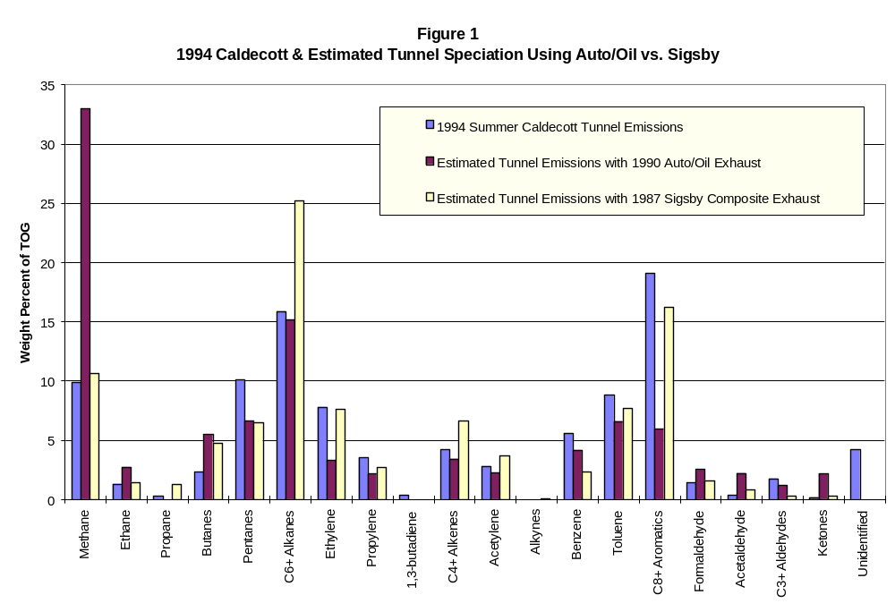

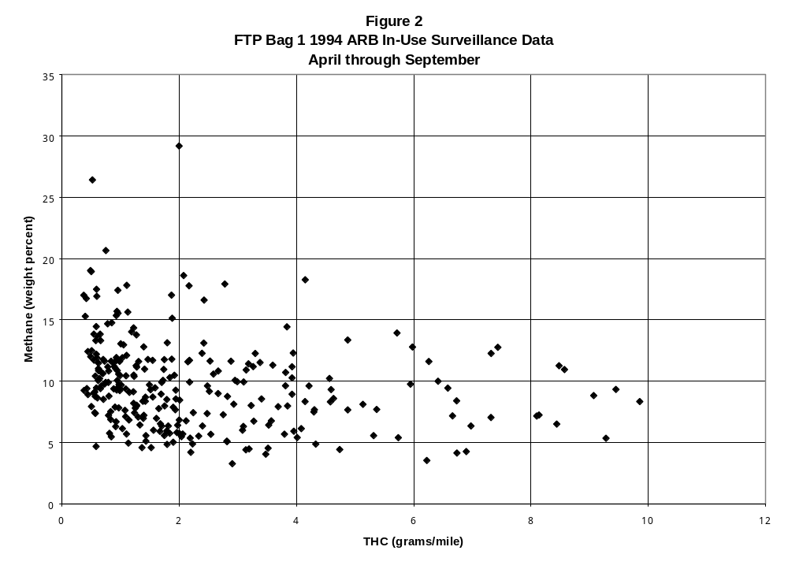
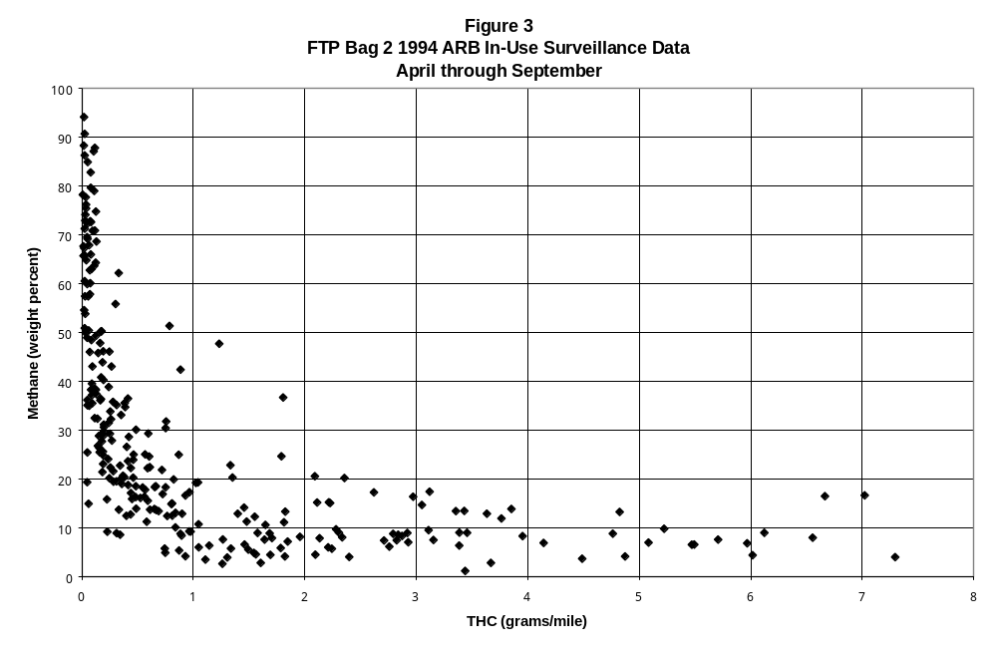
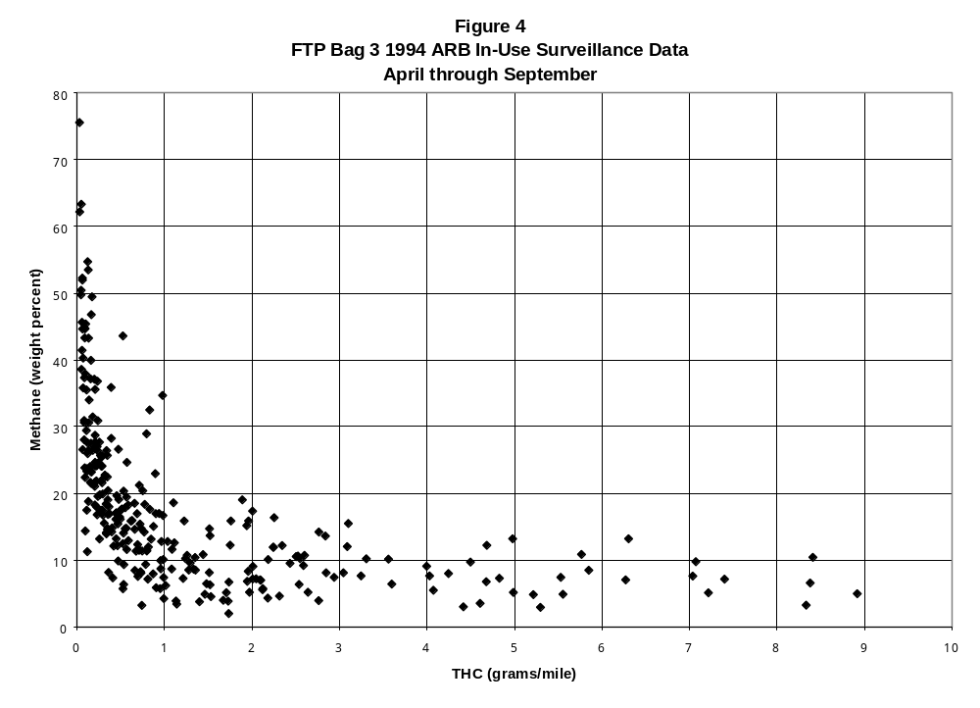
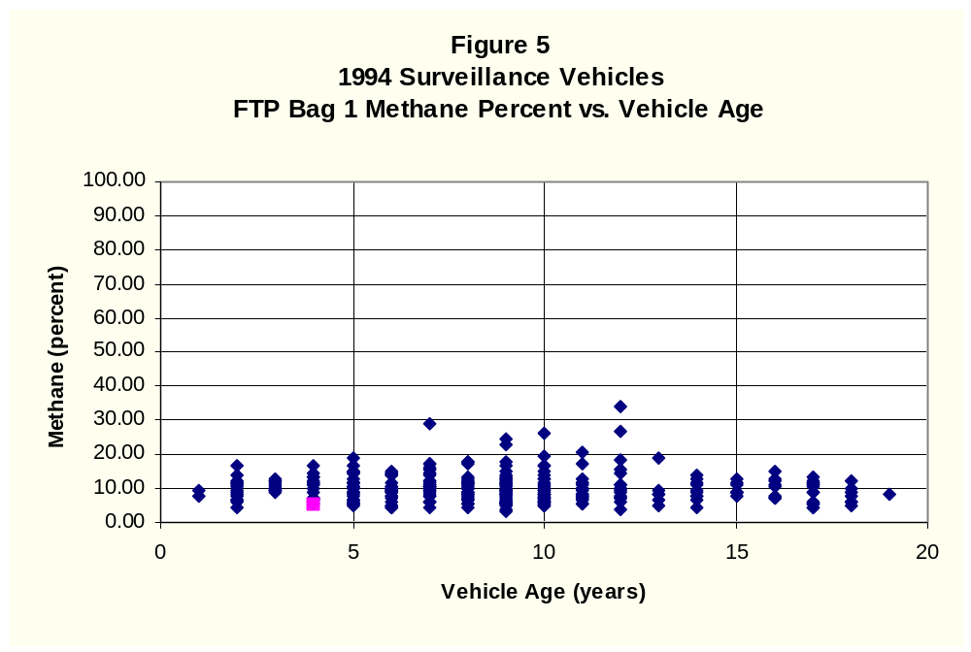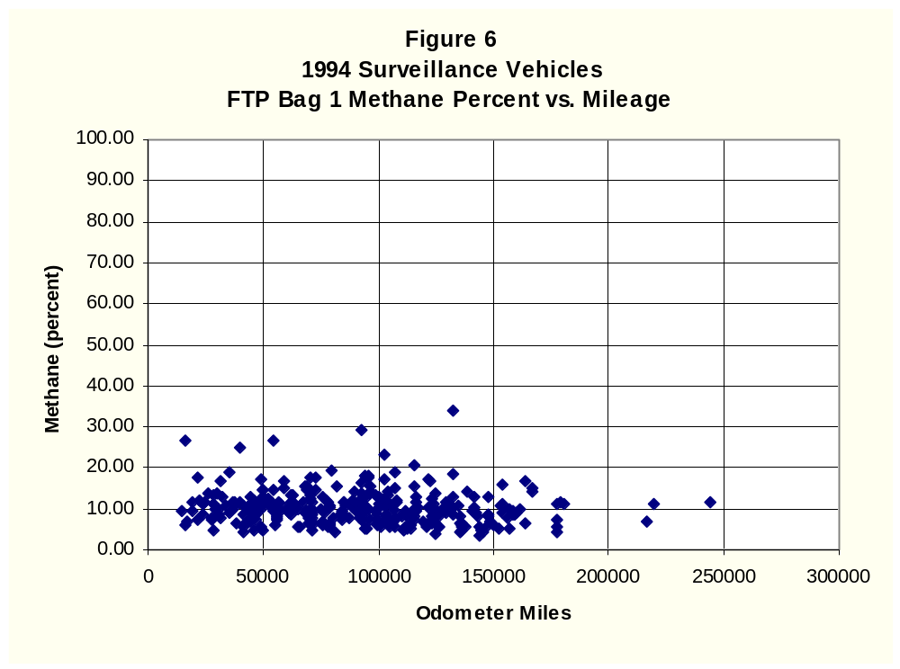
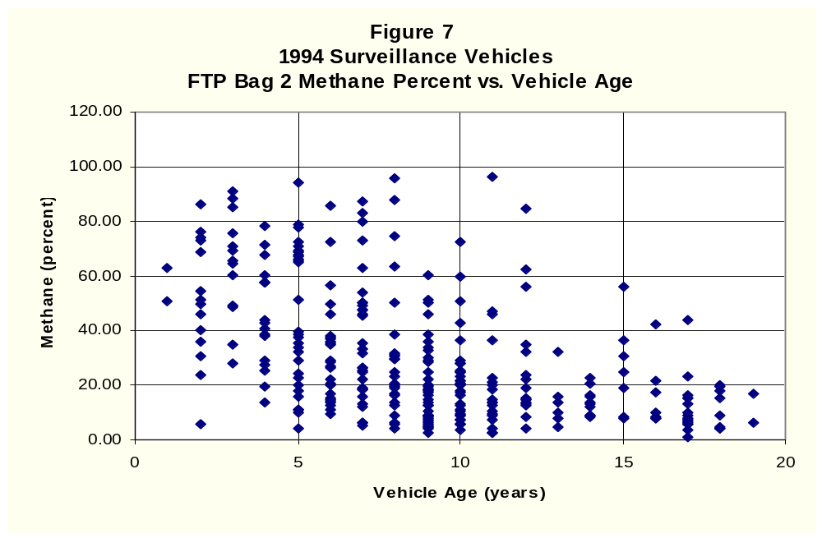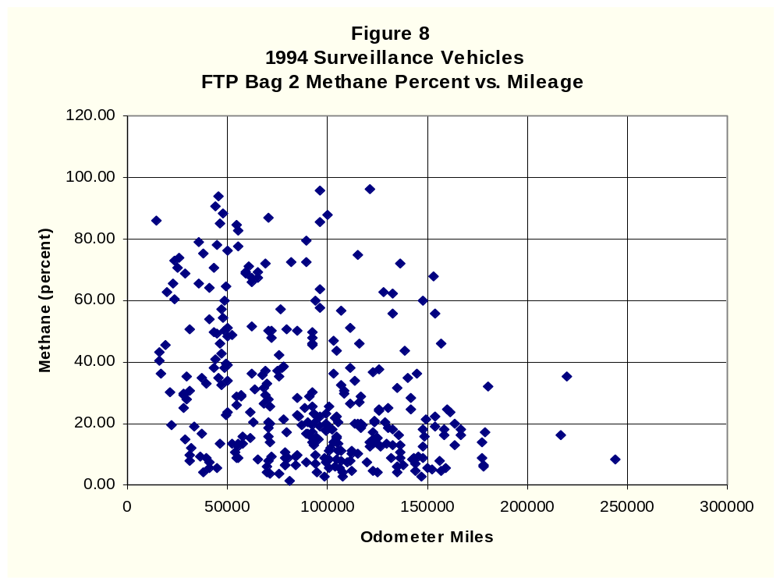
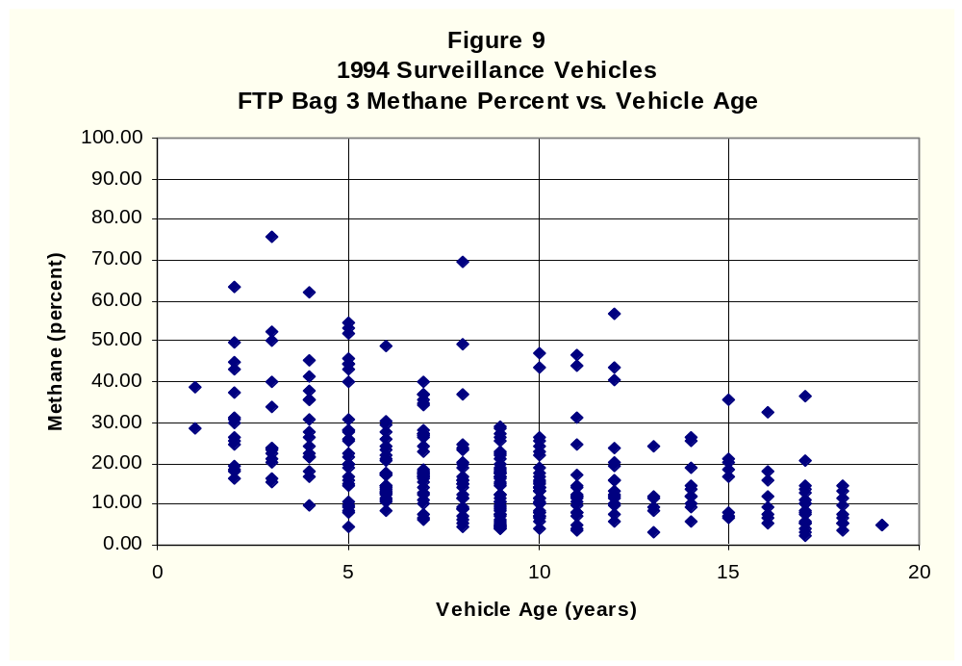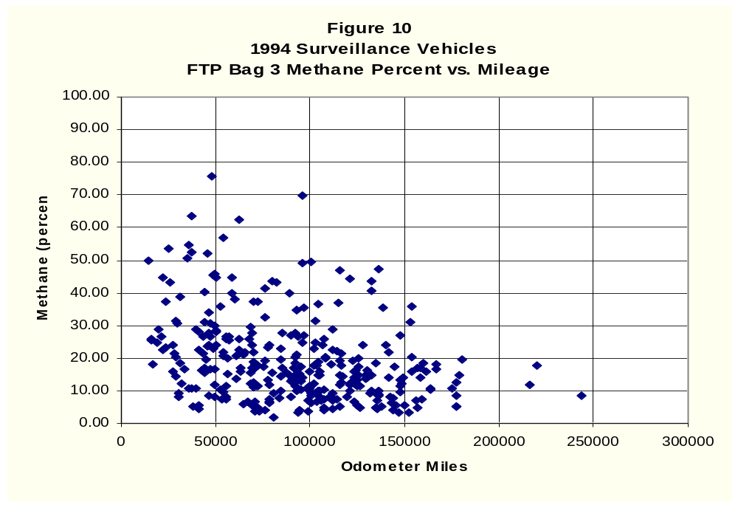
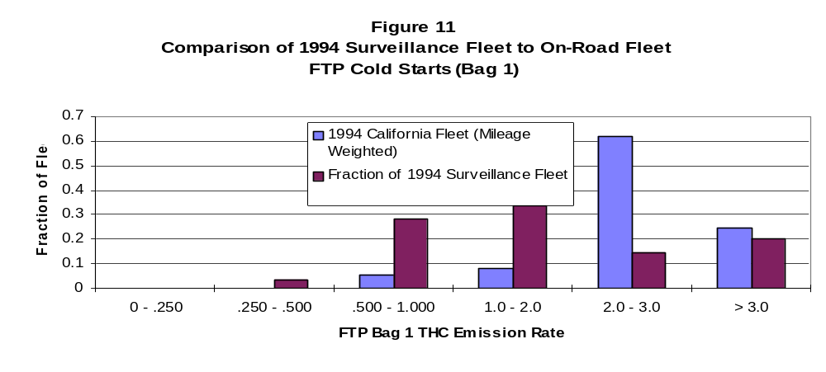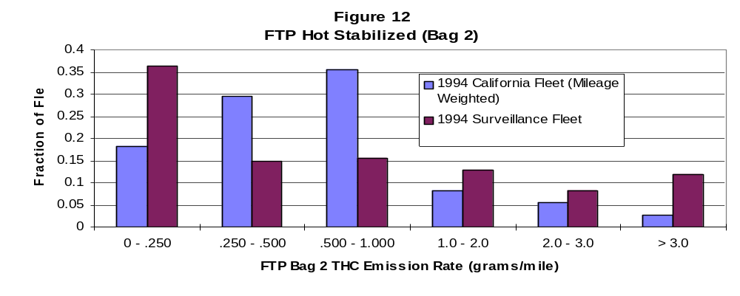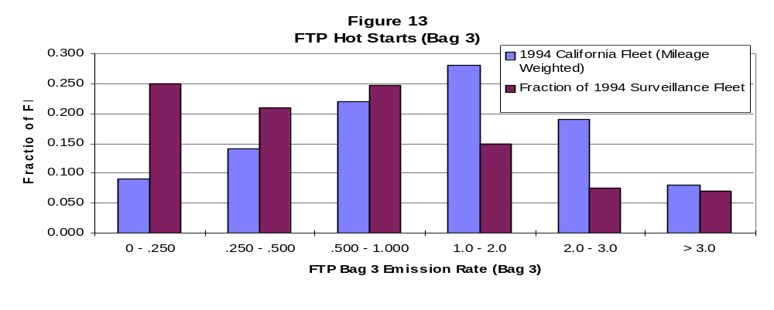
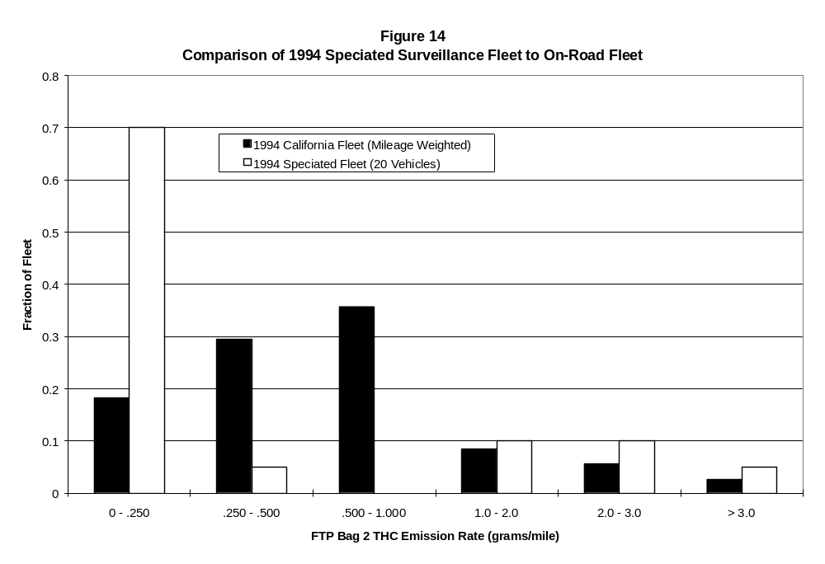

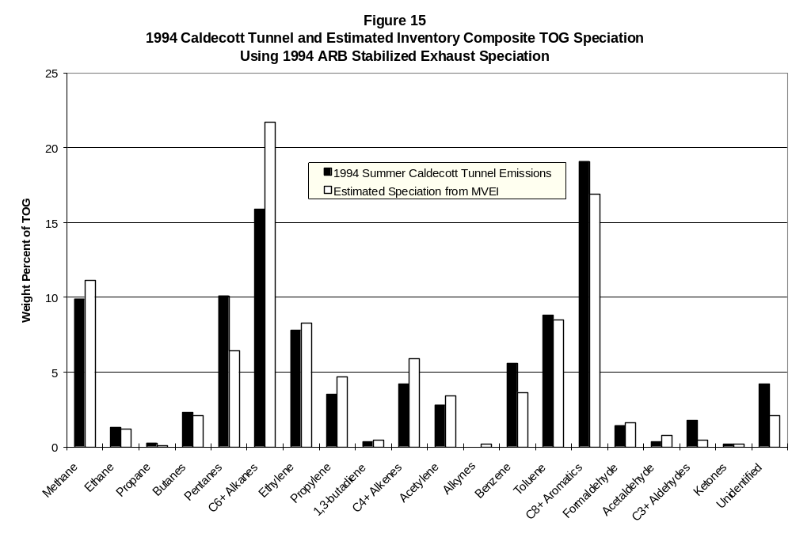
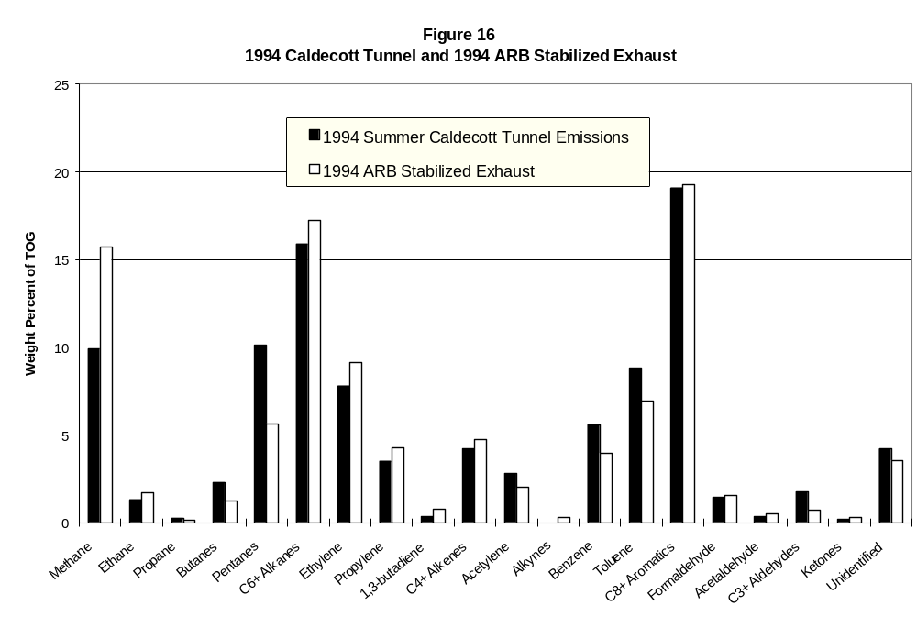
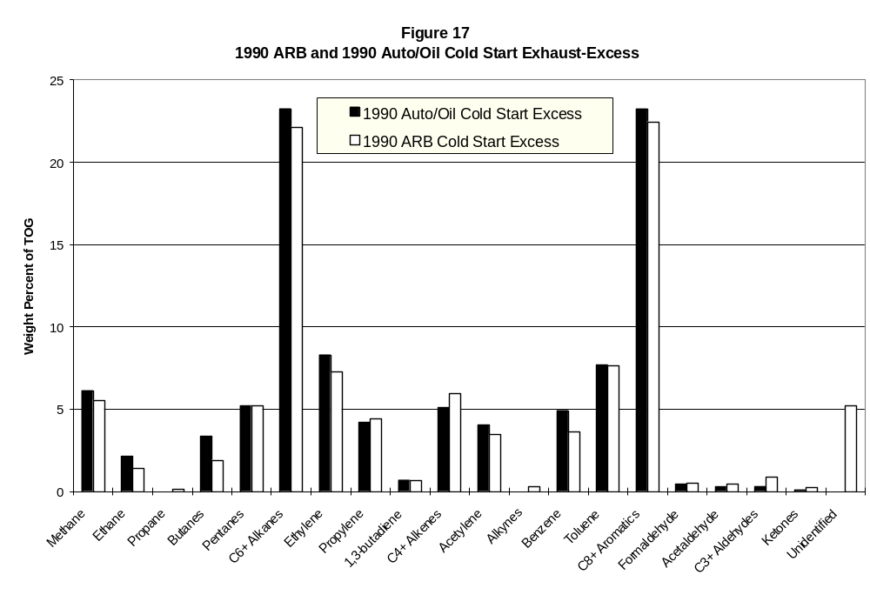
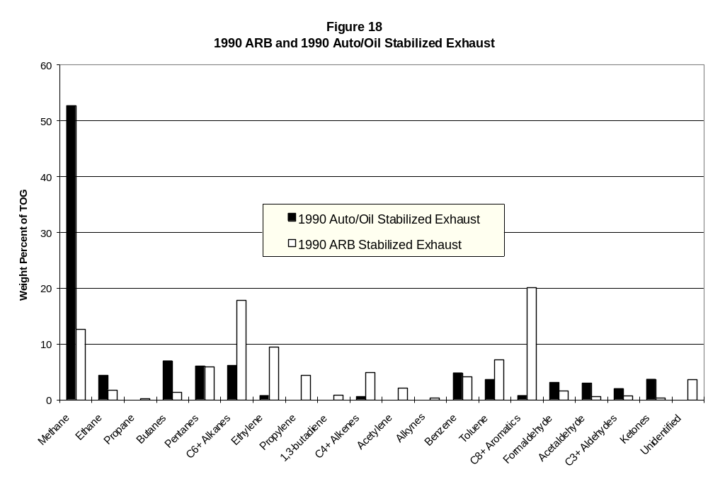
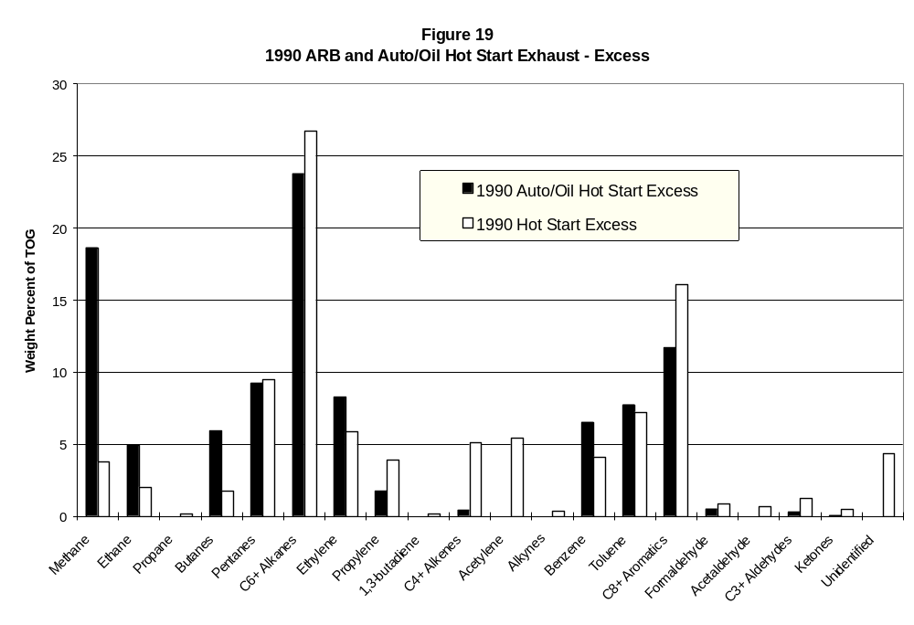
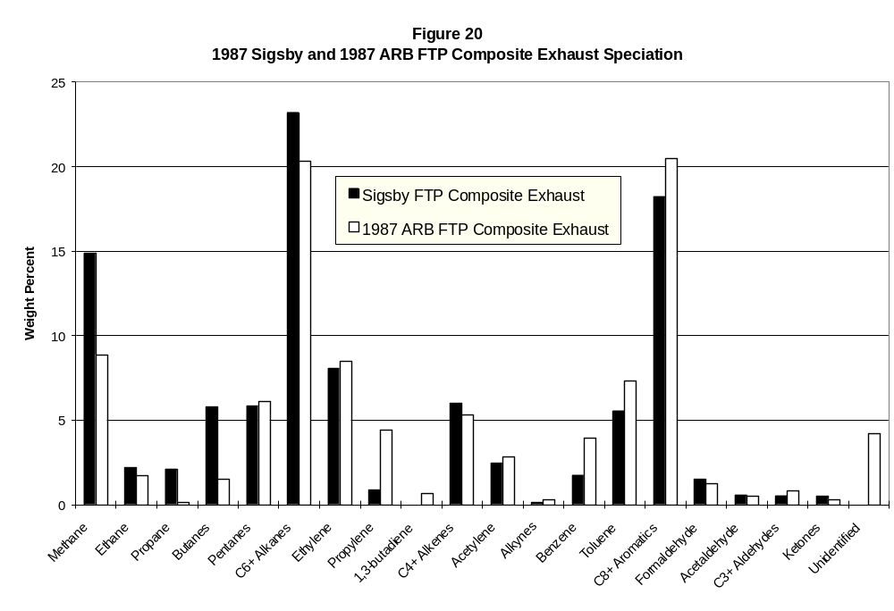
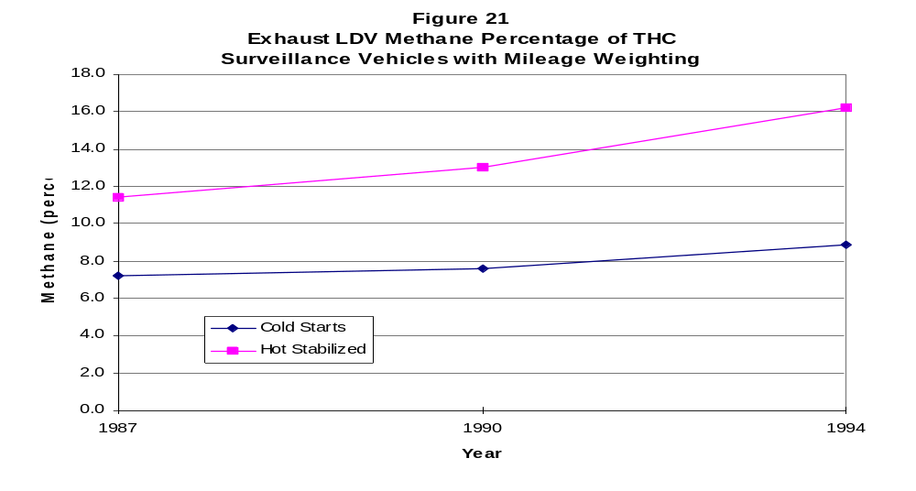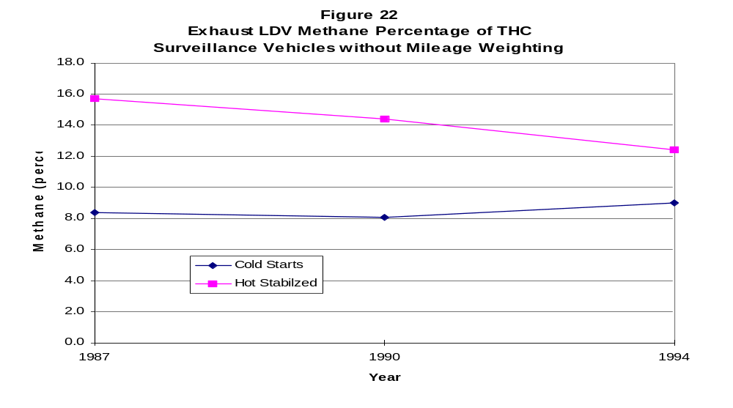

California emission inventories estimate cold and hot start “incremental” emissions in excess of stabilized emissions. This is explained in more detail in the section titled “Incremental Start Emissions”.
California emission inventories estimate cold and hot start “incremental” emissions in excess of stabilized emissions. This is explained in more detail in the section titled “Incremental Start Emissions”.

