Worksheet No. 2:

Drought and Health Vulnerability Assessment: Step for Conducting One

Your Jurisdiction or Community: _______________________________

Step 1: Reflect on Hazards

- First make a short list of possible drought related hazards below and then rank them accordingly to the probability of them happening again in your community.

- Severity of Consequences: “When something happens, how bad will it be?” Think of this holistically. You may want to consider a model like the Community Capitals Framework (CCF) to help you think of all the areas that could be affected.

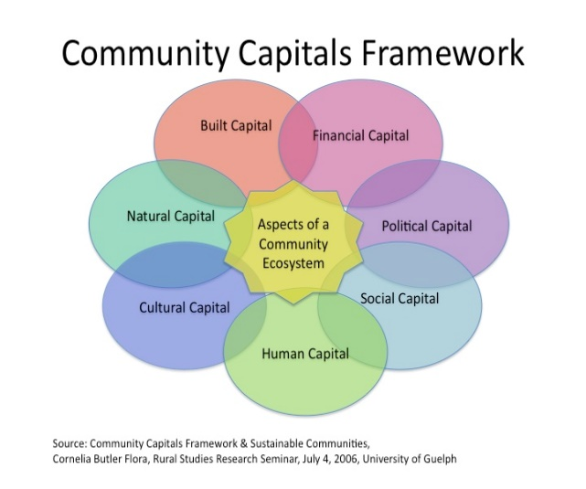
Community Capitals Impacts & Severity: Think Multi Year Drought

Built
Financial
Political
Social
Human
Cultural
Natural

- Scoring the Consequences: “When something happens, can we respond to it?”
Possible Resource: https://asprtracie.hhs.gov/technical-resources/resource/182/hazard-risk-assessment-instrument-hrai

- Risk Analysis: Combine your probability information with the severity data (A+B).

Step 2: Translating this into Practice (answer the following questions)

- What are the strengths and weaknesses have you learned from this quick assessment for your jurisdiction or community?

What actions will be needed to…

- Reallocate material resources and financing?

- Establish mutual aid agreements?

- Train and educate for staff and the public?

- Develop a communication plan?

- Other(s)?

Step 3: Evaluate the Results

What will be a suitable timeframe to revisit your assessment and adjust for changes to this plan? What resources will you need for this important step? Possible resource: CDC Framework for Program Evaluation: https://www.cdc.gov/eval/framework/index.htm
.

