February 7, 2024

Dear Cal EPA & CARB,

Thank you for the opportunity to comment on the [State of California Draft Priority Climate Action Plan.](https://ww2.arb.ca.gov/sites/default/files/2024-01/California%20Draft%20CPRG%20Priority%20Climate%20Action%20Plan%20as%20of%20January%2031%202024.pdf#page=16) (Draft Plan)

We support California’s efforts to reduce and eliminate greenhouse gases.  The Draft Plan provides important information and policy proposals.

One thing that it does not do is make it clear that California is not on track to reach the SB 32 requirement of 40% emissions reductions below the 1990 levels by 2030.  The graph below shows that, based on the 2022 estimate provided by CARB with its [2023 inventory report](https://ww2.arb.ca.gov/sites/default/files/2023-12/2000_2021_ghg_inventory_trends.pdf), California could reach 290 ppm emissions by 2030.  This is 30 ppm above the SB 32 target.  In fact, CARB’s 2022 Scoping Plan calls for a 48% reduction by 2030, which would set the target at 225 ppm–65 ppm below the current path in the graph below.

Unfortunately, the Draft Plan hides this reality by saying that the State’s progress is “well aligned” with its goals.

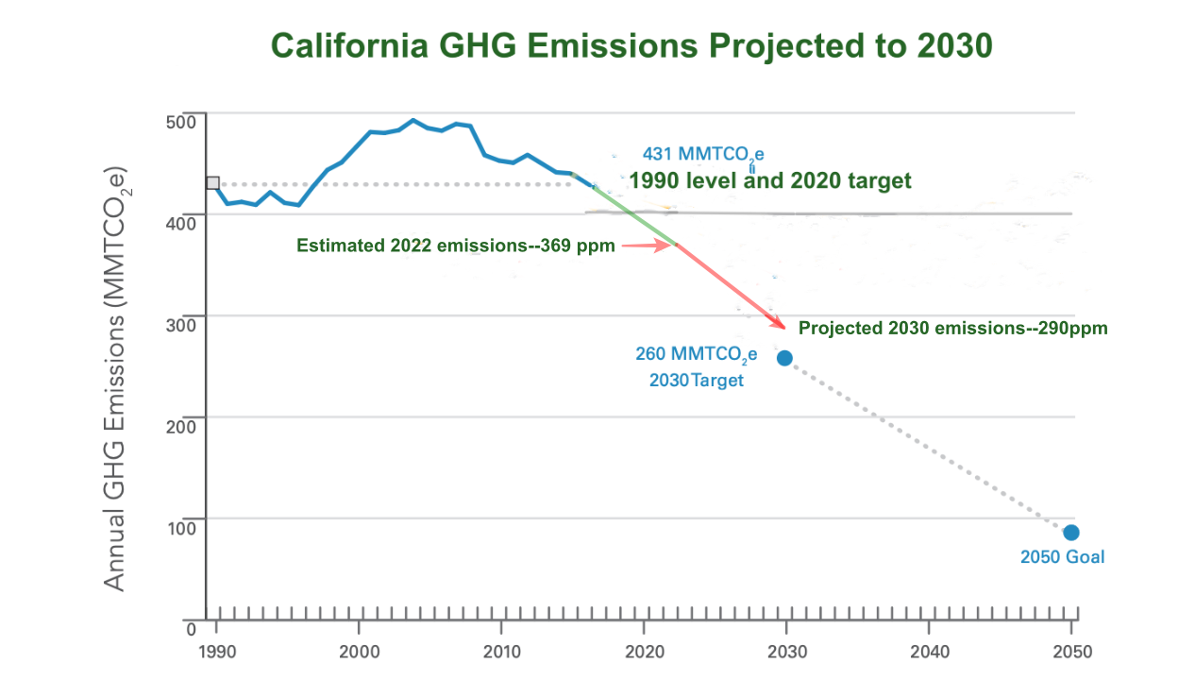

We ask that the final draft make it clear that, in spite of progress, California has to work even harder to meet its own goals, let alone the IPCC timetable, which is even more stringent.

Sincerely,

Jack Lucero Fleck

On behalf of 350 Bay Area