APPENDIX B-II

REPORTING FORMS AND INSTRUCTIONS

This Page Intentionally Left Blank
Appendix B - II
A facility required to submit an inventory plan, inventory report, or inventory update to the district (Health and Safety Code sections 44340, 44341, or 44344) shall use the CEIDARS HARP transaction format, incorporated by reference in Appendix G, or an equivalent format approved by the district, or the following paper forms.

Reporting Forms and Instructions
The following instructions are for completing core reporting forms, the Supplemental Use and Production Information Form, and the Update Summary Form as explained in sections V, VII, and VIII of the Emission Inventory Criteria and Guidelines Report:
The operator of each facility subject to the regulation shall complete one facility information Form, an entry on a stack Information Form for each stack or vent from which a listed substance may be released, an entry on a device information Form for each device associated with a release of a listed substance, and process information Forms and emission information Forms for each emitting process within each device. A process information Form and emission information Form and an entry on a device information Form shall be completed for each general location of fugitive emissions.
The Supplemental Use and Production Information Form shall be completed and submitted with the inventory report for all substances set forth in:
a) Appendix A-II which are 1) manufactured or produced as the result of any activity or process at the facility; 2) used as ingredients in any activity or process at the facility; or 3) otherwise associated with an activity or process, including but not limited to presence in a formulation operation or presence as a by-product or a reaction intermediate which appears temporarily during processing.
b) Appendix A-I which are used, manufactured, formulated, or released but for which emissions are below the applicable limit for degree of accuracy required by section VIII.E, unless a numeric estimate of such emissions is reported on an Emission Information Form for the appropriate emitting process. See the instructions for the Emission Information Form (Item (16)) for information on using the degree of accuracy values for reporting purposes.
c) Appendix A-III which are manufactured by any facility subject to the requirements set forth in VIII.E.(6).
The facility operator shall complete and submit to the district an Update Summary Form (US Form) as required to comply with the applicable update requirements specified in section V.A - M.
The district may, but need not, provide to the facility operator, forms which are partially filled out. The district may, but need not, provide to the facility operator, the stack and device information that presently exists for the criteria pollutant inventory. If the facility operator does not know this information, the operator may consult the district. If any of the provided information needs to be updated or corrected, the facility operator shall delete, add, or change the data according to the instructions provided for each form.
The shaded fields on the forms are fields used primarily for the criteria pollutant emission inventory reporting (under combined toxics and criteria pollutant reporting) or for district use. The shaded fields are not required to be filled out by the facility operator for purposes of Hot Spots reporting under this regulation.
The following are specific instructions for completing each required reporting form:

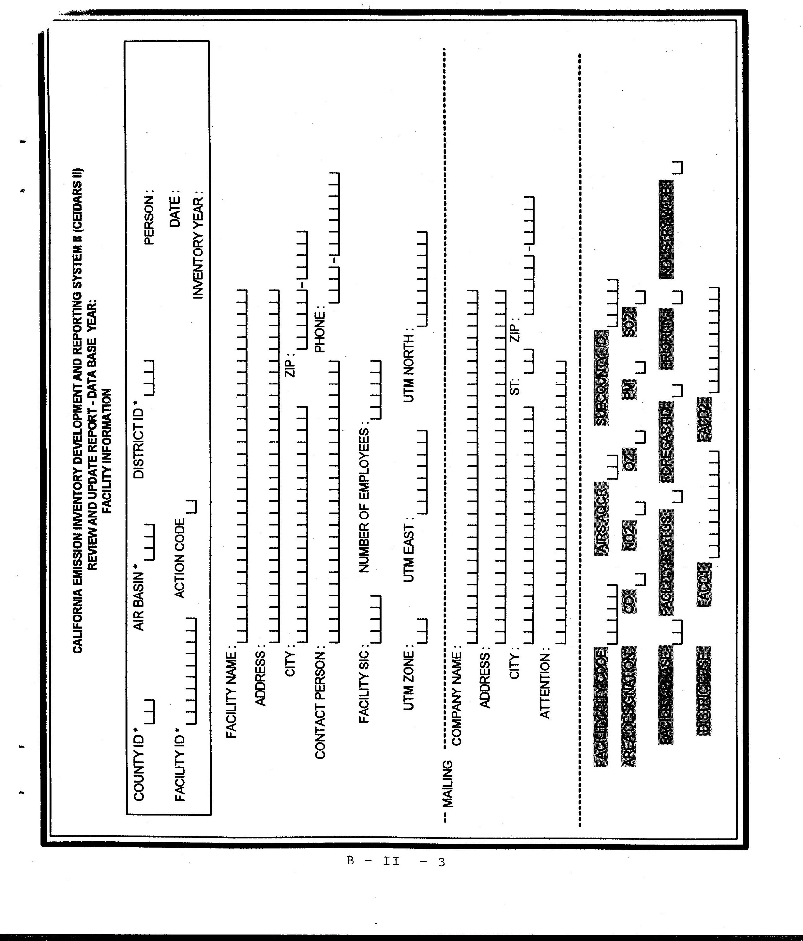

Facility Information Form
In the space provided on the upper right of the form, initial and date the form, and fill in the inventory reporting year for which you are reporting data.
(1) County ID, Air Basin, and District ID Codes: Using values provided in Table B-I, enter the appropriate County ID, Air Basin, and District ID codes that correspond to the facility location.
(2) Facility ID: Enter the district-assigned facility identification code. If the Facility ID is unknown, consult the district.
(3) Action Code: Enter the appropriate Action Code: A, C, or D.
'A' indicates Add -- This is a new facility that has not previously reported. Add the facility to the database.
‘C’ indicates Change -- Previously reported data on the form have been changed.
‘D’ indicates Delete -- The form is to be deleted. CAUTION!! Deletion of a Facility Information Form will cause ALL data for the facility to be deleted. This should only be used if the facility is no longer subject to reporting requirements.
(4) Facility Name: The name of the plant, station, or subsidiary company or division name, if necessary to clearly identify the establishment.
(5) Address (location): Street address where facility is located.
(6) City: City or nearby city or town where facility is located.
(7) ZIP: ZIP code and extension for the facility location.
(8) Contact Person: The person responsible for the information on these forms.
(9) Telephone: Area code and telephone number for the contact person.
(10) Facility SIC: The Standard Industrial Classification (SIC) number best describing the entire plant or facility. The SIC should be a full four-digit code. Do not use abbreviated two or three digit codes with trailing zeroes, such as "2600" or "2620". If unknown, consult the district.
(11) Number of Employees: Total number of employees working at the facility, including part-time and intermittent.
(12) UTM Zone, UTM East, UTM North: These codes are used to describe the facility location in Universal Transverse Mercator (UTM) coordinates. Enter the coordinates which most closely correspond to the facility location. For large facilities or if facility coordinates are unknown, consult the district, who should be able to provide guidance on assigning facility coordinates.
(13) Mailing Address: Name, Address, City, State, Zip code (and extension), and contact person (Attention) where correspondence regarding the facility should be mailed. If this information is the same as the facility address, write "same as above" diagonally across this section.
The following shaded fields have been included on the reporting forms for one of two reasons: a) these fields are optional and will be completed by district staff as tracking tools for the “Hot Spots” program; or b) they represent additional/optional merged data system fields that will also be completed by district staff if your district has chosen to submit a merged emission inventory report to the criteria pollutant and toxics data collection system. These fields are primarily related to emissions of criteria pollutants.
(14) Optional Fields: The fields FACILITY CITY CODE, FACILITY PHASE, FACILITY STATUS, PRIORITY and INDUSTRY WIDE are optional fields for district use and do not need to be filled in by the facility.
(15) Additional/Optional Merged Data System Fields: The fields AIRS AQCR, SUBCOUNTY ID, AREA DESIGNATION, CO, NO2, OZ, PM, SO2, FORECASTID, FACD1 and FACD2 are optional fields for those using the reporting forms to report emissions to the merged data system. The merged system allows the reporting of toxics and criteria pollutant emissions in one submittal.

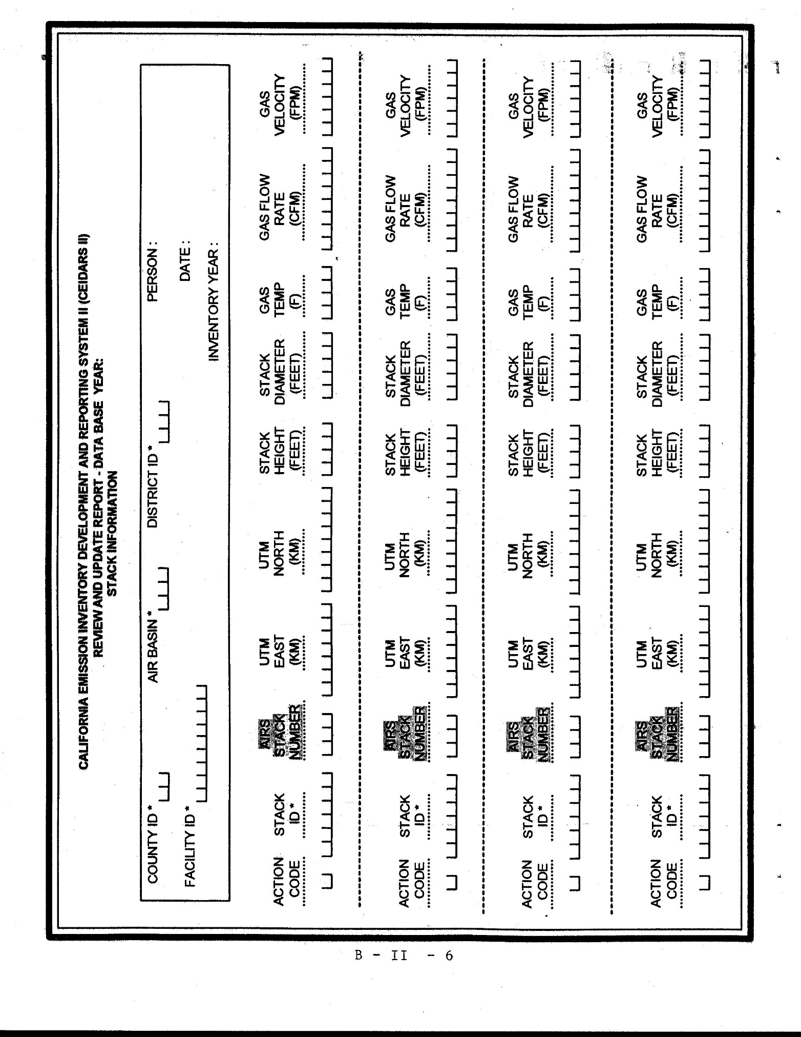
Stack Information Form
This form can be copied as many times as needed.
In the space provided on the upper right of the form, initial and date the form, and fill in the inventory reporting year for which you are reporting data.
The district may, but need not, provide information on the facility's Stack ID's and corresponding parameters that exist in the criteria pollutant inventory. If this information is not known or provided, consult the district.
Report on the stack information Form, with a unique Stack ID number, every stack, vent, ducted building exhaust site, and other site of exhaust release of a listed substance. "Exhaust" shall refer to a release where the listed substance is entrained in air and where the direction of the release is determined or influenced by a duct, louver, or similar construction. Do not report on the stack information Form a non-ducted, non-directional release. Instead, specify "fugitive", if applicable, in the process description field on the process information Form.
(1) County ID, Air Basin, and District ID Codes: Using values provided in Table B-I, enter the appropriate County ID, Air Basin, and District ID codes that correspond to the facility location.
(2) Facility ID: Enter the district-assigned facility identification code. If the Facility ID is unknown, consult the district.
(3) Action Code: Enter the appropriate Action Code: A, C, or D.
‘A’ indicates Add -- A new stack ID and the corresponding stack parameters have been added.
‘C’ indicates Change -- Previously reported data for the stack have been changed.
‘D’ indicates Delete -- The stack and its associated data are to be deleted. If deleting a stack, provide a brief explanation for the deletion. If a stack is being deleted because a device it serves is no longer in use, ensure the stack does not serve other devices.
(4) Stack ID: The Stack ID is a key numbering field used to link the information from these forms among stacks and to data in existing inventories. If a facility is adding a stack, a new stack ID needs to be created by the operator consistent with the existing number convention.
(5) UTM East, UTM North: These codes are used to describe the stack location in UTM (Universal Transverse Mercator) coordinates. Enter the coordinates which most closely correspond to the stack location. If the coordinates are not known, consult the district, who will provide guidance on assigning stack coordinates.
(6) Stack Height Above Ground: The vertical distance in feet, from ground to the point of emission.
(7) Inside Diameter: Inside diameter of the stack in feet. If the stack is not round, list the equivalent diameter (diameter of a circle of the same cross-sectional area as the stack).
(8) Exhaust Gas Temperature: Temperature, estimated to the nearest 50 degrees Fahrenheit, of the gas coming out of the stack under normal operating conditions.
(9) Exhaust Gas Flow Rate: The actual flow rate, measured in cubic feet per minute, of the gas exiting the stack at the reported gas temperature and atmospheric pressure. Ideally, the flow rate represents a measured value. If no measured data are available, a design rate may be used. Design rate or other available data may be expressed in standard cubic feet per minute (scfm) or any other reference cubic feet per minute (rcfm). The rate should be converted to actual cubic feet per minute (acfm) as follows:
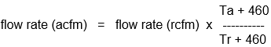
where: Ta = actual exhaust gas temperature in degrees F, and
Tr = temperature at reference conditions
(10) Exhaust Gas velocity: Exhaust velocity in feet per minute corresponding to exhaust flow rate. This field is optional if Exhaust Gas Flow Rate has been completed.
The following shaded fields have been included on the reporting forms for one of two reasons: a) these fields are optional and will be completed by district staff as tracking tools for the “Hot Spots” program; or b) they represent additional/optional merged data system fields that will also be completed by district staff if your district has chosen to submit a merged emission inventory report to the criteria pollutant and toxics data collection system. These fields are primarily related to emissions of criteria pollutants.
(11) Additional/Optional Merged Data System Fields: The field AIRS STACK NUMBER is an optional field for those using the reporting forms to report emissions to the merged data system. The merged system allows the reporting of toxics and criteria pollutant emissions in one submittal.

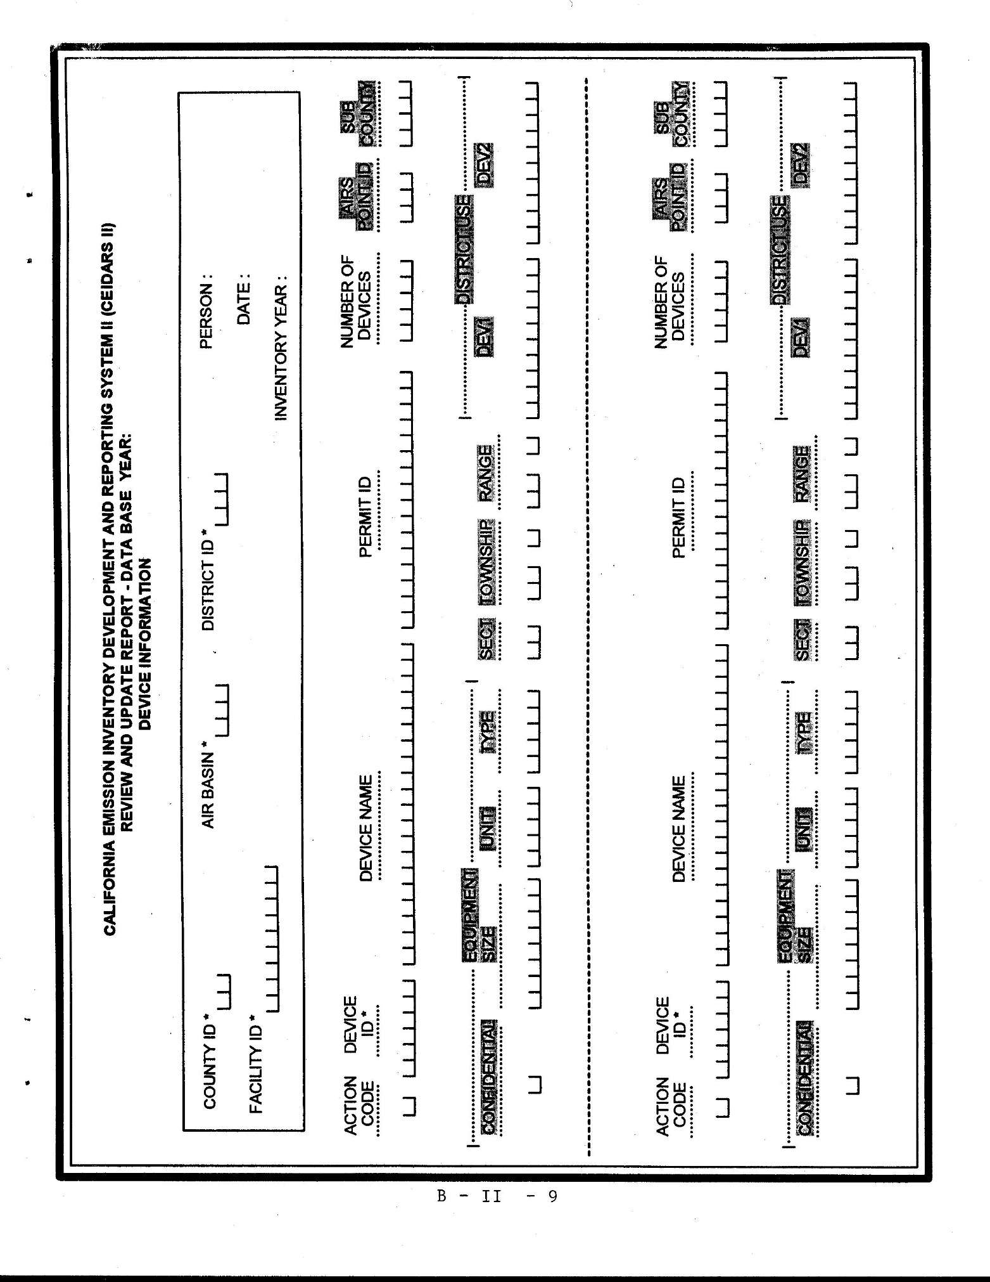
Device Information Form
This form can be copied as many times as needed.
In the space provided on the upper right of the form, initial and date the form, and fill in the inventory reporting year for which you are reporting data.
The district may, but need not, provide information on the facility's device ID's and corresponding parameters that exists in the criteria pollutant inventory. If this information is not known or provided, consult the district.
(1) County ID, Air Basin, and District ID Codes: Using values provided in Table B-I, enter the appropriate County ID, Air Basin, and District ID codes that correspond to the facility location.
(2) Facility ID: Enter the district-assigned facility identification code. If the Facility ID is unknown, consult the district.
(3) Action Code: Enter the appropriate Action Code: A, C, or D.

‘A’ indicates Add -- A new device has been added to the facility. Include corresponding device parameters.
‘C’ indicates Change -- Previously reported data for an existing device have been changed.
‘D’ indicates Delete -- The device and its associated data are to be deleted. CAUTION!! Deletion of a device will cause deletion of ALL process and emissions data (Process Information and Emission Information Form data) associated with the device.
(4) Device ID: The Device ID is a key numbering field used to link the information from these forms among devices and to data in existing inventories. To add a device, create a new device ID consistent with the existing numbering convention.
(5) Device Name: A common name used to identify the equipment or device.
(6) Permit ID: The district permit number for the device, if available.
(7) Number of Devices: This is the number of similar small devices that are aggregated together and considered for reporting purposes as one device. If this field is left blank it is assumed that there is only one device represented by the Device ID.
The following shaded fields have been included on the reporting forms for one of two reasons: a) these fields are optional and will be completed by district staff as tracking tools for the “Hot Spots” program; or b) they represent additional/optional merged data system fields that will also be completed by district staff if your district has chosen to submit a merged emission inventory report to the criteria pollutant and toxics data collection system. These fields are primarily related to emissions of criteria pollutants.
(8) Additional/Optional Merged Data System Fields: The fields AIRS POINT ID, EQUIPMENT CONFIDENTIALITY CODE, EQUIPMENT SIZE, EQUIPMENT UNIT, EQUIPMENT TYPE, SUBCOUNTY, SECTION, TOWNSHIP, RANGE, DEVD1 and DEVD2 are optional fields for those using the reporting forms to report emissions to the merged data system. The merged system allows the reporting of toxics and criteria pollutant emissions in one submittal.
Note: If the facility operator is reporting under the merged toxics and criteria pollutant emission inventory system, the Equipment Size (found on the Device Information Form) may be identified as confidential by putting a "Y" in the Equipment Confidentiality field on the Device Information Form. See the Process Information Form instructions for identifying confidential data fields on the Process Information Form and Emission Information Form.

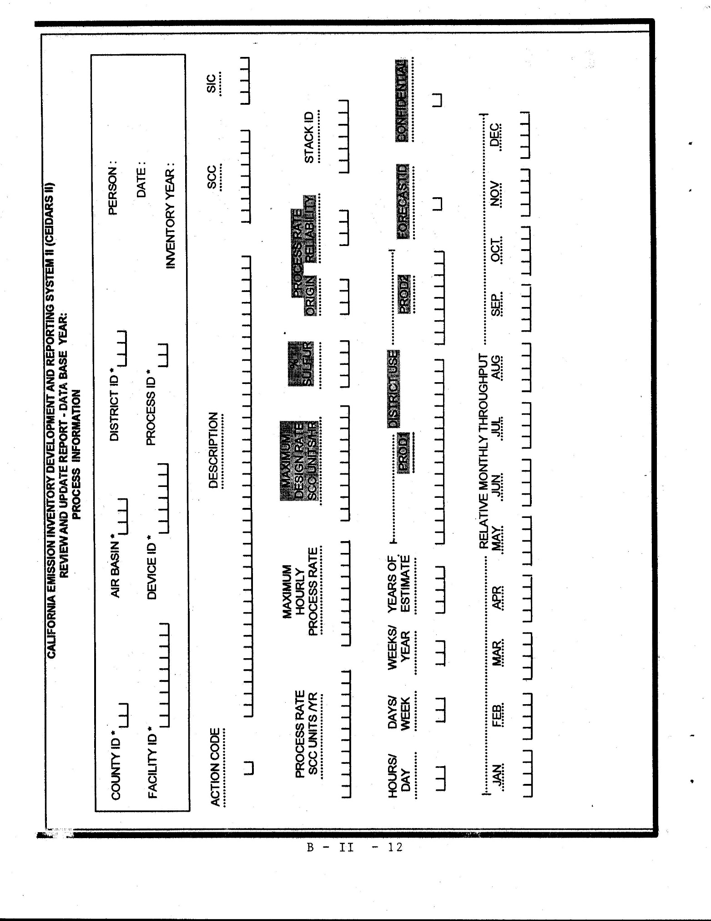
Process Information Form
In the space provided on the upper right of the form, initial and date the form, and fill in the inventory reporting year for which you are reporting data.
The district may, but need not, provide information on the facility's process and corresponding emittent data that exists in the criteria pollutant inventory. If this information is not known or provided, consult the district.
(1) County ID, Air Basin, and District ID Codes: Using values provided in Table B-I, enter the appropriate County ID, Air Basin, and District ID codes that correspond to the facility location.
(2) Facility ID: Enter the district-assigned facility identification code. If the Facility ID is unknown, consult the district.
(3) Device ID: The number of the device associated with the process. This device ID should be included on the Device Information Form.
(4) Process ID: Process ID identifies the process and is unique within a device and a specific process.
(5) Action Code/Process: Enter the appropriate Action Code: A, C, or D.
‘A’ indicates Add -- A new process has been added to the facility. Include all corresponding data on a Process Information Form.
‘C’ indicates Change -- Previously reported process data have been changed.
‘D’ indicates Delete -- The process and its associated data are to be deleted. CAUTION!! Deletion of a process will cause deletion of ALL process and emissions data associated with the process.
(6) Process Description: Enter a short description of the process.
(7) SCC: Enter the SCC (Source Classification Code) number which most closely corresponds to the process. Consult the district if assistance is needed in assigning codes.
(8) SIC: The Standard Industrial Classification number best describing the industrial activity associated with the process. If this information is unknown, consult the district. The SIC data field has been added to the process data to describe activity at a portion of the facility when it is not the same as that of the overall facility activity. The SIC that is reported should be a full four-digit code. Do not use abbreviated two or three digit codes with trailing zeros such as "2600" or "2620".
(9) Process Rate (in SCC Units/Yr): The actual annual process rate during the reporting year, expressed in the appropriate units specified for the SCC describing the process.
(10) Maximum Hourly Process Rate (in SCC units/hour): The greatest operating rate that would be expected for the source in a one hour period, expressed in the appropriate units specified for the SCC describing the process.
(11) Stack ID: Enter the number of the stack associated with the process. The stack ID entered should correspond to a stack entered on the Stack Information Form. By entering the stack ID on the Process Information Form, it is possible to assign more than one stack to a single device. For example, a boiler may burn two fuels, natural gas and fuel oil, which are reported on separate Process Information Forms with distinct SCC numbers (to indicate two processes). If different control devices are used based upon the fuel usage, stack parameters may be different between the processes. Therefore, in this case, although the same device is performing the combustion, it is appropriate to assign the emissions to different stacks on the individual Process Information Forms.
(12) Hours/Day: The number of hours per day the process is in operation during the reporting year. (Consult the district regarding codes to use for any non-uniform operation.)
(13) Days/Week: The number of days per week the process is in operation during the reporting year. (Consult the district regarding codes to use for any non-uniform operation.)
(14) Weeks/Year: The number of weeks per year the process is in operation during the reporting year.
(15) Year of Estimate/Process: Enter the year that corresponds to the process data submitted. For example, if the original submittal was for the 1989 inventory year, but in 1991, the value for the Total Yearly Process Rate was updated, the Year of Estimate/Process field should be set to 1991.
(16) CONFIDENTIAL: For identifying trade secret data. Indicate if any of the data items required on the facility diagram and designated on the facility diagram as instructed under Section VII.B are trade secrets by placing a "Y" in the confidential box. Putting a "Y" in this box identifies as confidential the following data fields on the Process Information Form and Emission Information Form:
Process Description, Process Rate, Maximum Hourly Process Rate, Maximum Design Rate, % Sulfur in fuel (all found on the Process Information Form), Uncontrolled Emission Factor, Emission Factor, Emission Factor Origin Code, and Method of Estimate Code (all found on the Emission Information Form).
Note: If the facility operator is also reporting under the merged toxics and criteria pollutant emission inventory system, the Equipment Size (found on the Device Information Form) may also be identified as confidential by putting a "Y" in the Equipment Confidentiality field on the Device Information Form.
A facility operator may notify the district in writing in the emission inventory report that additional information is a trade secret. However, this additional information will not be included in the data system.
Refer to section 44346 of the Health and Safety Code for additional information about trade secret data and its disclosure.
(17) Relative Monthly Throughput: The relative percentage of annual activity for the process that occurred during the month, reported to no more than three significant figures. For example, 12.3 in January would mean 12.3% of the yearly activity occurred in January.
The following shaded fields have been included on the reporting forms for one of two reasons: a) these fields are optional and will be completed by district staff as tracking tools for the “Hot Spots” program; or b) they represent additional/optional merged data system fields that will also be completed by district staff if your district has chosen to submit a merged emission inventory report to the criteria pollutant and toxics data collection system. These fields are primarily related to emissions of criteria pollutants.
(18) Additional/Optional Merged Data System Fields: The fields MAXIMUM DESIGN RATE (in SCC UNITS/HR), % SULFUR in fuel, PROCESS RATE ORIGIN, PROCESS RATE RELIABILITY, PROD1, PROD2, and FORECASTID are optional fields for those using the reporting forms to report emissions to the merged data system. The merged system allows the reporting of toxics and criteria pollutant emissions in one submittal.

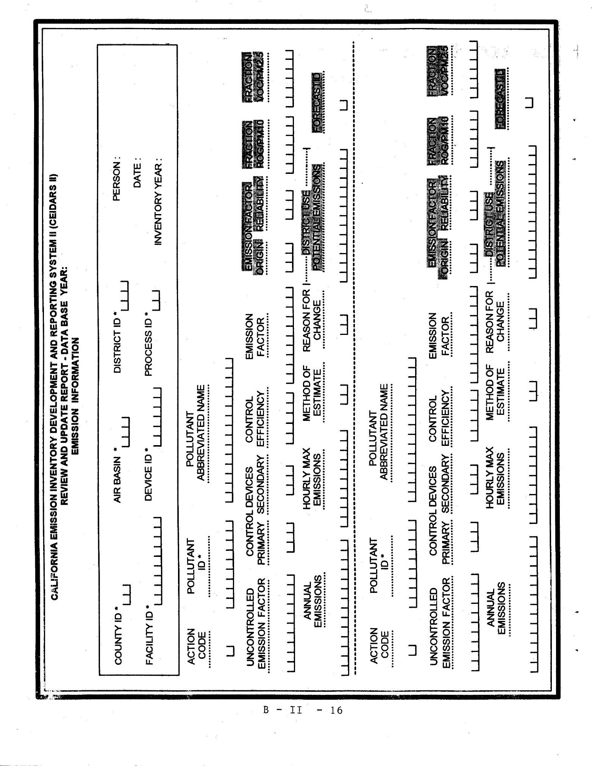
Emission Information Form
In the space provided on the upper right of the form, initial and date the form, and fill in the inventory reporting year for which you are reporting data.
(1) County ID, Air Basin, and District ID Codes: Using values provided in Table B-I, enter the appropriate County ID, Air Basin, and District ID codes that correspond to the facility location.
(2) Facility ID: Enter the district-assigned facility identification code. If the Facility ID is unknown, consult the district.
(3) Device ID: The number of the device associated with the process. This device ID should be included on the Device Information Form.
(4) Process ID: Process ID identifies the process and is unique within a device and a specific process. This Process ID should be included on the Process Information Form.
(5) Action Code/Emissions: Enter the appropriate Action Code: A, C, or D.
‘A’ indicates Add -- A substance not previously reported is being emitted by the process. Include all corresponding emissions data.
‘C’ indicates Change -- Previously reported emissions related data for the process data have been changed.
‘D’ indicates Delete -- The substance identified is no longer emitted from the process.
(6) Pollutant ID: Enter the Chemical Abstracts Service Registry number (CAS number) or Emittent ID code created by the ARB for substances in Appendix A-I, A-II, or A-III.
Mixtures: In accordance with section VIII.F, emissions of any individually listed substances shall be reported individually (except as specified in parts (a), (b), (c), and (d) below) even if the substances in Appendix A-I are included as part of a mixture or they are included in a group heading for a class of substances. Any unspecified (not individually listed) substances that are included in a mixture or group shall be summed and reported under the emittent identification number for the mixture or group heading. If there is not an emittent ID number in Appendix A-I for a mixture or group heading for a class of substances, only those component substances which are individually listed shall be reported.
(a) Emissions of unspecified metal compounds shall be reported as the amount of the metal atom equivalent, using the metal emittent identification number for the metal itself (or the emittent identification number indicated in Appendix A, such as for reporting inorganic versus other-than-inorganic arsenic compounds). For unspecified metal compounds that contain two or more listed metals (e.g., zinc chromate), each component metal shall be reported as the amount of the appropriate metal atom equivalent (i.e., the zinc portion of the weight as zinc equivalent and the chromate portion as hexavalent chromium equivalent).
For specific, individually listed metal compounds (e.g. lead chromate), emissions shall be reported for the compound (as pounds of the compound), using the emittent identification number for that compound.
(b) Emissions of gasoline exhaust shall be reported as emissions of total particulate matter and total organic gas using the emittent identification numbers specified in Appendix A. Individually listed substances from external combustion diesel sources, and all gasoline combustion, must also be reported using the applicable emittent identification numbers.
(c) For gasoline vapors, total gasoline vapor emissions shall be reported using the applicable emittent identification number. Emissions of individual components of gasoline vapors which are listed substances shall also be reported.
(d) To avoid double counting of emissions in the cases listed in sections VIII.F.(7) and (8), pertaining to polycyclic aromatic hydrocarbons (PAHs) and polychlorinated dibenzo-p-dioxins (dioxins), respectively, the following instructions apply:
(i) Where the emissions of the individual substances are required to be quantified by source testing or other methods, the emissions shall be reported for each individual substance using the corresponding CAS number or 4-digit Emittent ID code. Also, emissions of all substances source tested (even if not individually listed) for the substance group (PAHs or dioxins) shall be summed and reported using the Emittent ID code indicating "Total, with individual substances also reported".
(ii) Where the emissions of the individual substances are not required to be quantified by source testing or other methods, and information is not available to estimate emissions of individually listed substances, only the aggregate substance shall be reported, using the Emittent ID code indicating "Total, with individual substances not reported."
(7) Pollutant Abbreviated Name: Write the name of the substance emitted. Use the substance names as shown in Appendix A. Because of space limitations, it is acceptable to abbreviate or truncate the substance names entered into this field.
(8) Uncontrolled Emission Factor: The average rate at which the pollutant is emitted to the atmosphere in pounds per SCC process unit, not including the effect of any pollution control equipment which reduces emissions of the listed emittent.
(9) Control Device Codes (Primary and Secondary) and Control Efficiency Code: The primary control device is any installed equipment whose main purpose is to reduce emissions of the emittent listed. When more than one piece of control equipment is used, the equipment that is most effective in reducing the emissions of the listed emittent is the primary equipment; other equipment may be listed as secondary for that emittent. Control equipment which is primarily designed to remove another emittent and is not typically considered effective in controlling the listed emittent, but is demonstrated to affect the removal of the listed emittent, is considered secondary. Thus, a secondary control device may be the only equipment controlling the listed emittent or may be used in conjunction with the primary control device which has a greater effect in reducing the listed emittent.
Enter the 3-digit code number from Table B-II that best describes the control device equipment used for a listed emittent, if applicable.
Table B-II also shows the various emittents, Particulate Matter (PM), Total Organic Gases (TOG), and Sulfur Dioxide (SO₂ ) that are affected by each control equipment listed. An "x" in an emittent's column means the control equipment is known to reduce the particular emittent. Report the control efficiency approved by the district in the inventory plan for each affected substance.
On the far right-hand side of Table B-II are listed substances that may be reduced by the specific control equipment. The column is not exhaustive but provides guidance in determining for what substances emissions may be reduced by different control devices.
For consistency with state and federal emission inventory practices, do not report a device as a control device if it is used as a normal part of a process. For example, the recovery system for by-product gases from a coke oven should not be reported as VOC control equipment; a baghouse used to separate carbon particles from the main process vent gas stream at carbon black plants should not be reported as a particulate control. The effect of these devices on resultant emissions should be accounted for within the basic emission calculation.
There are several gaseous control methods which are unique in that they function both as control devices while also producing emissions separate from the process(es) they are controlling. Examples are afterburners, CO-boilers, and flares. For consistency with state and federal emission inventory practices, the emissions produced by these control devices should be reported as a separate device.
(10) Emission Factor: The average rate at which the pollutant is actually being emitted to the atmosphere in pounds per SCC process unit. The emission factor should include the effect of any pollution control equipment which reduces emissions of the listed emittent.
(11) Annual Emissions: The actual annual emissions of the emittent under typical (average) operating conditions, expressed in pounds per year, except for radionuclides and other radioactive substances, which shall be expressed in Curies per year. For instructions on how to use degree of accuracy values (section VIII.E) in reporting facility emissions, refer to item (16). For reporting emissions derived from below Limit of Detection (LOD) source test data, refer to the Below Limit of Detection Emissions instructions in item (17).
(12) Hourly Maximum Emissions: The maximum hourly emissions of the emittent, expressed in pounds per hour, except for radionuclides and other radioactive substances, which shall be expressed in milliCuries per hour.
(13) Method of Estimate: Enter a code from Table B-III that describes the method used to collect or calculate the emissions of this substance.
(14) Reason for Change: Enter a code from Table B-IV that describes the reason for the change in the emissions.
The following shaded fields have been included on the reporting forms for one of two reasons: a) these fields are optional and will be completed by district staff as tracking tools for the “Hot Spots” program; or b) they represent additional/optional merged data system fields that will also be completed by district staff if your district has chosen to submit a merged emission inventory report to the criteria pollutant and toxics data collection system. These fields are primarily related to emissions of criteria pollutants.
(15) Additional/Optional Merged Data System Fields: The fields EMISSION FACTOR ORIGIN, EMISSION FACTOR RELIABILITY, FRACTION ROG/PM10, FRACTION VOC, DISTRICT USE/POTENTIAL EMISSIONS, and FORECASTID are optional fields for those using the reporting forms to report emissions to the merged data system. The merged system allows the reporting of toxics and criteria pollutant emissions in one submittal.
Using Degree of Accuracy Values in Reporting Facility Emissions
(16) Degree of Accuracy. The general use of the degree of accuracy values is described in section VIII.E of the regulation. The actual degree of accuracy values for each substance are listed in Appendix A. This item specifically describes how to apply the degree of accuracy values when reporting facility emissions.
Note that degree of accuracy values are to be applied on a facilitywide basis, and not at the process level. For reporting, the total facility emissions of substances should be rounded to the nearest unit of the applicable degree of accuracy to determine if they must be reported on Emission Information Forms. In other words, if facility emissions of a substance exceed one-half of the applicable degree of accuracy unit for the substance, then the substance emissions shall be reported on Emission Information Forms. For example, assume that the total emissions of benzene from a facility are 1.7 lbs/year. The degree of accuracy value for benzene is 2 lbs/yr. Because the facility emissions exceed one-half of the benzene degree of accuracy, the emissions must be reported for any devices emitting benzene. If the total facility benzene emissions were 0.9 lbs/yr, the emissions (to the nearest unit of two pounds) would round down to zero and would not need to be reported on any Emission Information Form. However, the presence of benzene would be required to be reported on the Supplemental Use and Production Information Form.
The foregoing degree of accuracy discussion pertains only to reporting emissions that are calculated from estimation methods (such as mass balance or emission factors). Emissions from processes for which source testing is required must be reported to within the detection limit of the applicable source test method (see item (17) below).
Reporting Emissions Derived from
Below the Limit of Detection Source Test Results
(17) Below Limit of Detection Emissions. This section provides instructions for reporting required "Hot Spots" source test data where some or all of the individual source test runs for a substance produce values which are below the limit of detection ("below LOD"). These instructions are intended to provide a uniform convention which ensures that the manner of reporting the data on the "Hot Spots" reporting forms conveys the available information most completely and consistently.
The below LOD instructions can be applied to the handling of "non-detected" test data from all types of source testing and measurement methods conducted under the "Hot Spots" program. These methods may include stack testing, fuel analysis, laboratory analysis of materials, and other monitoring and measurement methods.
In the following instructions, two cases are discussed separately: (a) a case for which some (but not all) runs are below the LOD, and (b) a case for which all runs are below the LOD.

(a) Some (But Not All) Test Runs Below LOD.
In situations where several test runs are performed for a given substance from a specific source, and one or more of the runs produced values below the LOD, while at least one run produced a value above the LOD, assign one-half of the corresponding LOD for each run which is below the LOD. Average the one-half LOD values together with the other runs that were above detectable limits for use in emissions computations.
The resultant Annual Emissions (in pounds per year) and the Hourly Max Emissions (in pounds per hour) shall be reported on the "Emission Information Form". In addition, a value of "98" must be recorded in the "Method of Estimate" field on the Emission Information Form to identify that the emissions have been computed from some detection-limited data. The "98" code indicates that a source test was conducted, but that some runs were above and some below the LOD. If all runs had been above the detection limits, the "normal" estimation method code for the applicable type of source test would have been used; for example, a Method of Estimate code of "1" for stack testing, "2" for fuel analysis, etc.
(b) All Runs Below LOD:
In situations where several test runs are performed for a given substance from a particular source, and all of these runs resulted in values below the detection limits ("below the LOD"), facility operators shall report Annual Emissions and the Hourly Max Emissions on the "Emission Information Form" as "0" followed by “ND”. In addition, a value of "99" must be recorded in the "Method of Estimate” field on the Emission Information Form. The code of "99" indicates that a source test was conducted, but that all runs were below detectable limits.
When these values are reported, the actual analytical limit of detection for all runs and the number of sample runs shall be reported in the source test report with other required source test results. Also, all tests shall be performed using appropriate sampling times, methods, and protocols as specified in the district approved source test protocol, and there must be no site-specific data which could indicate the presence of the tested substance.
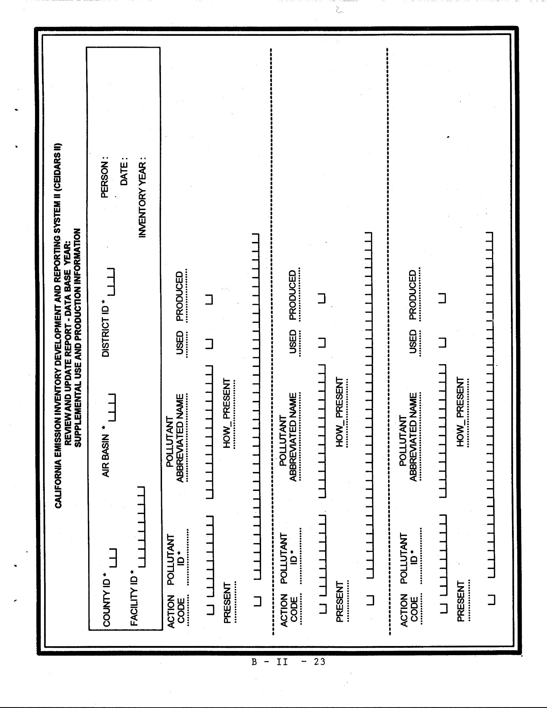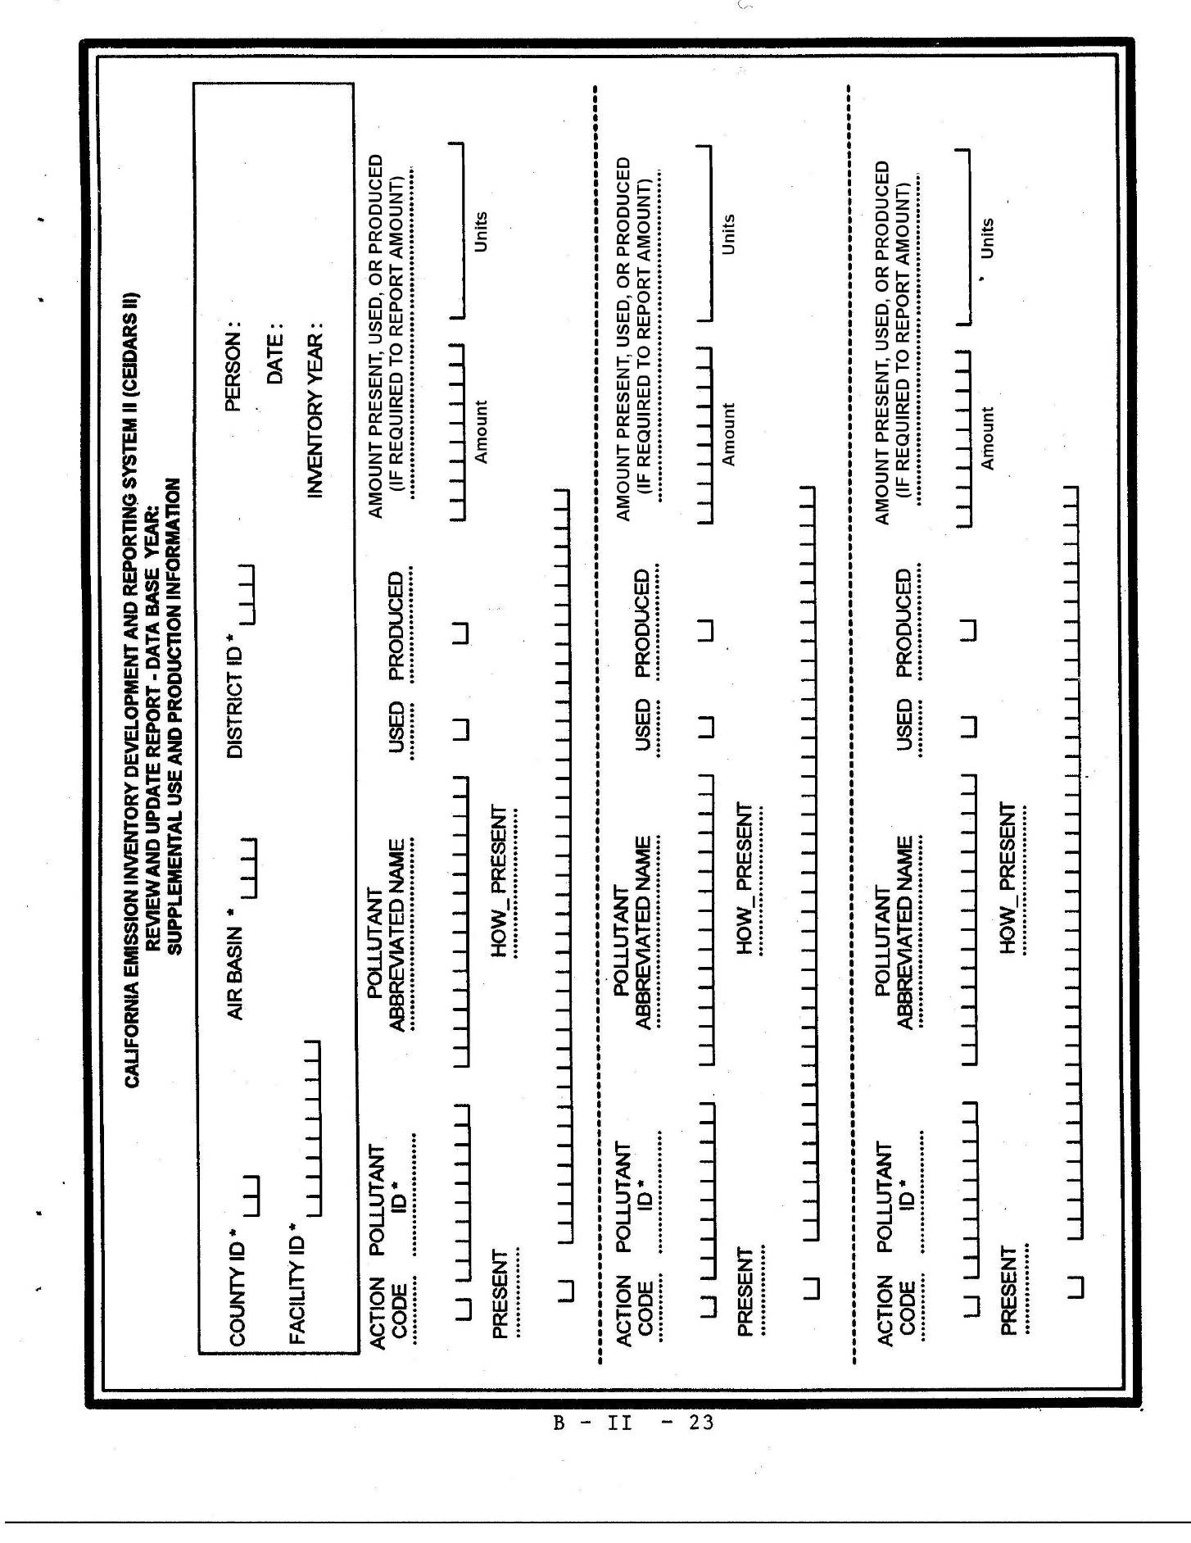

Supplemental Use and Production Information Form
Copy the form as many times as necessary for your facility. The Supplemental Use and Production Information Form is used to satisfy three separate reporting requirements.
(a) Any substances listed in Appendix A-I (list of substances to be inventoried) which are emitted in quantities below the applicable degree of accuracy for the facility are to be reported on the Supplemental Use and Production Information Form unless the emissions are based on source test results or reported on Emission Information Forms.
(b) Substances listed in Appendix A-II that are used, produced, or otherwise present at the facility are to be reported on the Supplemental Use and Production Information Form.
(c) Substances listed in Appendix A-III that are manufactured and released to the air.
(1) In the space provided on the upper right of the form, initial and date the form, and fill in the inventory reporting year for which you are reporting data.
(2) County ID, Air Basin, and District ID Codes: Using values provided in Table B-I, enter the appropriate County ID, Air Basin, and District ID codes that correspond to the facility location.
(3) Facility ID: Enter the district-assigned facility identification code. If the Facility ID is unknown, consult the district.
(4) Action Code: Enter the appropriate Action Code: A, C, or D.
'A' indicates Add -- A new substance is being reported for the facility on the Supplemental Use and Production Information Form.
'C' indicates Change -- Previously reported data for a substance has been changed.
'D' indicates Delete -- The substance is no longer used, produced, or otherwise present at the facility.
(5) Pollutant ID: Enter the Chemical Abstracts Service Registry number (CAS number) or Emittent ID code created by the ARB for substances in Appendix A-I, A-II, or A-III. Refer to the Emission Information Form Emittent ID instructions for instructions on reporting listed substances which are mixtures or classes of substances.
(6) Pollutant Abbreviated Name: Write the name of the substance emitted. Use the substance names as shown in Appendix A. Because of space limitations, it is acceptable to abbreviate or truncate the substance names entered into this field.
(7) Substance Used Field - "Used" refers to substances which are ingredients in any activity or process at the facility.
-Used: Enter an "X" in the space provided if the reported substance is used at the facility.
(8) Substance Produced Field - "Produced" refers to substances that are the result of any activity or process that takes place at the facility.
-Produced: Enter an "X" in the space provided if the reported substance is produced at the facility.
(9) Substance Present Field - "Otherwise Present" refers to substances present in any other way in an activity or process, such as by-products or reaction intermediates that appear temporarily during processing. Please specify the nature of the presence of the substance.
-Otherwise Present: Enter an "X" in the space provided if the reported substance is present at the facility.
(10) Amount Field - “Amount” refers to the amount of the substance present, used, or produced, if the facility is required to report the amount.
(11) Units Field – “Units” refers to the dimensional units for the Amount field reported, including the per unit of time for the units, which should generally be on a “per year” basis.
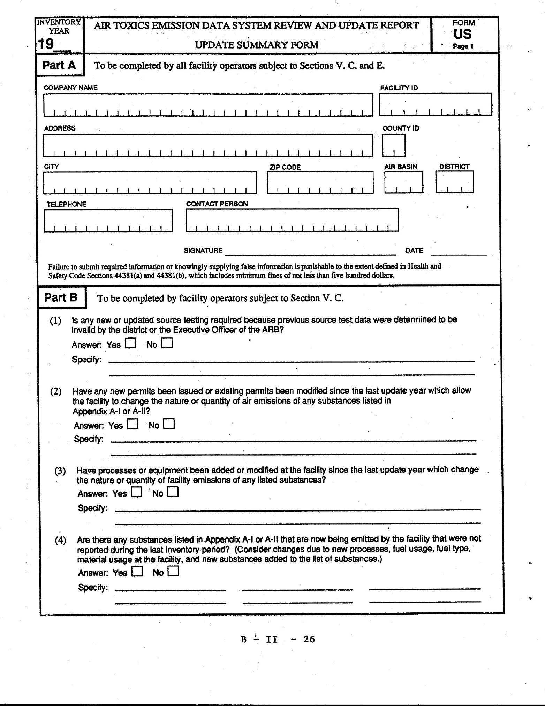
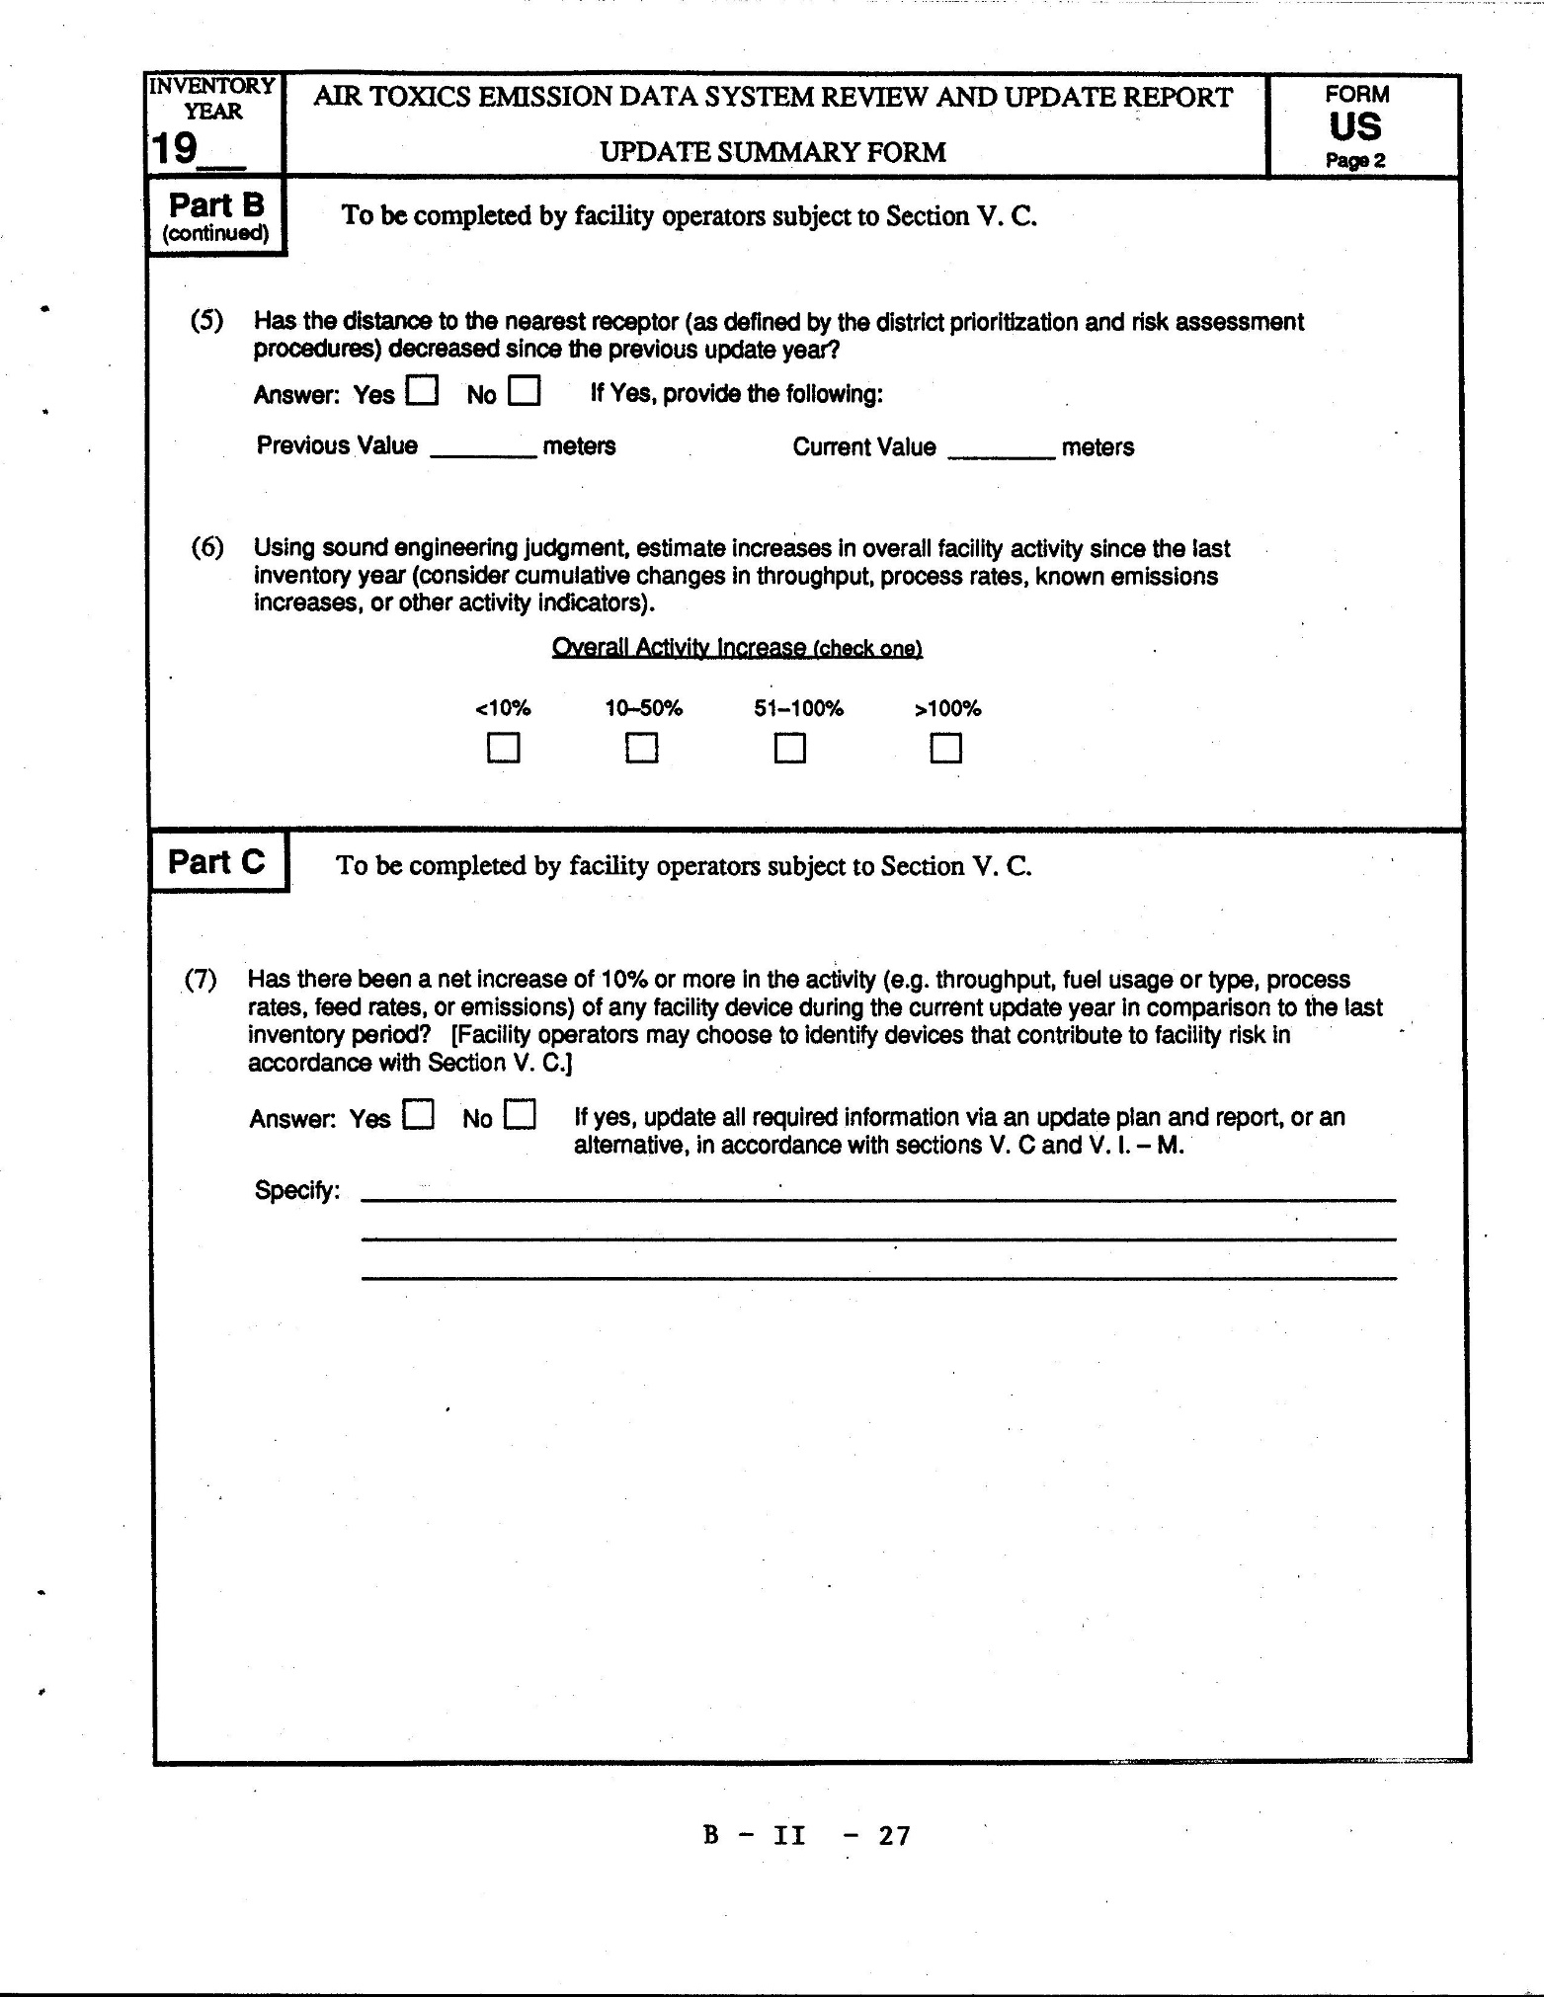
Update Summary Form (US Form)
Note: All information provided on the Update Summary Form is subject to verification by the district staff.
For the purposes of completing the Update Summary Form (the form), "update year" is defined as the calendar year prior to the year the form is due. The "last inventory period" is defined as the most recent reporting year for which an approved facility emission inventory report was submitted.
Fill in the update year in the space provided at the top of the form for the inventory year.
PART A
Fill in the Company Name. Enter the Address, City, and Zip Code for the facility location. Enter the name of a contact person for the facility and the phone number. Enter the district assigned facility identification code. If the Facility ID is unknown, consult the district. Using Table B-I, locate and enter the appropriate County ID, Air Basin, and District ID codes which correspond to the facility location.
PART B
Part B of the form is to be filled out by all facility operators subject to
Section V.C. The information provided in this section will be reviewed by the district to determine if there have been significant changes at the facility which could increase the facility risk.
(1) Updated Source Tests. If any new or updated source testing is required, check "Yes". Also, if conditions specified in section V.J.(3) are met (regarding when previous source test data cannot be used), check "Yes", and specify the affected sources and the condition(s) met. Answering yes to this question does not necessarily require re-source testing. It is provided to assist the districts in determining if the changes and substances affected are substantial enough to warrant retesting.
(2) New or Modified Permits. Check "Yes" for this question if ANY new permits or modifications to existing permits have been issued to the facility which affect the nature or quantity of emissions of substances listed in Appendix A-I or A-II. Specify the new permits. For example: "Permit #394-453 issued on 8-28-90 to add XXX BTU Natural Gas Fired Boiler". Also, answer yes and specify any changes to existing permits which increase, or have the potential to increase emissions. Modifications to permits may include but are not limited to changes in fuel types, feed rates, production rates, or other parameters. For example: "Permit #887-124 modified to allow use of fuel oil in boiler".
(3) New Processes or Equipment. If any new processes or equipment have been added or modified at the facility since the last update year which affects the nature or quantity of the emissions of any listed substance, check "Yes" and describe the changes. This question should address new sources of emissions which result from new processes or equipment, or are due to changes in solvent types, fuel types, control equipment, or other process modifications.
(4) New Substances. If there are any substances listed in Appendix A-I or A-II that were not reported during the last inventory period, answer “Yes” to the question and write the substance name. Consider substances resulting from new processes or material usage, and any new substances added to the list of substances that were not previously addressed.
(5) Receptor Proximity Changes. If, since the last update year, the distance to the nearest receptor has decreased as defined by the district's prioritization and risk assessment procedures, answer yes and enter the previous and current values in meters. In answering the question consider changes at the facility which may have moved emission sources closer to property boundaries, changes which may have placed receptors closer to facility property boundaries, and changes in proximity to residential and nonresidential receptors. Distance estimates should be accurate to within 50 meters.
(6) Increases in Facility Activity. Check the box which most accurately describes the changes in facility activity since the last update year. For this question estimate overall facility activity increases using fuel usage, process rates, throughput, economic, or other applicable indicators of facilitywide activity.
PART C
Part C shall be completed by facility operators subject to section V.C.
(7) Increases in Device Activity. If the activity for any identified device at the facility has increased by 10 percent or more since the last inventory period, answer "Yes" to question (7). Facility operators shall identify devices as specified in section V.C. Device activity increases can be measured as increases in either the throughput, fuel usage, process rates, emissions of any listed substances, or other activity indicators.
For facility operators subject to section V.C which answer "Yes" to question (7), updated process and emissions data for the identified devices with increases shall be reported via an update plan and report as specified in sections V.C. and V.I. - V.M.
For those facilities with no device activity increases (question (7) is "No"), the Update Summary Form shall meet their update requirements unless, based upon data reported on the Update Summary Form or other information required by the district, the district requires an update plan and report.
For the purposes of answering question (7) devices may be consolidated. Consolidated devices must be within the same Source Classification Code (SCC). When the sum of the changes in activity for all consolidated devices within an SCC exceeds a 10 percent increase, an updated Process Information Form(s) and Emission Information Form(s) must be submitted by the facility operator for any individual device or groups of devices (reported on the same Process Information Form) whose activity increases by 10 percent or more.

TABLE B-I

COUNTY, AIR BASIN, AND DISTRICT CODES
CO | County Name | AB | Air Basin Name | DIS | District Name
1 | ALAMEDA | SF | SAN FRANCISCO BAY AREA | BA | BAY AREA AQMD
2 | ALPINE | GBV | GREAT BASIN VALLEYS | GBU | GREAT BASIN UNIFIED APCD
3 | AMADOR | MC | MOUNTAIN COUNTIES | AMA | AMADOR COUNTY APCD
4 | BUTTE | SV | SACRAMENTO VALLEY | BUT | BUTTE COUNTY APCD
5 | CALAVERAS | MC | MOUNTAIN COUNTIES | CAL | CALAVERAS COUNTY APCD
6 | COLUSA | SV | SACRAMENTO VALLEY | COL | COLUSA COUNTY APCD
7 | CONTRA COSTA | SF | SAN FRANCISCO BAY AREA | BA | BAY AREA AQMD
8 | DEL NORTE | NC | NORTH COAST | NCU | NORTH COAST UNIFIED AQMD
9 | EL DORADO | MC | MOUNTAIN COUNTIES | ED | EL DORADO COUNTY APCD
9 | EL DORADO | LT | LAKE TAHOE | ED | EL DORADO COUNTY APCD
10 | FRESNO | SJV | SAN JOAQUIN VALLEY | SJU | SAN JOAQUIN VALLEY UNIFIED APCD
11 | GLENN | SV | SACRAMENTO VALLEY | GLE | GLENN COUNTY APCD
12 | HUMBOLDT | NC | NORTH COAST | NCU | NORTH COAST UNIFIED AQMD
13 | IMPERIAL | SS | SALTON SEA | IMP | IMPERIAL COUNTY APCD
14 | INYO | GBV | GREAT BASIN VALLEYS | GBU | GREAT BASIN UNIFIED APCD
15 | KERN | MOJ | MOJAVE DESERT | KER | KERN COUNTY APCD
15 | KERN | SJV | SAN JOAQUIN VALLEY | SJU | SAN JOAQUIN VALLEY UNIFIED APCD
16 | KINGS | SJV | SAN JOAQUIN VALLEY | SJU | SAN JOAQUIN VALLEY UNIFIED APCD
17 | LAKE | LC | LAKE COUNTY | LAK | LAKE COUNTY APCD
18 | LASSEN | NEP | NORTHEAST PLATEAU | LAS | LASSEN COUNTY APCD
19 | LOS ANGELES | SC | SOUTH COAST | SC | SOUTH COAST AQMD
19 | LOS ANGELES | MOJ | MOJAVE DESERT | AV | ANTELOPE VALLEY APCD
20 | MADERA | SJV | SAN JOAQUIN VALLEY | SJU | SAN JOAQUIN VALLEY UNIFIED APCD
21 | MARIN | SF | SAN FRANCISCO BAY AREA | BA | BAY AREA AQMD
22 | MARIPOSA | MC | MOUNTAIN COUNTIES | MPA | MARIPOSA COUNTY APCD
23 | MENDOCINO | NC | NORTH COAST | MEN | MENDOCINO COUNTY APCD
24 | MERCED | SJV | SAN JOAQUIN VALLEY | SJU | SAN JOAQUIN VALLEY UNIFIED APCD
25 | MODOC | NEP | NORTHEAST PLATEAU | MOD | MODOC COUNTY APCD
26 | MONO | GBV | GREAT BASIN VALLEYS | GBU | GREAT BASIN UNIFIED APCD
27 | MONTEREY | NCC | NORTH CENTRAL COAST | MBU | MONTEREY BAY UNIFIED APCD
28 | NAPA | SF | SAN FRANCISCO BAY AREA | BA | BAY AREA AQMD
29 | NEVADA | MC | MOUNTAIN COUNTIES | NSI | NORTHERN SIERRA AQMD
30 | ORANGE | SC | SOUTH COAST | SC | SOUTH COAST AQMD
31 | PLACER | MC | MOUNTAIN COUNTIES | PLA | PLACER COUNTY APCD
31 | PLACER | LT | LAKE TAHOE | PLA | PLACER COUNTY APCD
31 | PLACER | SV | SACRAMENTO VALLEY | PLA | PLACER COUNTY APCD
32 | PLUMAS | MC | MOUNTAIN COUNTIES | NSI | NORTHERN SIERRA AQMD
33 | RIVERSIDE | SC | SOUTH COAST | SC | SOUTH COAST AQMD
33 | RIVERSIDE | MOJ | MOJAVE DESERT | SC | SOUTH COAST AQMD
33 | RIVERSIDE | MOJ | MOJAVE DESERT | MOJ | MOJAVE DESERT AQMD
33 | RIVERSIDE | SS | SALTON SEA | SC | SOUTH COAST AQMD
34 | SACRAMENTO | SV | SACRAMENTO VALLEY | SAC | SACRAMENTO METROPOLITAN AQMD
35 | SAN BENITO | NCC | NORTH CENTRAL COAST | MBU | MONTEREY BAY UNIFIED APCD
36 | SAN BERNARDINO | SC | SOUTH COAST | SC | SOUTH COAST AQMD
36 | SAN BERNARDINO | MOJ | MOJAVE DESERT | MOJ | MOJAVE DESERT AQMD
37 | SAN DIEGO | SD | SAN DIEGO | SD | SAN DIEGO COUNTY APCD
38 | SAN FRANCISCO | SF | SAN FRANCISCO BAY AREA | BA | BAY AREA AQMD
39 | SAN JOAQUIN | SJV | SAN JOAQUIN VALLEY | SJU | SAN JOAQUIN VALLEY UNIFIED APCD
40 | SAN LUIS OBISPO | SCC | SOUTH CENTRAL COAST | SLO | SAN LUIS OBISPO COUNTY APCD
41 | SAN MATEO | SF | SAN FRANCISCO BAY AREA | BA | BAY AREA AQMD
42 | SANTA BARBARA | OCS | OUTER CONTINENTAL SHELF | SB | SANTA BARBARA COUNTY APCD
42 | SANTA BARBARA | SCC | SOUTH CENTRAL COAST | SB | SANTA BARBARA COUNTY APCD
43 | SANTA CLARA | SF | SAN FRANCISCO BAY AREA | BA | BAY AREA AQMD
44 | SANTA CRUZ | NCC | NORTH CENTRAL COAST | MBU | MONTEREY BAY UNIFIED APCD
45 | SHASTA | SV | SACRAMENTO VALLEY | SHA | SHASTA COUNTY APCD
46 | SIERRA | MC | MOUNTAIN COUNTIES | NSI | NORTHERN SIERRA AQMD
47 | SISKIYOU | NEP | NORTHEAST PLATEAU | SIS | SISKIYOU COUNTY APCD
48 | SOLANO | SF | SAN FRANCISCO BAY AREA | BA | BAY AREA AQMD
48 | SOLANO | SV | SACRAMENTO VALLEY | YS | YOLO SOLANO APCD
49 | SONOMA | NC | NORTH COAST | NS | NORTH SONOMA APCD
49 | SONOMA | SF | SAN FRANCISCO BAY AREA | BA | BAY AREA AQMD
50 | STANISLAUS | SJV | SAN JOAQUIN VALLEY | SJU | SAN JOAQUIN VALLEY UNIFIED APCD
51 | SUTTER | SV | SACRAMENTO VALLEY | FR | FEATHER RIVER AQMD
52 | TEHAMA | SV | SACRAMENTO VALLEY | TEH | TEHAMA COUNTY APCD
53 | TRINITY | NC | NORTH COAST | NCU | NORTH COAST UNIFIED AQMD
54 | TULARE | SJV | SAN JOAQUIN VALLEY | SJU | SAN JOAQUIN VALLEY UNIFIED APCD
55 | TUOLUMNE | MC | MOUNTAIN COUNTIES | TUO | TUOLUMNE COUNTY APCD
56 | VENTURA | SCC | SOUTH CENTRAL COAST | VEN | VENTURA COUNTY APCD
57 | YOLO | SV | SACRAMENTO VALLEY | YS | YOLO SOLANO APCD
58 | YUBA | SV | SACRAMENTO VALLEY | FR | FEATHER RIVER AQMD

TABLE B-II

CONTROL DEVICE EQUIPMENT IDENTIFICATION CODE NUMBERS AND
VARIOUS EMITTENTS AFFECTED
EQUIPMENT CODE | CONTROL DEVICE/METHOD | VARIOUS EMITTENTS AFFECTED |  |  | TOXIC SUBSTANCES THAT MAY BE CONTROLLED
 |  | PMª | TOG^{b} | SOx^{c}
000 | No equipment
001 | Wet Scrubber | x | x | x | Cadmium, Chlorobenzene, Chromium, Nickel, Toluene diisocyanate
002 | Impingement Plate Scrubber | x | x | x
003 | Venturi Scrubber | x | x | x
004 | Fluid Bed Dry Scrubber | x | x
005 | Other Scrubbers (includes magnesium oxide, dual alkali, citrate process, ammonia, Wellman-Lord/ sodium sulfite, wet lime slurry, alkaline fly ash, sodium carbonate, sodium-alkali, sulfur oxides, hydrogen chloride, tray scrubber) |  | x | x
006 | Gravity Collector | x
007 | Centrifugal Collector | x
008 | Electrostatic Precipitator (wet and dry) | x |  |  | Arsenic, Beryllium, Cadmium, Chromium, Copper, Manganese, Nickel, Lead, Zinc, and other trace metals
009 | Gas Scrubber |  | x | x
010 | Mist/ Vapor Suppressant in Solution | x |  | x
011 | Drift Eliminator for Cooling Towers | x |  |  | Chromium
012 | Fabric Filter (Baghouse) | x |  |  | Arsenic, Beryllium, Cadmium, Chromium, Copper, Manganese, Nickel, Lead, Zinc, and other trace metals
013 | Catalytic Afterburner | x | x
014 | Direct Flame Afterburner | x | x
015 | Catalytic Incineration |  | x |  | Acrylonitrile, Benzene, 1,3 Butadiene, Ethylene dichloride, Ethylene oxide, Phenol
016 | Incineration |  | x |  | Acrolein, Acrylonitrile, Benzene, Benzyl chloride, 1,3 Butadiene, Epichlorohydrin, Ethylene dichloride, Formaldehyde, Methyl chloroform, Perchloroethylene/ trichloroethylene, Toluene, Toluene diisocyanate, Vinylidene chloride
017 | Flaring | x | x |  | Acetaldehyde, Acrolein, Acrylonitrile, Allyl chloride, 1,3 Butadiene, Chloromethanes^{d}, Chloroprene, Ethylbenzene/styrene, Ethylene oxide, Formaldehyde, Methyl methacrylate, Propylene oxide
018 | Foam Blanket on plating solution | x |  |  | Chromium
019 | Plastic/Styrofoam Balls or Plastic Bead Covering for Plating Solution | x |  |  | Chromium
020 | Catalytic Oxidation- Flue Gas desulfurization |  |  | x
021 | Alkalized Alumina |  |  | x
022 | Dry Limestone Injection |  |  | x
023 | Wet Limestone Injection |  |  | x
024 | Sulfuric Acid Plant-Contact Process |  |  | x
025 | Sulfuric Acid Plant-Double Contact Process |  |  | x
026 | Sulfur plant |  |  | x
027 | Vapor Recovery System (includes condensers, hooding, and other enclosures) |  | x
028 | Adsorption (includes use of activated carbon, activated clay, molecular sieve, and resins) |  | x |  | Acrylonitrile, Benzene, Carbon Tetrachloride/Perchloroethylene, Chlorobenzene, Chloroform, Ethylene dichloride, Methyl chloroform, Methyl methacrylate, Methylene chloride, Phenol, Naphthalene, Phosgene, Styrene, Toluene, Toluene diisocyanate, Trichloroethylene, Vinyl chloride, Vinylidene chloride, Xylene
029 | Liquid Filtration System | x
030 | Absorption Column | x | x | x | Acetaldehyde, Acrylonitrile, Allyl chloride, Benzene, Benzyl chloride, 1,3 Butadiene, Carbon tetrachloride, Chlorobenzene, Chloromethanes^{d}, Chloroprene, Epichlorohydrin, Ethylbenzene/ Styrene, Ethylene dichloride, Ethylene oxide, Methyl chloroform, Perchloroethylene/Trichloroethylene, Phenol, Phosgene, Propylene/oxide, Vinylidene chloride, Xylene
031 | Spray Tower | x | x | x
032 | Dynamic Separator | x
033 | Mat or Panel Filter | x
034 | Metal Fabric Filter | x
035 | Process Gas Recovery |  | x
036 | Dust Suppression by Water Sprays, Chemical Stabilizers, or Wetting Agents | x
037 | Gravel Bed Filter | x
038 | Annular Ring Filter | x
039 | Condensers |  | x |  | Acetaldehyde, Acrylonitrile, Allyl chloride, Benzene, Benzyl chloride, Butadiene, Carbon tetrachloride, Chlorobenzene, Chloromethanes^{d}, Chloroprene, Ethylbenzene/Styrene, Ethylene dichloride, Ethylene oxide, Formaldehyde, Methyl chloroform, Methyl methacrylate, Perchloroethylene/Trichloroethylene, Phenol, Toluene, Toluene diisocyanate, Vinylidene chloride, Xylene
040 | Cyclones | x |  |  | Cadmium, Copper, Nickel
041 | Chemical Oxidation | x | x
042 | Chemical Reduction |  | x
043 | Ozonation |  | x
044 | Chemical Neutralization |  | x | x
045 | Water Curtain | x | x
046 | Nitrogen Blanket |  | x
047 | Conservation Vent |  | x
048 | Bottom Filling |  | x
049 | Submerged Filling |  | x
050 | Other Fugitive Emissions Controls (includes tank covers, collection hoods, and closed containers) | x | x |  | Methyl Chloroform, Methylene Chloride, Perchloroethylene, Trichloroethylene, Trichloroethane
051 | Diesel Oxidation Catalyst or Diesel Particulate Filter | x |  |  | Diesel PM
052 | Miscellaneous Control Devices

ª Particulate Matter
^{b} Total Organic Gases
^{c} Sulfuric Oxides
^{d} Chloromethanes include Methylene chloride, Chloroform, and Carbon tetrachloride.

TABLE B – III

METHOD OF ESTIMATE CODES
- Not applicable or emissions are known to be zero (e.g., intermittent process).

MEASUREMENT-DERIVED METHODS
- Emissions based on source testing (primarily stack testing).
- Emissions based on fuel analysis.
- Emissions based on fence-line monitoring.
- Emissions based on laboratory analysis of composition.

ESTIMATION/CALCULATION METHODS
- Emissions calculated using ARB emission factors.
- Emissions calculated using other factors.
- Emissions based on material balance using engineering expertise and knowledge of process.
- Emission based on Material Safety Data Sheets or Technical Data Sheets.
- Emissions calculated from an emission estimation technique developed by the ARB.
- Emissions calculated from other emission estimation techniques.
- Emissions based on other engineering calculations.
- Best estimate.

OTHER
- New construction, not yet in operation.
- Operation ceased.

LIMITED BY DETECTION LIMIT OF TEST METHOD
- Source test or measurement conducted; however emissions from some (but not all) test runs were below detection limit.
- Source test or measurement conducted, however, emissions from all test runs were below detection limit.

TABLE B - IV

REASON FOR CHANGE CODES AND DESCRIPTION
CODE NO. | REASON FOR CHANGE | EXPLANATION
1 | Control Regulation | Process emissions are lower than the previous year because a rule or regulation has required a permanent change to the operation, process, or equipment.
2 | Voluntary Control | Process emissions are lower than the previous year because of voluntary modification to the equipment, process or operating hours. Reduction in emissions may not be permanent.
3 | Change in Operation | Process emissions may be higher or lower then the previous year and are due to normal seasonal or economic changes in the facility activity.
4 | Previously Unreported | Emissions are higher because of emissions that were not recorded in the previous year database.
5 | New / Modified Source | An increase in emissions because of new equipment or a process that was not in operation in previous years.
6 | Ceased Operation | A decrease in emissions because the equipment or process that was in operation the previous year will not operate in the future.
7 | Temporary change | Process emissions are higher or lower than previous year emissions because of special circumstances that are not anticipated to continue into subsequent years. For example, equipment malfunction or a plant that operates on a variance.
8 | Error | Emissions are higher or lower than the previous year emissions because of an error in the previous year's data. This code would only be used to correct an error. Reasons 1, 2, or 3 should be used if they are more significant.
9 | Better Emission Factor / Method | Change in emission factor or change in method of emission estimate.

